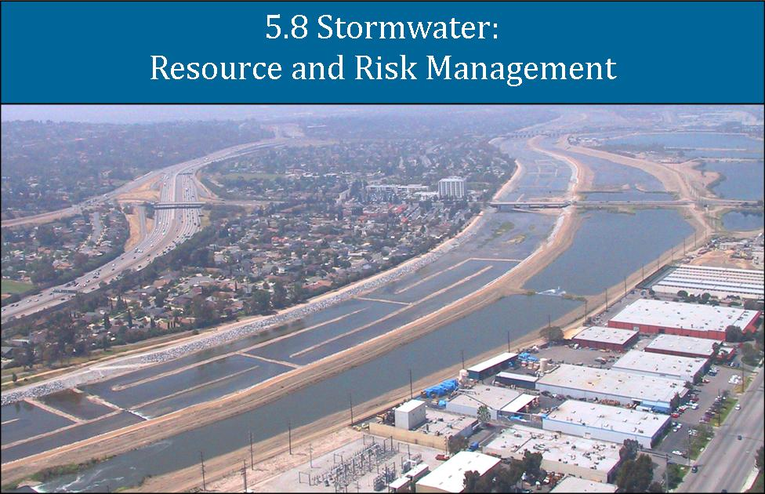

Chapter Findings and Recommendations Summary
The purpose of this Chapter is to 1) describe the mission, facilities, and operations of Flood Control Management agencies in the Santa Ana River Watershed; 2) identify past, current, and emerging key watershed priorities; 3) evaluate how key priorities have been, and potentially can be, addressed by Flood Control Districts/Divisions (FCDs) using a range of strategies; and 4) recommend the strategies and projects most likely to be effective to ensure watershed sustainability over a range of timescales. Finally, this OWOW 2.0 Plan (Plan) updates and revises the 2010 Plan.

Priority Issues
- Water supply is challenged by increased demand due to population growth in the watershed; reductions in imported water supplies; reduced groundwater recharge from expansion of urbanization and impervious surfaces placed over viable recharge areas; loss of riparian habitat; losses to the ocean due to concrete channelization and lost recharge in the channels themselves, seawater intrusion due to decreased groundwater recharge in coastal areas, and uncertain, but expected, long-term reductions in average annual precipitation due to climate change.
- High priority water quality problems include maintaining the salt balance in the watershed (see Chapter 5.5 Beneficial Use Assurance), reducing anthropogenic pollutants in surface water runoff to optimize beneficial uses,preventing pollutants from contaminating groundwater; and cleanup and management of existing contaminated groundwater sites (Chapter 5.5 Beneficial Use Assurance).
- Watershed management efforts of past decades were driven largely by individual entity priorities or programs. However, more comprehensive and integrated projects driven by a multi-stakeholder project paradigm can more effectively and more efficiently address watershed needs. Such projects can assist stakeholders to achieve compliance with the increasingly complex Municipal Stormwater NPDES Permits (MS4 Permits), while providing increased stormwater capture and groundwater recharge using favorable cost benefit approaches. Cooperative projects also unite various watershed jurisdictions and information, and more readily adapt to future conditions—and adaptability will be essential to effectively manage uncertain future conditions such as climate change.
- Reducing the risk of loss of life and property damage due to flooding remains a high priority within the Santa Ana River Watershed. The completion of the Santa Ana River Mainstem Project will reduce the risk of a catastrophic flood event in the Santa Ana River Watershed. However, there remains significant flood risk related to tributary watercourses within the watershed, compounded by potential impacts of wildfires and earthquakes.

Policy and Procedure Recommendations

- Describe a process to link public and private project development processes among stakeholders that promotes consideration of watershed priorities and stakeholder priorities very early in the planning process;
- Preserve floodplain functions through stricter management of development in floodplains—limit project construction in areas subject to flooding, preserve and restore riparian habitat functions, and enhance groundwater recharge;
- Where appropriate, FCDs, and all watershed stakeholders, should develop procedures and guidelines to ensure consideration of IRWM goals and watershed protection principles and priorities, consistent with the MS4 Permits, when planning and designing CIP or other projects, and during development or revisions of Master Drainage Plans (MDPs) and planning of projects that implement the MDPs;
- Create a lead watershed-wide Plan coordinating advisory and facilitation group that brings stakeholders together for decision making, partnership formation, and resource allocation to achieve Plan goals;
- Create a source of funds targeted at multi-agency Plan projects.

Implementation Recommendations

- Develop a water conservation-recharge optimization plan for existing and potential future flood control facilities, using the example work of the Chino Basin Recharge Master Plan and implementation projects as a template.
- Connect existing county or program-specific geodatabases to create a comprehensive watershed geodatabase that provides access to appropriate stakeholders, and set up a data quality control and maintenance program. The main component County MS4 geodatabases are well under way as described under “Map-Based Watershed Plans” in Section 6.
- Develop adaptable mechanisms to implement regional BMPs and alternative compliance options (see Table 5.8-1) under the MS4 Permits where appropriate (see example concept project in Appendix F).
- Describe role of a lead watershed-wide Plan coordinating advisory group with facilitation to ensure coordination of project partners.
- Preserving and restoring riparian habitat areas in conjunction with the comprehensive and integrated project recommendations within the 2.0 Plan.

Table 5.8-1 Alternative Stormwater Compliance Elements for Development Projects in the Santa Ana Region MS4 Permits
Alternative Compliance Options
(MS4 Permits: San Bernardino Co.--Section XI.G; Riverside Co.—Section XII.G; Orange Co.—Section XII.E)
1 | If a preferred BMP is not technically feasible, other BMPs should be implemented to mitigate the project impacts, or if the cost of BMP implementation greatly outweighs the pollution control benefits, the Permittees may grant a waiver of the BMPs. All waivers, along with waiver justification documentation, must be submitted to the Executive Officer at least 30 days prior to Permittee approval of the WQMP. Only those projects that have completed a feasibility analysis as specified in the WQMP Guidance and Template (see Section XI.E.7) and approved by the Executive Officer shall be considered for alternatives and in-lieu programs. If a waiver is granted, the Permittees shall ensure that project proponents participate in one of the in-lieu programs discussed in this section.
2 | The permittees may collectively or individually propose to establish an urban runoff fund to be used for urban water quality improvement projects within the same watershed that is funded by contributions from developers granted waivers.  The contributions should be at least equivalent to the cost savings for waived projects and the urban runoff fund shall be expended for water quality improvement or other related projects approved by the Executive Officer within two years of receipt of the funds. If a waiver is granted and an urban runoff fund is established, the annual report for the year should include the following information with respect to the urban runoff fund:  - Total amount deposited into the funds and the party responsible for managing the urban runoff fund;  - Projects funded or proposed to be funded with monies from the urban runoff fund;  - Party or parties responsible for design, construction, operation and maintenance of urban runoff funded projects; and  - Current status and a schedule for project completion.
3 | The obligation to install structural treatment control BMPs at a new development is met if, for a common plan of development, BMPs are constructed with the requisite capacity to serve the entire common project, even if certain phases of the common project may not have BMP capacity located on that phase in accordance with the requirements specified above.  This goal may be achieved through watershed-based structural treatment controls, in combination with site-specific BMPs. All treatment control BMPs should be located as close as possible to the pollutant sources, should not be located within waters of the US, and pollutant removal should be accomplished prior to discharge to waters of the US. Regional treatment control BMPs shall be operational prior to occupation of any of the priority project sites tributary to the regional treatment BMP.
4 | The permittees may establish a water quality credit system for alternatives to infiltration, harvesting and reuse, evapotranspiration, and other LID BMPs and hydromodification requirements specified above.  Any credit system that the permittees establish should be submitted to the Executive Officer for review and approval. The following types of projects may be considered for the credit system:  - Redevelopment projects that reduce the overall impervious footprint  - Brownfield redevelopment  - High density developments (>7 units per acre)  - Mixed use and transit-oriented development (within ½ mile of transit)  - Dedication of undeveloped portions of the project to parks, preservation areas and other pervious uses  - Regional treatment systems with a capacity to treat flows from all upstream developments  - Contribution to an urban runoff fund (see 2, above)  - Offsite mitigation or dedications within the same watershed  - City Center area  - Historic Districts and Historic Preservation areas  - Live-work developments  - In-fill projects  Riverside County Only  - Projects that enhance the transport of coarse sediment to the coast for beach replenishment.
5* | The water quality credit system should not result in a net impact on water quality.
6* | A summary of waivers of LID (along with a short description of the Section XII.G.2 through XII.G4 In-Lieu program selected), Hydromodification and Treatment Control BMPs along with any water quality credit granted, in-lieu projects, or urban runoff fund contribution required by each Co-Permittee shall be included in the Annual Report.
*Not specified in the Orange County MS4 Permit.

Evolution of OWOW Plan Flood Risk Management Pillar from 1.0 to 2.0
The Plan has evolved in the past few years as water supply and water quality problems, and flood, fire, and earthquake risks have been further evaluated and better understood. The linkage to FCD agency activities, as described in the Plan, version 1.0 and 2.0, are summarized below.

OWOW 1.0
- Evaluate how to achieve the goal to “manage rainfall as a resource,” thereby maximizing beneficial use of rainwater and providing adequate flood control capacity and other community benefits; and,
- Develop potential improved metrics for the expression of risk that are more understandable and more universal, to facilitate the establishment of better flood protection standards.
- The 1.0 Plan objectives are reflected in its “vision of flood risk management in 2030”:
- Each person in the watershed feels secure that there is a less than one in one hundred chance in any given year that their home will be flooded.
- There is no loss of life and no uninsured property damage in the watershed due to flooding.
- Stormwater is managed with the understanding that it is both a potential risk and a valuable resource.
- The 1.0 Plan, Chapter 5.6, describes the watershed’s physical geography, basic hydrology, land uses, and the history of the region’s floods and flood response. Regional flood response culminated in the ongoing Santa Ana River Project, and management strategies focused on hardening and straightening stream channels to maximize drainage efficiency, and buffering peak flows by providing large flood storage facilities.

Chapter Findings
- Very early land use decisions have preceded implementation of flood management strategies, severely limiting feasible flood control alternatives. Significant urban encroachment has occurred in most regional floodplain areas, where regional storage and hardened, straightened, and levied channels may be the only feasible and effective flood protection approaches.
- If flood management strategies were developed during the original (earliest) planning for development of the region, and implemented in a proactive, rather than reactive, manner, flood risk management could be balanced with other watershed priorities, and overall benefits could be optimized.
- To address the current regional priorities, given the existing systems, the Flood Risk Management Pillar and the Water and Land Use Pillar will need to collaborate to develop more effective new approaches going forward.

Challenges for the Future
- Watershed Coordination: To improve upon the results of traditional approaches to flood risk management, more collaborative and comprehensive planning and implementation needs to be coordinated at the watershed scale.
- Water Conservation: Develop additional ways to modify our infrastructure, or build new infrastructure components with more effective designs, to maximize the capture of local water while maintaining the required level of flood protection. Water conservation is part of the missions of the watershed FCDs (see Section 5.b, below). Probably the greatest opportunities for increased capture and recharge of stormwater are in the Inland Empire (generally San Bernardino and Riverside Counties and the incorporated cities in the SAR Watershed), where geology and open space allow enhanced recharge to reduce downstream flood magnitudes.
- Stormwater Quality Management and Flood Risk Management: MS4 Permits adopted in 2009 and 2010 for the watershed include explicit requirements to limit changes in runoff volume and velocity of runoff from new development and significant redevelopment projects using “low impact development” (LID) design concepts. These include minimizing impervious surface area, including pervious areas to interrupt flows across impervious areas, and maximizing stormwater infiltration. However, LID concepts and other methods used to avoid changes to the hydrograph will not address flood management issues. The LID requirements apply predominantly to new development projects so will not provide short-term solutions for existing developed areas, and a large proportion of the suitable watershed areas are already mostly built-out.
- Ecological Impacts: Construction of flood control conveyance facilities and dams for flood detention have a direct effect on riparian and wetland habitats. New projects of this type have become increasingly unacceptable to the public and environmental groups, and when approved, incur major costs for environmental mitigation. This Plan should develop a regional consensus on how to balance habitat protection and restoration priorities with flood protection and regulatory requirements.
- Money and Advocacy: Flood control projects and water supply projects are expensive. Public investment for such projects has typically been spread over a large population, and required as a condition of project approvals, leading to the expectation that infrastructure improvements depended on growth to be affordable. The Watershed needs to find alternatives to relying on future development to fund infrastructure.

Flood control infrastructure project construction often depends on State and Federal subsidies. This approach necessitates a sustained commitment to advocacy in Sacramento and Washington, DC, that is expensive and has not always been well coordinated. A comprehensive, watershed-wide plan for flood management, integrated with other water resources programs, would be the foundation for focused advocacy efforts of all stakeholders and the entire delegation of legislators in the Watershed.

- Decision Making: Historical land development and land planning decisions have occurred before flood protection planning and implementation. Therefore, land development has pre-empted flood control and constrained the available flood management approaches, thus limiting the ability of FCDs to fully achieve their flood control missions and address the economic and environmental impacts of those actions.
- Quantification of Risk (to prioritize): Flood risk needs to be clearly communicated to elected officials, and to compare that risk to other priority community needs, including water resources. It is important for the public to understand what 100-year flood protection means. Currently, the average citizen is concerned mainly whether flood insurance premiums are required, and whether the local FCD is doing its job.

Conclusions (OWOW 1.0)
- Environmental Review requirements have increased the complexity of FCD infrastructure management.
- FCD Management priorities should be integrated into the earliest stages of land use planning and decision/approval processes.

OWOW 2.0
- Build on the work of OWOW 1.0 to identify implementation actions to address strategies for flood risk and stormwater management.
- Define any new opportunities to address flood protection and integrate storm water management and water conservation with reduction of risk to property from flood events.
- Explore feasibility of automated rainwater harvesting systems and networks that could provide water conservation and flood control, as well as water quality benefits.
- Examine the framework and potential development of regional mitigation banks.
- Evaluate “alternative compliance,” options provided by MS4 Permits include regional BMPs, retention credits, in lieu BMP implementation, and an urban runoff fund.
- Identify approaches and processes to partner with FCDs on projects.

These objectives and recommendations for the 2.0 Plan are discussed further in the following sections.

Relation to other OWOW Pillars
FCD Jurisdictions cross virtually all other jurisdictional areas in the watershed, and almost all surface water infrastructures are managed by the FCDs, some in partnership with the U.S. Army Corps of Engineers (USACE), the U.S. Bureau of Reclamation USBR, the California Department of Water Resources (DWR), water districts, cities, or other agencies. Projects requiring surface water conveyance or storage will typically require permits from the FCDs and other agencies. Therefore, FCDs are mandatory project stakeholders and partners in the vast majority of existing and potential projects to enhance stormwater capture and groundwater recharge. FCD legislative authorities included water conservation, but the highest mission priority is flood protection. Any cooperative project with a FCD as a partner must ensure that project design and operation does not compromise flood protection priorities.

In California, most MS4 Permits designate FCDs as Principal Permittees. In the Santa Ana River (SAR) Watershed, the Principal Permittees are the San Bernardino County Flood Control District (SBCFCD), the Riverside County Flood Control & Water Conservation District (RCFCWCD), and the County of Orange. SBCFCD, RCFCWCD, and OCFCD (OC/OCFCD) are collectively referred to herein as the FCDs. Principal Permittees lead the development of required implementation documents and programs and coordinate implementation of the MS4 Permits among all of their co-permittees (cities and counties). Therefore, the Principal Permittees and FCDs are a primary source of information and guidance for the co-permittees and other stakeholders in the watershed. These MS4 Permit requirements include:

- WQMPs—Water Quality Management Plans are enforceable guidance that specifies the requirements for stormwater quality and hydromodification mitigation project designs and BMPs.
- Watershed Plans—Detailed plans to address watershed management within specific subwatersheds with the SAR Watershed and within specified jurisdictional or hydrologically defined areas. These include plans to address specific water quality problems (such as TMDLs), and/or hydromodification management, specific habitats, or other subwatershed-specific concerns.
- Tools: MS4 programs are required to develop a variety of tools to address urban runoff impacts, including public outreach materials and programs, technical guidance for development project design and conditioning, mapping and GIS, hydrology manuals, water quality and biological monitoring programs, and various special studies to address specific concerns.

Therefore, the Principal Permittees and FCDs (and their co-permittees) are the direct link to compliance with the MS4 Permits. These permits require consideration of water quality, changes in runoff hydrology, integration of runoff water quality issues into land use planning and development project approval, preservation and improvement of habitat, and compliance with all related state and federal regulations (USACE 404 Dredge and Fill permits; CDFW stream alteration agreements; USFW species and habitat concerns; RWQCB Section 401 Water Quality Certifications, and others) as well as local ordinances and codes. The broad scope of the MS4 Permits and the watershed-wide jurisdiction of the Principal Permittees link the FCDs to all the other OWOW Pillars.

Background
Santa Ana Watershed Physical Characteristics
The Santa Ana River watershed covers about 2,450 square miles. Maximum elevations in the Watershed exceed 11,000 feet, and more than one-third of the watershed area lies within three steep mountain ranges. Most of the rest occurs in lower-sloped valleys formed by a series of broad alluvial fans that extend from the base of the mountain front. The SBCFCD has jurisdiction over the largest and most upgradient areas in the watershed, RCFCWCD manages the intermediate and lower eastern section, and OC/OCFCD manages the lower, more coastal portion.

The watershed comprises three main sub-watersheds: 1) The Santa Ana River above Prado Dam (upper SAR Watershed) which drains of about 62% of the watershed, 2) the San Jacinto River which drains about 30% of the watershed into Lake Elsinore--flows from the San Jacinto River only reach Prado Dam when Lake Elsinore spills over into Temescal Wash (last spillover occurred in 1980), and 3) the S A R Watershed below Prado Dam which drains about 8% of the watershed and includes the Santa Ana Mountains, Chino Hills and the broad coastal plain.

Physiographic differences between the three areas result in significant differences in the design and operation of FCD facilities. The upper SAR Watershed includes three significant tributaries, Mill Creek, Bear Creek, and Lytle Creek. The Upper SAR Watershed has areas of extreme slopes and elevations, the average gradient of the Mountain reaches of the upper SAR average 240 ft. /mile, and 30 ft. /mile near Prado Dam. The gradients of the main tributaries average 700 ft. /mile in the mountains and 30 ft. /mi in the valley reaches. Storm and runoff events in the upper SAR Watershed can be extremely dynamic and subject to high levels of sediment and debris delivery in very short timelines. One large rainfall season, or event (or fire) can cause impacts to the FCD system that takes all available resources to recover from—thus delaying work on other planned projects for up to several years.

The San Jacinto River flows from headwaters in the San Jacinto Mountains. Mountains and foothills account for 471 square miles while 288 square miles are considered valley floor (SWRB, 1955). Elevations range from less than 1,250 feet above sea level at Lake Elsinore to approximately 1,400 to 1,700 feet on the valley floor to 10,834 feet at Mt. San Jacinto in the San Jacinto Mountains. More than 90 percent of the San Jacinto River Watershed drains to Lake Elsinore (McKibbin, Stuart 2013). Runoff from as far as Moreno Valley, San Jacinto, Hemet, and Perris contribute to surface flows that reach Lake Elsinore during rainfall events. During normal to dry periods, when the San Jacinto River and the surrounding tributaries are essentially dry, little or no flow enters Lake Elsinore.3

Approximately 60% of the drainage area for the SAR Watershed below Prado Dam lies within the Santa Ana Mountains and the Chino Hills. Most of the remaining area lies within the broad coastal plain that extends southwestward to the Pacific Ocean. Numerous tributaries contribute to the Santa Ana River within this reach. The principal tributary is Santiago Creek with a drainage area of approximately 102 square miles. Lesser tributaries include Wardlow Canyon, Aliso Canyon, Gypsum Canyon, Blue Mud Canyon, Walnut Canyon, and Carbon Canyon Creek. The average gradient of these tributaries is about 300 feet/mile, while the average slope of the Santa Ana River from Prado Dam to the ocean is about 15 feet/mile2.

The climate is generally mild, but both temperature and precipitation vary considerably with distance from the ocean, elevation, and topography. Most precipitation occurs as rain from December through March, although some falls as snow at higher elevations. The average annual rainfall varies from ten inches per year south of Riverside, to about 45 inches per year in the higher mountains.

Winter storms usually move in from the Pacific Ocean bringing widespread rain, and snow at the higher elevations. Such storms often last several days. More localized episodic storms associated with frontal systems can occur at any time of the year, and can produce high-intensity precipitation over a comparatively small area for up to six hours.

Stream flow is perennial in the canyons of the Santa Ana River and in the headwaters of most of its tributaries, but is generally ephemeral in most valley segments. Stream flow increases rapidly in response to precipitation. High-intensity precipitation, especially following wildfire, may result in intense sediment-laden floods, with some debris load in the form of shrubs and trees.
There are several large lakes and reservoirs within the watershed that help regulate flood flows; the largest being Prado Dam, Seven Oaks Dam, Lake Elsinore, Big Bear Lake, Lake Hemet Reservoir, and Santiago Reservoir.

Historical Flooding
The SAR Watershed has experienced flooding on numerous occasions in the American era, including floods in 1825, 1862, 1884, 1914, 1916, 1927, 1938, 1965, 1969, 1980, 1983, 1995, 2005 and 2010. The critical event in flood management in the SAR Watershed was the 1938 flood. In that event, Orange County experienced California’s worst flooding of the 20th century. The City of Anaheim experienced 15 feet of water in some places, and 182,000 total acres were inundated. Dozens of deaths occurred. In Riverside and San Bernardino Counties, the 1938 flood made it painfully clear that the County governments did not have an adequate program of flood protection. The Orange County FCD was formed in 1927, San Bernardino County created its flood control district in 1939, and Riverside County followed the same course in 1944.

Missions
The FCDs’ highest priority is to ensure flood protection of life and property and comes directly from legislative authority (CWC Section 8100). However, FCDs also have parallel missions to provide water conservation, and recreational and irrigation use of impounded waters within their jurisdictions, while preserving flood protection effectiveness (see Section 5.a, below).

Flood Control Improvements

Santa Ana River
The Santa Ana River has been the focus of USACE of Engineers projects starting with the authorization of Prado Dam in 1936. The dam was completed in 1941. Levees were constructed in Riverside in 1955.
Prado Dam was built primarily for downstream flood protection, and 92 percent of the watershed lies above it. More recently, the dam also has become a vital component of the water supply management program in the region, and has allowed the creation of ecologically important habitat areas behind it.

Prado Dam originally was designed to provide protection against flooding in a 200-year event, but as the watershed urbanized, the protection had decreased to a 70-year event with the downstream channel having capacity for only a 50-year event. To address these deficiencies the USACE initiated study of the Santa Ana River Main Stem Project (SARP) in 1964. Construction of the SARP was initiated in 1989.
The SARP is located along a 75-mile reach of the Santa Ana River in Orange, Riverside and San Bernardino Counties. The project’s objective is to provide the developed and developing areas in the watershed with approximately 100-year flood protection through the end of the project life. The plan for flood control improvements included three principal features:

- Lower river channel modification for flood control along the 30.5 miles of the Santa Ana River from Prado Dam to the Pacific Ocean. Construction of a retarding basin and channel improvements on Santiago Creek are also planned. (Ongoing, estimated completion date: 2016)
- Enlargement of Prado Dam to increase reservoir storage capacity from 217,000 acre-feet to 362,000 acre-feet. (Ongoing, projected completion date 2024.)
- Construction of Seven Oaks Dam (about 35 miles upstream of the existing Prado Dam) with gross reservoir storage of 145,600 acre-feet. (Completed in 1999.)
- The drainage area behind Seven Oaks Dam comprises 177 square miles, excluding 32 square miles that drains internally to Baldwin Lake. The principal tributary is Bear Creek, which drains 55 square miles, and has an average gradient of 460 feet/ mile. The only existing structure that would affect flood flows in this sub-watershed is Big Bear Lake, which is a water conservation reservoir. It collects water from a 38-square-mile drainage area, and has a surcharge storage capacity of about 8600 AF between the top of the conservation pool and the top of the dam.

San Jacinto River
The San Jacinto River Watershed Council (SJRWC) developed an Integrated Regional Water Management Plan (IRWMP) for that 770-square-mile sub-watershed (now incorporated into the Plan). The San Jacinto IRWMP, addressed water supply, water quality, drought-proofing, and critical habitat protection. The plan also addresses flood risk concerns, and recognizing that the issue is risk management and not purely a matter of engineering, the SJRWC approach frames the issue as “provid[ing] flood protection to existing disadvantaged communities.” The plan acknowledges a number of flood risk management strategies as alternatives to channelization.

In 1960 the USACE constructed the San Jacinto River Levee to protect the city of San Jacinto. The levee was rehabilitated by the USACE in 1980 after the levee was breached by a 30-year return frequency flood event. Another major USACE project was the Lake Elsinore Management Project constructed in 1995; the project allows for better management of the lake water levels and provides a safe outlet for the lake when it spills.

Improvements to Tributaries
Other flood control improvements exist along some of the smaller tributaries: San Antonio, Chino, Cucamonga, Deer, Lytle, San Sevaine, Day, San Timoteo, City, and Cajon Creeks, above Prado Dam; Carbon Canyon Dam and Villa Park Dam in Orange County; and Perris Valley Storm Drain and Salt Creek above Lake Elsinore. These improvements include channelization, debris basins, storm drains, levees, stone and wire-mesh fencing, stone walls or rip-rap along the banks of stream channels, concrete side slope protection, and drop structures.

Other improvements not aimed mainly at flood control include spreading grounds, recharge basins, and water conservation reservoirs. There are more than 100 water conservation and recreational reservoirs in the watershed, with storage volumes ranging from 5 AF to 182,000 AF in Lake Mathews. These improvements affect the regimen of lesser flood flows, but do not appreciably affect major flood flows.
Below Prado Dam in Orange County, local and tributary projects include: improvements to Fullerton Creek Channel, Greenville-Banning Channel, Bolsa Chica Channel, East Garden Grove-Wintersburg Channel, Huntington Beach Channel, Talbert Channel, Peters Canyon Channel, Aliso Creek Channel, Serrano Creek Channel, San Juan Creek Channel, Westminster Channel, and Atwood Channel.

Flood Risk
Risk is the product of the likelihood of the flood control facility failing, the amount of damage that might occur for given depths of flooding and the likelihood of a flood discharge. For example, a levee made from sand is much more likely to fail than one made of concrete and the risk for residents behind it is higher. Or if an area is flooded to a depth of 1-foot but all the buildings in the area are elevated 2-feet above the ground the risk from flooding is dramatically reduced.

Flood discharges can be estimated. One way to estimate flood discharges is the Probable Maximum Flood (PMF) which is the most severe combination of critical meteorological and hydrological conditions that are reasonably possible in the region. Application of PMF is mostly confined to determination of spillway requirements of high dams in order to give virtually complete security against potential floods catastrophes.

The USACE has chosen to design many flood control structures in the region to the Standard Project Flood (SPF), which represents the discharge that may be expected from the most severe combination of meteorological and hydrological conditions that are considered reasonably characteristic of the geographical region involved, including extremely rare combinations. SPF is selected where some small degree of risk can be accepted but an unusually high degree of protection is justified by hazards to life and high property values within the area to be protected. It is estimated that the SPF discharges are generally equal to 40-60 percent of the MPF discharges for the same basin. For example the Prado Dam and Seven Oaks Dam storage areas and the Santa Ana levees were designed for the SP F.

Today, the discharge most commonly used by local jurisdictions for planning and design is the 100-year flood, a hypothetical event that is defined as having a 1 in 100 (1%) chance of occurring in any given year. This standard came about through the National Flood Insurance Act of 1968 which created the National Flood Insurance Program (NFIP). At the outset of the program, a national standard was needed to enable all properties to be treated similarly. The 100-year or base flood was selected as a trade-off between two possible extremes. At one end of the spectrum, the program could have sought to protect everyone from almost all floods, no matter how large or rare, which would have placed economic improvement restrictions on very large areas. At the other end, the program could have provided protection only for the smaller floods, which would have left many buildings exposed to damage. The 100-year standard was the balance point between the pros and cons of both extremes.

In order to take advantage of the federal government’s offer of affordable flood insurance, communities that participate in the NFIP must manage their floodplains by applying land use regulation and construction standards in an effort to reduce future flood losses. Local communities adopted the 100-year standard to be consistent with the NFIP, although some critical flood facilities are designed to higher standards. For example, the California State Legislature adopted SB5 in 2005 which established that levees and floodwalls in the Sacramento-San Joaquin Valley provide protection against a flood that has a 1-in-200 chance of occurring any given year.

The California Department of Water Resources and the USACE have developed a program called “California’s Flood Future.” They found that millions of Californians live in areas exposed to flood risk, and believe there is an unacceptable level of flood threat to public safety and the economy. They evaluated risk in 100-yr and 500-yr flood zones as defined by FEMA and statewide county sources. They found an expectedly larger population would be affected by a 500-yr flood with concomitant economic losses. They also found that the South Coast Region has the greatest population exposed to floods, with the majority in the Orange and Los Angeles Counties: 250,000 in the 100-yr floodplain, and over 3 million in the 500-yr flood plain. The results of this work will influence flood risk management approaches in the future, and explicitly suggests use of integrated water management and IRWMs to address this challenge.

The NFIP has mapped 100-year floodplains for the major tributaries throughout the watershed. The Table below shows the scope of the existing flood hazard within the Santa Ana River Watershed.

Table 5.8-2 Square Mileage of 100-Year Floodplain
County | 100-year floodplain (sq. mi) | Number of structures | Value of structures
Orange | 46
Riverside | 90 | 7200 | $2.4 Billion
San Bernardino | 191

Figure 5.8-1 Flood Channels and 100-Year Flood Zones in the Santa Ana River

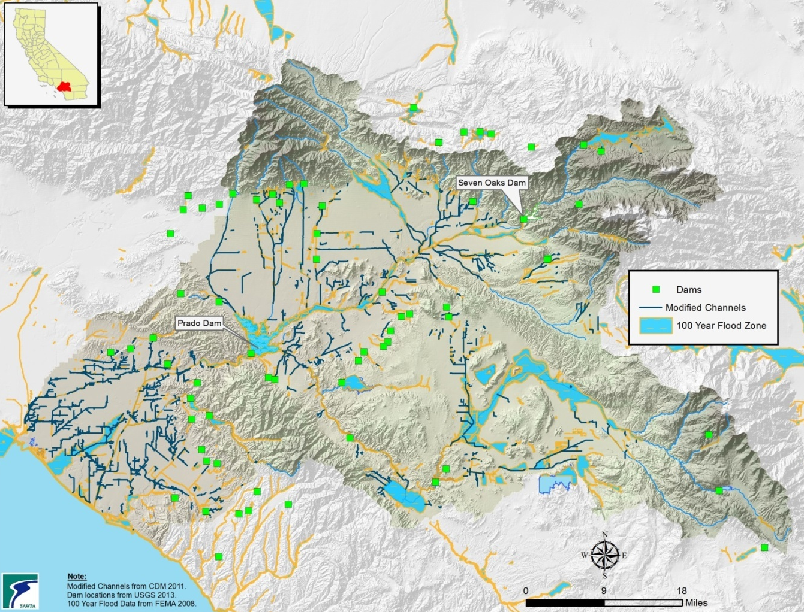

Sediment management (sediment as a resource)
- There are many benefits associated with managing sediment within the Watershed. With Seven Oaks and Prado Dams, sediment transfer could provide a longer usable life of the dams for flood control purposes. The costs of raising the elevation of a dam in the future have large economic and social implications. Some of the impacts include the cost of construction, purchase of property that will lie within the new flood zone and the relocation of infrastructure. Sediment-filled reservoirs behind dams have been addressed elsewhere by plans to remove the dams (e.g. Matilija Dam in Ventura County: http://www.matilijadam.org/).
- Removing sediment from behind our dams would also preserve and create valuable storage volume for water conservation efforts. Water conservation is limited based on storing water at elevations that minimally impact flood control efforts and natural resources. As sediment accumulates behind a dam it reduces the available volume for water conservation. Active management of sediment at the Prado Dam is being investigated by the USACE’s Prado Basin, California Feasibility Study and the Proposition 84-funded Prado Basin Sediment Management Demonstration Project (Project ID #2098, Table SW-2a and b).
- Sediment released below a dam is carried further downstream and provides replenishment sediment that could replace eroded areas that have compromised critical infrastructure. Two examples in the SAR Watershed include the CA 91 Freeway and the current location of the Inland Empire Brine Line. This replenishment sediment would also preserve stream embankments and critical flood control levees. As the river incises due to reduced sediment loads, it erodes the embankments and adversely impacts wildlife habitat for protected riparian species. This adverse impact is termed “hydromodification” in the MS4 Permits.
- Sediment is needed in the Santa Ana River for groundwater recharge operations between Imperial Highway and the CA 57 Freeway. Coarsening, and subsequent armoring, occurs when the natural sands in the river are washed downstream and not replaced by new sediment deposition. Over time the accumulation of these fine sediments create an impermeable layer in the river bottom thereby reducing percolation rates.
- The Santa Ana River is also a major source of sediment for beach sand. While anthropogenic beach replenishment is a regular activity, the full effects of sediment impoundment by Prado Dam have yet to be felt by Orange County coastal communities. Consequences of reduced sediment at the coast will affect private and public properties, infrastructure, and adverse environmental impacts.
- Effective sediment management requires a watershed-wide approach. Sediment originates from erosion in the local mountains and foothills and is transported through and stored within the jurisdictions of numerous agencies on its way to the ocean.

Floating Debris
Floating debris and trash can cause clogging and slow drainage of flood facilities and water quality BMPs. If such facilities are not adequately maintained, these materials can become a source for mosquitos, and other disease vectors and nuisance pests. Accumulated trash and debris are also remobilized to downstream areas with successive storm events, and blown by strong winds.

Fire
Episodic wildfires are natural occurring events in southern California landscapes. However, fire suppression practices in the past decades have altered the character of natural landscapes and plant communities, and urban expansion and encroachment into natural areas has resulted in an increased frequency of wildfires (Figure 5.8-2). Increases in runoff, erosion, and sediment loading during storm events have been well documented. Flood facilities can be overwhelmed and uncontrolled debris flows and floods can occur. Long-term slope stability is compromised by intense wildfire events, and post-fire runoff contains increased levels of pollutants that can cause severe impacts to receiving waters. These impacts are not fully understood, but may be best managed by prevention. Anthropogenically-intensified wildfires also cause longer-lasting landscape impacts, and habitat recovery may be delayed. The “Forest-First” programs under development between SAWPA and the USFS should provide proactive management actions to reduce wildfire impacts over time.

Figure 5.8-2 Major Wildfire Areas in the Santa Ana River Watershed in 2003, 2007, and 2008
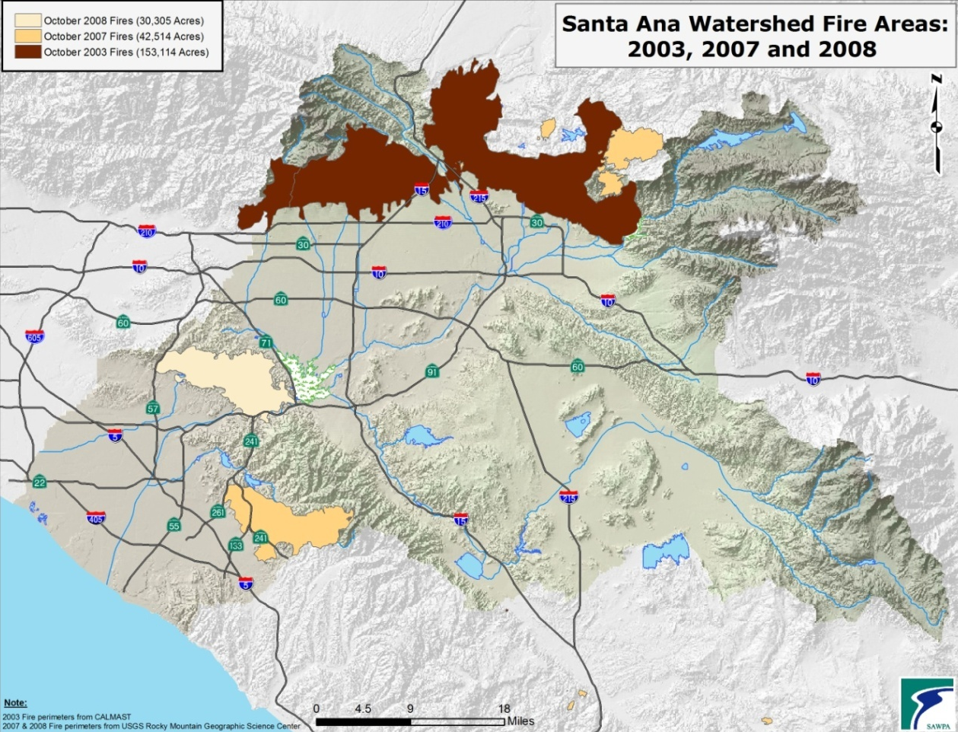

Earthquake
The Santa Ana River Watershed very seismically active, being affected by three major fault systems, the San Andreas, San Jacinto, and Elsinore faults (Figure 5.8-3). Although FCD facilities and dams have been engineered and constructed to meet all applicable seismic hazard requirements (e.g. Seven Oaks dam is designed to withstand an 8.0 magnitude earthquake), actual infrastructure damage from earthquakes remains uncertain.

The USGS has developed a theoretical, yet plausible, San Andreas Fault earthquake scenario called The Great California Shakeout. The Great California Shakeout scenario depicts the impacts from a 7.8 magnitude earthquake on the San Andreas Fault in Southern California. On average, such an earthquake occurs south of the San Gabriel Mountains every 150 years; the most recent was 300 years ago. A 7.8 magnitude earthquake is expected to affect 7.5 million people. An estimated 200,000 people commute over the San Andreas Fault for work and would potentially be separated from their homes. Ground shaking would last as long as 2 minutes and some areas will experience ground level displacement of up to 10 feet. Thousands of aftershocks would be expected in the following months. There would be an estimated 1,800 deaths and 53,000 injuries in the first minutes of the event. As many as 1,500 buildings would collapse and 300,000 structures would be severely damaged causing $213 billion in damages. 255,000 people would be homeless. In the minutes following the earthquake Southern California would expect up to 1,600 fires due to severely reduced fire-fighting capability from damaged infrastructure, and a lack of running water and/or electricity for weeks or months.

The SAR Watershed would be significantly affected, especially by interruptions in the supply of imported water. Such an earthquake event could cause extensive levee failure along the State Water Project, resulting in significant imported water loss and flooding of surrounding areas.

Figure 5.8-3 Major Geologic Fault Zones in the Santa Ana River Watershed
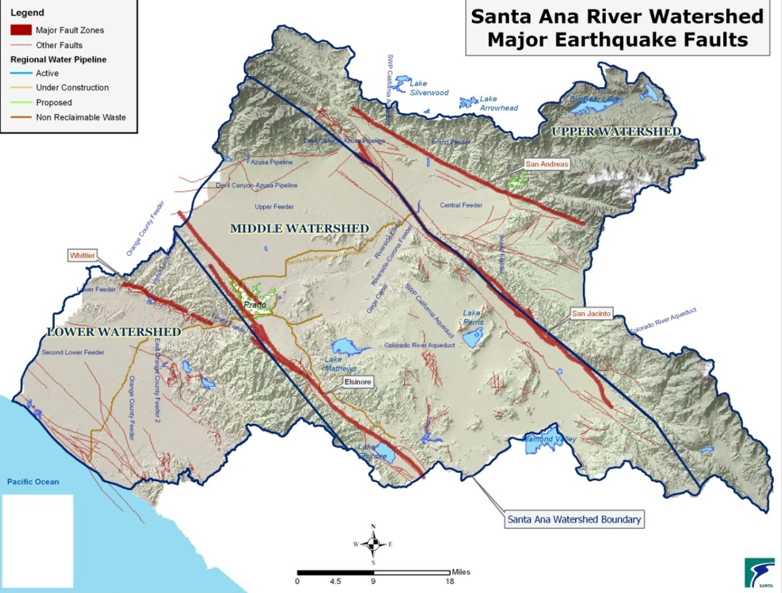

Climate Change
The OWOW Plan includes evaluation of climate change impacts and recommendations to the watershed through mitigation and adaptation to a changing climate. Details of the watershed's evaluation can be found in the Bureau of Reclamation's Technical Memorandum: 86-68210-2013-02: Climate Change Analysis for the Santa Ana River Watershed, dated August 2013. It is located at [Appendix G] in the OWOW 2.0 Plan. Some of the highlights of the watershed's climate change analysis reveal that in the next 50-years and beyond, average annual temperatures will increase, total annual precipitation will probably decrease, and winter snowpack will melt sooner, causing more runoff in the winter rather than in the spring.

In the Santa Ana River Watershed, nearly 95% of the average annual rainfall occurs in about a 4.5 day period. Collecting a substantial portion of large runoff volumes in the short timeframes characteristic of intense, short duration events in such a short timeframe in detention or recharge basins is difficult. Given the same average annual rainfall, runoff from more frequent and less intense storms could be captured more effectively by typical basins. However, changing weather conditions resulting from climate change are expected to increase the intensity of storms in the SAR Watershed while decreasing their frequency, which would decrease the expected volume captured by existing approaches.
FCDs are not expected to make significant changes to facilities in the near future, but should evaluate their systems to address variable runoff scenarios in partnership with other stakeholders. It may be possible to modify the runoff capture facilities to optimize groundwater recharge for shorter duration, larger magnitude, and higher intensity storm events. Collaborative projects with water supply and groundwater management agencies as partners would provide a multi-perspective approach, and higher likelihood for success for climate change adaptation projects, than FCDs conducting such projects in isolation. Successful flood control and stormwater capture/groundwater recharge projects will likely require adaptive management approaches for long-term optimization.

Intersection of IRWM (OWOW) and Flood Control District Missions
California’s Flood Future (2013) identified the following problems currently facing FCDs:

- Land use decisions may not adequately prioritize public safety;
- Differing methodologies and inadequate data make risk assessment complex and costly;
- Flood management projects are not prioritized from a system wide perspective;
- Emergency preparedness may not receive necessary funding;
- Delayed permit approvals and complex permit requirements are obstacles to flood risk reduction; and,
- Lack of reliable, sustained funding puts Californians at significant risk.
- This section links these and other problems, from the perspective of FCDs, with the purpose of the Plan and efforts to improve compatibility and how to partner with FCDs.

FCD Missions
The missions of FCDs hold flood protection as their highest priority. FCDs are natural partners for many projects due to their broad jurisdictional areas, and parallel missions of water conservation and water quality improvement. However, FCD funding is generated from property assessments which may limit the applicability of FCD funds to the areas from which fees are derived (FCD Zone areas). Mission statements for the SAR Watershed FCDs:

RFCWCD
“The objects and purposes of this act are to provide for the control of the flood and storm waters of the district and the flood and storm waters of streams that have their source outside of the district, but which streams and the waters thereof flow into the district, and to conserve the waters for beneficial and useful purposes by retarding, spreading, storing, retaining and causing to percolate into the soil within the district, these waters, or to save or conserve in any manner all or any of these waters and protect from these flood or storm waters, the watercourses, watersheds, public highways, life and property in the district, and to prevent waste of water or diminution of the water supply in, or unlawful exportation of water from the district, and to obtain, retain and reclaim drainage, storm, flood and other waters for beneficial use in the district.

SBCFCD
“To provide for the control of flood and storm waters of the District in order to protect watercourses, watersheds, public highways, life and property; to conserve such waters for beneficial purposes by spreading, storing and causing to percolate in the soil.”

OCFCD
The purposes of this act are to provide for the control of the flood and storm waters of the district, and the flood and storm waters of streams that have their source outside of the district, but which flow into the district, and to conserve those waters for beneficial and useful purposes by spreading, storing, retaining, and causing them to percolate into the soil within the district, or outside the district, or to save or conserve in any manner all or any of those waters and protect from damage from those flood or storm waters, the harbors, waterways, public highways, and property in the district.”

Right of Way
FCDs are also constrained by right-of-way and easements. Master Plans of Drainage (MPDs) typically develop a conceptual conveyance system for a plan area, with the intention to preserve adequate right-of-way for FCD facilities to be built when needed. However, many MPDs were developed without due consideration for enhanced stormwater capture, or for soft-bottom or more ecological alternatives to standard hardened and concrete facilities. Therefore, existing right-of-way for FCD facilities may be inadequate to accommodate multi-use facility designs.

Environmental permitting requirements
Construction of most FCD facilities requires environmental permitting, including CEQA documents and permits from the USACE (404 Dredge and Fill Permits), RWQCBs (401 Water Quality Certifications), and CDFW (1601 Streambed Alteration Agreements). Increasing concern over the environmental impacts of the construction of hardened and concrete-lined facilities has resulted in increased environmental mitigation requirements for such facilities. Permitting for more ecologically benign designs and multi-benefit facilities can be less costly and more streamlined. This provides an incentive for FCDs to incorporate such project concepts and designs into their CIP plans, and enhances their benefits as partners in cooperative projects.

Focus Areas from the SAWPA OWOW 2.0 IRWMP Proposition 84 Proposal:
- Water Demand Reduction Strategies
- Water Quality Improvement and Awareness
- Targeted and Expanded Community Outreach
- Restore Natural Systems and Hydrology
- Expand Collaboration
- Climate Change and Energy Impacts
- System-Wide Approaches and Leadership

Challenges for collaboration
The FCDs have been implementing CIP projects and maintaining these facilities in the watershed for approximately 80 years, acting with legislative authority to protect life, property, and navigation. This includes debris basins in the steep foothills, engineered conveyance and storage facilities in the inland valleys, and dams and channel protection measures to allow flood runoff to flow to the ocean with a minimum of uncontrolled floodwaters. On a parallel track, the FCDs have implemented water conservation elements within their facilities, particularly as an aid to flood protection, and to remove sediment and improve water quality as it moves downstream in the watershed. These facilities were built and maintained to protect large pre-existing urban areas, and to serve constantly growing urban and suburban areas in the watershed. These works were completed with local, state and federal funding, and were constructed in part by the USACE.

Each FCD (SBCFCD, RCFCWCD, and OC/OCFCD) has differing challenges based on their physiography (as described in Section 4), on their proportion of existing urbanized area and remaining developable areas, and on economic factors. Orange County has the lowest gradient topography and conveyance system overall, has the greatest population and economic resources, yet probably has the biggest challenge to find new space for recharge basins or to enlarge FCD facilities to meet greater flood flows. Riverside County has high gradient and lower gradient areas, a smaller population and less economic resources than OC/OCFCD, and has added constraints associated with a large existing Multi-Species Habitat Conservation Plan. San Bernardino County has the highest gradient areas and the Seven Oaks Dam, has significant sediment and debris removal needs, and has several large groundwater basins and potential for increased storage, somewhat more developable area, yet fewer economic resources than the other counties. Each county has existing sites of groundwater contamination, but only Orange County has the issue of seawater intrusion.

With the adoption of the environmental regulations in the late 1960s and early 1970s (Porter-Cologne Water Quality Act; reauthorized and amended Federal CWA; CEQA; NEPA; and the ESA), regulatory permitting has impacted the planning, design operations, and maintenance activities of the FCDs. In more recent decades, the environmental impacts of FCD facilities and activities have been observed and criticized by environmental protection advocacy groups. FCD facility planning, design, and permitting, and maintenance has become more complex and costly as a result of this layer of regulation and scrutiny, while the flood protection and water conservation directives have continued as highest priorities.

There appears to be great benefit for significantly increasing the degree of project planning, design, implementation, and maintenance conducted collaboratively among the FCDs; with watershed partners including water suppliers, groundwater management agencies, Watermasters, sewering agencies, local land development authorities, and the USACE and the USFS. Each of these entities brings experience, design ideas, and potentially funding and maintenance resources to the project. A collaborative project development team also fulfills the objectives of IRWMP implementation and is more competitive in the quest for grant funding. This was recognized by the Board of Supervisors of the RCFCWCD when they approved Resolution Number F2004-18 in June 2004. This resolution directs RCFCWCD and Western Municipal Water District (WMWD) to jointly plan and develop water conservation projects in western Riverside County, including a conjunctive use program for Colton and Riverside groundwater basins; the Riverside-Corona Feeder Project; and joint participation in new conservation at Seven Oaks Dam. RCFC also investigated with WMWD whether an existing detention basin in the City of Riverside would function for water conservation. However, high groundwater in the area precluded an increase in infiltration at the site.

In San Bernardino County, the SBCFCD and the San Bernardino Valley Municipal Water District first entered into a cooperative agreement to recharge groundwater using SBCFCD basins in 1972. Several projects have been developed since this first agreement. Most recently, the SBCFCD and the SBVMWD have approved a MOU for the purpose of evaluating SBCFCD facilities for dual purposing to provide increased groundwater recharge while maintaining flood protection as the highest priority. Current work is focused on the Cactus FC/Recharge Basins in Rialto. Here, the SBCFCD, in cooperation with SBVMWD, obtained $1 million from a Proposition 84 Grant to enhance Cactus Basins 3/3A for flood control and groundwater recharge purposes.

However, collaborative projects using FCD facilities must acknowledge the overarching priority for flood protection. Projects must be designed to allow FCD facilities to function unimpeded and dynamically during and in preparation for potential flood conditions. In addition, FCD facilities may have other constraints regarding design and maintenance that support their flood protection function, and these must be accommodated by the design and operation of the project. FCDs are willing partners to accomplish watershed-based objectives, but must fulfill their legislative mandate when conditions demand it.

Compliance with the MS4 Permits may provide significantly increased incentives for FCDs to collaborate on watershed projects that address MS4 Permit requirements (see discussions in Sections 3 and 6).
Stormwater as an Essential Resource for the SAR Watershed
This section builds on the work of OWOW 1.0 to provide examples of three projects successfully implemented in the SAR Watershed to achieve IRWM goals. Each project includes multiple component projects, and are either ongoing or are planning future implementation actions. This is, or course, not an exhaustive project list. These particular projects are presented as examples of how several of the “challenges for the future” (as listed in Section 2, above) can and have already been met in parts of the SAR Watershed—some were achieved decades earlier. The approaches, tools, and partnerships developed during these projects will help guide and improve future implementation projects for flood risk and stormwater management.

Successful Implementation Projects
The Santa Ana River Mainstem Project (SARP) (described in Section 4, above)
This ongoing project is designed to provide flood protection to the growing urban communities in Orange, Riverside and San Bernardino Counties. The proposed improvements to the system cover 75 miles, from the headwaters of Santa Ana River east of the city of San Bernardino to the mouth of the river at the Pacific Ocean between the cities of Newport Beach and Huntington Beach. This project is perhaps the most significant successful project in the SAR Watershed. Although it began with a flood protection priority as a driver that leveraged state and federal funding, it has incorporated a wide range of water quality and water conservation components over several decades—and is managed by a multi-agency entity. It is a model for adaptive infrastructure management with changing priorities.

All three counties, collectively, work closely with the USACE to design and construct the project elements. The project approach has been significantly improved through use of facilities on the SAR to increase groundwater recharge, especially in the lower SAR. The project pioneered the reoperation of Prado Dam and the use of Seven Oaks Dam to allow more use of storage capacity for water conservation, without unacceptably diminishing flood protection.
Project success factors:

- Overriding flood threat mitigation priority initiated the project.
- Legislative mandates drove project implementation and funding.
- Strong and long-term ongoing cooperation among federal, state, and local project partners with a multi-party Agreement.
- Demonstrable short and long-term benefits.

Chino Basin Facility Improvement Project
In the Chino Basin, over 25 flood control retention basins were retrofitted to allow infiltration of stormwater, and to infiltrate imported water and recycled water when seasonal storm control functions were not needed. Funding for these improvements was provided by SAWPA under the Year 2000 Proposition 13 Water Bond, Southern California Integrated Watershed Program.

Enhanced imported and stormwater infiltration in the Chino Basin has been studied and implemented since the adjudicated basin yield was defined by the Court in 1978 (Case No. 164237). The adjudication found that the “safe yield” of 145,000 AFY (acre-feet/year) had been routinely exceeded in previous years. Corrective action was identified as augmenting the recharge of imported and natural flows by the use of offline recharge basins. Following the adjudication, the Chino Basin Watermaster began replenishing groundwater with imported water. This plan recognized that impervious surfaces of flood control facilities and urbanization reduced groundwater recharge and that offline recharge basins should compensate by additional recharge to the extent feasible. It also recognized the advantage of infiltration of natural runoff due to the higher relative concentration of total dissolved solids present in imported water. So, the CBWM and the SBCFCD began a water conservation and stormwater capture project in the early 1980’s that continues to the current day. Improvements include monitoring wells and SCADA (computer controlled operating system) for the basins.

The project determined that flood control facilities can be successfully augmented for stormwater recharge, that stormwater infiltration/ recharge and flood protection objectives are often compatible, and that communication among project partners was critically important.
Project success factors:

- Hydrologic studies were ongoing to develop groundwater and surface water data acceptable by all parties—estimated conservable runoff were almost 11,000 AFY (acre-feet/year) for Day Creek, and 31,000 AFY for San Sevaine; The most efficient recharge areas were identified based on soils and geology; The Inland Empire Utilities Agency reported that these improvements have captured approximately 100,000 AFY each year of operation;
- Flood protection must be the highest priority and has been incorporated into the operating plans for the system by all parties;
- Facility operation and maintenance responsibilities were to be shared among the parties;
- Stakeholder trust, backed up by formal Four-Party Agreement for the project (Agreement for Operation and Maintenance of Facilities to Implement the Chino Basin Recharge Master Plan). See related update report on these efforts.
- SAWPA/State grant funding assistance (Proposition 13) for construction.

The Hemet-San Jacinto Integrated Recharge and Recovery Program.
The Hemet-San Jacinto Basins are located within the San Jacinto River Watershed in Western Riverside County, and consist of the Hemet South, Hemet North, Canyon, and San Jacinto Upper Pressure sub basins or management zones. These sub basins underlie Eastern Municipal Water District’s (Eastern MWD) service area and are utilized for groundwater supply for the cities of San Jacinto and Hemet, as well as unincorporated areas of Riverside County.

This project involves 100 acres of ponds, eight recovery wells, and a 60-inch diameter pipeline from Eastern MWD’s EM-14 connection to the ponds. The objectives of the project include: providing Tribal Settlement Water (long-term average of 7,500 AFY), elimination of groundwater overdraft (10,000 AFY) and additional long-term supply (15,000 AFY). The project includes 20 acres of wet pond recharge area in the San Jacinto River channel, and has captured and recharged over 10,000 acre-feet since June 2012.
A Stipulated Judgment (including the Soboba Tribe, EMWD, MWD, and LHMWD) has been filed as a collaborative solution to promote the efficient and coordinated management of surface water and groundwater, to avoid problems from overdraft, to assist in protecting the rights of the Tribe, to sustain and enhance water resources, and to resolve competing claims to surface water and groundwater.
Project success factors:

- Currently, Eastern MWD has a Planning Department that pursues efforts to work with other agencies and private groundwater producers to establish cooperative groundwater management programs including groundwater storage and conjunctive use programs.
- The project was guided by a unique committee that included construction oversight staff, attorneys, and managers (the CAM committee). Although impetus to initiate the project came from a water rights decision, the project has been a successful multi-agency recharge project.
- The project team recommends that future projects should conduct thorough early planning, identify and secure funding from multiple sources, and involve regulatory permitting agencies early in the project development process. The San Jacinto Upper Pressure Groundwater Basin has a large remaining capacity for storage.²⁰

Riverside City/FCD/WVMWD basin retrofit projects
These are in various stages of implementation—planning, design, and contract procurement.

Key Project Success Factors
- Partnering with FCDs requires adoption of flood protection as the highest priority.
- Thorough early planning and feasibility studies will streamline project design and implementation.
- Long-term strong project leadership and management.
- Strong and long-term ongoing trust and cooperation among all project partners, supported by a multi-party Agreement.
- Adequate funding sources to plan, design, construct, and maintain the project must be identified, and be available.
- Collaborative projects benefit from multiple stakeholder expertise and resources, and improve the cost-benefit balance.
- Regulatory, judicial, or legislative mandates can rapidly initiate project development and implementation.
- Participation in the OWOW Plan.

Stormwater Recharge Projects awarded under OWOW 1.0 and 2.0
Tables 5.8-3a and 3b list the projects recently funded and currently under varying phases of implementation, which were awarded funding under Phases 1.0 and 2.0 of Proposition 84 per the Plan.
The FCDs expect to have further discussions with all stakeholders to Identify potential site-specific opportunities for flood damage reduction and stormwater capture projects in partnership with stakeholders, using the map-based Watershed Geodatabase tools (see Recommendation 8.a.ii).

Agency | Project | Benefits
City of Ontario | Cucamonga Creek Watershed Regional Water Quality Project (Mill Creek Wetlands) | - New storage of 160 AF  - 14 acres of preservation restored
Western Municipal Water District | Arlington Basin Water Quality Improvement Project | - Stormwater capture storage increase of 1,300 AFY  - 16 acres of preservation restored
Table 5.8-3a Implementation Projects Funded by Proposition 84 Round 1

Table 5.8-3b Implementation Projects Funded by Proposition 84 Round 2
Agency | Project | Benefits
San Bernardino Valley Municipal Water District | Enhanced Stormwater Capture and Recharge along the Santa Ana River | - Stormwater capture storage increase of 14,600 AFY
Inland Empire Utilities Agency | San Sevaine Ground Water Recharge Basin | - Stormwater capture storage increase of 2,000 AFY  - 26 acres of preservation restored
City of Fontana | Vulcan Pit Flood Control and Aquifer Recharge Project | - Stormwater capture storage increase of 2,000 AFY  - 60 acres of preservation restored
City of Yucaipa | Wilson III Basins Project and Wilson Basins/Spreading Grounds | - Stormwater capture storage increase of 1,300 AFY
San Bernardino Valley Water Conservation District | Plunge Creek Water Recharge and Habitat Improvement | - Stormwater capture storage increase of 1,250 AFY  - 50 acres of preservation restored
Orange County Water District | Prado Basin Sediment Management Demonstration Project | - Stormwater capture storage increase of 450 AFY

Planned Project Site
The City of Santa Ana in association with the Cities of Newport Beach and Costa Mesa, is developing conceptual engineering for a proposed urban discharge diversion facility. The proposed facility will be located in the downstream portions of the Santa Ana Delhi Channel near the intersection of Mesa Drive and Irvine Avenue. The proposed project is intended to capture and divert urban discharge low-flow into the sanitary sewer system to address urban surface water quality in accordance with the Orange County MS4 Permit and the Total Maximum Daily Load (TMDL) for selenium discharge to the Upper Newport Bay. The Selenium TMDL includes waste load allocations for MS4 Dischargers in the Upper Newport Bay watershed, including discharges from the Santa Ana Delhi Channel watershed and facilities owned and operated by the Cities of Santa Ana, Costa Mesa and Newport Beach and the Orange County Flood Control District. The primary impetus of developing the proposed Urban Discharge Diversion System is to address the current Selenium TMDL, but also to address potential future TMDL's including bacteria, trash, toxics, metals and nutrients. The proposed diversion system has the ability to essentially eliminate discharges to the Upper Newport Bay and, therefore, eliminate the threat of pollutants entering the Backbay.

Three design concepts have been developed for discharging the treated flows. One concept would allow the treated water to be harvested for irrigation by the Newport Beach Golf Course.

MS4 Permits as a driver for Plan implementation
Renewed MS4 Permits for Orange, Riverside, and San Bernardino Counties in the Santa Ana River Watershed were adopted in 2009 and 2010. These permits contain broad and specific requirements to implement programs and conduct projects that are consistent with the objectives of the Plan and this Chapter. The requirements for New Development and Significant Redevelopment emphasize the implementation of LID principles. The default requirement is for development projects to be designed and built so that stormwater is infiltrated to the extent feasible. Infiltration of stormwater from these projects should benefit groundwater recharge in areas suitable for recharge. However, the water quality volume to be captured is the runoff from the 24-hour 85th percentile storm event (generally varying from 0.5 – 1.25 inches per 24 hours). This capture volume is small compared to flood protection design storms (10-yr, 50-yr, or 100-yr frequency event) so flood protection infrastructure will likely still be required for the foreseeable future, in spite of LID implementation.

The MS4 Permits also require projects to implement BMPs to maintain the predevelopment hydrograph for the 2-yr 24-hour storm event. Similarly, the control of runoff from this small storm event size will not provide the required flood protection.

However, the MS4 Permits provide several requirements to incentivize the development of watershed-based compliance alternatives to meet MS4 Permit requirements for sites where LID implementation is not feasible. Table 5.8-4 excerpts the specific requirements from the MS4 Permits. Despite the potential benefits, the MS4 Permit alternative compliance options have been proposed and evaluated to some degree, but have yet to be widely implemented in the SAR Watershed. Note that the successful projects summarized in Section 6 were initiated without specific intent to comply with MS4 Permits, and some component projects predate the MS4 Permits. Another study has been proposed by the Inland Empire Utilities Agency. The proposed project will study the feasibility to increase stormwater capture and improve water quality by diverting and recharging up to 100% of the urban dry weather flow, and first-flush wet weather flow from a 303-d listed waterbody segment with a TMDL for pathogens. The project will investigate the feasibility of retrofitting existing recharge basins as part of the regional strategy to augment groundwater resources, and comply with urban stream TMDLs and MS4 permits.

Examples of recent projects that were developed with MS4 Permit compliance in mind include: the New Model Colonies offline treatment wetlands in the Chino Basin (see Chapter 5.7 Land Use and Water Planning figures 5.7-9 and 5.7-10). These wetlands are being construction downstream and are separate from the development project site. However, it has not been designed or approved as an acceptable alternative BMP for any other development projects to exploit; and the County of Orange is conducting a feasibility study for the creation of a retention credit system using an existing site where a basin has been filled in. This project was submitted for funding under Proposition 84, but was not funded (see project description in Appendix F).

Alternative watershed-or sub-watershed based compliance options include:
- Establishment of an urban runoff fund—development projects could contribute funding that would be pooled with funds from other projects and used to fund water quality projects elsewhere in the watershed.
- Off-site or Regional BMPs—BMPs may be implemented downstream from the project site, or are watershed-based structural BMPs.
- Establish a water quality credit system—certain project types can comply with water quality BMPs requirements through credits produced by alternative environmentally beneficial actions (brownfields, in-fill projects, redevelopment and transit –oriented projects, credit for urban runoff fund contribution, etc.).

Map Based Watershed Plans (GIS-based or geodatabase development)

Figure 5.8-4 Web-Enabled Watershed Geodatabase Components (adapted from RCFC&WCD slide)

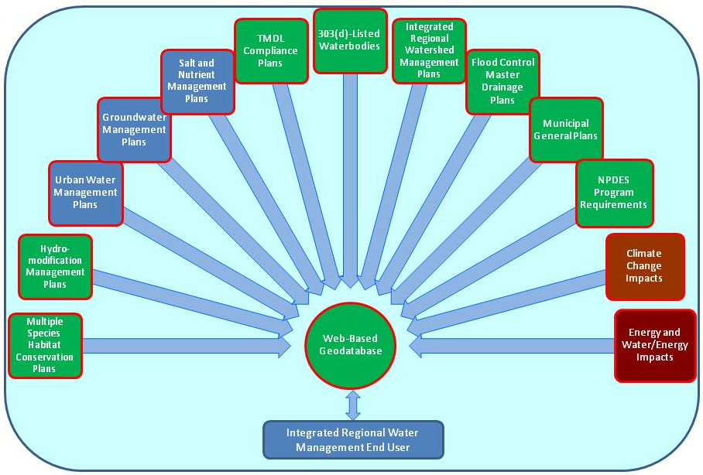

Planning Tools
The geodatabases described below were designed as a resource for long-term land planning as well as for project siting and design evaluations. The planning aspects are described in the Chapter 5.7 Land use and Water Planning. Development of planning tools is recommended to include significant outreach to and participation from Planning Departments and Commissions.

Development tools
San Bernardino County (Watershed Action Plan)
MS4 Permittees (cities and counties) must develop an integrated watershed approach to integrate planning and approvals for water quality and water quantity control measures. The requirements include revising the General Plan and CEQA documents to incorporate the water quality and watershed management principles. The Watershed Action Plan (WAP) is required to “improve integration of water quality, stream protection, storm water management, water conservation and re-use, and flood protection, with land use planning and development processes.”

Phase 2 of the WAP requires the development and implementation of a Hydromodification Monitoring Plan, and a Hydromodification Management Plan. It also requires the development of “recommendations for streamlining regulatory approval of Regional Treatment Control BMPs.”
In support of the San Bernardino MS4 Permit Watershed Geodatabase and the Watershed Action Plan, SAWPA participated in monthly meetings led by the San Bernardino MS4 Permit staff and other interested agencies from Jan. 2010 through Jan. 2011. Outreach meetings in conformance with watershed linkages to the OWOW process and SAWPA task forces were conducted on Dec. 15, 2010. San Bernardino Flood Control District hired RBF to develop the Watershed Geodatabase and provided demonstrations of the tool periodically throughout its development with input provided by stakeholders. The tool was submitted to the Regional Board as part of the Phase I deliverables under the MS4 Permit in Jan. 2011.

Status: WAP Phase 1 has been submitted and approved, Phase 2 tasks are ongoing.

Riverside County (Watershed Action Plan)
The Permittees must develop a Watershed Action Plan that describes and implements the Permittees’ stated approach to coordinated watershed management. The WAP should address watershed scale water quality impacts of urbanization in the Permit Area associated with Urban TMDL WLAs, stream system vulnerability to Hydromodification from Urban Runoff, cumulative impacts of development on vulnerable streams, preservation of Beneficial Uses of streams in the Permit Area, and protection of water resources, including groundwater recharge areas.

Within two years from Permit adoption, the Permittees shall identify existing unarmored or soft-armored stream channels in the Permit Area that are vulnerable to Hydromodification.
Within three years the Permittees must submit the WAP that includes proposed regional approaches to meet urban TMDL WLAs, recommendations for retrofit studies of public facilities to address TMDLs, hydromodification, and LID implementation. They must also describe regional collaborative efforts (e.g. Task Forces) that benefit water quality and how the Permittees should link these to their Urban Runoff Programs.

Further requirements include developing a hydromodification management plan and a schedule to develop a watershed geodatabase available via the World Wide Web, and to provide training regarding implementation of the WAP and associated tools to all appropriate personnel.

In support of the Riverside MS4 Permit Watershed Geodatabase development, SAWPA held a joint meeting of the Stormwater and Flood Risk Management Pillar (formerly the Multi-Hazard Preparation Pillar) and the Land Use and Water Planning Pillar (formerly the Low-Impact Development Planning Pillar) on October 5, 2012. The Riverside County Flood Control and Water Conservation District provided an overview of the Watershed Geodatabase tool purpose and future use. Data for the tool was requested from the audience. SAWPA received a formal request for specific data from the RCFCWD in Sept. 2012 and available data was provided to them in Oct. 2012.

Status: Draft WAP was submitted for review January 29, 2013; the RWQCB provided comments on March 26, 2013; the revised draft WAP is due for submittal by June 24, 2013. RCFCWCD made a formal request for GIS and other data to water districts in their county area in January 2013.

Orange County (Watershed Master Plan)
The Permittees are allowed a compliance approach for mitigating impacts from hydromodification using mapping, modeling and reconnaissance methods. These tools are to be integrated into Watershed Master Plans (WMPs) that are an alternative means to comply with site-by-site implementation of hydromodification BMPs. WMPs are limited in scope by the MS4 Permit to apply only for alternative hydromodification compliance. The WMPs are similar in approach to the WAPs, but less comprehensive.

In the Orange County MS4 permit, though not specifically required, a geodatabase tool has been developed to support the MS4 compliance described as the Watershed Characteristic/ Mapping Tools under the Watershed Infiltration and Hydromodification Management Plan (WIHMP). This work was prepared by PACE Advanced Water Engineering Inc. under contract with the Orange County Watershed and Coastal Resources Division.

Status: The County of Orange is currently developing WIHMPs for the regional drainage areas in the SAR Watershed. The WIHMPs incorporate more comprehensive watershed data.

Since the three county MS4 permits were not approved at the same time, the schedule to implement the tools is staggered with the first efforts in the development of a support tool having occurred in Orange County with approval of their permit on May 22, 2009 and the San Bernardino permit and the Riverside County permit approval in Jan. 29, 2010.

Policy and Procedure Opportunities and Recommendations
- Develop procedures and guidelines to ensure consideration of IRWM goals at project concept, planning, and design stages
- Collaborate with Land Use and Water Pillar on development of geodatabase and other planning tools.
- Create a lead watershed advisory and facilitation group as forum for stakeholder planning and project development
- Preserve floodplain functions through stricter management of development in floodplains. Consider development of Model General Plan Language to implement this priority.
- Where appropriate, FCDs, and all watershed stakeholders, should develop procedures and guidelines to ensure consideration of IRWM goals and watershed protection principles and priorities, consistent with the MS4 Permits, when planning and designing CIP or other projects, and during development or revisions of Master Drainage Plans (MDPs) and planning of projects that implement the MDPs.
- Create a watershed-wide IRWM coordinating advisory group that continues the work of the OWOW Stormwater: Resource and Risk Management Pillar that brings FCDs, groundwater managers, and other stakeholders together for decision making, partnership formation, and resource allocation to achieve IRWM goals.
- Water Agencies and Flood Control Districts should partner together via site specific agreements and general memorandums of understanding to develop multi-use facilities and optimize existing facilities for flood control, water conservation and water quality purposes. These agencies should work together to develop funding mechanisms to compensate the constituencies of the FCDs for the use of the facilities in re-charge activities, and preserve existing water rights.
- Evaluate impacts of 500 year flood management standard.

Implementation Recommendations
Develop Watershed Geodatabase Tools
Align and connect the San Bernardino, Riverside, and Orange County Watershed Geodatabase tools to create a system-wide or true watershed-wide tool supporting the entire Santa Ana River Watershed, coinciding with the Santa Ana Regional Board jurisdiction. This would enhance development and implementation of system-wide and watershed-wide solutions under the next round of MS4 Permits, due for renewal in 2014 and 2015. Connecting these geodatabase tools would greatly aid the development of an optimization and prioritization plan for the capture and recharge of stormwater, imported water, and low flow urban runoff to enhance water availability and reliability for the future of the watershed. Some additional data layers will be needed, particularly consideration of the impacts of climate change and energy, and energy/water use in watershed evaluations and planning. See integration of multiple watershed inputs in [Figure 5.8-4.]Coordinate and host geodatabase for the SAR Watershed (from WAPs and HCOC Maps): compile, coordinate, and provide hosting/access to GIS/geodatabase resources for the entire SAR Watershed.

- Accessible by all stakeholders, with data quality assurance and maintenance program
- Maps developed to support development project conditions and acceptable BMPs
- Infiltration emphasized in MS4s
- Connecting 3 county geodatabase layers will support watershed project concepts, and identify likely project partners
- Includes FCD facility analyses for retrofit opportunities
- Have been and will be reviewed by regulatory agencies
- Set up a data quality control and long-term maintenance program
- Provide user-friendly access to these tools from a single portal
- Geodatabase tools provide preliminary project sites and priorities
- Site lists have been developed by FCDs
- Must prioritize flood protection
- Ideally, must address MS4 Permit compliance
- Ensure full participation of FCDs in early planning and project siting and design
- Costs/benefits need to be spread over FCD constituency
- Identify top three sites for demonstration project
Develop tools for analysis and pre-populated standard form templates related to development projects:

Map layers will include the following (and many others as are relevant):

- Recharge areas
- Preservation areas
- Multi-jurisdictional contacts for project sites
- Water supply areas by agency; imported water dependent sites, imported water infrastructure
- Water sources—groundwater wells, recycling plants, desalters
- Links to on-line climate change models
- Links to energy use and water/energy use data
- Include Regional Transportation Plan data and project concepts and potential partnering on transportation/water resource projects
- Include Utility data and evaluate coordination and cooperation with Utility Company sites and right-of-way

Coordinate/collaborate with EcoAtlas and/or other relevant map or model efforts, such as the DWR Integrated Water and Land Smart Planning Tool [See Chapter 5.7 Land Use and Water Planning]

Implementation-Specific Tools

- WQMP Templates
- Regional BMP sites
- Feasibility determinations—e.g. does the site provide more benefit as a regional BMP?
- Pollutants of concern

Identify top three sites for multi-benefit regional BMP demonstration projects, initiate partner relationships, and develop background needed to prepare funding applications:

Riverside County potential project example sites:

- Kansas Basin
- Marlborough Basin
- Columbia Basin
- Arlington Basin Projects (depending on status)

Develop ground water recharge optimization and prioritization
Develop optimization and prioritization plan for existing and potential future flood control facilities for the capture and recharge of stormwater, imported water, and low flows in the SAR Watershed. Use Geodatabases and facility evaluation lists and prioritize top three basins for each County for feasibility study and further work as warranted. Identify pilot/demonstration projects for FCD Basin retrofits in partnership with Water Agencies and other stakeholders.

Considerations to Include:

- Groundwater basin recharge area optimization and prioritization: FCDs collaborate with groundwater management agencies to develop GIS/geodatabase of groundwater basin recharge potential; develop and execute an optimization methodology and prioritize watershed areas for stormwater capture recharge project planning.
- Consider where and how to maximize water supply and minimize waste.
- Existing FCD basin and facility retrofit evaluation and implementation studies (MS4 Permit requirement): Determine stormwater capture and groundwater recharge potential, concomitant with continued flood protection requirements, for FCD facilities throughout the SAR Watershed. Develop list of priorities for implementation, and consult with potential project partners.
- Use existing county or program-specific geodatabases, and/or the recommended comprehensive watershed geodatabase (Recommendation (a), above) that provides access to appropriate stakeholders.
- Develop guidance for development of WQMPs for Flood Control CIPs that recognizes the flexibility in the MS4 Permits and goals of the Plan.

Develop Watershed-Based Tools for Alternative MS4 Stormwater Compliance the Serves Regional Priorities
This project involves creating a Task Force that includes the county FCDs, the water agencies, regulators, environmental NGOs, and interested stakeholders in parallel with demonstration projects and upcoming MS4 Permit renewals. Watershed-based and optimized BMPs also will provide compliance with MS4 Permit compliance where applicable. Alternative compliance approaches (see Table 5.8-4) will include:

- Identification of regional water quality and/or infiltration sites for watershed-based compliance
- Pilot sites for off-site or Regional BMPs—BMPs will typically be implemented downstream from the project site. Identify 3 pilot sites for watershed-wide applicability
- Water quality and/or water quantity credit system, and/or an Urban Runoff Fund
- Build on Orange County’s retention credit pilot project [see Appendix E]
- Development projects contribute funds used for water quality/recharge/habitat projects elsewhere in the watershed.
- Current MS4 permits list project types which can comply via credits produced by alternative environmentally beneficial actions.
- Assessment of regulatory constraints and flexibility regarding alternative compliance approaches.

Table 5.8-4 Watershed Action Plan, Watershed Master Plan, and Hydromodification Requirements in the Santa Ana River Watershed MS4 Permits.
Watershed Action Plan and Watershed Master Plan Requirements
(Excerpted from the San Bernardino County MS4 Permit Section XI.B; similar requirements excerpted from the Riverside County MS4 Section XII.B. The WAPs in the Orange County MS4 Section XVIII are focused on TMDL implementation; relevant OC MS4 requirements for Watershed Master Plans excerpted from Hydromodification Requirements Section XII.D.5)
San Bernardino County MS4 Section XI.B
B. Watershed Action Plan
1. The Permittees shall develop an integrated watershed management approach to improve integration of planning and approval processes with water quality and quantity control measures. Management of the water quality and hydrologic impacts of urbanization will be more effective whether managed on a per site, sub-regional or regional basis, if coordinated within the Watershed Action Plan. Pending completion of a Watershed Action Plan, management of the impacts of urbanization shall be accomplished using existing programs.
2. Within twelve months of adoption of this Order, each Permittee shall review the watershed protection principles and policies, specifically addressing urban and stormwater runoff, in its planning procedures, including CEQA preparation, review and approval processes; General Plan and related documents including, but not limited to its Development Standards, Zoning Codes, Conditions of Approval, Development Project Guidance; and WQMP development and approval processes.
3. The Principal Permittee, in collaboration with the Co-Permittees, shall develop a Watershed Action Plan (WAP) that describes and implements the Permittees' approach to coordinated watershed management. The WAP shall improve coordination of existing programs and identify new and/or enhanced program elements as applicable. The objective of the WAP is to improve integration of water quality, stream protection, storm water management, water conservation and re-use, and flood protection, with land use planning and development processes. The WAP shall be developed in two phases:
a. Phase 1: within 12 months of adoption of this Order, the Principal Permittee, in coordination with the Co-Permittees shall:
i. Identify program-specific objectives for the WAP; the objectives will include consideration of:
1. The watershed protection principles specified in Section XI.C.3.a - g, below;
2. The Permittee's planning and procedure review required in XI.B.2, above;
3. Potential impediments to implementing watershed protection principles during the planning and development processes, including but not limited to LID principles and management of the impacts of hydromodification;
4. Impaired waters [CWA § 303(d) listed] with and without approved TMDLs, pollutants causing impairment, monitoring programs for these pollutants, control measures, including any BMPs that the Permittees are currently implementing, and any BMPs the Permittees are proposing to implement. In addition, if a TMDL has been developed and an implementation plan is yet to be developed, the WAP shall specify that the responsible Permittees should develop constituent-specific source control measures, conduct additional monitoring and/or cooperate with the development of an implementation plan, where feasible, and consistent with the MEP standard.
ii. Develop a structure for the WAP that emphasizes coordination of watershed priorities with the Permittees' LIPs via the areawide model LIP;
iii. Identify linkages between the WAP and the SWQSTF, MSWMP, WQMP, the implementation of LID, and the TMDL Implementation Plans;
iv. Identify other relevant existing watershed efforts (Chino Basin Master Plan, SAWPA's IRWMP, etc., and their role in the WAP;
v. Ensure that the HCOC Map/Watershed Geodatabase is available to watershed stakeholders via the World Wide Web, and has incorporated the following information:
1. Delineation of existing unarmored or soft-armored drainages in the permitted area that are vulnerable to geomorphological changes due to hydromodification and those channels and streams that are engineered, hardened, and maintained.
2. GIS layers for known sensitive species, protected habitat areas, drainage boundaries, and potential storm water recharge areas and/or reservoirs;
3. 303(d)-listed waterbodies and associated pollutants;
4. Available and relevant regulatory and technical documents accessible via hyperlinks;
b. Phase 2: within 12 months of the approval by the Executive Officer of the Report from Phase 1, above, the Principal Permittee, in coordination with the CoPermittees, shall:
i. Contingent upon consensus with Regional Board staff and other resource agencies as described in XI.B.3.a.vii, above, specify procedures and a schedule to integrate the use of the Watershed Geodatabase into the implementation of the MSWMP, WQMP, and TMDLs;
ii. Develop and implement a Hydromodification Monitoring Plan (HMP) to evaluate hydromodification impacts for the drainage channels deemed most susceptible to degradation. The HMP will Identify sites to be monitored, include an assessment methodology, and required follow-up actions based on monitoring results. Where applicable, monitoring sites may be used to evaluate the effectiveness of BMPs in preventing or reducing impacts from hydromodification.
iii. Develop and implement a Hydromodification Management Plan prioritized based on drainage feature/susceptibilitylrisk assessments and opportunities for restoration.
iv. Conduct training workshops in the use of the Watershed Geodatabase. Each Permittee must ensure that their planning and engineering staff attend a workshop.
v. Conduct demonstration workshops for the Watershed Geodatabase to be attended by appropriate upper-level managers and directors from each Permittee.
vi. Develop recommendations for streamlining regulatory agency approval of regional treatment control BMPs. The recommendations should include information needed to be submitted to the Regional Board for approval of regional treatment control BMPs. At a minimum, this information should include: BMP location; type and effectiveness in removing pollutants of concern; projects tributary to the regional treatment system; engineering design details; funding sources for construction, operation and maintenance; and parties responsible for monitoring effectiveness, operation and maintenance. The Permittees are encouraged to collaborate and work with other counties to facilitate and coordinate these recommendations.
vii. Implement applicable retrofit or regional treatment recommendations from the evaluation conducted in Section B.3.a.ix, above.
viii. Submit the Phase 2 components in a report to the Executive Officer. The submitted report shall be deemed acceptable to the Regional Board if the Executive Officer raises no written objections within 30 days of submittal.
XI.B.3.a.
ix: Conduct a system-wide evaluation to identify opportunities to retrofit existing storm water conveyance systems, parks, and other recreational areas with water quality protection measures, and develop recommendations for specific retrofit studies that incorporates opportunities for addressing applicable TMDL implementation plans, hydromodification management, and/or LID implementation within the permitted area. (Orange County Section XIV.10)
x. Conduct a system wide evaluation to identify opportunities for joint or coordinated development planning to address stream segments vulnerable to hydromodification and coordinated re-development planning to identify restoration opportunities for hardened and engineered streams and channels. The WAP shall identify contributing jurisdictions and the stream segments that will benefit from this coordination.
XI.B.3.a.xi: Invite participation and comments from resource conservation districts, water and utility agencies, state and federal agencies, non-governmental agencies and other interested parties in the development and use of the Watershed Geodatabase;
Riverside County MS4 Section XII.B.
B. WATERSHED ACTION PLAN
1. An integrated watershed management approach may facilitate integration of planning and project approval processes with water quality and quantity control measures. Management of the impacts of Permit Area urbanization on water quality and stream stability is more effectively done on a per-site, neighborhood and municipal basis based on an overall watershed plan. Pending completion of the Watershed Action Plan consistent with this section, management of the impacts of urbanization shall be accomplished using existing programs. The Permittees shall develop a Watershed Action Plan to address the entire Permit Area. The Permittees may choose to develop sub-watershed action plans based on the overall Watershed Action Plan in the future based on new 303(d) impairments, TMDL requirements, or other factors.
2. The Permittees shall develop and submit to the Executive Officer for approval a Watershed Action Plan that describes and implements the Permittees’ approach to coordinated watershed management. The objective of the Watershed Action Plan is to address watershed scale water quality impacts of urbanization in the Permit Area associated with Urban TMDL WLAs, stream system vulnerability to Hydromodification from Urban Runoff, cumulative impacts of development on vulnerable streams, preservation of Beneficial Uses of streams in the Permit Area, and protection of water resources, including groundwater recharge areas.

3. Within three years of Permit adoption, the Co-Permittees shall develop the Watershed Action Plan and implementation tools to address impacts of urbanization in a holistic manner. At a minimum, the Watershed Action Plan shall include the following:
a. Describe proposed Regional BMP approaches that will be used to address Urban TMDL WLAs.
b. Develop recommendations for specific retrofit studies of MS4, parks and recreational areas that incorporate opportunities for addressing TMDL Implementation Plans, Hydromodification from Urban Runoff and LID implementation.
c. Description of regional efforts that benefit water quality (e.g. Western Riverside County Multiple Species Habitat Conservation Plan, TMDL Task Forces, Water Conservation Task Forces, Integrated Regional Watershed Management Plans) and their role in the Watershed Action Plan. The Permittees shall describe how these efforts link to their Urban Runoff Programs and identify any further coordination that should be promoted to address Urban WLA or Hydromodification from Urban Runoff to the MEP.
4. Within two years of adoption of this Order, the Permittees shall delineate existing unarmored or soft-armored stream channels in the Permit Area that are vulnerable to Hydromodification from New Development and Significant Redevelopment projects.
5. Within two years of completion of the delineation in Section XII,B.4 above, develop a Hydromodification management plan (HMP) describing how the delineation will be used on a per project, sub-watershed, and watershed basis to manage Hydromodification caused by urban runoff. The HMP shall prioritize actions based on drainage feature/susceptibility/risk assessments and opportunities for restoration.
a. The HMP shall identify potential causes of identified stream degradation including a consideration of sediment yield and balance on a watershed or subwatershed basis.
b. Develop and implement a HMP to evaluate Hydromodification impacts for the drainage channels deemed most susceptible to degradation. The HMP will identify sites to be monitored, include an assessment methodology, and required follow-up actions based on monitoring results. Where applicable, monitoring sites may be used to evaluate the effectiveness of BMPs in preventing or reducing impacts from Hydromodification.
6. Identify Impaired Waters [CWA § 303(d) listed] with identified Urban Runoff Pollutant sources causing impairment, existing monitoring programs addressing those Pollutants, any BMPs that the Permittees are currently implementing, and any BMPs the Permittees are proposing to implement consistent with the other requirements of this Order. Upon completion of XII.B.4, develop a schedule to implement an integrated, world-wide-web available, regional geodatabase of the impaired waters [CWA § 303(d) listed], MS4 facilities, critical habitat preserves defined in the Multiple Species Habitat Conservation Plan and stream channels in the Permit Area that are vulnerable to Hydromodification from Urban Runoff.
7. Develop a schedule to maintain the geodatabase required in Section XII.B.4 and other available and relevant regulatory and technical documents associated with the Watershed Action Plan.
8. Within three years of adoption of this Order, the Watershed Action Plan shall be submitted to the Executive Officer for approval and incorporation into the DAMP. Within six months of approval, each Permittee shall implement applicable provisions of the approved revised DAMP and incorporate applicable provisions of the revised DAMP into the LIPs for watershed wide coordination of the Watershed Action Plan.
9. The Permittees shall also incorporate Watershed Action Plan training, as appropriate, including training for upper-level managers and directors into the training programs described in Section XV. The Co-Permittees shall also provide outreach and education to the development community regarding the availability and function of appropriate web-enabled components of the Watershed Action Plan.
10. Invite participation and comments from resource conservation districts, water and utility agencies, state and federal agencies, non-governmental agencies and other interested parties in the development and use of the Watershed Geodatabase;
Orange County MS4 Section XII.D.
Section XII.D.5 provides a compliance approach for mitigating impacts from hydromodification using mapping and reconnaissance methods.
5. The permittees shall address the hydrologic conditions of concern on a watershed basis by preparing a Watershed Master Plan as described below:

The Watershed Master Plans shall integrate water quality, hydromodification, water supply, and habitat for the following watersheds: Coyote Creek-San Gabriel River; Anaheim Bay-Huntington Harbour; Santa Ana River; and Newport Bay-Newport Coast. Components of the Plan shall include: (1) maps to identify areas susceptible to hydromodification including downstream erosion, impacts on physical structure, impacts on riparian and aquatic habitats and areas where storm water and urban runoff infiltration is possible and appropriate; and, (2) a hydromodification model to make available as a tool to enable proponents of land development projects to readily select storm water preventive and mitigative site BMP measures.

The maps and a model Plan for one watershed shall be prepared by May 22, 2011. The model Plan should specify hydromodification management standards for each sub-watershed and provide assessment tools. In the preparation of the model Plan, the permittees are encouraged to use currently available information from other sources such as: (1) Orange County Flood Control Master Plan; (2) Irvine Ranch Water District’s Natural Treatment System Master Plan; (3) Orange County Watershed Plans; (4) Nutrient and Selenium Management Program; (5) TMDL and 303(d) Listing information from the U.S. EPA and/or the Regional Board, and (6) and water districts.
The model Watershed Master Plan shall be submitted to the Executive Officer for approval. Watershed Master Plans shall be completed for all watersheds 24 months after approval of the model Watershed Master Plan.
The Watershed Master Plans shall be designed to meet applicable water quality standards and the Federal Clean Water Act.

Possible Approaches and Products of the Task Force:

- Develop approaches for streamlined regulatory approval of off-site, regional BMPs, or other alternative compliance options.
- Develop a draft Regional Board Resolution regarding alternative compliance options
- Develop a model administration program for a water quality/quantity credit system
- Clarify MS4 permit language, applicable to permit renewals coming up
- Identify lead agency (involve Southern California Monitoring Coalition)
- Develop model for mechanism to initiate and manage a Regional Urban Runoff Management Fund in a pilot area of the watershed.

Development Process and Watershed Planning Coordination Group
To support important coordination and collaboration among the development and planners, it is recommended that the OWOW Steering Committee, supported by SAWPA staff, serve as the lead organization to ensure coordination of project partners (e.g. Chino Basin Groundwater Recharge Coordinating Committee) tasked with coordinating and persuading through coordinated meetings to cooperatively discuss mission and goals of the agencies, resources available among agencies, understand economic and technical constraints, and discuss opportunities for cooperative efforts to promote watershed sustainability priorities. The OWOW Steering Committee is uniquely situated to perform this function with representation on the Committee by cities, counties, environment, Regional Board and sustainable land development interests.

- Needs to transcend Proposition 84 or other funding decisions
- Should include the Regional Board
- Evaluates project ideas using the geodatabase
- Recommends necessary elements of training programs

Specific Agency/Committee Tasks:

- Develop a process to link project development processes for various watershed stakeholders with each other, and align project plans and designs with watershed sustainability priorities
- Develop an approach to coordinate agencies’ processes for project planning and design
- Increased flood control system and management capacity and reliability
- Projects and efforts that attenuate peak storm flows resulting from urbanization
- Projects and efforts that increase recharge of stormwater
- Projects that allow the region to meet nonpoint pollution control goals
- Projects and efforts for groundwater clean-up by infiltrating high quality water into the groundwater basins
- Improved habitat and facility maintainability.
- Proposed Participants:
- US Army Corps of Engineers
- Santa Ana Regional Water Quality Control Board
- San Bernardino County Public Facilities and Flood Control District
- Riverside County Flood Control and Water Conservation District
- Orange County Flood Control District, OC Public Works
- Eastern Municipal Water District
- Inland Empire Utilities Agency
- Orange County Water District
- San Bernardino Valley Municipal Water District
- Western Municipal Water District
- Chino Basin Watermaster
- San Bernardino Valley Water Conservation District
- Santa Ana Watershed Project Authority
- Cucamonga Valley Water District
- Other parties of interest and affected agencies
- Outline project development and implementation processes of watershed stakeholders
- Identify decision/influence points in each process
- Determine approach to incorporate watershed optimization priorities into project concepts and designs
- Develop mechanisms or procedures to ensure watershed priorities are adequately incorporated or considered
- Identify and coordinate with regulatory project permitting processes
- Watershed optimization priorities inform permit processes and qualifiers
- Evaluate the role of CEQA

Conduct further study of the 500-year flood impacts
Develop recommendations regarding appropriate changes to local policies based on the 500-year storm frequency standard for flood protection.

List of Contributors
Contributors to the OWOW 2.0 Stormwater: Resource and Risk Management Pillar Chapter include:
Matt Yeager Yeager Environmental Associates
Mary Ann Skorpanich Orange County Public Works
Stuart McKibben Riverside County Flood Control and Water Conservation District
Kevin Blakeslee San Bernardino County Flood Control District
Marc Rodabaugh San Bernardino County Flood Control District
Marsha Westropp Orange County Water District
Daniel Kopulsky Caltrans
Larry McKenney SAWPA
Rick Whetsel SAWPA

The Orange County Flood Control District, administered by the Orange County OC Public Works (OC Public Works), is governed by the Orange County Board of Supervisors. OCFCD is a political entity that has no employees, but owns land, and assesses an annual benefit on all taxable real property in Orange County. Because OCFCD has no specific employees, the District and its property are administered, maintained, and operated by OC Public Works staff, who are in turn employed by the County of Orange. (http://ocflood.com/about/history)
This section follows very closely with only some ammendation (and where elsewhere referenced) the hydrology section of the Review Report on the Santa Ana River Main Stem---including Santiago Creek and Oak Street Drain for flood control and allied purposes, US Army Corps of Engineers, Los Angeles District, December 1975
USACE, 1988. Design Memorandum No. 1 PHASE II GDM ON THE SANTA ANA RIVER MAINSTEM including Santiago Creek
Tetra Tech, WRIME, Inc., for the San Jacinto Watershed Council, 2007. San Jacinto River Integrated Regional Watershed Management Plan
Public Law 534, 78th Congress, 1944, and specific projects referenced therein and as updated since.
Orange County Public Works, Flood Control Division: http://ocflood.com/sarp/lower
See: NFIP Website at: http://www.floodsmart.gov/floodsmart/; and High Risk definition at: http://www.floodsmart.gov/toolkits/flood/downloads/FloodInsuranceFloodMaps-11%2019%2010.pdf
http://www.water.ca.gov/sfmp/flood-future-report.cfm, and http://www.water.ca.gov/sfmp/resources/PRD_AttachF_Exposure_4-3-13.pdf
Sediment management section adapted from the OWOW Santa Ana River Watershed Planning Framework white paper, Sediment Transfer Section, p. 10-11, April 17, 2012.
Stein and Brown, 2009. Effects of post-fire runoff on surface water quality: Development of a southern California regional monitoring program with management questions and implementation recommendations. Southern California Coastal Water Research Project, Technical Report 598.
OWOW Santa Ana River Watershed Planning Framework white paper, Forest First Program Projects Section, p. 11-13, April 17, 2012.
USGS, Great Shake Out, updated 2013. http://earthquake.usgs.gov/regional/nca/simulations/shakeout/
California’s Flood Future Highlights: Recommendations for managing the State’s Flood Risk. Public Review Draft March 2013, California Department of Water Resources and the USACE.
Riverside County Flood Control Act, 1944.
SBCFCD Flood Control Act of 1938.
Orange County Flood Control Act, Chapter 723 of the State of California Statutes of 1927
Santa Ana River Project Website: http://cms.ocgov.com/gov/pw/flood/sarp/default.asp
Bill Mann and Associates, 1983. Day, Etiwanda, and San Sevaine Creeks Drainage Plan, Water Conservation Report
Campbell, 2011. Planning and Operations Experiences with the Chino Basin Groundwater Recharge Program. Managed Aquifer Recharge Symposium January 25-26, 2011 Irvine, California. www.nwri-usa.org/rechargesymposium2011.htm
Wildermuth Environmental, 2008.Chino Basin Optimum Basin Management Program, 2008 State of the Basin Report.
Eastern Municipal Water District 2000.State of the Hemet/San Jacinto basins. http://www.emwd.org/modules/showdocument.aspx?documentid=93
EVWD 2013. Hemet/San Jacinto Groundwater Basin Management: The Stipulated Judgment—PowerPoint Presentation. http://www.emwd.org/modules/showdocument.aspx?documentid=5593
Daverin, John. Personal communication May 30, 2013.
Excerpted and paraphrased from Santa Ana Delhi Channel Diversion Project: Preliminary Design Report. September 2012 Revision.
Urban Runoff Capture Retrofits at Recharge Sites--Feasibility and Case Study. Inland Empire Utilities Agency, January 2012 Proposition 84 Concept Proposal, PIN 24000.

