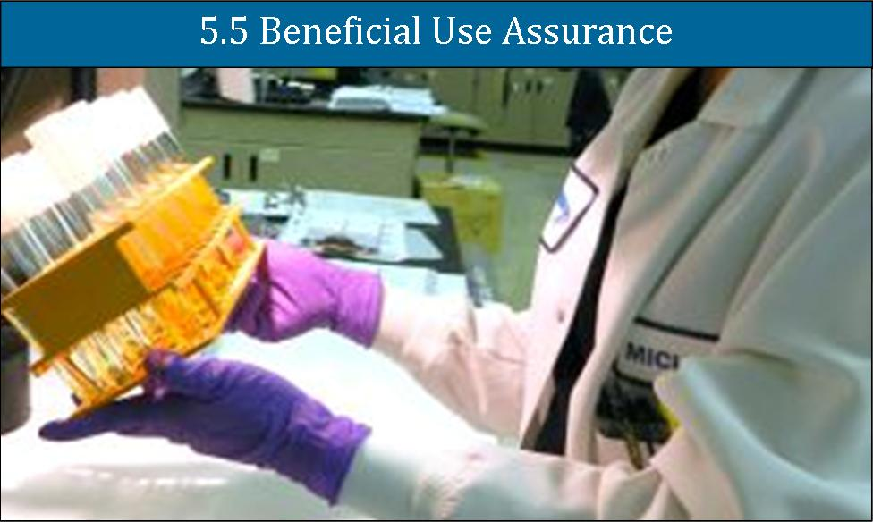

This chapter presents a general overview of water quality issues in the Santa Ana River Watershed and programs to improve water quality. The change in name from “Water Quality Improvement” from the OWOW 1.0 Plan to “Beneficial Use Protection” reflects a focus on striving to meet water quality objectives for all water bodies in the Santa Ana River Watershed. Collaboration of stakeholders with the Santa Ana Regional Water Quality Control Board is essential to achieve this goal. To expand outreach with Regional Water Board staff, the Chief of Regional Planning Programs served as the Co-Chair of the Beneficial Use Protection Pillar Group.
The three focus areas of this chapter, surface water, groundwater, and ocean water quality, are described from the top of the Watershed downstream to the ocean. This discussion includes the significant impact of imported water supplies and stormwater runoff on water quality.
Surface water discharges to the ocean impact ocean water quality. Ocean water, defined as the zone from the beach to three miles offshore, and bays and estuaries near the coast, are included in this report, reflecting the comprehensive, integrated approach utilized in the development of the new Integrated Regional Water Management Plan (IRWMP).
This chapter also includes coastal watersheds such as Anaheim Bay-Huntington Harbor, Newport Bay, and Newport Coastal streams as well as Coyote Creek and Carbon Creek in the San Gabriel River Watershed in the northern part of the Watershed. Although outside the Santa Ana River Watershed boundaries, these areas are within the jurisdiction of the Santa Ana Regional Water Quality Control Board (Region 8).

Brief History of Santa Ana River Watershed
The Santa Ana River (SAR), its tributary streams, and the groundwater basins provided adequate water for early inhabitants of the Watershed. By the late nineteenth century, the region had developed a successful agricultural economy. By the early twentieth century, expanding farms and orchards along with increased population began to outgrow available water supplies. The Colorado River Aqueduct (CRA) was the first facility to bring imported water into the region, followed by the State Water Project (SWP).
By the time of passage of the California Porter-Cologne Water Quality Act in 1969, population growth, agriculture, and industry already had created a legacy of water quality problems. Agricultural irrigation, fertilizer use, and dairy operations added nutrients and salts to groundwater supplies. Use of pesticides contributed to the contamination of soils and groundwater. In some areas, chemicals used in military facilities and industrial processes were improperly disposed of, resulting in the migration of hazardous substances into groundwater. Impacts from urbanization of the Watershed included stormwater runoff from urban areas, non-storm nuisance flows from landscape irrigation, increased salt concentrations, and elevated levels of nutrients.
Local agencies, non-governmental organizations, and other stakeholders, working in conjunction with regulatory agencies, have made progress in restoring the quality of water in the Watershed. Challenges still remain.

Regulatory Framework

Drinking Water Regulations
The California Safe Drinking Water Act (Health and Safety Code, Section 116270 et seq.) directs the California Department of Public Health (CDPH) Division of Drinking Water and Environmental Management to set standards for drinking water quality. Drinking water regulations are addressed in Title 17 and Title 22 of the California Code of Regulations. These include establishing the Maximum Contaminant Limits (MCLs) and treatment requirements for potable water and recycled water.

Water Quality Control Plan, Santa Ana River Basin
The State Water Resources Control Board (SWRCB) and the Santa Ana Regional Water Quality Control Board (Regional Board) are responsible for implementing California’s Porter-Cologne Water Quality Control Act and the Federal Clean Water Act. These State and Federal laws, and associated regulations and policies, provide the overall framework for managing water quality. Extensive voluntary efforts of stakeholders play an important role in protecting and improving water quality in the Watershed.
The Water Quality Control Plan, Santa Ana River Basin (Basin Plan) guides the Regional Board’s water quality control programs, water quality management decisions, and enforcement efforts. The Basin Plan establishes water quality standards, which include beneficial uses, water quality objectives (WQOs), and implementation plans to achieve the standards.
Beneficial uses as listed in the Basin Plan for waterbodies within the Santa Ana River Watershed include municipal and domestic supply; agricultural supply; industrial service supply; industrial process supply; groundwater recharge; navigation; hydropower generation; water contact recreation; non-contract water recreation; commercial and sport fishing; warm freshwater habitat; cold freshwater habitat; preservation of biological habitats of special significance; wildlife habitat; rare, threatened, or endangered species; spawning, reproduction and development; marine habitat; and shellfish harvesting. WQOs are set to establish reasonable protection of the beneficial uses. WQOs and beneficial uses are specified according to water body type: ocean waters, enclosed bays and estuaries, inland surface waters, and groundwater.
Since its last major revision in 1995, the Basin Plan has been amended eleven times. Amendments added Total Maximum Daily Loads (TMDLs) in 1998, 1999, 2003, 2004, 2005 and 2006; made provisions for and included time schedules in waste discharge requirements (2000); revised bacterial objectives in ocean waters (1997); and incorporated a revised Nitrogen/Total Dissolved Solids (N/TDS) management plan (2004). To implement the N/TDS plan, stakeholders and the Regional Board formed the Basin Monitoring Program Task Force. The Task Force is developing and implementing a monitoring program for nitrate and TDS in both groundwater and surface water in the Watershed.
Basin Plan amendments are adopted through a public basin planning process. The process requires approval by the Regional Board, SWRCB, California Office of Administrative Law, and United States Environmental Protection Agency (U.S. EPA). The Regional Board establishes priorities for Basin Plan revisions approximately every three years; the latest of these triennial reviews was conducted in 2006. Clearly, the schedule for triennial reviews has slipped reflecting a lack of resources and staff at the Regional Board to be able to conduct these reviews as planned. Updating the 2006 triennial review would be the first step in an effort to determine water quality project preferences in the watershed and to integrate with other regional needs to define integrated management strategies that meet water quality and water supply goals.
The primary methods of enforcing water quality regulations are through the issuance of the (Federal) National Pollutant Discharge Elimination System (NPDES) Permits and State Waste Discharge Requirements (WDRs). In California, both permit programs are administered by the SWRCB and the Regional Boards. These permits regulate discharges to surface water bodies of both wastewater and urban runoff from municipal and industrial systems and stormwater runoff from municipal separate storm sewer systems, industrial sources, and construction sites. Permit requirements are based on technology-based limits for wastewater and maximum extent practicable (MEP) standard for stormwater intended to meet water quality standards.

Several monitoring programs in the watershed involve the collection of data on the water quality of surface water bodies and groundwater basins. The Basin Monitoring Program Task Force is responsible for collecting and analyzing data in order to calculate the ambient TDS and nitrate concentrations in the region’s groundwater basins. The Regional Board requires a re-calculation of ambient concentration every three years. The Imported Water Recharge Workgroup is tasked with the responsibility of documenting the TDS and nitrate load to groundwater basins from the use of imported water for groundwater recharge. The Emerging Constituents Workgroup conducts a program to sample and analyze surface water bodies in the watershed to test for a selected group of emerging constituents. The Middle Santa Ana River TMDL Task Force developed and is implementing a Comprehensive Bacteria Reduction Plan for Riverside and San Bernardino Counties which includes sampling selected surface water sites to be analyzed for fecal bacteria indicators. The Stormwater Quality Standards Task Force conducted a comprehensive evaluation of surface water bodies to assess conditions for and existing use of sites for water-contact recreation.

Total Maximum Daily Loads
The Federal Clean Water Act Section 303(d) requires states to identify as impaired those waters that do not or are not expected to meet water quality standards. Impaired water bodies are placed on the Clean Water Act Section 303(d) List of Water Quality Limited Segments which initiates a process to develop TMDLs. A TMDL is considered to be adopted when approved by the Regional Board, the SWRCB, the California Office of Administrative Law, and the U.S. EPA.
A TMDL defines how much of a pollutant a water body can tolerate and still meet water quality standards. Each TMDL must account for all sources of the pollutant, including: discharges from wastewater treatment facilities; non-point source pollutants in runoff from residential areas, forested lands, agriculture, streets or highways, etc.; soils/sediments polluted with legacy contaminants such as DDT and PCBs; on-site disposal systems (septic systems); and deposits from the air. Projected growth that could increase pollutant levels may be considered. TMDLs allocate allowable pollutant loads for each source and identify management measures that, when implemented, will assure that water quality standards are attained.

California Toxics Rule
The California Toxic Rule was promulgated by the U.S. EPA to set numeric water quality criteria for priority toxic pollutants and other provisions for water quality standards to be applied to California waters. The criteria apply to all inland surface waters and enclosed bays and estuaries regulated by the Clean Water Act.

California Ocean Plan
The California Ocean Plan (Ocean Plan) is the state water quality control plan for ocean waters prepared by the SWRCB as required by the Clean Water Act. The plan is implemented by SWRCB and the coastal Regional Boards. It lists beneficial uses for marine waters including protection of Areas of Special Biological Significance (ASBS), rare and endangered species, marine habitat, fish migration, recreation, fishing, aesthetic enjoyment, and others. Narrative and numerical WQOs are set to protect designated beneficial uses. The objectives are implemented through a program that sets waste discharge limitations, monitoring, and enforcement. Through a triennial review process, the plan sets priorities for actions over the next three-year period.

Ocean Water-Contact Standards- AB 411
In 1996, AB 411 (Wayne) required the establishment of bacteriological ocean water quality standards to protect public health (CCR Sections 7956-7962). Contaminated runoff and untreated sewage spills are two of the most common factors that negatively impact ocean water quality. The AB 411 standards require that waters adjacent to ocean and bay public beaches be monitored for total coliforms, fecal coliforms, and enterococci bacteria. When any waters adjacent to a public beach fail to meet any of the standards, warnings are issued to the public. In the event that sewage is known or suspected, access to the affected waters is restricted.

Agriculture and Dairies: Water Quality Protection
Regulatory agencies in the watershed have taken a number of regulatory actions to address water quality impacts related to agricultural and dairy practices in the region, including impacts to both surface water and groundwater due to runoff from manure in dairy farm corrals, spreading of manure for fertilizer in agricultural fields, and use of pesticides.
In 2007 the Santa Ana RWQCB issued R8-2007-0001 (NPDES No. CAG018001): General Waste Discharge Requirements for Concentrated Animal Feeding Operations (Dairies and Related Facilities) within the Santa Ana Region (Santa Ana RWQCB, 2007) prohibiting all dairies in the watershed from discharging process wastewater or stormwater runoff up to a 25-year, 24-hour rainfall event and requiring each facility to develop a Engineered Waste Management Plan. This permit was amended with adoption of R8-2013-0001, which directed dairies in the San Jacinto Watershed to collaborate with Eastern Municipal Water District’s Salinity Management Program.
The Riverside County Ordinance 427.2 passed by the Riverside Board of Supervisors regulates safe transportation and application of manure in certain county districts by requiring operators and/or landowners to report manure application. The purpose of the ordinance is to minimize impacts to neighboring properties, local waterways, underground water supplies, and soil resources.
The San Jacinto Basin Resource Conservation District (SJBRCD) and the Western Riverside County Agriculture Coalition (WRCAC) developed a multi-phase process for establishing and running a Manure Manifest System (MMS) as part of the Integrated Regional Dairy Management Plan (IRDMP). The IRDMP addresses dairy issues of concern on a regional basis. The MMS addresses nutrient and salt loadings by specifying that manure be applied to land at rates consistent with cropping practices and groundwater conditions. The MMS will prohibit over-application at sites where potential impacts to groundwater basins are a concern. Excerpts of the MMS have been adopted by the RWQCB in the new manifest forms under the new 2013 permit.

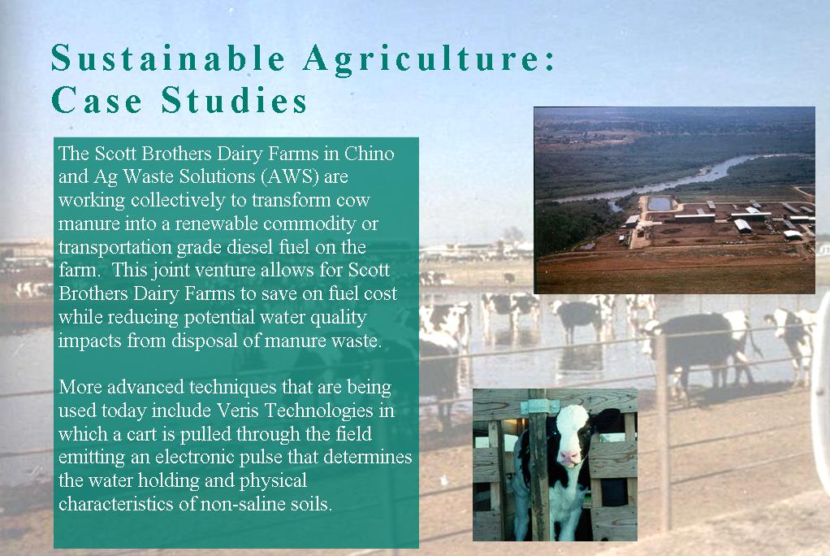

Constituents of Emerging Concern
The potential impact of trace levels of constituents of emerging concern in water supplies has become an increasing concern for water and wastewater agencies, regulators, and the public.
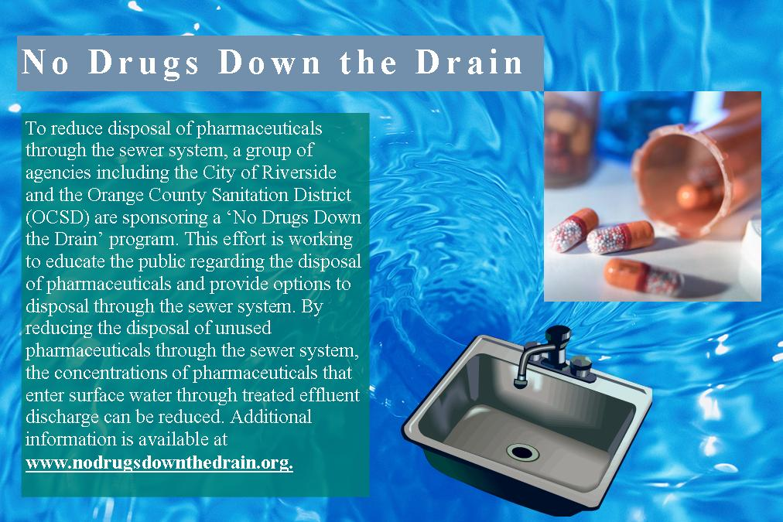
These constituents, also referred to as ‘emerging constituents’, include a wide range of chemical constituents including pharmaceuticals, personal care products, pesticides, and other synthetic organic compounds. Potential constituents may include thousands of chemicals in consumer and health-related products such as drugs, food supplements, fragrances, sun-screen agents, deodorants, and insect repellants. Typically, these constituents of emerging concern are found at very low concentrations (i.e., parts per trillion) in water bodies. Some of these chemicals enter surface water through the discharge of treated effluent when the public disposes of unused pharmaceuticals through the sewer system or the pharmaceuticals that are consumed are not entirely broken down in the human body.
Constituents of emerging concern currently are not regulated by federal or state agencies and very few have regulatory levels or California Notification Levels. In general, when detected, the chemicals occur at low concentrations in surface water. Although ecological impacts to fish and other wildlife have been shown for some of these trace contaminants in water bodies, less is known about potential human health effects. However, some of these constituents are known or suspected to have endocrine disrupting effects if present at a sufficiently high concentration. In addition, concerns are being raised about the potential reproductive and developmental effects of these compounds. There is a significant amount of research being done in the area of ecological and human health effects and new information continues to be developed on the significance of this issue.
A major driver in characterizing these constituents in water supplies is the use of newly developed analytical methods. As laboratory methods improve, new tests can detect substances at lower and lower concentrations. As many of these methods are not standard, they are considered research methods with development still ongoing. As part of the methods development process, issues such as method detection limits and intra- and inter-laboratory comparisons are being evaluated.
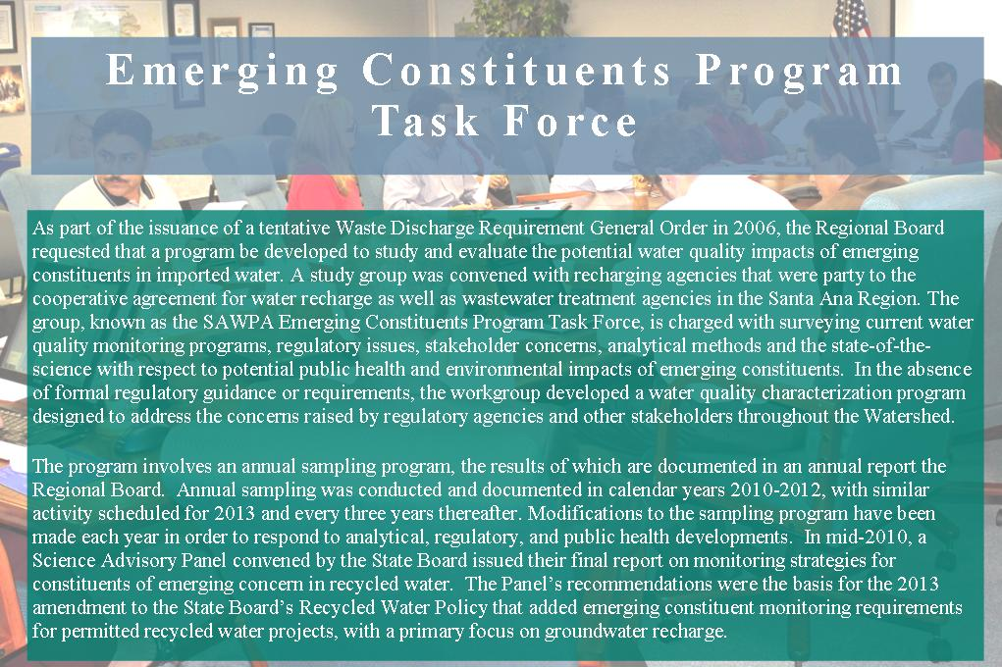
Additional research is needed on the public health significance of low level concentrations of these constituents, especially when they occur as mixtures. Knowledge of the potential human health effects at low concentrations is limited for compounds other than pharmaceuticals, and data gaps exist in trying to establish levels of human health risk or regulatory limits. However, public concern is a significant issue and will need to be addressed before complete scientific-based health information is available.

Surface Water
Surface water in this chapter includes rivers, streams, creeks, lakes, and bays and estuaries. These waters provide many benefits to the Watershed including water supply, habitat, and recreation.

Current Conditions
Water in less developed and non-agricultural areas of the Watershed is typically the highest quality water in the Watershed. Agricultural, industrial, commercial, and residential developments over the last approximately 150 years have degraded surface water quality. Pollutants include nutrients, sediment, pesticides and microbial contaminants such as bacteria. Concentrations of soluble mineral substances commonly referred to as ‘salinity’ or ‘TDS’, also impact surface water quality. In developed areas and agricultural areas, stormwater carries pollutants from roads, parking lots, and other sources, degrading the quality of water as it flows downstream. The following sections describe surface water conditions in each Reach of the Santa Ana River Watershed as defined by the Basin Plan and shown in Figure 5.5-1.
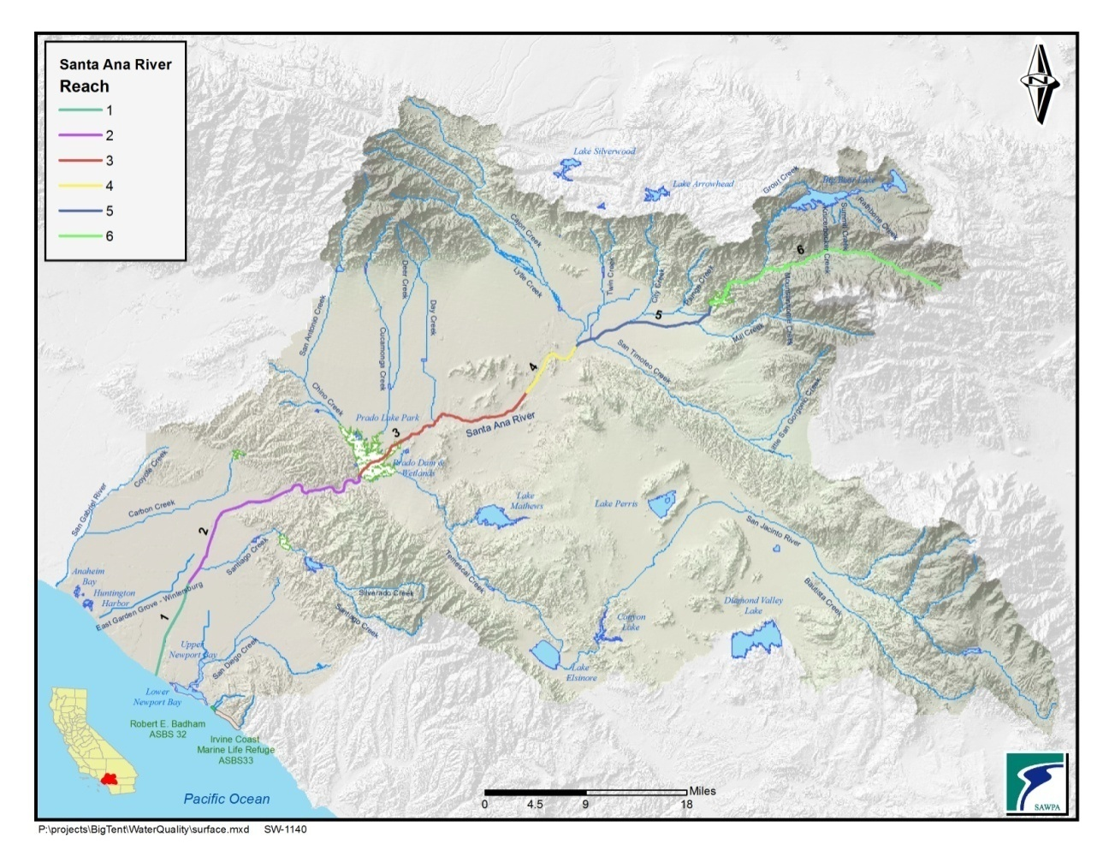
Figure 5.5-1 Santa Ana River Watershed, Surface Waters

Water bodies that do not meet water quality standards are identified as impaired and are placed on the 303(d) List of Water Quality Limited Segments. A water body remains on the list until a TMDL is adopted and the water quality standards are attained or there are sufficient data to demonstrate that water quality standards have been met and delisting should take place.
Figure 5.5-2 shows the locations of impaired water bodies where the Regional Board has yet to begin the process of developing TMDLs. Surface water bodies where TMDL projects are in the process of development, as shown on the Regional Board’s TMDL project list, are shown in Figure 5.5-3.

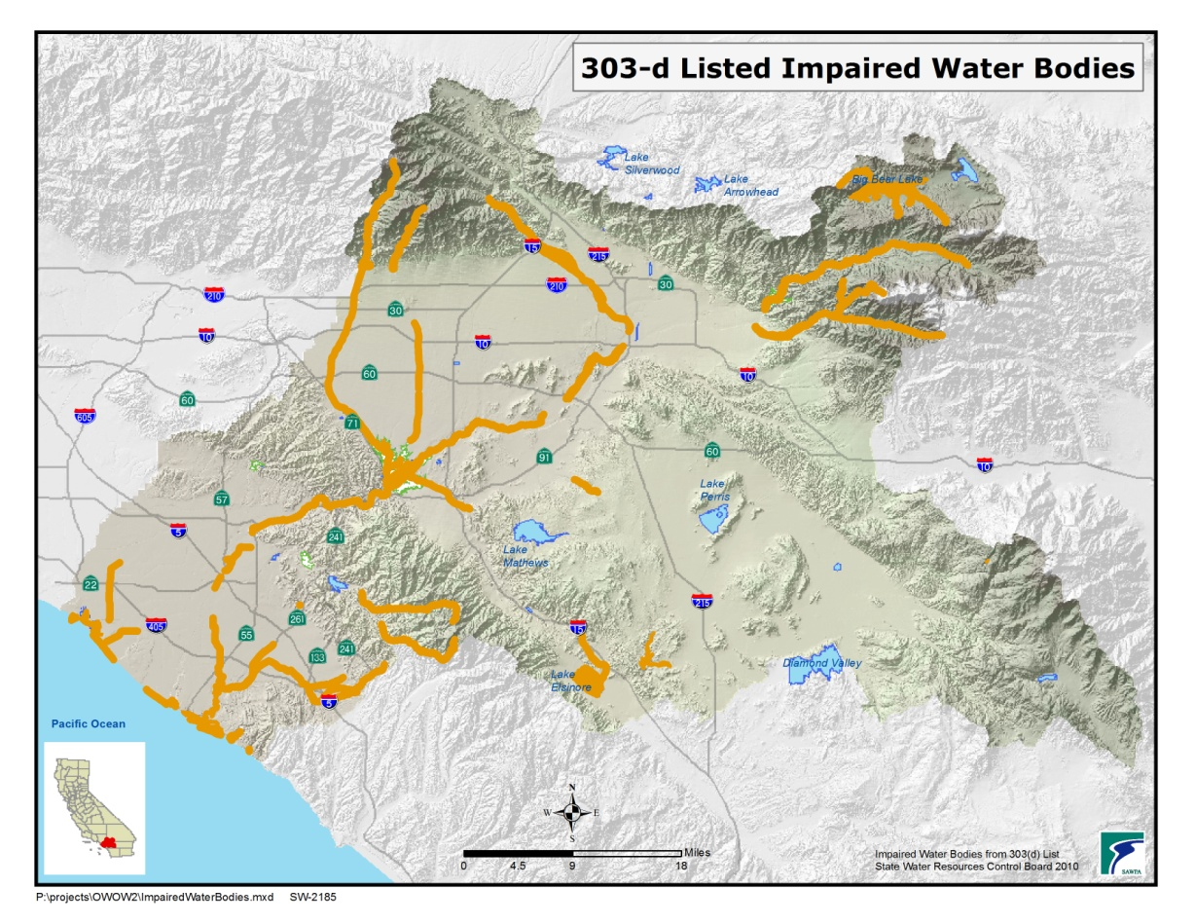
Figure 5.5-2 Santa Ana River Watershed, Impaired Water Bodies
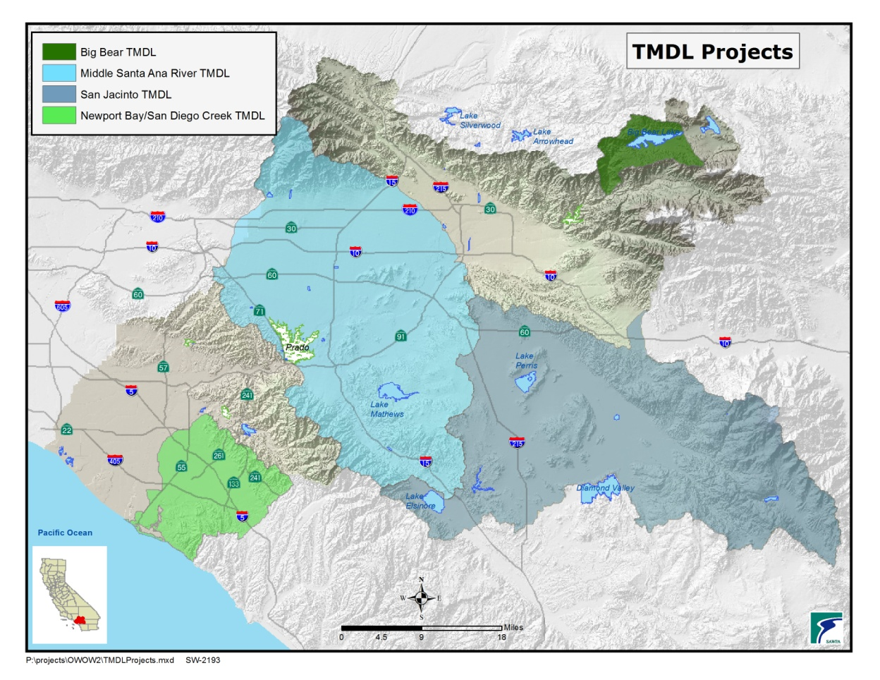
Figure 5.5-3 Santa Ana River Watershed, TMDL Projects

SAR Reach 6
Past and present land use practices have negatively impacted water quality in Big Bear Lake and the SAR, Reach 6. Impairments and current TMDL projects are shown in Table5.5-1 and Table5.5-2.
Table 5.5-1 2010 CWA 303(d) List of Water Quality Limited Segments Requiring TMDLs – Big Bear Lake Watershed
Table 5.5-2 TMDL Projects – Big Bear Lake Watershed
Water Body | Pollutant/Stressor | Potential Sources | Proposed TMDL Completion
Big Bear Lake | Mercury | Resource extraction | 2007
 | PCBs | Unknown | 2019
 | Noxious Aquatic Plants | Construction/Land Development and Unknown Nonpoint Source | 2007
 | Nutrients | Construction/Land Development and Snow Skiing Activities | 2007
Water Body | Pollutant (s) | TMDL Project | Status
Big Bear Lake | Noxious aquatic plants Nutrients | Nutrient TMDL for Dry Hydrological Conditions for Big Bear Lake | Implementation Phase

Shay Creek, Shay Meadows, and Baldwin Lake are relatively undeveloped areas that contain natural resources highly valued by stakeholders. Shay Creek and Baldwin Lake have threatened and endangered plant species as well as the endangered, unarmored three-spine stickleback fish and a unique wetlands system. The U.S. Fish and Wildlife Service, U.S. Forest Service, and the California Department of Fish and Game are interested in restoring the quality of these waters.
Grout, Knickerbocker, Summit, and Rathbone (Rathbun) Creeks, tributaries to Big Bear Lake, are listed as impaired, as shown in Table 5.5-3.

Table 5.5-3 TMDL Projects in the Big Bear Lake Watershed
Impaired Water Body | Pollutant (s) |  | TMDL Project | Status
Grout Creek | Nutrients |  | Nutrient TMDLs for Big Bear Lake Tributaries | Under development
Knickerbocker Creek | Pathogens |  | Knickerbocker Creek Bacterial Indicators | USEPA Action
Rathbone Creek | Nutrients |  | Nutrient TMDLs for Big Bear Lake Tributaries | Under development
 | Sedimentation/ siltation |  | Sediment TMDLs for Big Bear Lake and Rathbone Creek | Other Action
 | Cadmium |  | Cadmium TMDLs for Rathbone Creek | TMDL Required
 | Copper |  | Copper TMDLs for Rathbone Creek | TMDL Required
Summit Creek | Nutrients |  | Nutrient TMDLs for Big Bear Lake Tributaries | TMDL Required
Mountain Home Creek and mountain reaches of Mill Creek and Lytle Creek are impacted by high seasonal recreational use and/or flow through remote residential communities. Impairments are shown in Table 5.5-4. Although the potential sources on the official 2010 303(d) list for pathogens is “unknown nonpoint source”, sources are likely from sewage spills, recreational activities, and residential development.
Table 5.5-4 2010 CWA 303(d) List of Water Quality Limited Segments Requiring TMDLs
Water Body | Pollutant/Stressor | Potential Sources | Proposed TMDL Completion
Lytle Creek, Mountain Home Creek, Mountain Home Creek-East Fork, Mill Creek- Reaches 1 & 2 | Pathogens | Unknown nonpoint source | 2019
Santa Ana River Reach 6 | Cadmium. Copper, Lead | Source Unknown | 2021
San Antonio Creek | pH | Source Unknown | 2021
The water quality of Reach 6 (the SAR upstream of the Seven Oaks Dam) and Reach 5 (the Seven Oaks Dam to the San Jacinto Fault) and their tributaries is generally very good, with low to very low levels of TDS, indicator bacteria, or other pollutants. Impounding water behind the Seven Oaks Dam reduces water quality because of sediment entrapment and algae growth. This may render some of the impounded water unsuitable for use unless additional treatment is provided. The U.S. Army Corps of Engineers is studying this problem.
Many of the mountain reaches of these streams support self-sustaining populations of trout and other indigenous aquatic species. Several rare, threatened, and endangered species inhabit these areas including the unarmored three spine stickleback, the San Bernardino kangaroo rat, the yellow-legged mountain frog, the speckled dace, the Santa Ana woolly star, the least Bell’s vireo, and the Southwest Willow Flycatcher.

Santa Ana River Reach 5
Reach 5 and its primary tributaries are believed to meet the Basin Plan’s water quality standards. However, this may be due to the lack of recent or rigorous water quality assessments rather than a true indication of water quality. Segments of many of these streams support or have the potential to support a wide range of beneficial uses.

Santa Ana River Reach 4
Water Body | Pollutant/Stressor | Potential Sources | Proposed TMDL Completion
Santa Ana-Reach 4 | Pathogens | Nonpoint source | 2019
Reach 4 includes the river from the San Jacinto Fault down to Mission Boulevard Bridge in Riverside. In this reach, all the WQOs are being met except for fecal coliform. Table 5.5-5summarizes the 303(d) listing for pathogens for Reach 4.
Table 5.5-5 2010 CWA 303(d) List of Water Quality Limited Segments Requiring TMDLs

Santa Ana River Reach 3 and Chino Basin Surface Water Bodies
Reach 3 includes the portion of the river from Mission Boulevard Bridge to Prado Dam. Rising groundwater feeds small creeks tributary to Reach 3 that are important breeding and nursery areas for native fish. Excessive nutrient loading in Reach 3 was addressed by amendments to the Basin Plan as recommended by the N/TDS Task Force. Watershed partners are working closely with regulators to improve the quality of impaired water bodies and to develop TMDLs as shown in Tables 5.5-6and5.5-7.

Water Body | Pollutant/ Stressor | Potential Sources |  | Proposed TMDL Completion
Chino Creek-Reach 1 and Mill Creek (Prado Area) | Nutrients | Agriculture, dairies |  | 2019
Mill Creek (Prado Area) | TSS | Dairies |  | 2019
Prado Park Lake | Nutrients | Nonpoint source |  | 2019
SAR Reach 3 | Lead | Source Unknown |  | 2021
 | Copper | Source Unknown |  | 2021
Chino Creek Reach 2 | pH | Source Unknown |  | 2021
Cucamonga Creek – Valley Reach | Cadmium | Source Unknown |  | 2021
 | Copper | Source Unknown |  | 2021
 | Lead | Source Unknown |  | 2021
 | Zinc | Source Unknown |  | 2021
Cucamonga Creek – Mountain Reach | pH | Source Unknown |  | 2021
Chino Creek Reach 1B | COD | Source Unknown |  | 2021
 | Nutrients | Agriculture |  | 2019
Temescal Creek Reach 1 | pH |  | Source Unknown |  | 2021
Temescal Creek, Reach 6 | Indicator Bacteria |  | Source Unknown |  | 2021
Table 5.5-6 2010 CWA 303(d) List of Water Quality Limited Segments Requiring TMDLs – Santa Ana River, Reach 3

Table 5.5-7 TMDL Projects-Santa Ana River Watershed, Reach 3
Impaired Water Body | Pollutant(s) | TMDL Project | Status
Chino Creek-Reach 1, Mill Creek (Prado Area); SAR-Reach 3, Prado Park Lake | Pathogens | Bacterial Indicator TMDLs for the Middle SAR Watershed Water Bodies | Implementation Phase
Chino Creek-Reach 2;Cucamonga Creek- Valley Reach | High coliform count
SAR – Reach 3 | Nitrate | SAR, Reach 3 Nitrate TMDL | Implementation Phase

Prado Wetlands
The Orange County Water District (OCWD) operates the Prado Wetlands in Riverside County to remove nitrogen from SAR water. During non-storm conditions, the river flow upstream of the Prado Wetlands consists predominately of tertiary-treated effluent discharged from wastewater treatment plants. Before reaching the Prado Dam, river water is diverted through 465 acres of constructed wetlands with more than 50 engineered ponds. Following wetland treatment, the water is then discharged into Chino Creek, and then back to the SAR. The wetlands serve as a natural, cost-effective treatment to reduce nitrate levels before the water flows to Orange County, where it is used for groundwater recharge. The Prado Basin is home to several rare and endangered bird and waterfowl species. More than 124 acres are set aside as protective habitat for the endangered least Bell's vireo and Southwestern Willow Flycatcher.

Temescal Creek
Temescal Creek, also called Temescal Wash, stretches approximately 25 miles from Lake Elsinore to Prado Basin. However, water overflows from the lake to the creek only during very wet periods. For most of the year, portions of the creek are dry, and flow in Temescal Creek originates downstream of Lake Elsinore. Water quality in the creek is impacted by non-point source pollution.
Recycled water produced at Eastern Municipal Water District’s (EMWD) Regional Water Reclamation Facilities, Elsinore Valley Municipal Water District’s Regional Water Reclamation Facility, City of Corona’s Wastewater Treatment Plant IB, and Lee Lake Water District’s Wastewater Treatment Plant is discharged to Temescal Creek.

Lake Mathews
Lake Mathews, located in Riverside County, is the terminal reservoir for the Colorado River Aqueduct. Metropolitan owns and operates the 182,000 acre-foot reservoir to supply Colorado River water to its member agencies. The Lake Mathews Watershed is drained primarily by Cajalco Creek which has intermittent flows during storm events or in the presence of urban or agricultural runoff.
The Lake Mathews Drainage Water Quality Management Plan (DWQMP) was completed in the early 1990’s through a partnership between Metropolitan, County of Riverside, and Riverside County Flood Control and Water Conservation District (RCFC&WCD) to protect water quality in Lake Mathews from runoff pollution. Under the DWQMP, runoff would be managed and mitigated by the implementation of BMPs throughout the watershed, including several regional stormwater treatment facilities. As recommended in the DWQMP, the Cajalco Creek Dam and Detention Basin and multiple sediment basins have been constructed to detain runoff flows and allow sediment to settle. In 2012, Metropolitan, County of Riverside, and RCFC&WCD completed the Lake Mathews Watershed Study and developed a watershed model for Lake Mathews to assess the effects of future development on runoff pollution. The study evaluated and prioritized storm water management options that would be pursued, as watershed development conditions warrant, to ensure long-term protection of Lake Mathews.

San Jacinto Watershed
The San Jacinto River (SJR) originates in the San Jacinto Mountains and flows through the San Jacinto Valley. The valley, although undergoing considerable development, still contains citrus orchards, dairy farms, and other agricultural operations.
The SJR passes through Railroad Canyon to Canyon Lake before draining into Lake Elsinore. Lake Elsinore is a natural endpoint for its tributaries, and has no natural outlet. Historically, the lake was known to dry completely; imported and recycled water are now used to maintain the water level. To provide a water outlet during heavy rains, Lake Elsinore was modified to allow overflow into Temescal Creek, which drains into the SAR. Nutrients from sources such as septic systems, farming, reclaimed water, and poor land use practices can cause significant algae growth in the lake, thereby impairing recreational use and degrading aesthetic values. Moreover, excessive algae growth in the lake depletes dissolved oxygen resulting in occasional fish kills.
Middle Santa Ana River TMDL Task Force
In 2007, in support of local stakeholders, SAWPA formed a multi-agency task force to address the pathogen TMDLs in the Santa Ana River Reach 3 and its tributaries. This area was named the Middle SAR by the Regional Board. This task force includes county agencies, cities, dairies, and agricultural operators. The MSAR Bacteria TMDL requires implementation of a watershed-wide compliance monitoring program for bacterial indicators. The first water quality assessment was submitted to the Regional Board for sampling conducted from 2007-08. The Counties of Riverside and San Bernardino have completed and are implementing Comprehensive Bacteria Reduction Plans. The agricultural community is developing an Agricultural Source Management plan.

Lake Elsinore and Canyon Lake Nutrient TMDL Task Force.
In 2006, LESJWA administered the formation of a multi-agency task force to address nutrient TMDLs for Lake Elsinore and Canyon Lake. Over 20 agencies joined the task force to work with the Regional Board to implement studies, monitoring and water quality improvements necessary to achieve TMDL targets for 2015 and 2020 at both lakes. . Many water quality improvements at Lake Elsinore implemented by LESJWA from 2005-2012 that produced significant improvements and progress toward TMDL compliance. With TMDL interim targets approaching, greater focus has been place on water quality improvements at Canyon Lake, upstream of Lake Elsinore.

To assist the Task Force, the Regional Board agreed to defer lake monitoring at Canyon Lake and Lake Elsinore from 2013-2015 to allow funding resources to directed for implementation measures at Canyon Lake. Canyon Lake improvements include chemical addition, alum application, a common nutrient flocculating agent used in water treatment and possible an oxygenation injection system dependent on the results of alum application. The improvements at both lakes will also be supplemented by ongoing BMP measures implemented in the upper watershed by the municipal stormwater permittees and agricultural operators. This task force established one of the first TMDL agreements signed by federal, state, and local parties in the State. The cooperative effort has enabled agencies to combine efforts, economically address water quality challenges, and pursue additional grant funding for this process.

Lake Elsinore
Lake Elsinore is on the 303(d) list as impaired for PCBs and unknown toxicity. Nutrient TMDLs for Lake Elsinore and Canyon Lake have been developed as shown in Table5.5-8andTable5.5-9. A Nutrient Source Assessment, a Nutrient Management Plan, and a Bacteria Source Assessment have been completed on Canyon Lake. The bacterial indicator TMDL for Canyon Lake may be revised by the Regional Board if the Stormwater Quality Standards Task Force’s recommended change of the REC-1 Pathogen Standards from fecal coliform to E. coli is adopted into the Basin Plan. Should this change occur, Canyon Lake would be in compliance with REC-1 standards and taken off the 303(d) list.

Table 5.5-8 2010 CWA 303(d) List of Water Quality Limited Segments
Requiring TMDLs – San Jacinto Watershed
Water Body | Pollutant/Stressor | Potential Sources | Proposed TMDL Completion
Lake Fulmor | Pathogens | Unknown nonpoint source | 2019
Lake Elsinore | PCBs | Source unknown | 2019
 | Unknown toxicity | Unknown nonpoint source | 2007

Table 5.5-9 TMDL Projects – San Jacinto Watershed
Impaired Water Body | Pollutant (s) | TMDL Project | Status
Canyon Lake (Railroad Canyon Reservoir) | Nutrients | Nutrient TMDLs for Lake Elsinore and Canyon Lake | Implementation Phase
 | Pathogens | Bacterial Indicator TMDLs for Canyon Lake | Other Action
Lake Elsinore | Nutrients | Nutrient TMDLs for Lake Elsinore and Canyon Lake | Implementation Phase
 | Organic Enrichment/ Low Dissolved Oxygen
Conditional Waiver of Waste Discharge Requirements in the San Jacinto River Watershed
IN the San Jacinto River Watershed, waste discharges from a variety of sources (urban, agriculture, transportation, and other) are contributing to pollution in Canyon Lake and Lake Elsinore. In response, the Regional Board adopted nutrient Total Maximum Daily Loads (TMDLs) for the two lakes. The TMDLs include a variety of tasks that need to be completed by watershed stakeholders to achieve the objectives of restoring water quality in the watershed.
Whereas dairy operators are already contributing to the TMDL program, many other agriculture operators are not. To include all operators of irrigated and other agricultural or livestock operations the Regional Board is developing the Conditional Waiver (of waste discharge requirements) for Agricultural Discharges (CWAD, or “quad”) program. This program will allow for the waiving of waste discharge requirements provided that certain conditions, established by the regional board, are met. The CWAD program will also satisfy the State’s policy for “Implementation and Enforcement of the Non-Point Source Pollution Control Program.”
With stakeholder involvement, Regional Board staff is developing conditions that will be incorporated in a draft conditional waiver that will be considered by the Regional Board. Once the conditional waiver of caste discharge requirements is adopted affected agricultural operators will be required to enroll in the CWAD program or to obtain individual waste discharge requirements.

Lake Perris
Lake Perris, located in western Riverside County, is owned and operated by the California Department of Water Resources (DWR) and is the 2,000-acre terminal reservoir of the East Branch of the California Aqueduct (State Water Project). The lake is a source of water for the Metropolitan Water District of Southern California (MWDSC). Water quality concerns, including pathogens, taste and odors, algal toxins, and anoxia within the lake’s bottom layer, have limited its use for water supplies.
Recreational activities at the lake include body-contact recreation such as swimming and water skiing and non-body contact activities such as boating, fishing, camping, and hiking. Over a million people visit each year, with an estimated 50 percent of the peak season visitors involved in body-contact recreation. Beach closures occur in spite of implementation of several BMPs aimed at reducing coliform levels.
The SWRCB provided funding to MWDSC to study microbial contamination at the lake. The studies concluded that body-contact recreation was a key source of fecal contamination and recommended voluntary alternatives to swimming in the lake, such as swim lagoons, water play areas and other water features. Modeling and risk analysis suggest that such alternatives would reduce the consumer health risk by one-half (to approximately a 5 percent probability of exceeding the U.S. EPA maximum risk level). A CALFED Science Panel in March 2005 concurred with the main findings of the report.

Santa Ana River Reaches 2 and 1 and Santiago Creek Watershed
Reach 2 extends from Prado Dam to 17th Street in the City of Santa Ana. In this reach, the OCWD recharges as much of the river water as possible into the Orange County groundwater basin. Reach 1 extends from 17th Street in the City of Santa Ana to the ocean. In Reach 1, the Talbert and Huntington Beach Channels drain urban and stormwater runoff from the western side of the Watershed carrying flow to the Talbert Marsh along the coast. The Greenville-Banning Channel drains the southeast side of the Watershed and carries flows to the SAR. This area also includes Huntington Beach State Park.
SAR, Reach 2 is listed as impaired for indicator bacteria. The river’s main tributary in Orange County, Santiago Creek, has several impairments as does its tributary, Silverado Creek. Water quality impairments in this area are shown in Table 5.5-10.
Water Body | Pollutant/Stressor | Potential Sources | Proposed TMDL Completion
SAR, Reach 2 | Indicator bacteria |  | 2021
Santiago Creek Reach 4 | Salinity, TDS, chlorides | Source unknown | 2019
Silverado Creek | Pathogens, Salinity/TDS/ Chlorides | Unknown nonpoint source | 2019
Huntington Beach State Park | PCBs | Source unknown | 2019
Morning Canyon Creek | Indicator Bacteria | Source Unknown | 2021
Serrano Creek | Ammonia (Unionized)/Indicator Bacteria/pH | Source Unknown | 2021
Table 5.5-10 2010 CWA 303(d) List of Water Quality Limited Segments Requiring TMDLs – Santa Ana River Watershed, Reaches 1 and 2

West Orange County and Coastal Watersheds
This section discusses the water quality challenges facing coastal bays and harbors and coastal area tributary streams, as shown in Figure 5.5-4.
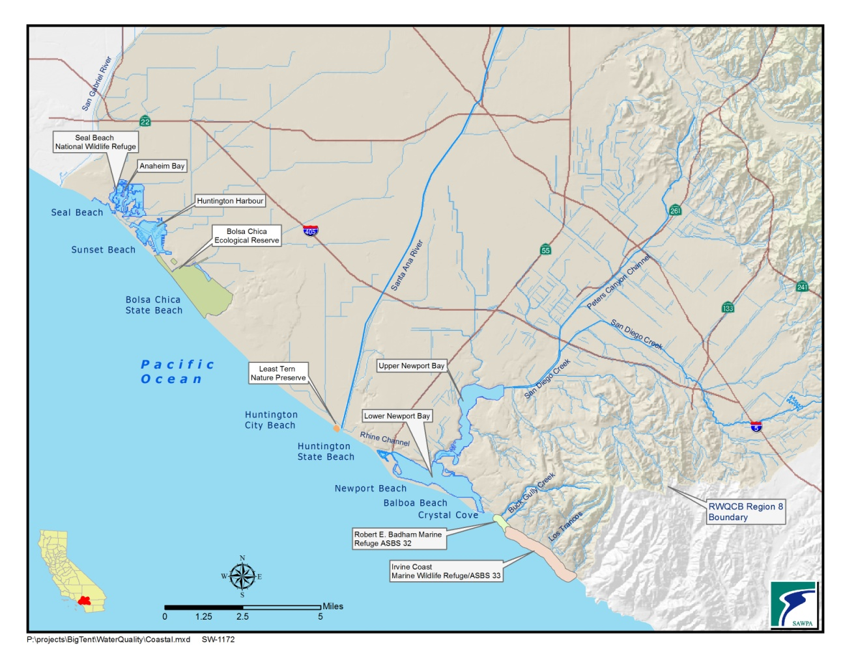
Figure 5.5-4Coastal Area

San Gabriel River Watershed- Coyote Creek
The San Gabriel River Hydrologic Unit lies within Los Angeles and Orange Counties. Approximately 86 square miles are within Orange County. The area is drained by a number of tributaries to the San Gabriel River, including Coyote Creek and Carbon Creek that originate in the foothills of northern Orange County. This area is highly urbanized and dry weather urban runoff and wet weather stormwater runoff discharge pollutants into the river. Seal Beach is located just south of the mouth of the San Gabriel River and is impacted by local drainage as well as the water quality of the river. TMDLs for Coyote Creek are listed in Table 5.5-11.
Table 5.5-11 2010 CWA 303(d) List of Water Quality Limited Segments Requiring TMDLs – San Gabriel Watershed

Water Body | Pollutant/Stressor | Potential sources | Proposed TMDL Completion
Coyote Creek | Lead | Major Municipal Point Source-wet weather discharge | TMDL Approval in 2007
 | Toxicity | Point source | 2008
 | Diazinon, pH | Point, nonpoint source | 2019
 | Indicator Bacteria | Source Unknown | 2009
 | Copper, Dissolved | Source Unknown | TMDL Approved in 2007
 | Ammonia | Point Source | 2019
Seal Beach | Enterococcus, PCBs | Source unknown | 2019
Coyote Creek | Lead | Major Municipal Point Source-wet weather discharge | San Gabriel River Metals (39)
 | Copper, Dissolved | Source Unknown | San Gabriel River Metals (39)

Note: Dissolved Copper and Lead is being addressed by a USEPA approved TMDL (San Gabriel River Metals (39)) and is being considered for removal under sections 2.2 and 4.1 of the Listing Policy.
Anaheim Bay - Huntington Harbour Watershed
The Anaheim Bay-Huntington Harbor Watershed covers approximately 80 square miles in northwestern Orange County. One of its three tributaries, the Los Alamitos Channel, drains into the San Gabriel River. The Bolsa Chica Channel empties into the Anaheim Bay-Huntington Harbor complex. The East Garden Grove-Wintersburg Channel drains through Bolsa Bay into Huntington Harbor.
The Anaheim Bay-Huntington Harbor complex is located at the northwestern edge of Orange County. Cattle ranching, agriculture, and commercial port facilities preceded rapid urbanization in the 1940s. Discharges containing metals and pesticides from a variety of sources including boating-related activities; stormwater, urban, and agriculture runoff; and past historical inputs have negatively impacted water quality. Impairments in Anaheim Bay and Huntington Harbor are shown in Table 5.5-12.

Name | Pollutant/Stressor | Potential Sources | Proposed TMDL Completion
Anaheim Bay | Dieldrin (tissue), nickel, PCBs, sediment toxicity | Source unknown | 2019
Huntington Harbor | Chlordane, copper, lead, nickel, PCBs, sediment toxicity | Source unknown | 2019
 | Pathogens | Urban runoff, storm sewers | 2019
Bolsa Chica State Beach | Copper, nickel | Source unknown | 2019
East Garden Grove Wintersburg Channel | Ammonia (Unionized) | Source Unknown | 2021
Bolsa Chica Channel | Ammonia (Unionized) | Other Urban Runoff/Surface Runoff/Storm Sewers/Unknown Nonpoint | 2021
 | Indicator Bacteria | Source Unknown | 2021
 | pH | Source Unknown | 2021

Newport Bay Watershed
Table 5.5-12 2010 CWA 303(d) List of Water Quality Limited Segments Requiring TMDLs – Anaheim Bay-Huntington Harbor Watershed

The Newport Bay Watershed covers approximately 152 square miles in central Orange County draining into Upper Newport Bay. San Diego Creek drains 80 percent of the Watershed, with Santa Ana Delhi Channel draining 15 percent.

San Diego Creek
San Diego Creek Reach 1 and Reach 2 impairments and TMDL projects are listed in Tables 5.5-13and5.5-14. The TMDLs include all San Diego Creek tributaries.

Impaired Water Body | Pollutant | TMDL Project | Status
San Diego Creek-Reach 1 | Nutrients | Nutrient TMDL for the Newport Bay-San Diego Creek Watershed | Implementation Phase
 | Pesticides | San Diego Creek-Newport Bay Organochlorine Compounds TMDLs | Technical TMDLs
 |  | Diazinon and Chlorpyrifos TMDL for San Diego Creek and Upper Newport Bay | Implementation Phase
 | Siltation | Sediment TMDL for the Newport Bay-San Diego Creek Watershed | Implementation Phase
San Diego Creek-Reach 2 | Nutrients | Nutrient TMDL for the Newport Bay-San Diego Creek Watershed | Implementation Phase
 | Siltation | TMDL for Sediment in the Newport Bay-San Diego Creek Watershed | Implementation Phase
 | Unknown toxicity | Addressed by metals and organochlorine TMDLs | Implementation Phase (Being addressed by EPA Approved TMDL)
Table 5.5-13 TMDL Projects - Newport Bay/San Diego Creek Watershed

Table 5.5-14 2010 CWA 303(d) List of Water Quality Limited Segments Requiring TMDLs – Newport Bay/San Diego Creek Watershed
Name | Pollutant/Stressor | Potential Sources | Proposed TMDL Completion
San Diego Creek- Reach 1 | Selenium | Source unknown | 2007
 | Fecal coliform | Urban runoff, storm sewers, other urban runoff | 2019
 | Toxaphene | Source unknown | 2019
San Diego Creek- Reach 2
 | Indicator Bacteria | Source Unknown | 2021
Peters Canyon- Channel | DDT, Toxaphene, | Source unknown | 2019
 | pH | Unknown Point Source, Urban Runoff/Storm Sewers | 2021
 | Indicator Bacteria | Source Unknown | 2021
Borrego Creek | Ammonia (Unionized) | Other Urban Runoff/Unknown Nonpoint Source/Surface Runoff/Storm Sewers | 2021
 | Indicator Bacteria | Source Unknown | 2021

Newport Bay
San Diego Creek flows into Upper Newport Bay. The bay is a unique area containing a fragile coastal ecosystem that is designated as a State Ecological Reserve. Newport Bay is divided into two distinct areas. The 750-acre Upper Bay begins at the Pacific Coast Highway Bridge and extends five miles inland. The Lower Bay encompasses the area below the bridge and includes the Rhine Channel; it is separated from the ocean by Balboa Peninsula.

Upper Newport Bay (CCA No. 69)
Upper Newport Bay, a Critical Coastal Area (CCA) with a significant ecosystem, is the receiving waters for impaired flows emanating from the San Diego Creek Watershed. It supports seven diverse estuarine habitats with several hundred species of marine and terrestrial flora and fauna including six federal and state listed, threatened, and endangered species (five bird species, one plant species). The Bay’s fish diversity is rated as the highest of the seven major coastal embayments between San Diego and Point Conception; it provides critical habitat for commercially and ecologically important species, such as California halibut, sand bass, gobies, topsmelt, and anchovy. Impairments and TMDL projects for Upper Newport Bay are listed in Table 5.5-15and Table5.5-16.
Table 5.5-15 2010 CWA 303(d) List of Water Quality Limited Segments Requiring TMDLs – Newport Bay/San Diego Creek Watershed
Name | Pollutant/Stressor | Potential Sources | Proposed TMDL Completion
Newport Bay, Lower | Copper | Source unknown | 2007
 | Chlordane, DDT, PCBs, sediment toxicity | Source unknown | 2019
Newport Bay, Upper (Ecological Reserve) | Copper | Source unknown | 2007
 | Chlordane, DDT, metals, PCBs, sediment toxicity | Source unknown | 2019
Rhine Channel | Copper, lead, mercury, PCBs, sediment toxicity, zinc | Source unknown | 2019
Balboa Beach | DDT, dieldrin, PCBs | Source unknown | 2019
Santa Ana Dehli Channel | Indicator Bacteria | Source Unknown | 2021
Newport Slough | Enterococcus/Fecal Coliform/Total Coliform | Source Unknown | 2021

Name | Pollutant/ Stressor | Potential Sources | Status
Newport Bay, Lower | Nutrients | Nutrient TMDL for the Newport Bay-San Diego Creek Watershed | Implementation Phase
 | Pathogens | TMDL for Fecal Coliform Bacteria in Newport Bay | Implementation Phase
 | Pesticides/Priority Organics | San Diego Creek-Newport Bay Organochlorine Compounds TMDLs | Technical TMDLs
 |  | Organochlorine Compounds and Metals TMDL, Lower Newport Bay: Rhine Channel
 | Siltation | TMDL for Sediment in the Newport Bay-San Diego Creek Watershed | Implementation Phase
Newport Bay, Upper (Ecological Reserve) | Metals | San Diego Creek and Newport Bay Metals TMDLs | Technical TMDLs
 |  | Newport Bay-San Diego Creek Selenium TMDL
 | Nutrients | Nutrient TMDL for the Newport Bay/San Diego Creek Watershed | Implementation Phase
 | Pathogens | TMDL for Fecal Coliform Bacteria in Newport Bay | Implementation Phase
 | Pesticides | Diazinon and Chlorpyrifos TMDL for San Diego Creek and Upper Newport Bay | Implementation Phase
 |  | San Diego Creek-Newport Bay Organochlorine Compounds TMDLs | Technical TMDLs
 | Siltation | TMDL for Sediment in the Newport Bay-San Diego Creek Watershed | Implementation Phase
Table 5.5-16 TMDL Projects - Newport Bay Watershed

Lower Newport Bay and Rhine Channel
The Lower Newport Bay with two main channels is a small boat harbor berthing 9,000 boats. The Rhine Channel is located at the western end of lower Newport Bay. It has been designated by the Regional Board as one of Orange County’s hot spots for toxic sediments. Years of operating canneries, metal plating companies, and shipyards deposited PCBs, mercury, and other pollutants in the channel. Several studies have documented contamination in the channel. Impairments and TMDL projects in the Lower Bay and Balboa Beach are listed in Table5.5-17and Table5.5-18.

Newport Bay Watershed Toxics TMDLs
In addition to SWRCB TMDLs, the U.S. EPA has also promulgated Toxics TMDLs in the Newport Bay Watershed. U.S. EPA established technical TMDLs (without implementation plans) for toxic pollutants in San Diego Creek and Newport Bay on June 14, 2002. Regional Board staff is developing the State required Basin Plan amendments, including implementation plans. These TMDLs are listed in Table 5.5-17.
Table 5.5-17 Newport Bay Watershed Toxics TMDLs
Water Body | Element/Metal | Organic Compound
San Diego Creek | Cd, Cu, Pb, Se, Zn | Chlorpyrifos, Diazinon, Chlordane, Dieldrin, DDT, PCBs, Toxaphene
Upper Newport Bay | Cd, Cu, Pb, Se, Zn | Chlorpyrifos, Chlordane, DDT, PCBs
Lower Newport Bay | Cu, Pb, Se, Zn | Chlordane, Dieldrin, DDT, PCBs
Rhine Channel | Cu, Pb, Se, Zn, Cr, Hg | Chlordane, Dieldrin, DDT, PCBs

Newport Coastal Streams Watershed
The Newport Coastal Streams Watershed encompasses approximately eight square miles south of the Newport Bay Watershed. Several coastal canyons drain this area directly into the ocean, into two ASBS. Both Buck Gully and Los Trancos Creeks are listed as impaired for fecal coliform and total coliform, as shown in Table 5.5-18. The City of Newport Beach conducted a study of the water quality of eight coastal canyon creeks (Newport Coast Flow and Water Quality Assessment Final Report, January 2007) to determine if conditions protect beneficial uses and to investigate sources of water quality impairments.

Table 5.5-18 2010 CWA 303(d) List of Water Quality Limited Segments Requiring TMDLs
Name | Pollutant/Stressor | Potential Sources | Proposed TMDL Completion
Buck Gully Creek and Los Trancos (Crystal Cove Creek) | Fecal coliform, total coliform (downstream of Pacific Coast Highway) | Source unknown | 2019
Nitrogen and Selenium Management Plan
Nitrogen is an essential nutrient that causes algal blooms when present in excessive quantities. Selenium is a naturally occurring trace element that is found in ancient marine sediments in the foothills of Newport Bay Watershed. When selenium is released to surface water bodies, such as via passive groundwater seepage and groundwater cleanup/dewatering operations, it accumulates in the food chain to levels that can be harmful to fish and birds.
In renewing the region-wide permit for discharges that pose an insignificant (de minimus) threat in 2004, the Regional Board issued a separate permit for the Newport Bay Watershed for short term groundwater-related discharges. The concern was that high levels of nitrogen and selenium in groundwater discharges would violate established TMDLs. The Regional Board recognized that numerical effluent limits for selenium would be difficult if not impossible to meet as there is no technically feasible and economically practical treatment technology available for selenium. As an alternative, the permit allowed for the formation of a working group to develop a comprehensive understanding of and a management plan for controlling levels of selenium and nitrogen in groundwater discharges. In 2005, the participating Watershed stakeholders formed the Nitrogen and Selenium Management Program (NSMP) and agreed to fund and implement the NSMP Workplan, which was scheduled to be completed in 2009.

The NSMP Work Plan tasks include monitoring, testing and evaluation of best management practice (BMP), development of an offset and trading program, total maximum daily loads (TMDL) and site-specific water quality objective, among others. Since 2005, the NSMP Working Group has made significant progress and completed essentially all Work Plan tasks. However, achieving the numerical selenium limitations before the 2009 deadline was infeasible. On December 10, 2009, the Regional Board adopted the Time Schedule Order (TSO) No. R8-2009-0069 that extended the compliance deadline to December 9, 2014. Currently, watershed stakeholders are implementing the tasks outlined in the TSO.

Current Management Strategies for Surface Water
As described in the previous sections, regulatory efforts aimed at maintaining and improving surface water quality and cleaning up poor quality water are based on implementing the Basin Plan. Non-regulatory approaches are also being implemented to protect and improve water quality.
Attaining water quality standards is a framework identified in the federal Clean Water Act and its associated regulations, and includes four components:
- Protecting beneficial uses.
- Attaining water quality objectives to protect beneficial uses.
- Implementing the State and Federal anti-degradation policies.
- Executing the Implementation Plan.
The approaches available to manage surface water quality include managing urban runoff through municipal NPDES permits, developing Drainage Area Management Plans (DAMP) and water quality management plans for new development and redevelopment, and encouraging low impact development. Protection of surface waters also can be achieved through construction of wetlands, implementing BMPs, using brine lines, and building and operating appropriate wastewater treatment facilities. These tactics are listed in Table 5.5-19.

Table 5.5-19 Surface Water Quality Goals, Strategies, and Tactics

Goal | Strategies | Tactics
- Water Quality Standards attained (includes California Toxics Rule) | - Protect good surface water quality  - Clean up poor quality surface water  - Re-evaluate water quality standards where appropriate | - Monitoring water quality  - Protecting source water  - Wastewater treatment by publicly owned treatment works (POTWs): source control, tertiary treatment, and nutrient removal  - Urban runoff management  - NPDES permits for other dischargers such as dewatering operations  - TMDLs  - Brine lines  - BMPs that include constructed wetlands  - Research  - Public outreach

Future Water Quality Issues
In addition to addressing present water quality problems in the Santa Ana River Watershed, regulators and stakeholders will likely face new challenges. Below is a list of new challenges followed by a brief discussion of several of these issues.
- Establishing new pathogen indicators.
- Reevaluating water quality standards to assure that limited resources are allocated appropriately.
- Amending the Basin Plan including additions to the 303(d) list.
- Revising the Lake Elsinore/Canyon Lake TMDL.
- Setting new residual chlorine objectives.
- Establishing nutrient objectives.
- Setting new statewide sediment toxicity standards.
- Managing sediment loading.
- Encouraging appropriate low-impact development.
- Evaluating the effects of water use efficiency on wastewater treatment plants and recycled water.
- Remediating pollution from septic systems.

Recreational Water Quality Standards Basin Plan Amendment
As a follow up to the 2002 triennial review of the Basin Plan, the Stormwater Quality Standards Task Force was convened with representatives from major water, wastewater, and stormwater management agencies, environmental groups, the Regional Water Quality Control Board and the U.S. EPA. Funding for the effort was provided by the stormwater programs of Orange, Riverside, and San Bernardino Counties, and by SAWPA and Orange County Sanitation District. The Task Force’s approach was to work within the existing law, to understand the science underlying the standards, and to agree upon an approach to standards that is appropriate, enforceable, achievable, and that focuses effort on reducing the actual risk of illness.
The Task Force met regularly from 2003 to 2011 to evaluate key issues related to beneficial use designations and appropriate water quality objectives for water contact recreation, including definitions of body contact recreation and non-contact recreation, science underlying the use of bacteria as pathogen indicators, statistical risk bases for setting indicator objectives, channel characteristics associated with recreational uses, and the actual recreational uses that are occurring in the watershed. This deliberation was the most thorough consideration of recreational use standards ever undertaken in California. As part of the Task Force’s evaluation to measure the frequency and nature of activity associated with specific water bodies, digital cameras were installed to record images of the water bodies at 15-minute intervals. The resulting 275,000 images provided an unprecedented record of the incidence of water contact recreation in a number of representative water bodies. This information, together with water quality data and a GIS-based assessment of channel characteristics, supported the submission of use attainability analyses justifying the re-designation of beneficial uses in four channels.
The Task Force’s recommendations included changing the appropriate indicator to E.coli with new geometric mean objectives for that indicator, an agreement on how to address single sample data and the protection of water designated for non-contact recreation, and a consensus on defining and implementing a strategy for a high-flow suspension of recreational uses during dangerous flood conditions. In addition, the amendments expressly acknowledge the continuing requirement to protect beneficial uses not only at a particular location, but downstream from that location. The amendments address only fresh water and therefore do not affect the standards that apply at ocean beaches.
The amendments will allow local agencies responsible for protecting public health to focus their attention on those areas where recreation actually occurs, thus being more efficient with public resources and likely reducing public health risks. It will be feasible for municipalities to use treatment technologies where needed to protect swimmers without remaining technically out of compliance with basin plan standards.
During the long process, the Task Force was adamant about seeking consensus so as to avoid any opposition for its ultimate recommendations and actively sought the involvement of staff from the State Water Resources Control Board and the U.S. Environmental Protection Agency (EPA). By the end of 2012, the basin plan amendments recommended by the Task Force were approved by the Regional Board. The Task Force continues to work with the State Water Board and the U.S. EPA to incorporate language changes requested by the U.S. EPA.
Changes in Wastewater Characteristics
The water reclamation facilities located in the Santa Ana Watershed are experiencing changes in the influent flows to their facilities due to the depressed economy and heightened focus on water use efficiencies. Because of these changes, the Santa Ana River Dischargers Association (SARDA) compiled their respective wastewater quality data to determine if there have been any changes in the wastewater quality influents. The preliminary evaluations of the wastewater quality have indicated an increase of total suspended solids (TSS) and biological oxygen demand (BOD) in the influent quality. Though not yet conclusive, the data presented below indicates that flows are decreasing and wastewater quality is changing.

Influent flow data from the water reclamation facilities indicate flow rates increased until approximately 2007, then declined. Figure 5.5-5 shows a normalized summation of the total flow from sixteen facilities located in the watershed. The figure is a normalized set of values for each month data point with each facility having the same weighted value no matter the volume of flow. As shown, the summarized influent flow displays a bell-shaped curve with the peak around January 2007.

Figure 5.5-5 Normalized Summation of Total Flow from Sixteen Facilities Located in the Watershed
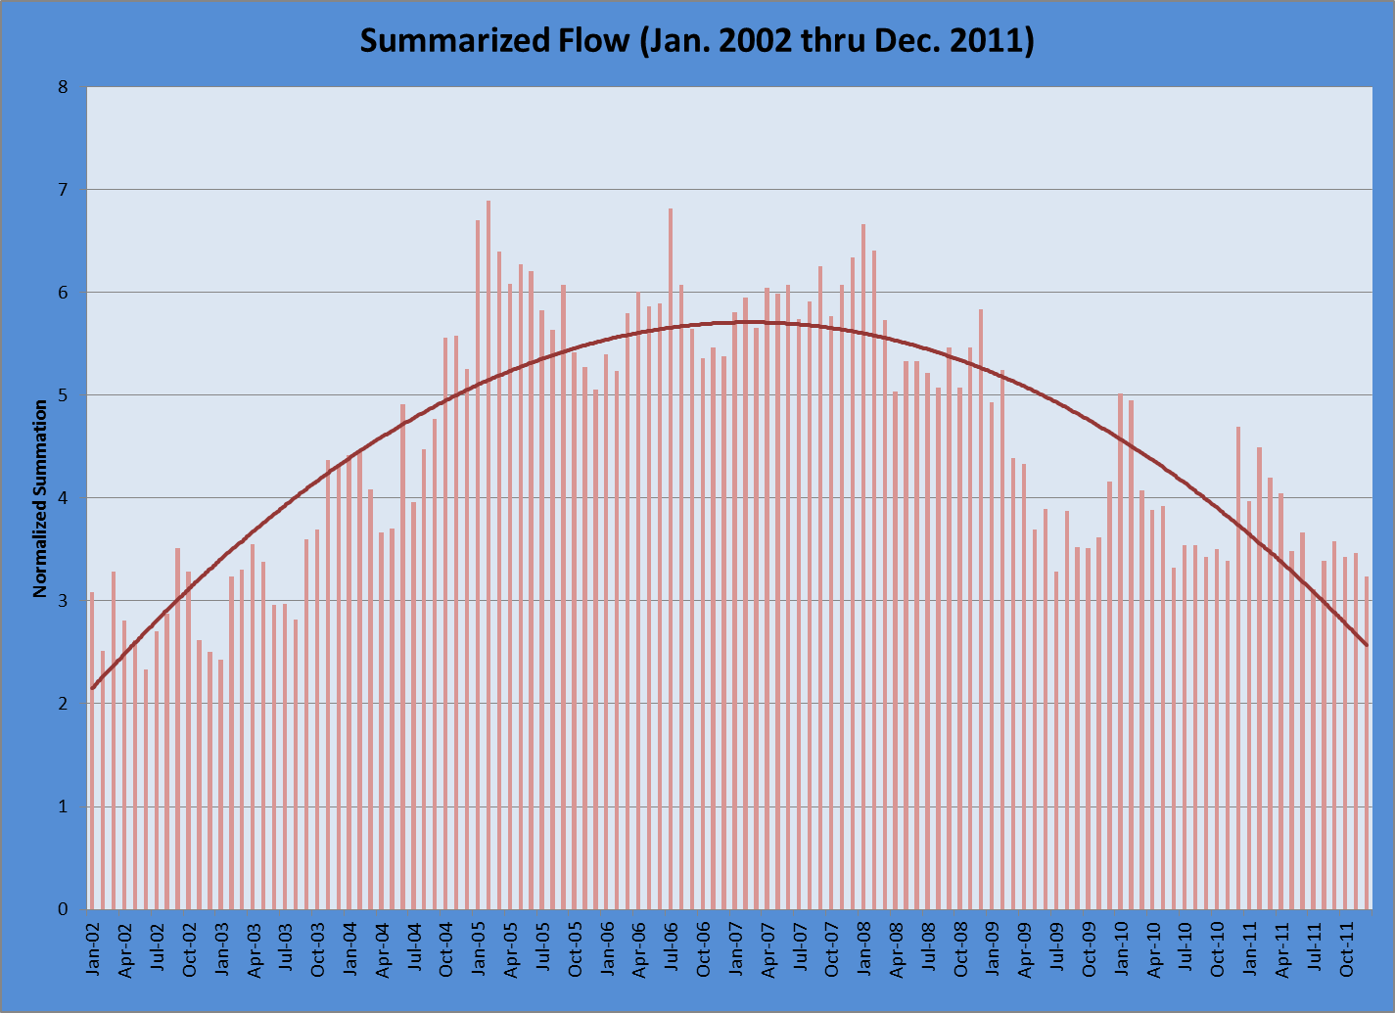

A hypothesis was considered that water use efficiency efforts would cause an increase in influent TSS and BOD. Ten years of data from eight water reclamation plants was compiled and graphed for trending purposes. Figure5.5-6 and Figure5.5-7 represent the influent water quality results for TSS and BOD, respectively. Both figures indicate an increasing trend in concentration of TSS and BOD for the Santa Ana Watershed water reclamation facilities since 2002. The influent BOD concentrations displayed more consistent increases than TSS, and thus appear amenable to linear interpretation. In comparison to the influent flow data in Figure 5.5-5 for the same facilities, both the influent TSS and BOD appear to be uninfluenced by the influent flow. That is, the influent flow data presented a “bell” shaped curve while the TSS and BOD displayed a more increasing linear line over the same time period. The hypothesis that water use efficiency strategies may increase influent TSS and BOD is a plausible conclusion.

Figure 5.5-6 Influent Water Quality Results for TSS

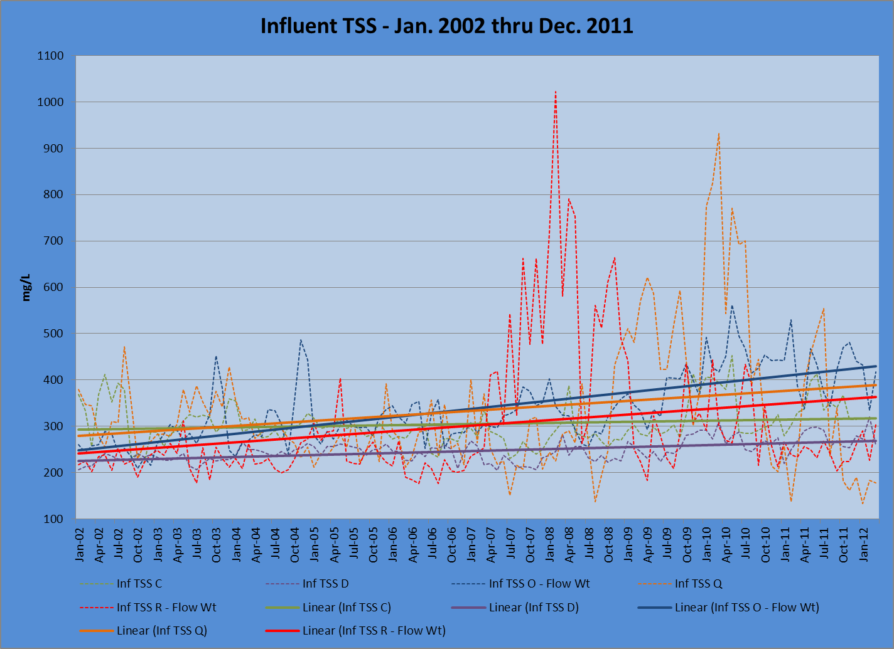

Figure 5.5-7 Influent Water Quality Results for BOD
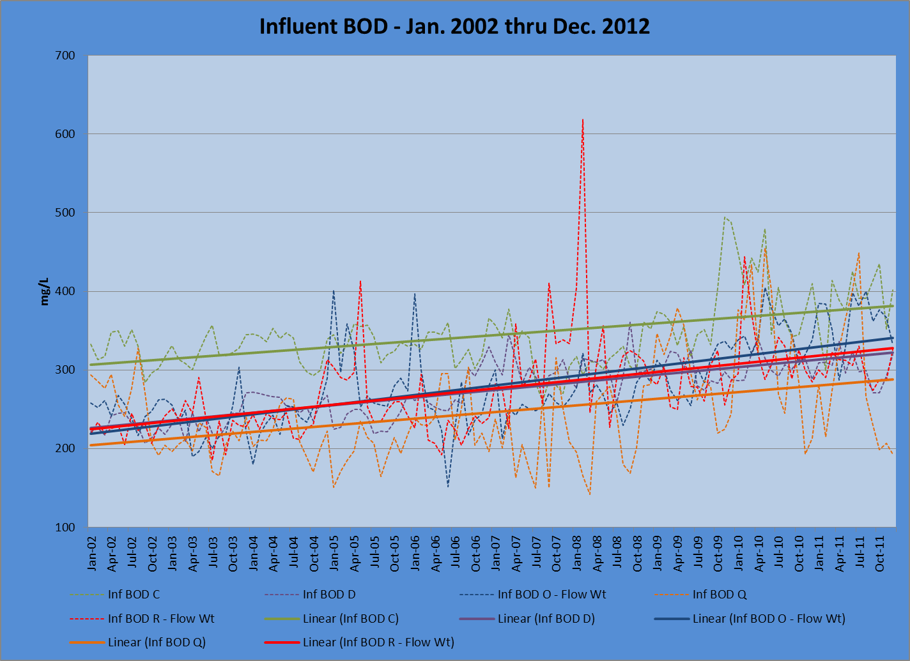

Based on these preliminary results showing a consistent trend in wastewater quality for the SARDA facilities, further evaluations may need to be done. BOD and TSS are only two of the key constituents to measure the strength of the influent. There are other constituents that may also be upward trending such as total dissolved solids (TDS) and nutrients. TDS is a concern because the wastewater plants do not effectively reduce TDS, and these changes may affect compliance with the discharge permits. Further evaluation will help agencies to better understand any potential impact to their facilities and these findings can be incorporated into water reclamation facility design and management.

Proposed New Water Quality Criteria for Nutrients and Biological Objectives
There are two efforts led by the State Water Resources Control Board (State) to develop new water quality criteria for nutrients and biological objectives. The intent of the water quality criteria is to protect aquatic systems. Presently, the State uses either narrative or numeric standards that have been identified in the Regional Water Quality Control Board’s (Regional Boards) basin plan for these aquatic systems. These standards then become NPDES permit limitations. The regulators recognize the complexity of aquatic systems and are attempting to include other indicators of adverse impacts rather than exclusively using chemical, physical, and toxicological thresholds. To add to this complexity it is understood that aquatic systems do not behave similarly. Therefore site specific indicators may be required. The outcome of the State’s effort will translate into revised NPDES permit limits and therefore these regulations need to be followed closely to ensure that the proposed criteria will be practicable. Brief descriptions of the two efforts underway are described below.

Nutrient Criteria
USEPA has committed to the development of nutrient criteria and knowing the complexity of the aquatic systems and that they vary significantly across the country, USEPA has delegated this effort to the States. California has been evaluating nutrient criteria models for several years. The State determined that the nutrient criteria framework needs to contain, in addition to nutrient concentrations, targeting information on secondary biological indicators such as benthic algal biomass, planktonic chlorophyll, dissolved oxygen, dissolved organic carbon, macrophyte cover, and clarity. These secondary indicators provide a more direct risk-based linkage to beneficial uses than the nutrient concentrations alone.

The State has evaluated a model called the California Numeric Nutrient Endpoint (NNE) approach. This approach classifies the water bodies based on three beneficial use risk categories, where Category I is not expected to exhibit impairment, Category II is in an intermediate range, where additional information and analysis may be needed to determine if a use is supported, threatened, or impaired, and Category III has a probable risk of impairment due to the presence of nutrients. Based on the site specific characteristics and secondary indicators, the NNE model will calculate a nutrient water quality objective for the water body. The State has pilot tested this approach and has learned that the development of nutrient criteria suggests that no one approach will be suitable for all diverse water bodies within California. However, the State further recognizes that the NNE and its risk based approach will provide solutions to many of the issues that need to be addressed in setting numeric nutrient endpoints in California.

Biological Objectives
The State is proposing a statewide biological objectives policy for perennial wadeable streams. The policy will address the need for statewide consistent, enforceable, and scientifically rigorous tools for evaluating aquatic life use attainment in these waterbodies. Most of the State’s waterbodies have one or more aquatic beneficial uses assigned to them, therefore this policy will affect the streams with beneficial use designations of warm water habitat, cold water habitat, marine or estuarine habitat, migration, spawning, wetland habitat, wildlife habitat, and preservation of rare, threatened, or endangered species. Currently, the biological indicators in most of the Regional Board basin plans are narrative and are therefore not enforceable.

The State is writing a policy and developing the tools to assess aquatic life uses in the perennial wadeable streams. In addition the State will supply consistent, statewide guidance for establishing biological targets for restorations, permits, and other regulatory actions. The State believes that this policy will maximize the efficiency of the extensive pool of bio-assessment data now available in California by producing objectives that are applicable to the greatest number of waterbodies possible in the state. And it reduces the expenditures of time and resources that are necessary to evaluate aquatic life uses on a case by case basis.

Regional Solutions for MS4 Stormwater Management
Regulators and watershed stakeholders agree that storm water is a valuable resource for the region and that increased capture of storm water will be an increasingly important component of the region’s local water supply. Currently, MS4 permit compliance is focused on integrating BMPs such as vegetated swales, meandering linear parks, and rain gardens into local permits. Two alternative compliance provisions, regional infiltration facilities and in-lieu fee programs, can complement BMPs and offer greater opportunities to transform storm water into long-term, sustainable groundwater supplies.
Interestingly, some of the obstacles to developing regional infiltration projects and in-lieu programs lie within the MS4 permits. For example, one of the requirements is that a regional facility, which may be on a separate construction timeline, must be fully operational once the development is completed. Another challenge is that some projects require costly evaluations to determine that a site is not suitable for infiltration so that alternative approaches can be incorporated into the project. And, although in-lieu payments are included as an option, a preliminary program has yet to be developed.
However, the greatest benefits will be realized when regulations and programs strike a balance between requiring on-site BMPs and utilizing alternative compliance approaches which improve surface water quality, maximize beneficial use of storm water for water supply, and protect groundwater quality, and progress is being made in these areas. Riverside and San Bernardino Counties have completed the first phase of their Watershed Action Plans. These are interactive on-line programs that will provide tools to locate an individual parcel, outline potential site constraints that may limit use of certain BMPs, and identify potential future sites for regional infiltration facilities. A similar program has been developed by the County of Orange, the Coyote Creek Watershed Infiltration and Hydromodification Management Plan, and is the first in a series of sub-watershed plans that has been finalized.

Existing Management Plans
A variety of water quality management plans have been prepared within the Watershed. This section discusses existing plans.

Upper Santa Ana River Watershed IRWMP (November 2007)
The Upper Santa Ana Water Resources Association members, lead by the San Bernardino Valley Municipal Water District (Valley District), prepared the Upper Santa Ana River Watershed IRWMP to address water management issues in the Upper Santa Ana River Watershed. This plan aims to evaluate water management opportunities, improve water supply reliability, reduce dependence on and optimize the use of imported water, and assist local agencies to optimize management and protection of water resources in the region. This plan’s objectives include improving surface and groundwater management, water supply reliability, the quality of surface water and groundwater resources, and ecosystem and environmental restoration. This plan was funded in part by the State of California Proposition 50 IRWMP Planning Grant and by local funding sources.

Western Municipal Water District, IRWMP (October 2006)
Western Municipal Water District prepared their IRWMP to evaluate water management alternatives, address long range water supply planning to meet future demands, and increase system reliability as the amount of available supply of imported water becomes less certain. This plan was funded in part by the State of California Proposition 50 IRWMP Planning Grant and by local funding sources.
This IRWMP identifies and evaluates management strategies that aim to increase local water supplies and to address local and regional water quality concerns. The report focuses predominately on projects that result in an increase in available local water supplies. Projects were ranked with an emphasis on those with regional benefits and based on total percent of demand met. A plan for water conservation also was included.

San Jacinto River IRWMP (December 2007)
Water resources in the SJR Watershed are particularly important due to high demand from urban, agricultural, and recreational users. The nutrient TMDL for Canyon Lake and Lake Elsinore, as well as NPDES stormwater permits are regulatory drivers for improved management of water resources. The IRWMP area consists of the SJR Hydrologic Unit. Most of the Watershed falls within Riverside County; with only a small portion extending into Orange County. The SJR, Salt Creek, Perris Valley Storm Drain, Mystic Lake, Perris Reservoir, Canyon Lake, and Lake Elsinore are the dominant hydrologic features in the Watershed. Through a collaborative process, the SJR IRWMP was developed and led by the San Jacinto River Watershed Council (SJRWC) with financial assistance from the State of California Proposition 50 Grant and in-kind support and input from a number of member and partnering agencies.

Chino Creek Integrated Plan (2006)
The Chino Creek Integrated Plan was prepared by a broad stakeholder group and administered by the Inland Empire Utilities Agency (IEUA). This plan focuses attention on the lower Chino Creek area as a step in the process of preserving and restoring the Prado Basin. IEUA, with a grant from SWRCB, technical support from OCWD, and funding from the City of Chino, worked with stakeholders over the course of four years to prepare the plan.
Integrated Plan goals were identified as implementable, multi-barrier strategies aimed at reducing pollutants and providing multi-purpose opportunities such as constructing treatment wetlands and natural flood control technologies. Recommended projects identified in the Integrated Plan aim to create recreational linkages, provide public education, develop sustainable development projects for the built environment, preserve habitat, and environmental restoration.

North Orange County Watershed Management Area IRWMP
With a wide range of stakeholders, the County of Orange has completed the North Orange County Watershed Management Area (WMA) IRWMP. This IRWMP will be used to guide watershed management programs and support the region in pursuing funding opportunities. The plan’s objectives will include:
- Protecting and enhancing water quality in the region, including current and planned TMDLs.
- Enhancing local water supplies.
- Promoting flood management.
- Enhancing wetlands.
- Addressing runoff and its related impacts from existing and future and uses.
- Enhancing public education programs.
- Reducing invasive species and enhance habitat.
- Promoting environmental justice.

Coyote Creek Watershed Management Plan (January 2007)
The Coyote Creek Watershed Management Plan provides a blueprint for improving the health of the Watershed through multi-objective projects, policies, and site design guidelines. Rather than focusing on the ecological problems that have resulted from piecemeal management of land and water resources, it serves as a user guide on how to improve the management of the Watershed for maximum social, economic, and environmental benefit.

Central Orange County Integrated Regional Water Management Plan (COC IRWMP)
The County of Orange led the first Integrated Regional Water Management effort for the Central Orange County Watershed Management Area (WMA) which culminated in the production of the Phase I Central Orange County IRWM Plan (IRWMP). The Phase I IRWMP was undertaken to provide a bridge between existing and developing watershed planning efforts, allowing for more effective collaboration and greater opportunity to leverage agency resources across jurisdictions. It had a strong emphasis on the sensitive coastal resources, Areas of Special Biological Significance (ASBS) and Critical Coastal Areas (CCAs) that are located within the Central Orange County WMA. The Phase I IRWMP was also developed to meet Proposition 50 priorities. The Phase I IRWMP was integral to subsequent watershed planning efforts led by the City of Newport Beach.
In January 2006, the City of Newport Beach was awarded a planning grant by the State Water Board through Proposition 40 for preparation of an Integrated Coastal Watershed Management Plan (ICWMP) to address ASBS and CCA issues along Newport Coast. Much of the material in the Phase I Central Orange County IRWMP was used during the preparation of the ICWMP. In May 2006, the City of Newport Beach was awarded a second planning grant by the California Department of Water Resources through Proposition 50 for the preparation of an IRWMP for the Newport Bay Watershed including data collection, analysis, and formulation of policy and guidelines. Though building on some new elements, this Phase II effort incorporated the Phase I Central Orange County IRWMP.
The County of Orange completed Phase III of the Central Orange County IRWMP. Phase III is a compilation and revision of the first two IRWMPs; the information contained in the Phase I and Phase II was used to form the basis of the Phase III plan. The purpose of the Central Orange County IRWM Plan is to provide a local plan that bridges the gap between existing and developing watershed planning efforts, allowing for more effective collaboration and greater opportunity to leverage agency resources across jurisdictions.

Extensive water resource program development and implementation has occurred in this region over the past three decades, with agency partnerships, agreements, and the formation of a formal stakeholder involvement structure. The water quality issues are daunting; within this region there are eight water body segments listed on the State Water Resources Control Board 2010 Section 303(d) list and there are five Total Maximum Daily Loads (TMDLs) for nutrients, fecal coliform, sediment, toxics, and organophosphate pesticides, with more TMDLs pending. Water quality has been the overarching issue that has brought the water resource and land use agencies, environmental groups, and other stakeholders within the region together in the spirit of collaboration. Public agencies and private interests have entered into numerous cooperative agreements to leverage financial resources for the development of programs that implement studies, best management practices (BMPs), and other control measures consistent with regulatory requirements and regional goals for watershed conditions. These water quality-related projects and programs have not been undertaken with a narrow focus or single purpose; the stakeholders within this region, both public and private, understand the nexus between growth, land use decisions, water resource management, and watershed impacts.

This region has experienced significant population growth over the past 20 years, with development of former agricultural lands and expansion in the established urban areas. In addition to addressing water quality issues, the water and wastewater agencies have established partnerships to develop local resources, including groundwater and recycled water, to ensure a reliable source of water supply and to minimize the need for imported water. Public agencies and private entities have implemented a broad range of multi-purpose projects and programs to protect and enhance watershed conditions. The IRWM Plan builds on this history of successful collaboration and furthers the interests of the stakeholders through this integrated planning approach.

Groundwater
Groundwater is a major source of water supply in the Watershed. Protection of this source is critical to maintain the viability of local water supplies. The Basin Plan identifies 39 groundwater management zones in the Santa Ana River Watershed as shown in Figure 5.5-8.
Basin Plan amendments that were approved by the Regional Board in 2004 provide a comprehensive, watershed approach to controlling nitrogen and TDS in the Watershed, while also encouraging water recycling and reuse.
This section describes the TDS and nitrate-nitrogen WQOs and current ambient water quality. Ambient water quality, as defined here, is based on the twenty year period ending in2009. Where the ambient water quality is better than the WQO, this increment is referred to as the assimilative capacity.
All but five groundwater management zones in the Watershed have TDS and nitrate WQOs identified in the Basin Plan. In this discussion, the groundwater management zones are grouped as follows:
- Upper Santa Ana River Basin
- Chino Basin
- Middle Santa Ana River Basin
- San Jacinto River Basin
- Lower Santa Ana River Basin
- San Jacinto River Basin
- Lower Santa Ana River Basin
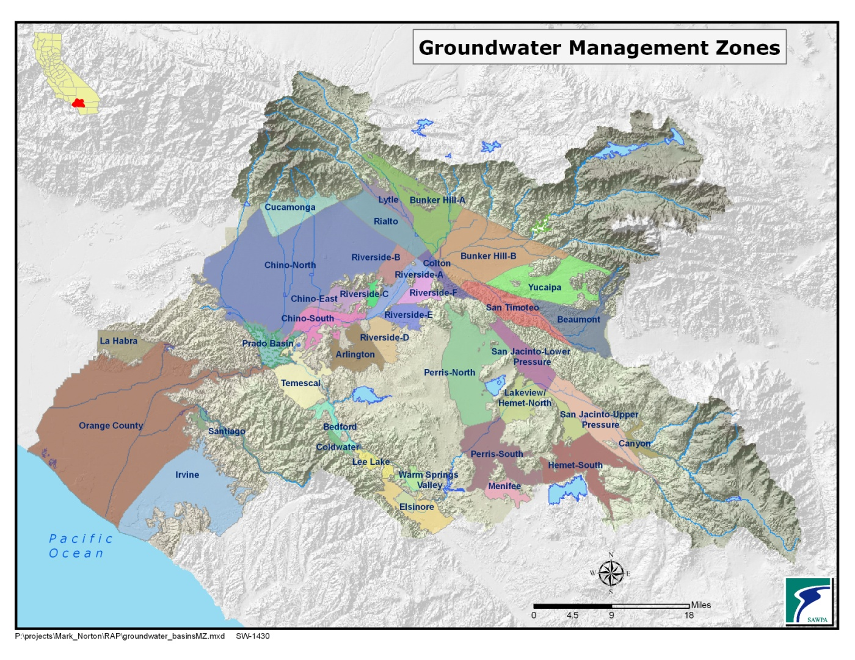
Figure 5.5-8 Santa Ana River Watershed: Groundwater Management Zones

The Basin Plan requires that concentrations of TDS and nitrate in each groundwater management zone be estimated every three years. These ambient conditions are compared to the WQOs to determine the amount of assimilative capacity in each zone. In areas where there is no assimilative capacity, the Regional Board will not permit waste discharges that degrade water quality. Figure 5.5-9 shows the ambient WQOs for TDS and nitrates in groundwater management zones. Ambient water quality for the years 1990-2009for nitrates is shown in Figure 5.5-10 and for TDS in Figure 5.5-11.
Figure 5.5-9 Ambient Water Quality Objectives

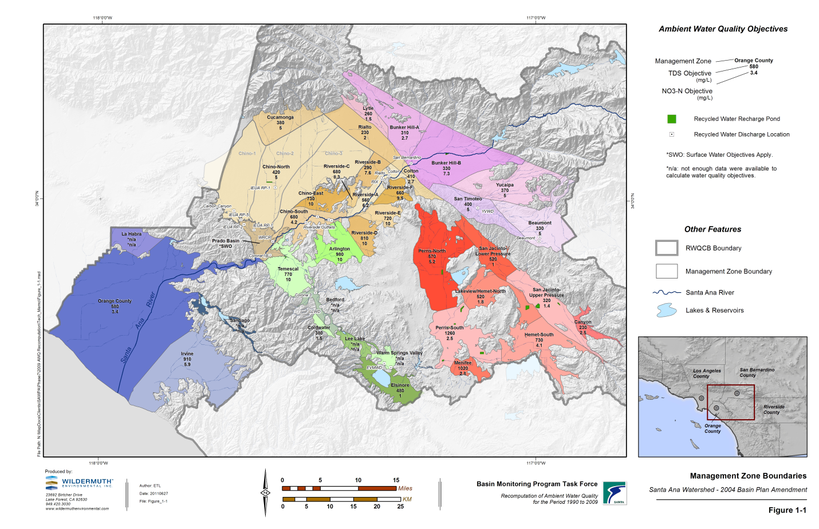

Current Conditions
High salt and nitrate concentrations are two long-standing groundwater quality issues in the SAR Watershed. Sources of elevated levels include mineral content in the sediments, recharge and drainage patterns, source water quality, irrigation, wastewater discharges, and historic land use. Managing levels of TDS in groundwater basins is a significant challenge as the recycling of waste water increases in the Watershed. Each cycle of residential water use typically adds approximately 200 mg/L of salt to the water. Industrial and commercial operations may contribute higher levels. Construction and use of salinity management facilities, such as brine lines and desalters, are being used to prevent salt-build up and to remediate high TDS groundwater basins.
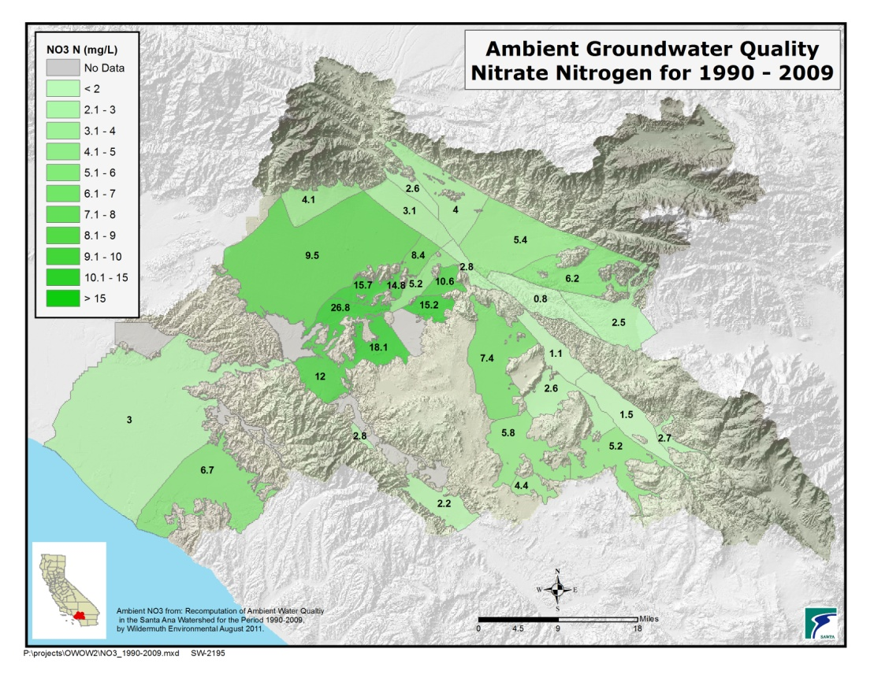
Figure 5.5-10 Ambient Water Quality Objectives 1990-2009 – Nitrates
Figure 5.5-11 Ambient Water Quality Objectives 1990-2009 – TDS
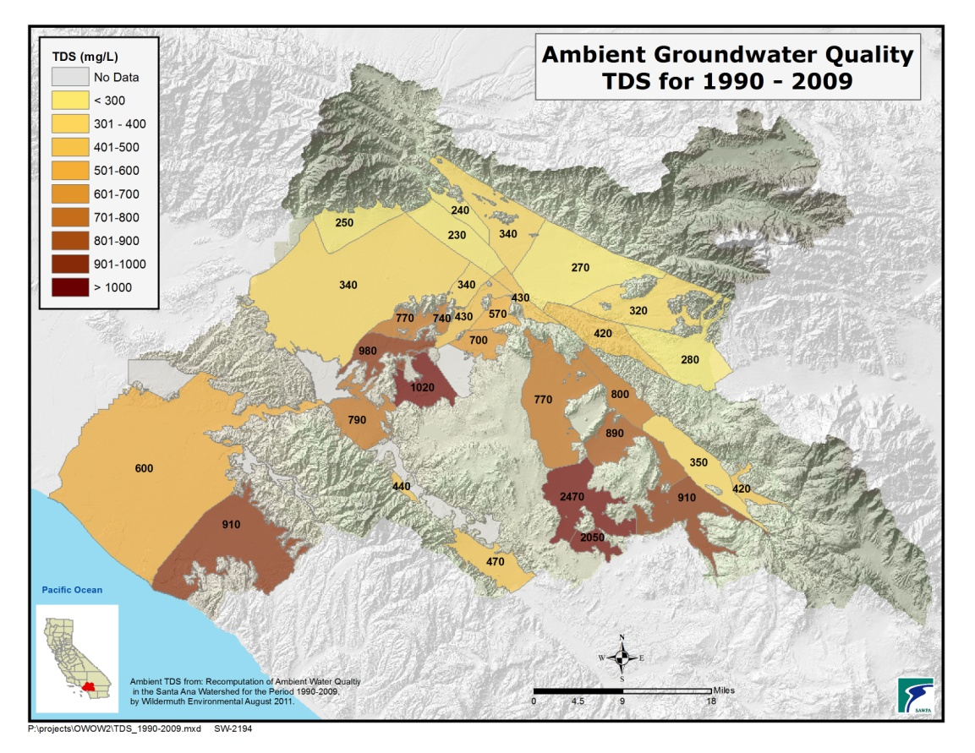

Elevated levels of nitrates in groundwater originate primarily from use of fertilizers, confined animal feedlots, and waste water treatment facilities. Areas with elevated nitrates (nitrate-nitrogen greater than the MCL of 10 mg/L, using the ambient water quality statistics) in groundwater are shown in Figure 5.5-12.

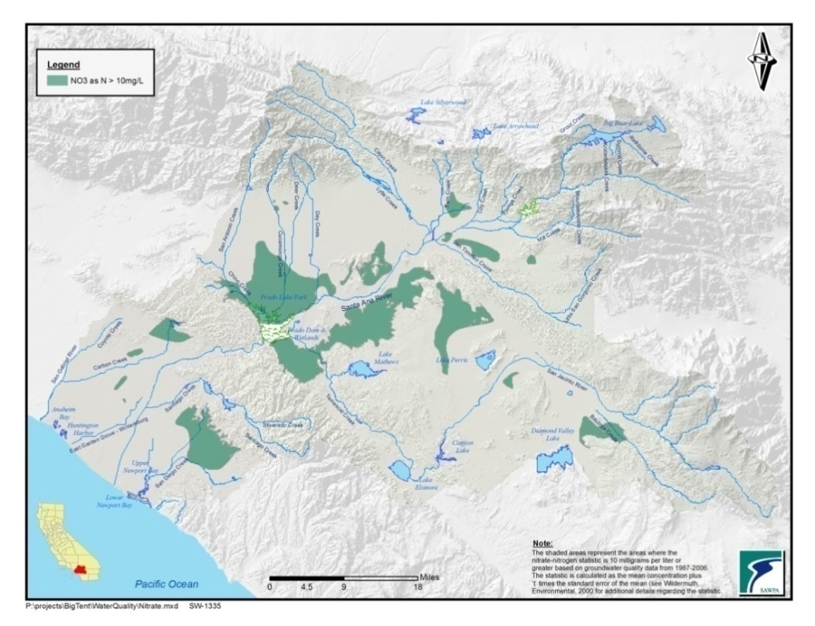
Figure 5.5-12 Groundwater with Elevated Nitrate Levels

Approximately 25 years ago, volatile organic compounds (VOCs) were discovered in groundwater in some areas. More recently, contamination due to perchlorate has become a major concern in some portions of the Watershed. Areas with groundwater contamination above the primary MCLs for VOCs and perchlorate are shown in Figure 5.5-13.
Figure 5.5-13 Groundwater Contamination Plumes

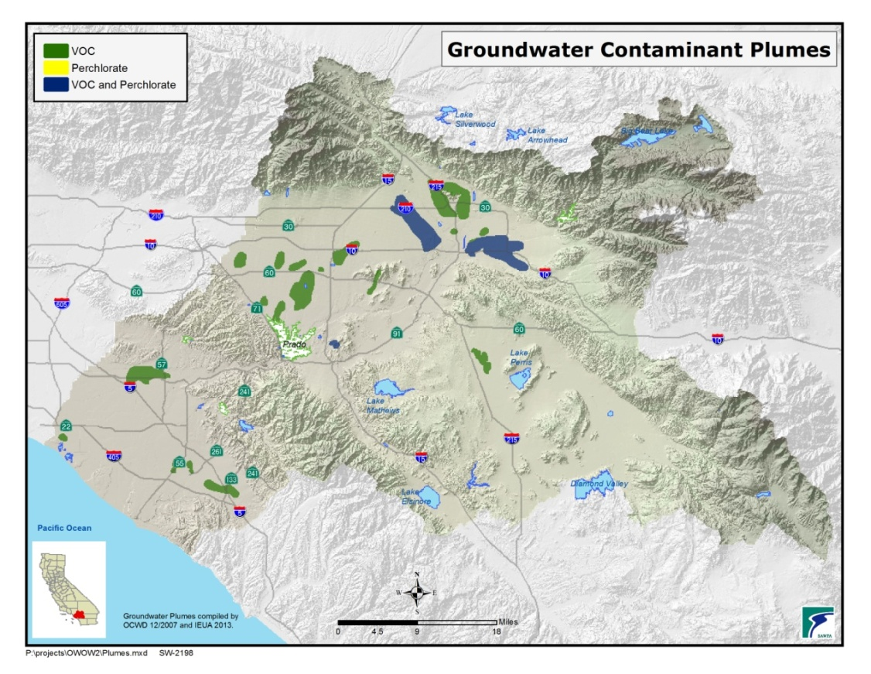

Upper Santa Ana River Basin
The Upper Santa Ana River Basin is divided into seven management zones. TDS and nitrate WQOs and current ambient water quality levels are summarized in Table 5.5-20.
In the Bunker Hill management zones, the largest area of groundwater contamination is the Newmark Superfund Site. Treatment plants are operating to remove VOC contamination. A total of thirteen extraction wells produce on average approximately 26,000 AFY, which is treated at the four treatment plants.
In the Bunker Hill B management zone, a six-mile long plume of VOC and ammonium perchlorate contamination, known as the Crafton-Redlands Plume, was first detected in the early 1980’s. Approximately 46 drinking water wells have been affected. A number of well head treatment units and treatment plants to remove these contaminants are being operated by the Cities of Redlands, Loma Linda and Riverside.
Cherry Valley is an unincorporated area located northeast of the City of Beaumont, in the Beaumont management zone. The community is not served by a sanitary sewer system. The only source of drinking water for the community is the groundwater. A study commissioned by the San Timoteo Watershed Management Authority indicated an ongoing degradation of the quality of the groundwater due to nitrate. The source of the nitrate was attributed to the onsite waste treatment systems, i.e., septic systems.
Table 5.5-20 Water Quality Objectives for Upper Santa Ana River Basins

Management Zone | TDS |  | Nitrate-nitrogen
 | Water Quality Objective  (mg/L) | Ambient Quality  (mg/L) | Water Quality Objective  (mg/L) | Ambient Quality  (mg/L)
Big Bear Valley | 300 | NA | 5.0 | NA
Beaumont | 330 | 280 | 5.0 | 2.5
Bunker Hill A | 310 | 340 | 2.7 | 4.0
Bunker Hill B | 330 | 270 | 7.3 | 5.4
Lytle | 260 | 240 | 1.5 | 2.6
San Timoteo | 400 | 420 | 5.0 | 0.8
Yucaipa | 370 | 320 | 5.0 | 6.2
Source: Wildermuth Environmental (2011)
Note: Current ambient water quality computations for the San Timoteo management zone were not made during this study. These values were published in Preliminary Assessment of Assimilative Capacity in the San
Timoteo Management Zone (WEI, 2010), using a surrogate methodology.

The County of Riverside has adopted three ordinances to ban new septic systems unless the systems are designed to remove 50 percent of the nitrogen in the discharged wastewater. Beaumont Cherry
Valley Water District is in the process of providing sewer service to a major portion of the area and has applied for State Revolving Fund loans for the project.

Chino Basin, Cucamonga, and Rialto Management Zones
The Chino Basin is divided into three management zones. This section covers these three zones, and the adjacent Cucamonga, Colton, and Rialto management zones. The Basin Plan established “maximum benefit” and “anti-degradation” TDS and TIN water quality for the Chino and Cucamonga management zones as summarized in Table 5.5-21.
Management Zone | TDS |  | Nitrate-nitrogen
 | Water Quality Objective  (mg/L) | Ambient Quality  (mg/L) | Water Quality Objective  (mg/L) | Ambient Quality  (mg/L)
Chino North | 420 | 340 | 5.0 | 9.5
Chino East | 730 | 770 | 10.0 | 15.7
Chino South | 680 | 980 | 4.2 | 26.8
Colton | 410 | 430 | 2.7 | 2.8
Cucamonga | 380 | 250 | 5.0 | 4.1
Rialto | 230 | 230 | 2.0 | 3.1
Source: Wildermuth Environmental (2011)
Table 5.5-21 Water Quality Objectives for Chino Basin and Rialto

The Chino Basin is experiencing rapid commercial and residential development. The groundwater quality in the basin is generally good, with better groundwater quality found in the northern portion where recharge occurs. Salinity (TDS) and nitrate concentrations increase in the southern portion of the Basin. Between 2001 and 2006, about 80 percent of the private wells south of Highway 60 had nitrate concentrations greater than the MCL. Pollution from point sources and emerging contaminants are concerns for the overall groundwater quality in Chino Basin. Constituents that have the potential to impact groundwater quality include VOCs, arsenic, nitrates, and perchlorate.
Groundwater in several areas is impacted by elevated levels of perchlorate. Sources of perchlorate include the Stringfellow Acid Pits ,Chilean nitrate fertilizer that was imported in the early 1900s for the citrus industry, and other manmade sources such as ammunition manufacturing.

Newmark Cleanup Restores Groundwater Supplies
In 1980, the California Department of Health Services discovered the chlorinated solvents tetrachloroethylene (PCE) and trichloroethylene (TCE) in several municipal water supply wells in the northern San Bernardino/Muscoy region. Investigations into the extent of contamination led the U.S. EPA to place the area on the National Priorities List in 1989. This Superfund site was determined to contain two plumes originating from the same source near the site of a closed World War II Army site: an approximately eight-mile Newmark plume and an approximately six-mile Muscoy plume.
Contamination impacted 25 percent of the municipal water supplies for the City of San Bernardino. In addition, 75 percent of the water supplies for the City of Riverside downgradient of the contamination plume were threatened as were water supplies for the Cities of Colton, Loma Linda, Fontana, and Rialto.
The San Bernardino Municipal Water Department, in cooperation with the U.S. EPA, constructed thirteen extraction wells to contain the plume and treat the contaminated groundwater. As a result, 12 of the 20 contaminated wells were brought back into operation; clean up operations continue.
Pictured below is a façade house built around one of the extraction wells.
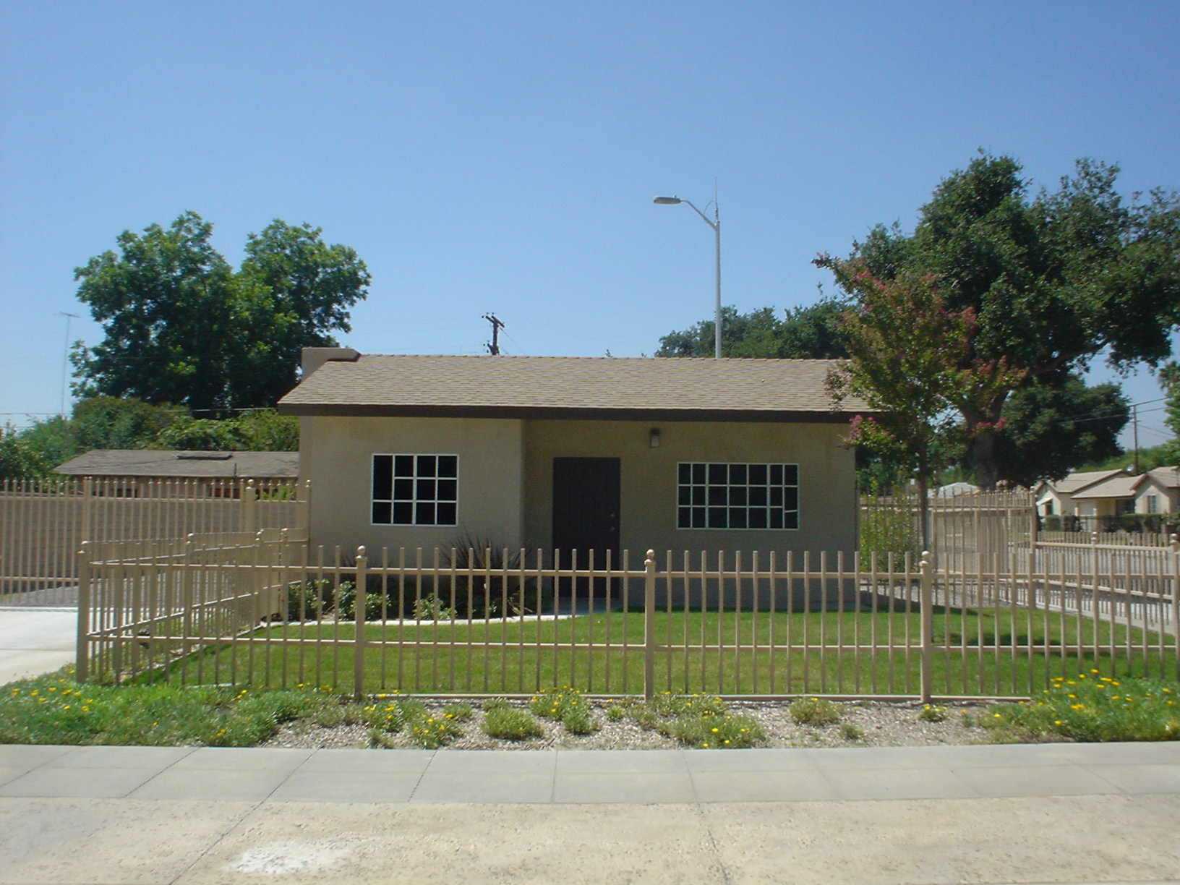
EPA Well 111 with façade house.

In the Rialto management zone, at least 20 wells providing 40,135 gallons per minute (gpm) of domestic water supply capacity to the Cities of Rialto and Colton, West Valley Water District and Fontana Water Company have been contaminated by perchlorate. Well head treatment is operating on 11 of these wells.
Arsenic at levels above the MCL appears to be limited to the deeper aquifer zone near the City of Chino Hills. Total chromium and hexavalent chromium, while currently not a groundwater issue for Chino Basin, may become so, depending on the promulgation of future standards.

Middle Santa Ana River Basin
Maximum Benefit Demonstrations in Santa Ana River Watershed
A successful template for groundwater quality management is the maximum benefit demonstration utilized in the Chino, Beaumont/Yucaipa, and San Jacinto basins. Stakeholders collaborated with the Regional Board to demonstrate that groundwater quality can be protected not solely based on historical quality (the “antidegradation” objectives). Instead, the Regional Board agreed to “maximum benefit” objectives to protect groundwater quality for the “maximum benefit to the people of the State”.
In the Chino, Beaumont/Yucaipa, and San Jacinto basins, local stakeholders proposed programs to implement local cooperative projects such as groundwater desalination plants, expanded stormwater capture and recharge basins, and comprehensive groundwater management plans in order to protect groundwater basin quality and meet existing and downstream beneficial uses. Through an aggressive series of monitoring requirements, the State will be able to assure that water quality is protected. The antidegradation objectives are defined as the default condition if the commitments made to protect water quality are not attained. The success of this multi-agency approach to maximize the use of water resources while protecting water quality as defined by the SWRCB serves as a progressive water management and water quality protection example for other regions in the state, according to the SWRCB.
The management zones for the Middle Santa Ana River Basin are listed in Table 5.5-22andTable5.5-23. Agriculture and dairy activities are suspected to be partially responsible for elevated salt and nitrate concentrations in the groundwater. As the population within the Riverside Basins continues to grow, homes, commercial centers, new industry, and warehouses are replacing agriculture and open space.
Several areas in the Riverside basin are impacted by the presence of nitrate, dibromochloropropane (DBCP), and perchlorate. As such, the City of Riverside has increased monitoring schedules at select production well sites and has implemented blending plans and provided treatment for DBCP removal at its Palmyrita GAC plant.

Table 5.5-22 Water Quality Objectives for Riverside Basin
Management Zone | TDS |  | Nitrate-nitrogen
 | Water Quality Objective  (mg/L) | Ambient Quality  (mg/L) | Water Quality Objective  (mg/L) | Ambient Quality  (mg/L)
Riverside-A | 560 | 430 | 6.2 | 5.2
Riverside-B | 290 | 340 | 7.6 | 8.4
Riverside-C | 680 | 740 | 8.3 | 14.8
Riverside-D | 810 | NA | 10.0 | NA
Riverside-E | 720 | 700 | 10.0 | 15.2
Riverside-F | 660 | 570 | 9.5 | 10.6
Source: Wildermuth Environmental (2011)

Table 5.5-23 Water Quality Objectives for Arlington, Elsinore, Corona Area Groundwater Management Zones
Groundwater  Management Zone | TDS |  | Nitrate-nitrogen
 | Water Quality Objective  (mg/L) | Ambient Quality  (mg/L) | Water Quality Objective  (mg/L) | Ambient Quality  (mg/L)
Arlington | 980 | 1020 | 10 | 18.1
Bedford | NA | NA | NA | NA
Coldwater | 380 | 440 | 1.5 | 2.8
Elsinore | 480 | 470 | 1.0 | 2.2
Lee Lake | NA | NA | NA | NA
Temescal | 770 | 790 | 10.0 | 12.0
Source: Wildermuth Environmental (2011)

San Jacinto River Basin
Agricultural activities in the San Jacinto River Basin are suspected to be partially responsible for elevated salt and nitrate concentrations in the groundwater. Septic tank discharges are creating significant water quality problems that have triggered local agency and the Regional Board’s regulatory response in the unincorporated areas of Quail Valley (north of Canyon Lake) and Enchanted Heights (west Perris). The basin is dotted with several other areas believed to be at risk of water quality degradation from septic systems. A septic system management plan has been developed by Riverside County Flood Control.
A Groundwater Salinity Management Program, developed by EMWD, addresses several water quality issues in this area. The Perris South Sub-basin contains a surplus of marginal to unusable quality groundwater that flows into the adjacent high quality Lakeview Sub-basin, rendering several wells unusable and threatening the remaining production of the basin. Due to the unavailability of imported water, blending to improve water quality is not an option. Therefore, three desalination facilities, two constructed and one being designed, will recover high TDS water in the Menifee and Perris South Groundwater Management Zones for potable use. In addition to providing clean drinking water, the desalters will play a role in reducing the migration of brackish groundwater into areas of good quality groundwater. WQOs are shown in Table 5.5-24.
Table 5.5-24 Water Quality Objectives for San Jacinto River Basins
Management Zone | TDS |  | Nitrate-nitrogen
 | Water Quality Objective  (mg/L) | Ambient Quality  (mg/L) | Water Quality Objective  (mg/L) | Ambient Quality  (mg/L)
Canyon | 230 | 420 | 2.5 | 2.7
Hemet – South | 730 | 910 | 4.1 | 5.2
Lakeview/Hemet- North | 520 | 890 | 1.8 | 2.6
Menifee | 1020 | 2050 | 2.8 | 4.4
Perris – South | 1260 | 2470 | 5.2 | 5.8
Perris – North | 570 | 770 | 2.5 | 7.4
San Jacinto – Lower | 520 | 800 | 1.0 | 1.1
San Jacinto – Upper | 320  500* | 350 | 1.4  7.0* | 1.5
*Maximum Benefit Objectives Source: Wildermuth Environmental (2008)

Lower Santa Ana River Basin
The Lower Santa Ana River Basin contains four groundwater management zones: Orange County, Irvine, La Habra, and Santiago. The La Habra and Santiago Management Zones have minimal pumping and TDS and nitrate WQOs have not been established due to the scarcity of data. This section focuses on the Orange County and Irvine Management Zones, which are important sources of water in Orange County.

Orange County Groundwater Basin
The Orange County Groundwater Basin is the source of approximately 70 percent of the water supply for 2.4 million people. Of this total production, about 90 percent meets drinking water standards without treatment. The remaining 10 percent requires treatment for VOCs, salts, or other constituents. WQOs for nitrates and TIN/TDS are listed in Table 5.5-25.

A shallow VOC plume exists in the Anaheim/Fullerton area where VOC concentrations exceed MCLs over approximately six square miles. To address this plume, the North Basin Groundwater Protection Project is being constructed to extract and treat VOC-contaminated groundwater and recharge treated water back into the groundwater basin. Other VOC plumes exist in Orange, Santa Ana, the Seal Beach Naval Weapons Station, and the now closed Tustin Marine Corps Air Station. Various other sites have generally shallow VOC contamination or other contaminants. The Tustin desalters, using reverse osmosis and ion exchange, treat high TDS, nitrate, and perchlorate levels in a section of Tustin. Areas in Garden Grove have groundwater with high nitrate concentrations that are likely the result of historic agricultural practices.

Management Zone | TDS |  | Nitrate-nitrogen
 | Water Quality Objective  (mg/L) | Ambient Quality  (mg/L) | Water Quality Objective  (mg/L) | Ambient Quality  (mg/L)
Orange County | 580 | 600 | 3.4 | 3.0
Irvine | 910 | 910 | 5.9 | 6.7
La Habra | NA | NA | NA | NA
Santiago | NA | NA | NA | NA
Source: Wildermuth Environmental (2008)
Table 5.5-25 Water Quality Objectives for Lower Santa Ana River Basin Management Zones

Irvine Management Zone
The Irvine Management Zone is a sub-basin of the Orange County Groundwater Basin. Water naturally flows between the boundaries but the operation of the Irvine Desalter limits movement of water between the two management zones.
Groundwater contaminated with VOCs exceeding MCLs from the now closed El Toro Marine Corps Air Station also contains high TDS and nitrate concentrations. The Irvine Desalter, using reverse osmosis, air stripping, and carbon absorption, was built to treat the contaminated water. Water treated for VOC contamination is distributed after treatment through the Irvine Ranch Water District non-potable system (irrigation and other non-potable uses); water treated for high TDS and nitrate is distributed through the potable system.

Current Management Strategies for Groundwater
Three goals are defined for groundwater quality. These goals are:
- Attaining water quality standards.
- Meeting drinking water standards.
- Achieving salt and nutrient balances.

Attaining water standards is a framework identified in the federal Clean Water Act and its associated regulations, and includes four components:
- Protecting beneficial uses.
- Attaining water quality objectives to protect beneficial uses.
- Implementing the State and Federal anti-degradation policies.
- Executing the Implementation Plan
Goals | Strategies | Tactics
- Water Quality Standards attained  - Drinking water standards (DWS) met  - Salt and nutrient balance achieved | - Protect good quality groundwater  - Clean up poor quality groundwater  - Re-evaluate water quality standards where appropriate | - Monitoring, assessment & reporting  - Source water protection programs  - Pollutant source identification & control  - Groundwater treatment  Pump and treat for local plumes  Wellhead treatment (e.g., for arsenic and perchlorate)  Desalters  - Brine lines  - Recharge of recycled, stormwater & imported water  - Research  - Public outreach
Table 5.5-26 Groundwater Quality Goals, Strategies, and Tactics

Meeting drinking water standards will require the attainment of both maximum contaminant levels for primary drinking water contaminants and secondary drinking water standards. Goals for improving groundwater quality and protecting groundwater supplies also include achieving a salt and nutrient balance. Strategies and tactics to achieve these goals are listed in Table 5.5-26. A summary of two of these issues is as follows:
Matching Water Quality with Water Use
The possibility of replacing potable water supplies used for landscape irrigation with pumped groundwater containing some contamination should be considered in discussions on improving local water supply reliability. Groundwater may have slightly elevated salinity or nutrient levels or, at the other extreme, may be contaminated with high levels of VOCs, pesticides, and/or perchlorate. In cases of groundwater with low levels of contaminants, use of this water for irrigation could have several benefits beyond reduced use of potable water supplies.

Supplies unsuitable for drinking water that are used for irrigation and carefully managed to allow for infiltration may naturally be purified of some contamination, such as low levels of VOCs and nitrates. Some contaminates also would be absorbed by vegetation. Over time as the water percolates back into aquifers, contamination levels may be reduced naturally.
One example of an approach utilizing groundwater contaminated by nitrates is a cooperative project by the City of Corona and the community of Home Gardens. Home Gardens ceased pumping of nitrate contaminated groundwater because of lack of treatment options. Construction of a pipeline will allowed for groundwater pumped by Home Gardens to be conveyed to Corona’s Temescal Desalter for treatment and blending. The resulting potable supply will be shared by the two agencies.
A potential new water supply may be to utilize shallow groundwater in Orange County for irrigation. In areas where slightly elevated nitrate levels or low concentrations of VOCs in the shallow aquifer preclude utilizing that supply, development of a clean-up strategy could consider irrigation use as a means to reduce contaminant concentrations and prevent spread of contamination into deeper drinking water aquifers.
Certainly, these projects must be carefully considered for unintended, negative impacts. One such consideration must be the likely increase in TDS of percolated water that would result from using pumped groundwater for irrigation.
Hindrances to Groundwater Cleanup Projects
When it occurs, groundwater contamination is ideally cleaned up by the entity that caused it. In cases where this does not occur, regulatory agencies may be required to force the responsible party to remedy the contamination.
In some situations, the regulatory agencies may not have the resources to investigate contaminated areas and oversee and enforce investigation and cleanup actions, particularly for contamination that has migrated beyond the property where the contamination originally occurred. In these situations, the local water district may desire to implement a cleanup or remediation project to protect local water supplies. The water district may do this at the district’s expense and seek cost recovery from the entities that caused the contamination.
Local agencies seeking to cleanup groundwater contamination encounter many hurdles. For example, a groundwater cleanup project proposed by a water district has experienced opposition by potentially responsible parties through legal challenges to California Environmental Quality Act (CEQA) documentation. Additionally, existing laws may not provide adequate legal authority for recovery of the cleanup costs from the entities that caused the contamination.
The issue considered here is the extent to which CEQA challenges can be used to discourage, hinder, and slow down a groundwater cleanup project. Arguably, the groundwater cleanup project is beneficial to the environment, since it benefits water quality and protects drinking water supplies. If the project is not implemented, contamination will continue to spread in the aquifer and the environment would continue to be degraded by continued migration of contamination.
An agency in the watershed received a CEQA legal challenge by entities believed to have caused the contamination the project was intended to address. In brief, the project consists of extraction wells, pipelines, a treatment plant, and injection wells to recharge the treated water. The challenge was unsuccessful in court. However, the agency had to expend substantial public funds to defend itself in court. Additionally, the legal challenge can delay project implementation.
If progress on implementing cleanup projects is hindered, this allows contamination to spread further, threatening even more drinking water supplies. Even if the project is ultimately constructed after legal challenges are addressed, the delays are harmful to the environment.
Consideration should be given to streamlining CEQA to facilitate groundwater cleanup projects implemented by public agencies with powers to manage groundwater. For example, a Statutory Exemption for groundwater cleanup projects could be proposed, or a streamlined approach to comply with CEQA could be proposed. There is an existing Categorical Exemption that may apply to certain relatively small projects. This Categorical Exemption should be evaluated and the type and size of projects covered under the exemption should be expanded if appropriate.

Existing Groundwater Management Plans

2005 Regional Groundwater Management Plan
A Regional Groundwater Management Plan was prepared by SAWPA in 2005. SAWPA is not directly responsible for managing groundwater basins in the Watershed. However, the agency coordinates numerous groundwater management planning efforts within the Watershed. This plan describes the water and groundwater management plans in the Santa Ana River Watershed.

Upper Santa Ana Basin Plans
In 2005, the Upper Santa Ana Water Resources Association developed an Integrated Regional Groundwater Management Plan (IRGM Plan) to address major water management issues for the communities of the Upper Santa Ana River Watershed. Valley District led the planning effort. The plan developed a process for managing the San Bernardino Basin Area and identified proposed regional projects. The two management objectives were to improve water reliability during drought periods and reduce liquefaction, and to protect water quality and maximize conjunctive use opportunities. Computer models were used to evaluate the various water management strategies.

San Jacinto Basin Plans
The West San Jacinto Groundwater Basin Management Plan was adopted in 1995. Annual reports on the status of groundwater and water resources efforts in the area have been published since 1996. The 2007 Annual Report compiled, reviewed, evaluated, and analyzed 2007 groundwater quality and water level monitoring program data; summarized groundwater-related changes; and reported results of an extraction monitoring program and on the status of previous recommendations.
To the east, the Hemet/San Jacinto Water Management Plan was completed in November 2007 by EMWD, Lake Hemet Municipal Water District, and the Cities of Hemet and San Jacinto to guide and support responsible water management. The plan’s objectives include reducing the historical impact of overdraft caused by past groundwater production, increasing recharge of the groundwater basin, providing for the water rights of the Soboba Tribe, ensuring water supply reliability, providing for planned urban growth, and protecting and enhancing water quality. Options to increase water supply and reliability include developing underutilized sources particularly recycled water and imported water. To accomplish the plan’s objectives, the Hemet/San Jacinto Integrated Recharge and Recovery Program is being implemented. This program includes the construction of numerous water supply and conjunctive use projects such as direct and in-lieu recharge, increased use of recycled water, increased conservation, and improved monitoring.

Elsinore Valley Municipal Water District, Elsinore Basin Groundwater Management Plan (March 2005)
The objective of this Groundwater Management Plan (GWMP) is to provide an evaluation of the groundwater basin and develop a reliable groundwater supply to meet drought and dry season demands through the year 2020. This plan addresses the hydrogeologic understanding of the basin, the evaluation of baseline conditions, identification of management issues and strategies, and the definition and evaluation of four alternatives. This document concludes with an implementation plan of the recommended plan. This GWMP was adopted by the Elsinore
Valley Municipal Water District Board of Directors on March 24, 2005 under the authority of the
Groundwater Management Planning Act (California Water Code Part 2.75, §10753) as amended.

Chino Basin Watermaster, Optimum Basin Management Plan, State of the Basin Report 2006 (June 2007)
The Chino Basin Watermaster (CBWM) is the manager of Chino groundwater basin. CBWM prepared the Optimum Basin Management Plan which describes the state of the basin in terms of historical groundwater levels, storage, production, water quality, and safe yield. Current and projected water demands and water supply plans are described. The goal of the plan is to develop a groundwater management program that enhances the safe yield and the water quality of the basin, enabling all groundwater users to produce water from the basin in a cost-effective manner. The plan includes a monitoring program for groundwater levels, as well as programs for monitoring well construction, abandonment, and destruction.

City of Corona, Department of Water and Power, Groundwater Management Plan (June 2008)
The City of Corona prepared a Groundwater Management Plan for the Temescal, Bedford, and Coldwater sub-basins. The conditions of each groundwater basin were described including groundwater levels, production, and quality. Current and projected water demands and supplies were evaluated. Basin management objectives were determined and management strategies were set. Objectives include to:
- Manage the groundwater basin in a sustainable manner.
- Prevent substantial water level declines in the Channel Aquifer.
- Protect groundwater quality in the unconfined aquifer.
- Maintain required outflow at Prado Dam.
- Monitor groundwater levels, quality, and storage.

OCWD Groundwater Management Plan (2009 Update)
The OCWD prepared the Groundwater Management Plan 2009 Update for the Orange County Groundwater Basin to identify key issues related to groundwater management. The three major objectives are to protect and enhance groundwater quality, to protect and increase the Basin’s sustainable yield, and to increase the efficiency of operations. Recommendations in the report to proactively manage the Basin include:
- Monitoring water quality and groundwater levels.
- Managing groundwater recharge.
- Managing groundwater quality by controlling seawater intrusion, evaluating emerging constituents, and preventing future contamination.
- Implementing projects to clean up existing contamination problems.
- Preparing an integrated demand and supply program.

WMWD Arlington Basin Groundwater Management Plan (September 2012)
The goal of this Groundwater Management Plan (GWMP) is to provide a planning framework to operate and manage the groundwater basin in a sustainable manner to ensure a long-term reliable supply for beneficial uses among all stakeholders in the basin.

The purpose of this GWMP, including development of the plan and the plan document itself, is to inform the public of the importance of groundwater to the Arlington Basin and the challenges and opportunities it presents; develop consensus among stakeholders on issues and solutions related to groundwater; build relationships among stakeholders within the Arlington Basin and with local, state, and federal agencies; and define actions for developing project and management programs to ensure the long-term sustainability of groundwater resources in the Arlington Basin. This GWMP provides action items that, when implemented, are designed to optimize groundwater levels, enhance water quality, and minimize land subsidence.

RPU Riverside Basin Groundwater Management Plan (October 2012)
The goal of the Riverside Basin Groundwater Management Plan (GWMP) is to provide a planning framework to operate and manage the groundwater basin in a sustainable manner to ensure a long term reliable supply for beneficial uses among all stakeholders in the basin.
The purpose of this Riverside Basin GWMP, including the development of the plan and the plan document itself, is to inform the public of the importance of groundwater to the Riverside Basin and the challenges and opportunities it presents; develop consensus among stakeholders on issues and solutions related to groundwater; build relationships among stakeholders within the basin and between local, state, and federal agencies; and define actions for developing project and management programs to ensure the long term sustainability of groundwater resources in the Riverside Basin. This GWMP provides action items that, when implemented, are intended to optimize groundwater levels, enhance water quality, and minimize land subsidence.

Imported Water Quality
Water agencies in the Santa Ana River Watershed receive imported water from the Colorado River Aqueduct (CRA) and the State Water Project (SWP). The majority of this imported supply used by local agencies is received from the Metropolitan Water District of Southern California (Metropolitan). The San Bernardino Valley Municipal Water District and the San Gorgonio Pass Water Agency also provide imported water from the SWP to local agencies within their service areas. The quality of imported water that is used for recharging groundwater directly affects groundwater quality. Since imported water is a significant source of potable water in the region, it affects the quality of discharges from wastewater treatment plants for certain constituents, such as salinity.
CRA and SWP source water is of high quality. This section provides a summary of key water quality constituents within the imported water systems. Source water protection activities aimed at maintaining a safe and reliable imported water supply are described.

Colorado River
The Colorado River travels approximately 1,400 miles from the Rocky Mountains to its outlet into the Gulf of California in Mexico. The Colorado River watershed encompasses 242,000 square miles including portions of seven states–Wyoming, Utah, Colorado, Nevada, New Mexico, Arizona, and California–and portions of Mexico. Several dams and reservoirs along the Colorado River control river flows and Lake Havasu, formed by Parker Dam, serves as the Forebay for Metropolitan’s CRA. The CRA, which has a flow capacity of 1,800 cubic feet per second (cfs), spans 242 miles between Whitsett Intake on Lake Havasu and Lake Mathews in Riverside County. The CRA system consists of pumping plants, reservoirs, conveyance infrastructure (i.e., canals, conduits, siphons and tunnels), and an extensive power transmission system. This section describes water quality in the CRA system.

Salinity
Colorado River salinity averages 630 mg/L, with cycles up and down over multiple years based on hydrologic conditions. Salinity changes are gradual over time due to large storage reservoirs along the river such as Lake Mead and Lake Powell. Figure 5.5-14 shows historical TDS levels at Lake Mathews, the terminal reservoir on the CRA system.
Salinity in the basin is due to both natural sources and anthropogenic activities. Metropolitan’s goal is to achieve an annual average salinity concentration of 500 mg/L for treated waters in order to reduce financial impacts to water consumers, impediments to recycling projects, and salt buildup in groundwater basins. This goal has been met primarily by blending Colorado River water with SWP supplies. It is anticipated that there may be periods when this goal cannot be achieved.

Figure 5.5-14 Imported Water TDS Levels
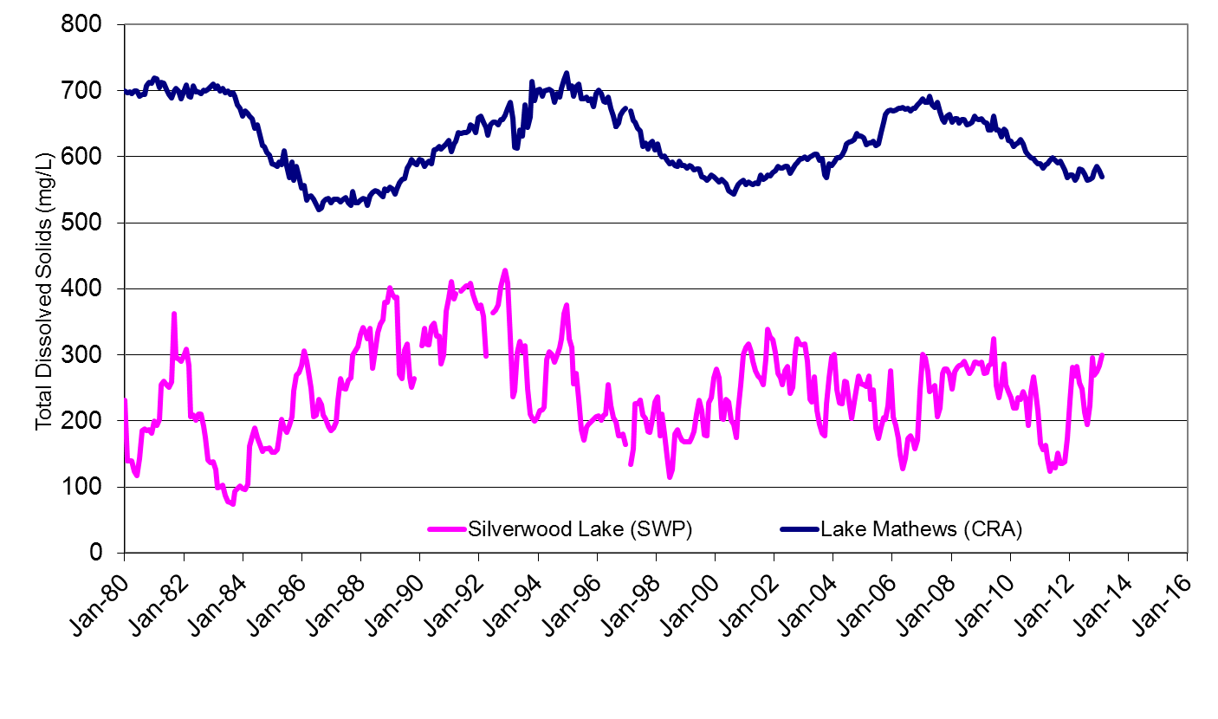

Nutrients
Phosphorus is the limiting nutrient for algal growth in the CRA system. Currently there is no regulatory limit for total phosphorus in drinking water. Despite relatively low concentrations (near 0.010 mg/L), any increase can cause algal growth; excessive growth can result in unpleasant taste and odor, filter clogging, organic carbon, and toxins.
Increasing wastewater discharges from the Las Vegas area to Lake Mead may increase nutrient loads in the lower Colorado River system. Metropolitan and other stakeholders work closely with Las Vegas area wastewater agencies who have taken steps to optimize treatment and reduce phosphorus loading.
A large number of septic systems are located near Lake Havasu, the intake for the CRA, and nearby communities have recorded some groundwater well sites with nitrate values well above the MCL. As a result of elevated nitrate levels in groundwater, many communities are converting to centralized wastewater treatment systems. Nitrate levels in recent years at the intake of the CRA have averaged <0.5 mg/L as nitrogen, well below the nitrate Maximum Contaminant Level (MCL) of 10 mg/L measured as nitrogen.

Perchlorate
Perchlorate has been detected at low levels in Metropolitan’s CRA water supply. In 1997, perchlorate contamination in the Colorado River was traced to Las Vegas Wash, originating from two chemical manufacturing sites in Henderson, Nevada. Under the oversight of the Nevada Division of Environmental Protection, remediation systems were put in place in the late 1990’s and since then perchlorate levels in the river have declined. Since 2006, monitoring has typically indicated non-detectable levels (less than 2 µg/L) entering Metropolitan’s conveyance system.

Uranium
Uranium is a naturally occurring radioactive element found at low levels in rock, soil, and water. A 16 million-ton pile of uranium tailings from a former uranium mill site near Moab, Utah lies approximately 750 feet from the Colorado River, approximately 650 miles upstream of the CRA intake at Lake Havasu. Although uranium levels at the intake are much lower than the MCL of 20 pCi/L, averaging 3.2-3.4 pCi/L, there continues to be a looming threat of the tailings being washed directly into the Colorado River during a significant flood or earthquake. This threatens downstream consumers and harms the public’s confidence in the safety of this critical water supply. In 2009, the United States Department of Energy (DOE) began removing the tailings via rail to an engineered disposal cell located 30 miles northwest of the mill tailings pile site. As of April 2013, approximately 5.9 million tons of uranium mill tailings have been removed.

Chromium VI
There is a contaminated groundwater plume located adjacent to the Colorado River near Needles, CA. This plume contains hexavalent chromium (chromium VI), a form of chromium used as an anti-corrosive agent. The chromium VI groundwater plume exists from past waste disposal practices at the Topock Pacific Gas and Electric gas-compressor station. The California Department of Toxic Substances Control is the lead regulatory agency responsible for the investigation and cleanup activities for the site. The project is currently in the design phase and construction is anticipated for completion in 2016. Chromium VI levels in the river downstream of the site have been mostly non-detect (<0.03 µg/L) with an occasional low background level (0.03-0.04 µg/L).

State Water Project
SWP water originates at Lake Oroville, located on the Feather River, and flows into the Sacramento-San Joaquin Delta from where it is transported through the California Aqueduct to water users in Central and Southern California. The two major sources of freshwater inflow to the Delta are the Sacramento and San Joaquin Rivers which during wet years can exceed flows of 100,000 cfs and 50,000 cfs, respectively. The SWP watershed vastly encompasses the 27,000-square-mile Sacramento River and the 13,000-square-mile San Joaquin River watersheds. Overall, the SWP, which terminates at Lake Perris in Riverside County, consists of a series of pump stations, reservoirs, aqueducts, tunnels, and power plants operated by the Department of Water Resources. This section describes water quality in the SWP system.

Organic Carbon and Bromide
Total organic carbon (TOC) can originate from decayed plant material and organics from wastewater and urban and agricultural runoff. Seawater intrusion is the primary source of bromide in the Delta and SWP. TOC and bromide in SWP water react with disinfectants during the water treatment process. Some disinfection byproducts are considered carcinogenic and may cause adverse reproductive or developmental effects in animals at very high doses. During the period of record through 2010, TOC levels ranged from <0.1 to 8.4 mg/L and bromide levels ranged from 0.03 to 0.64 mg/L at the intake to the California Aqueduct. Ozone treatment has been added to three of Metropolitan’s water treatment plants to reduce the formation of chlorine disinfection byproducts. Metropolitan’s other two plants are expected to have ozone treatment online in 2014 and 2016, respectively.

Salinity
Salt in the Sacramento and San Joaquin Rivers originates from natural sources, agricultural discharges, urban runoff and seawater intrusion. Although TDS concentrations in the East Branch of the California Aqueduct averages 250 mg/L, concentrations can vary significantly in response to hydrologic conditions in the Delta watersheds. SWP supplies, significantly lower in TDS concentrations than the Colorado River, are blended with CRA water to reduce the salinity of delivered water. Historical TDS levels at Silverwood Lake, a reservoir along the East Branch of the SWP system, are shown in Figure 5.5-14.

Nutrients
Wastewater discharges and agricultural drainage in the Delta are two primary sources of nutrient loading to the SWP. During the reporting period through 2010, nitrate levels along the California Aqueduct ranged from 0.2 to 7.1 mg/L as nitrate and total phosphorus levels ranged from 0.06 to 0.21 mg/L. Although nitrate levels are well below the MCL of 45 mg/L measured as nitrate, they are higher than those found in the Colorado River. Total phosphorus levels in the SWP are also higher than in the Colorado River.

Arsenic
Arsenic is a naturally occurring element found in rocks, soil, water, and air, and is used in certain agricultural applications, wood preservatives, paints, dyes, and soaps. Of all the regulated inorganic chemicals, arsenic is the most problematic in SWP supplies. Groundwater in the Central Valley which can contain higher arsenic concentrations enters the California Aqueduct through water exchange and banking programs. These programs are managed to protect downstream water quality while also meeting supply targets. Routine monitoring between 1997 and 2010 at key SWP locations recorded maximum concentrations of 6 μg/L. Although levels are still below the MCL of 10 μg/L, increasing coagulant dosages during drinking water treatment may be needed to maintain safe levels for delivered water.

Salinity and Nutrient Management
As stated earlier in this report, two of the most serious water quality problems in the Santa Ana River Watershed are the buildup of TDS in surface and groundwater and nitrogen levels. Consideration of potential changes to climate, as discussed in the Climate Change chapter of this report, includes prediction of an increase in drought conditions in the watershed. One of the most important impacts this may have to the watershed would be an increase in salinity of water resources. This section discusses on-going efforts aimed at achieving and maintaining a salt balance in the watershed, and efforts to manage nitrogen.

Salinity Management Facilities
The Santa Ana Regional Interceptor (SARI) line was built by SAWPA over a period of 25 years (1975-2000) to collect and transport industrial brine that could not be treated at local (inland) wastewater treatment facilities. The section of the 93-mile-long SARI line that runs above the Riverside-Orange County line (Reaches IV and V) is owned and operated by SAWPA. Reach IV serves the cities of Riverside, Chino, and San Bernardino; Reach V lies along the Temescal Wash and terminates near the City of Lake Elsinore. In Orange County, the SARI (Reaches I, II, and III) is owned by OCSD.
The SARI line is used to dispose of brine from groundwater desalters, industrial wastewater high in TDS concentrations, water with high nutrient levels, and other domestic and industrial wastewater. The wastewater is treated at OCSD’s treatment plant in Huntington Beach prior to discharge to the ocean. Additional brine lines have been constructed by IEUA (NRW line) and the IRWD (SIBL). Salinity management facilities in the Watershed are shown in Figure 5.5-15. These facilities are vital to on-going protection of water quality in the Watershed.
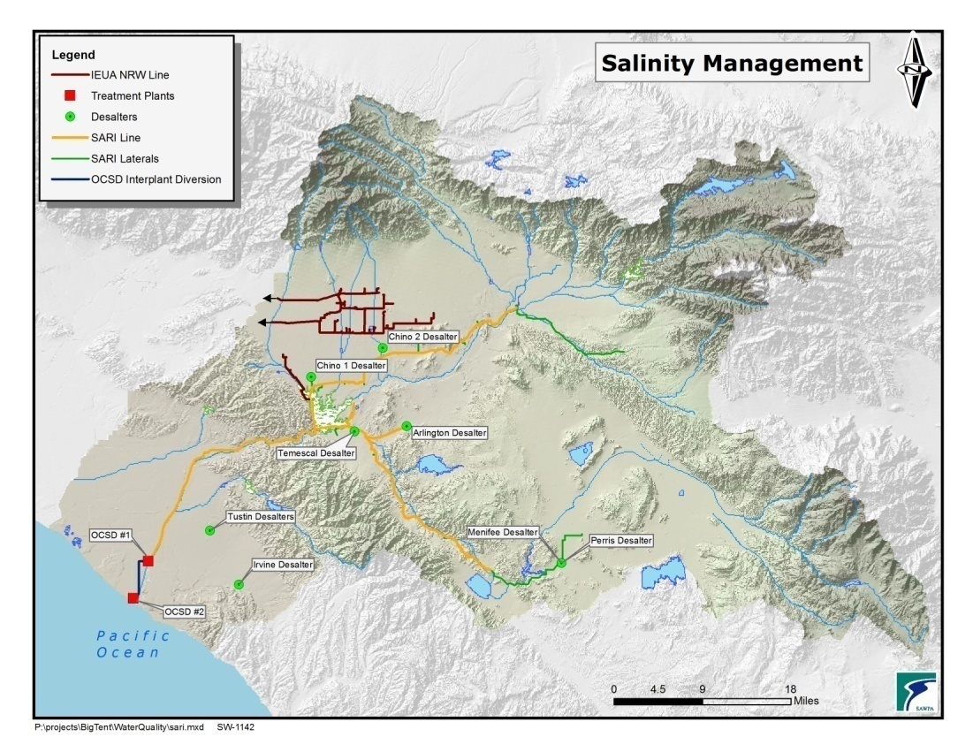
Figure 5.5-15 Santa Ana Region Salinity Management Facilities

In January 2010, SAWPA completed the Phase 1 Salinity Management Plan Technical Memorandum (CDM 2010), which identifies a significant long-term salt imbalance in the Watershed (see Table 5.5-27) , despite progress made over the years through the implementation and operation of the SARI line, groundwater desalters, and other projects and activities with salt reduction as a primary goal. Much of the discussion in this section is taken from this report.
Salinity problems are anticipated to exacerbate if no action is taken, as the import of surface water continues, particularly from the Colorado River Aqueduct which historically has a TDS concentration of 650 mg/L or more; water reuse increases, effectively increasing the salinity of the recycled water supply if demineralization is not provided; and as industrial and commercial growth continues.
In fact, the Salinity Management Plan projects that the seven groundwater management zones in the Watershed modeled will exceed Basin Plan TDS standards in the future, as groundwater extraction and saltier water import continues. Five of the seven management zones have some assimilative capacity that will allow them to meet TDS standards for some years (Beaumont, Bunker Hill-B, Chino-North, Elsinore, and Yucaipa); while the remaining two already are in excess of TDS standards and thus have no assimilative capacity available (Bunker Hill-A and Temescal).
Future salt removal needs in the Watershed will be driven by 4 main regulatory limits:
- TDS objectives in the Basin Plan.
- EPA secondary MCL for TDS in the potable water supply.
- TDS discharge limits in the NPDES permits of POTWs.
- TDS concentrations in recycled water that exceed the Basin Plan water quality objectives, thus preventing its use for irrigation or recharge in zones with no assimilative capacity.

TDS Objectives in Basin Plan: As previously mentioned, two of seven management zones in the Watershed have no assimilative capacity, and are already in excess of Basin Plan TDS criteria. For the remaining five, it is anticipated that desalination or other mitigation will be required if and when TDS concentration is within 10 mg/L of the standard. It is anticipated that this condition would occur by 2028 for Beaumont, 2016 for Yucaipa, and 2023 for Chino-North.
EPA Secondary MCL: The 500 mg/L secondary MCL may be exceeded in the future if mitigation measures are not taken. Potential measures include desalting, blending, importing lower-salinity water, and capturing and recharging more stormwater upstream of supply wells. According to the Salinity Management Plan, at least eight of 59 management zones in the Watershed will exceed potable water TDS standards and will require action.
TDS Discharge from POTWs: Similar to potable water, the Salinity Management Plan estimates likely exceedances of TDS effluent discharge limits by wastewater treatment plants in the Watershed. Plants exceeding NPDES limits, with TDS effluent concentrations in the 490 to 700 mg/L range, will require actions such as desalinating all or a portion of the effluent. According to these estimates, eight out of 12, POTWs in the region will require action at some point over the next 30 years.
TDS concentrations in recycled water: TDS concentration in recycled water is a function of the salinity in the original potable water supply (i.e., imported water and/or groundwater), which drives the salinity of effluent and in any salt reduction actions being taken. As described above, salinity issues are anticipated for groundwater basins, potable water supplies, and eventually wastewater effluent. Desalination of all or a portion of effluent may be required in the future in some areas to allow water recycling.
The Salinity Management Plan describes a number of projects planned or ongoing in the Watershed that will address salinity issues. These projects include:
- Yucaipa Valley Water District wastewater desalting and reuse.
- City of Riverside water supply and wastewater desalination projects.
- Western Municipal Water District and City of Corona water supply projects.
- Eastern Municipal Water District groundwater desalter expansion and wastewater desalting and reuse.
Even with the implementation of these projects, a gap for salt removal remains. The Salinity Management Plan identifies potential long-term options to address the need for additional salt removal, including:
- Best Management Practices (BMPs).
- Desalters for water supply.
- Desalters for wastewater.
- Zero liquid discharge/evaporative ponds.
- LACSD Non-reclaimable wastewater system.
Best management practices: BMP’s include source control measures aimed at reducing salt mass balances that would otherwise be discharged to ground or surface waters, or introduced into the wastewater stream. Examples of BMPs include: eliminating salt-based domestic water softening devices, promoting the use of low-salt detergents, addressing salt runoff, and implementing pre-treatment programs.
Desalters for water supply: As previously mentioned, there are some agencies whose blended water supply could slightly exceed the 500 mg/L secondary MCL. Agencies potentially could add additional source water desalination because it is cost effective or because there are limited alternative supplies.
Desalters for wastewater: Similar to potable water, some agencies potentially will exceed TDS effluent discharge limits. Agencies could reduce TDS in their effluent by implementing additional source control programs; reducing TDS of source water, as mentioned above; or adding desalination to all or a portion of their effluent stream. Providing advanced treatment to secondary effluent would also increase the possibility of reusing the effluent, including indirect potable water reuse via groundwater recharge or surface storage augmentation.
Zero liquid discharge: Some agencies in the Watershed are exploring brine concentration projects to reduce the quantity of flows to the SARI line, while exporting the same amount of salt but at a higher concentration.
LACSD non-reclaimable wastewater system: IEUA owns 60 miles of pipelines used to convey high TDS water to an interceptor owned by LACSD for treatment at Carson Treatment Plant and ocean discharge. Capacity is available (approximately six MGD) for additional brine disposal through this system.
The Salinity Management Plan projects a need for future brine exports in the amount of 35.5 MGD, which is approximately 23% greater than the nominal capacity of the SARI. This is equivalent to nearly 271,000 tons of salt per year. This amount does not include 2.27 MGD of domestic wastewater discharges that could potentially be eliminated from the SARI.
Table 5.5-27 Summary Potential Future Brine Export Needs
Project | Salt load (tons/yr) |  |  | Brine flow (mgd)
 | Current/ near term | Future | Total | Current/ near term | 2010-2015 increase | 2015-2025 increase | Beyond 2025 increase | Total
Water supply desalting | 131,392 | 38,144 | 169,536 | 10.08 | 0.32 | 5.00 | -- | 15.40
Wastewater & recycled water desalting | 8,760 | 69,170 | 77,930 | 1.20 | 0.80 | 11.55 | 0.00 | 13.55
Unspecified desalting ⁽¹⁾ | -- | 24,006 | 24,006 | -- | -- | -- | 3.74 | 3.74
Other
Domestic wastewater | -- | Remove | 0 | 2.27 | 0.00 | Remove (-2.27) | 0.00 | 0.00
Direct industrial connection & waste haulers | -- | -- | 0 | 0.69 | 0.50 | 1.00 | 0.60 | 2.79
Total | 140,152 | 131,320 | 271,472 | 14.24 | 1.62 | 15.28 | 4.34 | 35.48

The Phase 2 SARI Planning Technical Memorandum (CDM, May 10, 2010), complements the Salinity Management Plan as well as identified strategies and their associated cost to address the anticipated deficit in the capacity of the SARI. Six potential reconfigurations of the SARI system were considered:
- Baseline: Continue use of current configuration in which SARI flows to OCSD POTWs prior to ocean discharge.
- Centralized in-line brine minimization: All water flows are diverted from the SARI to a centralized facility with biological treatment and desalination. Concentrate will flow back to SARI, and in turn to OCSD and the ocean.
- Decentralized brine minimization: Groundwater desalters implement further concentrate management via secondary RO process, thus reducing flows to the SARI.
- Direct ocean discharge with brine minimization: Groundwater desalters implement further concentrate management via secondary RO process, and discharge directly to a new parallel pipeline to the ocean. Pretreatment will be required for some discharges to keep BOD concentrations below 30 mg/L.
- Direct ocean discharge without brine minimization: Groundwater desalters discharge brine without further concentration directly to a new parallel pipeline to the ocean. Pretreatment will be required for some discharges to keep BOD concentrations below 30 mg/L.
- Salton Sea discharge: A new 125-mile pipeline from south of Prado Dam to the Salton Sea is built to transport all SARI flows, with no treatment at OCSD.
SAWPA prepared the SARI Market Analysis (EEC August, 2009) to gain an understanding of how the use of the SARI by industry and other brine dischargers could be increased to increase revenue and reduce cost to all users. Several factors impacting the use of the SARI were identified, along with potential solutions. SAWPA believes that a stronger marketing effort is needed to convey to potential users the value they will receive from discharging brine to the SARI when compared to other alternatives, SAWPA estimates that waste disposal to the SARI costs approximately $0.05 per gallon, compared to a cost of $0.20 per gallon of discharging to other alternatives in the Los Angeles basin.

Colorado River Basin Salinity Control Forum
The Colorado River Basin Salinity Control Forum, established by the Colorado River Basin states in 1973, has developed projects to meet agreed-upon numeric criteria along the Lower Colorado River. The Salinity Control Program projects include improving agricultural irrigation practices in the Upper Colorado River Basin and reducing salinity from natural sources. The federal government and Colorado River Basin states contribute approximately $50 million annually for this effort.
Basin Monitoring Program Task Force
On January 22, 2004, the Regional Board approved the Basin Plan Amendment for Nitrogen and TDS. Approximately 20 specific agencies throughout the Watershed were charged with the responsibility to conduct several monitoring and analyses programs for nitrogen and TDS. These requirements included the preparation of an annual water quality report for the SAR and a triennial report to determine the ambient water quality (Nitrogen and TDS) in each groundwater management zone. To cost-effectively prepare these reports, a task force which included the Regional Board, was convened in 2004 with SAWPA as the administrator to conduct the data gathering, consultant support and river analyses programs.

In 2009, the State Water Resources Control Board adopted a “Policy for Water Quality Control for Recycled Water” that required the development of salt and nutrient management plans for all groundwater basins in the State. The basin monitoring program approved by the Santa Ana Regional Board in 2004 satisfies the requirements in the State Recycled Water Policy and as such as been determined to be in conformance with that policy.

Southern California Salinity Coalition
The Southern California Salinity Coalition (SCSC; www.socalsalinity.org) was formed in 2002 to address the critical need to control salinity in water supplies and to protect the water resources in California from increasing salinity. SCSC’s purpose is to coordinate salinity management strategies and programs, including research projects, with water and wastewater agencies throughout southern California. Members of the coalition include major water and sewer districts in San Bernardino, Riverside, Orange, Los Angeles, and San Diego Counties; the National Water Research Institute; and SAWPA. SCSC's objectives are to:
- Establish proactive programs to address the critical need to remove salts from water supplies.
- Preserve, sustain, and enhance the quality of source water supplies.
- Support economic development.
- Help drought-proof the community.
- Reach out to the general public on salinity problems.

Future Issues
Due to increased water usage, irrigation and agricultural use, and other activities, the control of salinity will continue to be a challenge for the region. Inland desalination studies of brackish water must be funded as well as construction of facilities for concentrate disposal and management to help address salinity issues. The use of high quality imported water and region-wide planning to promote BMPs for reducing runoff impacts will continue to be essential. Managing salinity inputs to wastewater collections from water softeners also is an important factor in protecting water quality and maintaining the ability to use recycled water.
Control of salinity will continue to be a challenge. Desalinization studies must be funded and additional facilities for brine disposal are needed. From a salinity standpoint, it is preferable for the Watershed to use SWP supplies compared to CRA supplies. Shortages of SWP supplies due to regulatory issues in the Sacramento-San Joaquin Delta or other factors can significantly impact the TDS concentrations in surface water and groundwater in the Watershed. When SWP supplies are decreased, the percentage of the imported supply that comes from the CRA is increased, resulting in increased salinity in the imported supply. As water is used, discharged, and used again downstream, this increase in salinity affects downstream users in addition to the area that first used the water.

Nutrient Management
Elevated nitrogen and phosphorus concentrations come from municipal and industrial wastewater, septic tanks, animal wastes, and agricultural and lawn fertilizers. Nitrogen-containing and phosphorus-containing compounds act as nutrients in streams and rivers. Nitrate in freshwater can cause oxygen depletion. Desalination facilities or desalters, in operation in Chino, San Jacinto, and Orange County basins reduce nutrient concentrations in groundwater. Brine lines also are being used to export high nutrient water to the OCSD for treatment and disposal to the ocean.
Imported Water Recharge Cooperative Agreement
The Santa Ana Region was the first in the State to develop a comprehensive management plan for nitrogen and total dissolved solids (collectively referred to as “salinity”). The Santa Ana Regional Water Quality Control Board (Regional Board) adopted the Total Dissolved Solids/Nitrogen Management Plan as an amendment to the Santa Ana Region Basin Plan in 2004. The plan was developed in collaboration with stakeholders to address salt management in the watershed.
Concentrations of salinity in some surface water supplies and some groundwater basins are elevated due in part to past agricultural and dairy operations. Besides the historical legacy of salinity contamination, there is an additional salt load to the water basins associated with importing water into the region and recycling and reusing local and imported water supplies. Some of the groundwater basins in the Santa Ana watershed have a higher water quality than imported water. As a result, one of the concerns which emerged from the Regional Board was that by replenishing groundwater with imported supplies basin quality would deteriorate, violating state anti-degradation policies.
The 2004 Basin Plan amendment provided a framework for regulating recycled water discharges to surface water or groundwater in order to meet groundwater salinity objectives and beneficial uses. However; the Basin Plan did not directly address the potential salinity impacts of using imported water for groundwater recharge. The Regional Board and the State Legislature recognized that conjunctive use of imported water was necessary to facilitate the long-term sustainability of water supplies. Therefore, to avoid the necessity of regulating imported water salinity as a waste, the Regional Board worked with water supply agencies to develop a cooperative means of achieving compliance with salinity objectives without issuing waste discharge requirements.
In January of 2008, the Regional Board and water supply entities in the Santa Ana Region signed a “Cooperative Agreement to Protect Water Quality and Encourage the Conjunctive Uses of Imported Water in the Santa Ana River Basin.” It states that:

"The Parties that intentionally recharge imported water within the Santa Ana Region (the "Recharging Parties") agree voluntarily to collect, compile and analyze the N/TDS water quality data necessary to determine whether the intentional recharge of imported water in the Region may have a significant adverse impact on compliance with the Salinity Objectives with the Region.”

The Cooperative Agreement was signed by the Regional Board and eight agencies in the watershed that import water to the region, import or export water between basins in the region, recharge groundwater basins with imported water, or treat or recharge wastewater in the region that includes imported water. The Cooperative Agreement directs the eight water agencies to prepare a summary of the amount of imported water recharged in each groundwater management zone, analyze the impact of such recharge on salinity levels in those zones, and compare projected water quality to historical ambient water quality. Specifically the agencies agreed to:
- Prepare a report every three years documenting the amount and quality of imported water recharged in each groundwater management zone during the previous three-year period; and
- Prepare a report every six years that projects ambient water quality in each groundwater management zone for the subsequent 20 years based on modeling that accounts for salt inputs from surface waters and reflects the effects of all existing and reasonably foreseeable recharge projects.
Each of the agencies importing water for groundwater recharge has completed these requirements. The first round of monitoring and modeling indicates that water quality impacts are minimal. The second round of the six-year reports is now in progress and will be completed by year 2015. Staffs from the agencies continue to meet regularly to discuss modeling approaches and coordinate the modeling efforts.
TDS and Nitrate Management in the Chino Basin
For many years, the Chino Basin was home to one of the highest concentrations of dairies in the world. Waste discharges from years of dairy operations, as well as discharges from other commercial operations, left the southern portion of Chino Basin with a serious salt-imbalance. While the water quality in the northern portion of the basin remained high, increasing TDS and nitrate levels degraded groundwater in the south, threatening the quality of Chino Basin’s groundwater supplies and SAR water that was flowing into Orange County’s groundwater recharge basins.
The Regional Board addressed the impacts of salt loads from dairy operations by adopting waste discharges requirements, which included the requirements for dairies to adopt engineered waste management programs and manure control programs. The Chino Basin Desalter Authority, composed of IEUA and other local agencies, operates two desalters to pump out and remove contaminants in the groundwater. OCWD operates wetlands in the Prado Basin to naturally filter out nitrates. In addition, economic changes have led to a decline in number of dairies located in the Chino Basin.
These efforts have begun to reduce levels of TDS and nitrate in the basin. Plans are underway by IEUA and the CBWM as part of their maximum benefit agreement with the Regional Board for construction of an additional desalter and to expand other programs to improve groundwater quality in this area.

Ocean Water
This section focuses on issues related to ocean water quality. The primary emphasis with ocean water is maintaining water quality in order to protect marine resources and public health. Furthermore, the quality of ocean water may become a concern for drinking water if seawater desalination facilities are built to create new water supplies.

Current Condition
Ocean water quality is evaluated using a number of different parameters and constituents related to beneficial uses. In the Basin Plan, one of the key beneficial uses is full body contact recreation, known as REC-1.
The California Health and Safety Code requires ocean waters adjacent to public beaches be tested for indicator bacteria to ensure public safety. This program, created by AB 411, establishes uniform and consistent water quality monitoring, response, and public notification requirements for the entire California coastline. The water quality standards established by AB 411 have been incorporated into the State Water Board’s California Ocean Plan and by reference into the Basin Plan. In addition to recreation, the ocean waters also support important habitat areas, including two ASBS and their related onshore Critical Coastal Areas (CCAs).

Compliance with California Health and Safety Code Standards
The County of Orange Health Care Agency implements AB 411 for Orange County’s beaches, harbors, and bays shown in Figure 5.5-4.
Regulatory compliance is determined from the percentage the time standards were met. Beach Mile Days (BMDs) are calculated from the number of days and the linear area of ocean or bay front that is in violation of the AB 411 standards. BMD represents the loss of beneficial use of ocean recreational waters. Table 5.5-28lists total number of BMDs posted for beaches due to violation of AB411 standards. Orange County beaches on the CWA 303 (d) list are shown in Table 5.5-29.
 | Seal/Surfside/Sunset | Bolsa Chica | Huntington City | Huntington State | Newport Beach | Crystal Cove
2000 | 3.7 | 5.4 | 10.1 | 67.6 | 2.2 | 1.3
2001 | 0.4 | 0.1 | 1.4 | 14.8 | 0.7 | 0.3
2002 | 1.2 | 0.9 | 1.2 | 23.8 | 1.2 | 0.1
2003 | 0.3 | 0.8 | 0.8 | 41.9 | 1.4 | 0.2
2004 | 2.4 | 0.1 | 0.5 | 10.6 | 1.2 | 0.1
2005 | 0.1 | 0.4 | 0.4 | 12.1 | 6.0 | 0.0
2006 | 0.6 | 0.7 | 0.9 | 21.9 | 1.9 | 0.4
2007 | 0.5 | 0.6 | 1.4 | 61.0 | 0.6 | 0.1
2008 | 1.3 | 0.2 | 0.7 | 26.2 | 0.6 | 0.4
2009 | 0.5 | 0.1 | 0.5 | 11.0 | 0.6 | 0.0
2010 | 0.3 | 0.1 | 0.2 | 8.1 | 0.7 | 0.2
2011 | 0.3 | 0.1 | 2.4 | 2.2 | 0.0 | 0.1

Table 5.5-28 Total Number of Beach Mile Days Posted for Open Coastal Ocean Water Areas Due to Violation of AB411

Table 5.5-29 2010 CWA 303(d) List of Water Quality Limited Segments Requiring TMDLs
Name | Pollutant/Stressor | Potential Sources | Proposed TMDL Completion
Balboa Beach | DDT, Dieldrin, PCBs | Source unknown | 2019
Bolsa Chica State Beach | Copper, nickel | Source unknown | 2019
Huntington Beach State Park | PCBs | Source unknown | 2019
Seal Beach | Enterococcus, PCBs | Source unknown | 2019

Newport Beach Marine Life Refuge (CCA No. 70/ASBS No. 32)
The Newport Beach Marine Life Refuge is bounded to the west by a line heading oceanward 1,000 feet along Poppy Avenue in Corona Del Mar and to the east by a line heading oceanward 1,000 feet along the westerly limits of Crystal Cove State Park. It extends from the mean high tide line to 1,000 feet offshore or 100 feet of ocean depth, whichever is nearer. This ASBS is so designated to protect dolphin breeding areas and other marine species. Water quality is impacted by the following:
- Stormwater and dry weather runoff from Buck Gully, its major tributary and from over two dozen direct discharge pipes from residential neighborhoods along the coastal edge of the ASBS.
- Sediment transported from Buck Gully and coastal bluffs.
- Beachgoer scavenging and trampling, despite educational efforts to discourage taking of tide pool species.

Irvine Coast Marine Life Refuge (CCA No. 71/ASBS No. 33)
The Irvine Coast Marine Life Refuge is bounded by the Newport Beach Marine Life Refuge to the west and to the east by a line heading oceanward 1,000 feet along the Irvine Cove cliffs at the edge of Laguna Beach. It extends from the mean high tide line to 1,000 feet offshore or 100 feet of ocean depth, whichever is nearer. Like its immediate neighbor, this ASBS is designated to protect dolphin breeding areas and other waterborne species. It is impacted by the following:
- Stormwater and dry weather runoff from the Pelican Hill/Point area and from Los Trancos Canyon and Muddy Creek.
- Stormwater and dry weather runoff from direct discharge facilities draining through Crystal Cove State Park, Pacific Coast Highway, and Pelican Point.
- Beachgoer scavenging despite educational efforts to discourage taking of tide pool species.
- Sediment transported from Los Trancos Canyon, Muddy Creek, and coastal bluffs.
- Pollutants from upcoast and downcoast discharges.

Algae water quality issues
Algae are found universally in all aquatic environments. Under certain conditions, harmful algae blooms can occur. Some species of algae are capable of producing potent biotoxins. The California Health and Safety Code prohibits the consumption of sport-harvested sea mussels every year from May 1 to October 31 because of risk of Paralytic Shellfish Poisoning (PSP). PSP toxins concentrate in the tissue of filter feeders like mussels. The toxin is harmless to the shellfish but extremely toxic to people and animals when consumed.
In early April 2007, a large harmful algae bloom (HAB) of Pseudo-nitzschiaoccurred in coastal waters from Santa Barbara County to Orange County. This was one of the largest outbreaks in recent history resulting in the deaths of many sea birds and marine mammals and an early quarantine on mussel consumption.
The cause of these blooms is not clearly understood. Oceanographic currents, wind, nutrient levels, sunlight, temperature and global sea temperature oscillations like El Nino are thought to be factors.
Recently the association between bloom initiation and nutrient associated rainfall runoff and anthropogenic sources has been raised. Research is ongoing into this complex issue.

Current Management Strategies for Ocean Water
The major goal for ocean water quality improvement is to achieve water quality standards, which includes meeting beneficial uses and WQOs, preventing anti-degradation and meeting California’s Ocean Plan and AB 411 standards. Goals, management strategies, and tactics are summarized in Table 5.5-30.
Southern California Coastal Water Research Project (SCCWRP)
SCCWRP was formed in 1969 as a JPA to conduct research about the effects of wastewater and other discharges to the Southern California coastal marine environment. Its mission is to contribute to the scientific understanding of linkages among human activities, natural events, and the health of the Southern California coastal environment; communicate this understanding to decision makers and other stakeholders; and recommend strategies for protecting the coastal environment for this and future generations.
SCCWRP’s 14 member agencies include representatives of city, county, state, and federal government agencies responsible for monitoring and protecting the marine environment. SCCWRP brings together a multidisciplinary team of scientists to address complex environmental problems; recommend protection strategies; and foster communication and cooperation between scientists, the regulated community, and regulators.
SCCWRP is a recognized leader in environmental research. Accomplishments include developing new environmental monitoring methods and defining the mechanisms by which biota are potentially affected by anthropogenic stressors. SCCWRP has participated in some of the most significant scientific discoveries, methodology developments, and environmental policy decisions of the past forty years.
In the 2013-2014 Research Plan, SCCWRP scientists address topics such as ocean acidification and hypoxia, beach bacteria, nutrients and eutrophication, freshwater and marine bioassessment, emerging contaminants, molecular method development, and regional monitoring, as well as environmental data acquisition, sharing, processing, and visualization technology.
Additional information may be found at www.sccwrp.org
Table 5.5-30 Ocean Water Quality (including Bays, Estuaries, and Tidal Prisms) Goals, Strategies, and Tactics
Goals | Strategies | Tactics
Water Quality Standards attained (includes Ocean Plan and AB 411 standards) | - Protect good quality ocean water  - Clean up poor quality ocean water | - Monitoring  - Source water protection  - POTWs implement source control & treatment  - Urban runoff managed through NPDES/DAMP  - NPDES permits for other dischargers  - Implement State Non-Point Source (NPS) Plan  - TMDLs  - Constructed wetlands  - Localized urban runoff treatment systems  - Surface water diversions to POTWs or other treatment systems  - Research  - Public outreach

The Newport Coast Watershed Management Program works on water quality issues from Buck Gully in Corona del Mar to El Morro Canyon. These concerns include canyon stability, impacts to sensitive marine life areas, water quality impacts due to dry-weather nuisance flows, and invasive plants. This watershed program, organized by the City of Newport Beach, coordinates efforts between City staff, community members, property owners, jurisdictional agencies, Orange County Coastkeeper and other interested parties.
Orange County Coastkeeper
The Orange County Coastkeeper, founded in 1999, is a non-profit organization dedicated to the protection and preservation of the marine habitats and watersheds of Orange County through programs of education, restoration, enforcement and advocacy. Members work with businesses, developers, cities, elected officials and regulatory agencies to develop solutions to the problems of polluted urban runoff. The long-term goal is to protect and preserve all of Orange County's water bodies and restore them to healthy, fully functioning systems that will protect recreational uses and aquatic life.

Seawater Desalination
In previous integrated water resource planning, potable water arising from seawater desalination had not appeared to be a viable or economic water supply alternative for the foreseeable future for Southern California. However, on Nov. 29, 2012 this scenario changed with the approval by the San Diego County Water Authority of a 30 year water purchase agreement with Poseidon Resources for the purchase of up to 56,000 acre-feet of desalinated seawater per year from a new Carlsbad Desalination Project projected to begin construction in early 2013. The seawater desalination facility takes advantage of an existing seawater intake operated by the Encina Power Station in Carlsbad. This unique operations and management agreement will result in a purchase price by the Authority of desalted seawater at $1897-$2097 per acre-foot in 2012 dollars. The Authority estimates that water produced by the project will account for about one-third of all locally generated water in San Diego County by the Year 2020.
Though the Carlsbad seawater desalination project is outside the Santa Ana River Watershed, planning efforts are underway for a similar type of project to be located at the Huntington Beach. In Feb. 2012 the Santa Ana Regional Board approved a permit for a large-scale desalination plant at Huntington Beach that would turn ocean water into drinking water. Similar to the Carlsbad plant, Poseidon Resources, a private investment firm that specializes in seawater desalination, will develop and manage the proposed Huntington seawater facility on a 12-acre site next to a coastal power plant. According to the company, it would be the largest such facility in the Western Hemisphere and supply 50 million gallons of drinking water a day -- enough to supply 300,000 people.
While local water agencies, lawmakers and the business community generally support building the plant, water quality concerns remain regarding the ocean water intake system that could impact or kill fish, plankton larvae and other sea creatures, discharge extra salty water known as “brine” and release water tainted with iron and cleaning fluids.
A state policy adopted in 2010 will phase out the use of seawater to cool coastal power plants, a process that may harm fish, larvae, eggs, seals, sea lions, turtles and other creatures when they get trapped against screens or sucked into the plant and exposed to heated water.
The new policy by the State Water Board would end seawater cooling by ocean beach power plants similar to the Huntington Beach plant as early as 2020. The Huntington Beach project, which has been in the works for more than 12 years, still needs approval from the state Coastal Commission to move forward. State water regulators are collecting scientific and technical data in order to draft new policies on seawater intake that will be specific to desalination plants that could be adopted in the next year. Environmental groups said they would appeal the decision to the State Water Board. The earliest the Huntington Beach plant could start operating is 2016.

CHALLENGE: Identification and Solutions
Table 5.5-31identifies current challenges for water quality management. The challenges were identified by members of the Water Quality Improvement Pillar. Because of the broad scope of issues, the diversity of challenges is significant. A range of potential solutions for each challenge are identified and categorized by the type of water body affected and the nature of the challenge (institutional/political, financial, regulatory, or insufficient data). Each item listed in the table is discussed in more detail below.
Table 5.5-31 Water Management Challenges
OWOW 1.0 Challenge | OWOW 1.0 Recommendations | Status of Addressing Challenge | OWOW 2.0 Suggested Implementation Activities
Regional Board’s resources insufficient for Basin Planning; priorities in most recent Triennial Review conducted in 2006 have yet to be completed | - Secure additional resources for Basin Planning | - No new funding for Basin Planning  - 2006 Triennial Review issues still incomplete  - Revisions needed for Lake Elsinore/Canyon Lake TMDL not being addressed | - Work with Regional Board staff to develop potential options to address funding challenges  - Evaluate potential for watershed stakeholder resources to be utilized to supplement work of Regional Board staff  - Identify top Basin Plan priorities in need of review  - Develop funding mechanism for Regional Board to develop revisions to the Lake Elsinore/Canyon Lake TMDL
Lack of prioritization in addressing water quality problems and limited resources make it difficult to solve the most pressing water quality issues in the watershed | - Create process to determine water quality problems presenting greatest human health and environmental risk  - Allocate funding and staff resources to identified priorities | - Stormwater Quality Standards Task Force (SWQSTF) developed proposed Basin Plan amendments addressing water quality impacts related to recreational water use and providing method for prioritizing regulatory efforts. Basin Plan amendment pending approval. | - Support adoption of SWQSTF proposed Basin Plan amendments  - Encourage development of additional programs that prioritize water quality improvements.  - Identify top Basin Plan priorities in need of review
Solving water quality challenges by developing multi-agency, multi-benefit projects has advantages but this is difficult to achieve as agencies have traditionally worked independently at the local level | - Increase regional dialogue  - Foster pooling of resources and cost sharing  - ID areas where regional efforts likely to have greatest impact & chance of success; target those areas for regional projects | - State grant programs have facilitated development of multi-agency, multi-benefit projects and have provided funding for such projects. | - Continue working toward development of regional solutions for water quality problems.

OWOW 1.0 Challenge | OWOW 1.0 Recommendations | Status of Addressing Challenge | OWOW 2.0 Suggested Implementation Activities
Regulatory barriers make it difficult to develop regional BMPs to manage municipal stormwater discharges | - Work to overcome regulatory barriers | - Stakeholders continue to discuss methods/options to addressing regulatory barriers. | - Regulators and stakeholders should address regulatory barriers in next phase of MS4 permits scheduled for adoption in 2014.  - Permits should allow for regional BMPs as co-equal to infiltration, harvest & reuse, and biotreatment BMPs.  - Assign watershed stakeholder task force to develop these options.
Fecal bacterial contamination in stormwater remains a problem | - Conduct research  - Assess health impacts from human vs. nonhuman sources & relationship between fecal indicators and health risks  - Develop sanitary survey criteria to assess urban and non-urban environments | - Middle Santa Ana River (MSAR) TMDL Task Force completed development and implementation of Comprehensive Bacteria Reduction Plans for Counties of Riverside and San Bernardino. | - Continue work of the MSAR TMDL Task Force
Floatable debris in stormwater hard to control | - Financial incentives to develop outreach & source control programs  - Develop & implement trash and litter control municipal ordinances  - Coordinate with the State Board’s Marine Debris Steering Committee | - Control of floatable debris continues to be a problem in the watershed. | - Continue efforts to address floatable debris and trash in stormwater  - Apportion funding from future stormwater funding and grant programs.

OWOW 1.0 Challenge | OWOW 1.0 Recommendations | Status of Addressing Challenge | OWOW 2.0 Suggested Implementation Activities
Problems with septic system impacts to groundwater difficult & expensive to solve | - ID lead agency for expanding sewers to areas outside local agency jurisdictions  - Extend sewers to areas without them  - Amend laws to simplify annexations of areas without sewer providers  - Provide source protection to reduce emerging contaminants  - Increase minimum lot size for septic systems | - Eastern Municipal Water District extended sewer system to community of Enchanted Heights; service extension to Quail Valley in progress.  - Diamond Park Mutual Water Company customers in Santa Ana connected to municipal supply  - Review of water quality data from small system water providers in Orange County completed  - Municipal stormwater permits required permittees to develop septic system inventories by 2012 | - As first step to working on remediating water quality problems from septic systems, produce an inventory map locating areas within the watershed that remain on septic systems  - Work to develop plan to extend sewer systems to these areas
WUE & conservation increases pollutant concentrations in influent water to wastewater treatment plants challenging discharge permit compliance, i.e. TDS limits | - Promote use of containers for food waste, pharmaceuticals, & household chemicals disposal  - Promote use of detergents & products with low salt levels  - Include higher loading levels in new treatment plant design & during CEQA & permit processes for new reclamation projects |  | - New section added to OWOW 2.0 discussing challenge of influent water quality.  - Promote source control efforts throughout watershed.

OWOW 1.0 Challenge | OWOW 1.0 Recommendations | Status of Addressing Challenge | OWOW 2.0 Suggested Implementation Activities
Salt balance not achieved in watershed | - Regional efforts for reducing salt impacts in runoff  - Establish mitigation plans for recycled water projects  - Ensure long-term viability of existing brine lines  - Expand existing brine lines  - Financial incentives for desalination studies & facilities  - Encourage regulators to recognize exporting certain brines & constituents as regulatory relief/offsets for wastewater permitting requirements  - Support elimination of water softeners  - Address long-term need for increased brine disposal capacity | - IEUA’s water softener program has removed over 600 salt-based softeners in the Chino Basin since 2008  - Water softener ordinances preventing the future installation of salt-based softeners have been passed in the cities of Montclair, Upland, and Fontana  - Throughout the Inland Empire, public agencies have joined the “No Drugs Down the Drain” program, installing drop off boxes in public locations and participating in the National Drug Take-Back Day  - Mitigation plans are required by Regional Board for recycled water projects where appropriate  - Mitigation plans approved for recycled water use by IEUA and EMWD  - SAWPA working on plans to ensure viability of and expansion of Inland Empire Brine Line | - Work toward adoption of the Delta Plan in order to promote reliability of low-TDS imported water supplies for use in the watershed.  - Consider brine concentration alternatives to reduce discharges to brine line and/or zero discharge projects.  - Increase outreach, promotion, and awareness of National Drug Take-Back Day and “No Drugs Down the Drain” programs by posting prominently on websites, etc.  - Implement salt and nutrient management plans consistent with the statewide Recycled Water Policy  - Identify regional strategies to support salinity control for imported water sources

OWOW 1.0 Challenge | OWOW 1.0 Recommendations | Status of Addressing Challenge | OWOW 2.0 Suggested Implementation Activities
Public agencies must comply with new regulations without ability to increase revenues | - Federal & state funds for infrastructure banks  - Amend Proposition 218  - Prepare strategies to address legal decisions adverse to public agencies setting/increasing fees for improvements  - Increase effectiveness of new regulations by encouraging ID of goals & implementation plans for those regulations  - Build public support for funds to address challenging water supply needs | - Public agencies continue to struggle to keep up with rising costs. | - Work toward implementation of recommendations from OWOW 1.0
Emerging constituents detected at low levels without understanding of human health and toxicological effects  Standard lab methods not available for emerging contaminants | - Outreach to agencies & Regional Board on status of studies & research  - Evaluate joint opportunities to conduct studies  - Encourage development of human health & ecological risk levels for specific compounds  - Develop list of appropriate surrogates & indicators of water quality for monitoring constituents  - Develop monitoring plan for water bodies & facilities and test for appropriate set of constituents  - Support creation of Blue Ribbon Commission to recommend monitoring of emerging contaminants in recycled water  - Collaborate on public information outreach  - Create collaborative efforts to develop new analytical methods  - Regulators & dischargers coordinate with CDPH to ensure analytical methods developed & approved  - Promote collection facilities and programs for unused pharmaceuticals and distribute smaller amounts to patients when possible | - State Blue Ribbon Commission completed report on monitoring of emerging constituents.  - Emerging Constituents (EC) Program Task Force completed two years of monitoring in watershed.  - EC Task Force created a Water Quality Program Public Relations Work Group to collaborate on outreach.  - Standard methodology is under development. | - Continue to support work of the Emerging Constituents Work Group.  - Work with CA Office of Environmental Health Hazard Assessment and CA Department of Public Health on development of Public Health Goals and water quality standards

OWOW 1.0 Challenge | OWOW 1.0 Recommendations | Status of Addressing Challenge | OWOW 2.0 Suggested Implementation Activities
Land for new water treatment facilities in urban areas difficult to obtain | - Financial incentives for property owners to make land available for cleanup facilities | - Land availability continues to be a challenge | - Continue working to implement recommendations from OWOW 1.0
Finding parties responsible for groundwater contamination is difficult.  Typical response to well contamination is to shut down well but pump & treat may be most effective means to cleanup | - Work with State & Federal agencies to obtain grants, including U.S. Dept. of Agriculture for perchlorate cleanup  - Set up an orphan share fund  - Develop incentives for groundwater producers to treat for wells producing contaminated water  - Change existing local rules & regulations that act as barriers to cleaning up water contamination | - Groundwater contamination clean-up efforts continue to be slowed  - In some cases potentially responsible parties are using CEQA or other means to delay clean-up | - Support efforts of water districts and other agencies to investigate parties responsible for groundwater contamination and collect funds from those parties to clean up contamination  - Evaluate methods to streamline groundwater cleanup projects  - Explore arrangements where multiple public agencies with grant funding form an MOU with non-public PRPs to share cost and provide regional water supply solutions
Local agencies limited in amount of fines & penalties able to assess & have limited regulatory jurisdiction over some agencies, i.e. school districts | - Consolidate enforcement authority to the regulating agency  - Expand local agencies’ enforcement authority.  - Develop panel to discuss current regulatory environment, interagency impacts, & impacts to business & residents such as groundwater discharge permitting requirements. | - Limitations on local agencies remain a problem. | - Continue to work on providing local agencies authority to properly enforce regulations protecting water quality.  - Utilize part of future stormwater funding to pay for cost of enforcement.

OWOW 1.0 Challenge | OWOW 1.0 Recommendations | Status of Addressing Challenge | OWOW 2.0 Suggested Implementation Activities
Solving 1 problem may cause new one, i.e. infiltrating runoff improves surface water but may cause ground-water problem | - Increase communication, planning & cooperation among stakeholders  - Collect data on infiltration BMPs at selected sites to evaluate potential impacts to groundwater quality | - Riverside County Flood Control and Water Conservation District’s (RCFCWCD) LID Testing and Demonstration Facility will collect water quality data on LID BMP performance  - County of Orange is implementing Glassell Yard Campus Stormwater LID Retrofit Project  - Business Industries of America completed study evaluating cost effectiveness of variety of LID BMPs | - Continue evaluation of LID BMPs to document long-term performance and water quality benefits.  - Promote and increase the profile of BMP examples within communities (e.g. RCFCWCD campus)
Changing public behavior is difficult | - Develop, pilot, & evaluate effectiveness of strategies to change public behavior.  - Foster watershed sustainability by encouraging behavior aimed at reducing runoff & preventing pollution  - Increase public perception of value of water. | - No Drugs Down the Drain website – http://www.nodrugsdownthedrain.org | - Continue efforts to educate public on water quality issues in the watershed.  - Expand efforts to change public behavior.
Planning for complex growth impacts difficult in rapidly urbanizing areas. Potential water quality impacts hard to ID. | - Educate local officials so water quality concerns become core issues.  - Conduct studies to identify water quality challenges in rapidly developing areas. | - Approaches used in Stormwater MS4 permits continue to be evaluated  - Managing growth impacts continues to be difficult | - Implement recommendations from OWOW 1.0  - Work with Regional Board in development of next Stormwater MS4 permit

OWOW 1.0 Challenge | OWOW 1.0 Recommendations | Status of Addressing Challenge | OWOW 2.0 Suggested Implementation Activities
Urbanization and concrete-channelization have seriously reduced groundwater recharge leading to water quality impairments and reduced water supplies | - Promote Low Impact Development principles  - Recognize in regulatory & funding frameworks that using design & retrofit technology to minimize runoff & increase infiltration is beneficial for water quality & TMDL goals. | - Chino Basin stakeholders preparing the Recharge Master Plan Update for the basin to monitor MS4 compliance and quantify benefits to basin. | - Continue to work toward recognition in regulatory and funding frameworks that using design and retrofit technology to minimize runoff and increase infiltration is beneficial for water quality and TMDL goals.

Challenges  OWOW 2.0 Recommendations | Recommendations
Fracking for oil or gas development, if conducted within the watershed, could cause groundwater contamination | - Support development of statewide regulations that protect water quality
New statewide regulations setting biological objectives for surface water are being developed and will be compliance challenge for wastewater agencies | - Participate in rule making process to support development of policies and regulations that are effective and efficient and do not place an undue burden on dischargers
New statewide regulations setting nutrient objectives for surface water are being developed that will be compliance challenge for wastewater agencies | - Participate in rule making process to support development of policies and regulations that are effective and efficient and do not place an undue burden on dischargers
Surface water quality monitoring is not coordinated within the watershed leading to duplicative sampling in some areas and inadequate sampling in others. In some cases this may lead to 303(d) listings that do not reflect real impairments. | - Assess surface water quality monitoring in watershed. Work on plan to improve coordination and development of regional approach to monitoring.  - Use monitoring developed by MSAR Watershed Pathogen TMDL Task Force, SWQSTF, SCCWRP’s Regional Bioassessment program, and SWAMP as models.
A small number of small water systems may be in operation within the watershed that do not have resources for monitoring and proper operations and maintenance, which may result in drinking water provided to customers that are in violation of drinking water standards. (25 people or more, or 15 or more connections is a public water system in CA; State Small Water Systems are at least 5 connections but less than 15 and are regulated by county health departments) | - Work with CDPH and county health departments to identify small system water providers, if any, which need assistance with providing safe drinking water. Develop plan to address any small system water providers that need assistance.
Sediment deposition in some areas creates water quality impairments, reduces aquatic habitat, and reduces water conservation storage. Reduced sediment flow downstream of dams causes armoring of river/creek beds resulting in reduction in percolation capacity, aquatic habitat, and beach replenishment. | - Support USACE/OCWD Prado Basin Sediment Management Demonstration Project  - Support efforts of Newport Bay Stakeholders to reduce sediment load into Upper Newport Bay

Description of Data Collection Process
Greg Woodside of the Orange County Water District and Mark Adelson of the Santa Ana Regional Water Quality Control Board co- chaired the Beneficial Use Protection Pillar Committee and coordinated the preparation of this report. Committee members, listed below, provided direction and assisted in collecting the information contained in this report and reviewed and commented on draft versions. The committee met in person and also held conference calls on a number of occasions.

References
California Environmental Protection Agency, State Water Resources Control Board, Division of Water Quality, Oceans Standards Unit, California Ocean Plan, Triennial Review and Workplan, 2005-2008, November 16, 2005
California Regional Water Quality Control Board, Santa Ana Region. Water Quality Control Plan for Santa Ana River Basin.1995 (as amended).
California State Water Resources Control Board, 2010 Integrated Report (Clean Water Act Section 303(d) List / 305(b) Report, http://www.swrcb.ca.gov/water_issues/programs/tmdl/integrated2010.shtml
CH2M Hill. 2006. Chino Creek Integrated Plan. Prepared for the Inland Empire Utility Agency/Orange County Water District. September 2006.
Chino Basin Watermaster. Chino Basin Optimum Basin Management Program, State of the Basin Report 2006, July 2007. (Downloaded from www.cbwm.org)
County of Orange. Central Orange County Integrated Regional and Coastal Watershed Management Plan. August 2007.
----- North Orange County Watershed Management Area Integrated Regional Water Management Plan (IRWMP). Draft Report 2008.
----- Coyote Creek Watershed Management Plan. 2007
County of Orange Health Care Agency-Environmental Health. Annual Ocean and Bay Water Quality Report. 2006
Eastern Municipal Water District. West San Jacinto Groundwater Management Plan. 1995.
----- West San Jacinto Groundwater Basin Management Plan.2006 Annual Report.
Newport Coast Flow and Water Quality Assessment, Final Report. City of Newport Beach. January 2007.
Orange County Coastkeeper.www.coastkeeper.org
Orange County Water District. Groundwater Management Plan. 2009 Update.
----- Unpublished data, 2007.
Riverside County Board of Supervisors. No date. Ordinance No. 427.3: An Ordinance of the
County of Riverside Amending Ordinance No. 427.2 Regulating the Land Application of Manure http://www.boardofsupervisors.co.riverside.ca.us/ords/400/427.htm

San Timoteo Watershed Management Authority. 2005. Integrated Regional Watershed Management Plan for the San Timoteo Watershed, Final Draft Report. June 2005.
Santa Ana Regional Water Quality Control Board (8).Watershed Management Initiative Chapter. Revised November 2004
----- Total Maximum Daily Load (TMDL) Program. www.waterboards.ca.gov/santaana/html/tmdls.html.
Santa Ana RWQCB. 2007. General Waste Discharge Requirements for Concentrated Animal
Feeding Operations (Dairies and Related Facilities) within the Santa Ana Region. Adopted September 7, 2007 http://www.swrcb.ca.gov/rwqcb8/board_decisions/adopted_orders/orders/2007/07_001_gen_wdr_cafo_09072007.pdf

Santa Ana Watershed Project Authority.2005 Regional Groundwater Management Plan. May 2005.
----- Santa Ana Integrated Watershed Plan 2005 Update: An Integrated Regional Water Management Plan. June 2005.
San Bernardino Valley Municipal Water District. 2005. Integrated Regional Groundwater Management Plan.
----- 2007. Upper Santa Ana River Watershed Regional Water Management Plan. November 2007.
San Jacinto River Watershed Council. Integrated Regional Watershed Management Plan for the San Jacinto Watershed. December 31, 2007.
Tetra Tech, Inc, .San Jacinto Basin Resource Conservation District. Analysis and Development
of a Manure Manifest System for the San Jacinto River Watershed. Golden, CO: , 2008. Print.

Tetra Tech, Inc, .San Jacinto Basin Resource Conservation District. San Jacinto Watershed
Integrated Regional Dairy Management Plan. Golden, CO: , 2009. Print.

Todd Engineers. 2008. AB 3030, Groundwater Management Plan. Prepared for the City of Corona Department of Water and Power. June 2008.
U.S. Environmental Protection Agency, Region 9. Total Maximum Daily Loads for Toxic Pollutants, San Diego Creek and Newport Bay, California. June 2002.
Western Municipal Water District, Integrated Regional Water Management Plan Report, October 2006.
Wildermuth Environmental, Inc. 2000.TIN/TDS Phase 2A: Tasks 1 through 5. TIN/TDS Study of the Santa Ana Watershed. Technical Memorandum. July 2000.
----- 2008. Recomputation of Ambient Water Quality in the Santa Ana Watershed for the Period 1987 to 2006, Final Technical Memorandum. Prepared for the Basin Monitoring Task Force. August 2008.
List of Contributors
Contributors to the OWOW 2.0 Beneficial Use Protection Chapter include:
Mark Adelson, Santa Ana Regional Water Quality Control Board
Pat Boldt,
Art Diaz, Riverside County Flood Control and Water Conservation District
Rebecca Franklin, City of San Bernardino Water Department
Michael Gold, Orange County Sanitation District
LeAnne Hamilton, Inland Empire Utilities Agency
Elizabeth Hurst, Inland Empire Utilities Agency
Al Javiar, Eastern Municipal Water District
Jayne Joy, Eastern Municipal Water District
Jerry A. King, J.A. King and Associates
Joe LeClaire, Wildermuth Environmental Inc.
Maria Lopez, Metropolitan Water District of Southern California
Mark Matsumoto, University of California: Riverside
Larry McKenney, SAWPA
Beatrice Musacchia, OC Watersheds
Mark Norton, SAWPA
Lee Reeder, Santa Ana Watershed Association
Lisa Rothbart, Orange County Sanitation District
Jennifer Shepardson, City of San Bernardino Water Department
Marsha Westropp, Orange County Water District
Rick Whetsel, SAWPA
Greg Woodside, Orange County Water District
Matt Yeager, Yeager Environmental Associates

MS4 permits: Municipal Separate Storm and Sewer System permits issued by Regional Water Quality Control Boards to municipalities. The permits regulate the discharge of stormwater into county and municipal storm drains and other surface waters.

