Chapter 3: Numeric Targets
Note to Reader: In preparation of this chapter, our team has noted a problem in the order of chapters. Typically, numeric targets are chapter 3 in TMDL reports, but with the approach used for the Canyon Lake and Lake Elsinore TMDL revision, the numeric targets rely heavily on the findings from the source assessment and linkage analysis. Connections to these other chapters are included herein, but we may consider a revised order of chapters in development of complete TMDL report.
Lake Elsinore and Canyon Lake are impaired for the warm freshwater aquatic habitat (WARM) and water contact and non-water contact recreation (REC1 and REC2) beneficial uses. A TMDL establishes numeric targets to provide a basis for demonstrating attainment of water quality objectives (WQOs) and protection of impaired beneficial uses. That is, achievement of the numeric target(s) is expected to result in the waterbody of concern no longer being impaired. Where the water quality objective(s) are narrative, the TMDL translate narrative water quality objective into appropriate response targets to assure attainment of the objective. This chapter establishes the numeric targets for the revised TMDLs and provides the technical basis for the selection of these targets.
Table 2-3 in the 2004 TMDL presents the numeric targets for Canyon Lake and Lake Elsinore for interim (2015) and final (2020) compliance timelines. The Staff Report for the TMDL describes the scientific basis used to determine these targets. This TMDL revision uses additional scientific understanding from research performed after the existing TMDL was adopted to revise these numeric targets for Canyon Lake (Main Lake and East Bay) and Lake Elsinore. The primary objective in the development of revised numeric targets is to establish water quality conditions that are equal to or better than what would occur in the lakes if the watershed was returned to a reference condition (i.e., pre-development). This chapter is organized into the following sections to describe how this objective has been achieved with the revised TMDL numeric targets described below:
- Section 3.1 - Water Quality Standards Interpretation: Water quality standards include beneficial use classifications, WQOs, and antidegradation criteria for named waters in the Basin Plan. For Canyon Lake and Lake Elsinore, a TMDL was developed to address impairment of water quality standards in these lakes. The WQOs for WARM serve as the building blocks for developing the TMDL numeric targets described in this chapter.
- Section 3.2 - Reference Watershed Approach: EPA provides multiple alternatives for developing TMDLs, including use of a reference watershed approach. This approach identifies the pollutant loads that can be allowed to a waterbody downstream of a reference watershed that does not result in any anthropogenic impairment of beneficial uses.
- Section 3.3 - Reference Watershed Characterization: –No watersheds comparable to Canyon Lake or Lake Elsinore exist in southern California or other areas with similar climatic regimes. As such it is not possible to establish allowable pollutant loads using another watershed/downstream waterbody combination as a means to describe an expected reference condition. Instead, using data from reference subwatersheds within the San Jacinto River watershed upstream of Canyon Lake and Lake Elsinore, a lake water quality modeling scenario representative of a hypothetical reference watershed condition for drainage areas to Canyon Lake and Lake Elsinore was developed to provide the basis for establishing numeric targets.
- Section 3.4 - Numeric Targets: – Numeric targets are presented as cumulative distribution functions (CDFs) to characterize spatial and temporal variability in water quality that may be expected in Canyon Lake (Main Lake and East Bay) and Lake Elsinore under a reference watershed condition. This section contains CDFs of model results for a reference watershed scenario for indicators of WARM use impairments, including nitrogen, phosphorus,
chlorophyll-a, dissolved oxygen, and ammonia.

3.1 Water Quality Standards Interpretation

3.1.1 Warm Freshwater Habitat (WARM) Beneficial Use
Water quality standards set forth in the Basin Plan include beneficial use designations, WQOs required to protect those uses, and an antidegradation policy. Where water quality standards are not being attained and a finding has been made that one or more beneficial uses is not protected, a TMDL is developed to establish the maximum allowable pollutant loads that the waterbody may be receive from all sources and meet water quality standards.
The Canyon Lake and Lake Elsinore Nutrient TMDLs were developed as a result of impairment of the Warm Freshwater Habitat (WARM) use. As defined in the Basin Plan;
“WARM waters support ecosystems that may include, but are not limited to, preservation and enhancement of aquatic habitats, vegetation, fish and wildlife, including invertebrates.”
Table 3-1 identifies specific metrics that may support an impairment finding for the WARM use. These metrics are listed in a hierarchy of causality ranging from direct measures of impairment of the WARM use (Levels 1 and 2) to indirect measures. Use of indirect² measures often require an understanding of complex inter-relationships among several factors prior to determining that the WARM use is impaired (Levels 3, 4, 5). Level 5 nutrients are causal variables because all other use impairment indicators at higher levels in the hierarchy are ultimately caused by excess nutrients. Accordingly, factors such as algae concentrations (Level 4) and water quality stressors (Level 3) may be referred to as response variables. However, in the impairment hierarchy, Level 3 and 4 indicators may also cause direct use impairments themselves. For example, low levels of dissolved oxygen can directly impair the WARM use.
Table 3-1. Hierarchal Assessment of WARM Use Attainment in Canyon Lake and Lake Elsinore
Priority | Use Integrity Indicator
Level 1 | Fish kills
Level 2 | Biological health indices: Species richness & abundance
Level 3 | Water quality stressors: Dissolved oxygen, unionized ammonia, hydrogen sulfide, cyanotoxins
Level 4 | Algae bloom concentration and persistence
Level 5 | Nutrients: Nitrogen and phosphorus
Direct impairment of the WARM use can be assessed with indices of biological integrity and frequency of fish kills. Since fish kills do not routinely occur and biological integrity indices require focused snapshot surveys, using these indicators to measure progress towards attainment is challenging. The State Water Board is in the process of developing a Biological Integrity Assessment Implementation Plan (for Perennial Streams and Rivers), which may evolve to include lakes and provide a new methodology for use of this impairment indictor in future assessments. Instead, other indicators can be measured directly using field and laboratory techniques including Level 3 water quality stressors.
Level 3 water quality stressors include a series of indicators that may contribute, in varying degrees, to impacts on biological community health and occurrence of fish kills. The degree to which each contributes individually is unknown, i.e., to date, little to no data exist to point to which of these stressors are the primary cause of impairment of the WARM use in Canyon Lake or Lake Elsinore. Each Level 3 stressor is described below:
- Dissolved Oxygen: When algae decay and settle, the lake bottom sediments become enriched with nutrients and oxygen demanding organic matter. Sediment oxygen demand creates anoxic conditions in lake bottom waters. For stratified lake segments, there is not enough reaeration from the lake surface to offset sediment oxygen demand and oxygen can be depleted throughout most of the hypolimnion. Turnover is the mixing of bottom waters with top waters after the lake mixes (de-stratifies) around October-November when the top waters cool. Immediately following turnover, low dissolved oxygen conditions throughout the water column may occur and cause stress for fish.
- Unionized Ammonia: Anoxic conditions in the lake bottom, an indirect result of algae decay and enrichment of bottom sediments as described above, facilitates the process of ammonification. Ammonification is the conversion of organic nitrogen to ammonia by anaerobic decomposition. In its unionized form (NH₃), ammonia is toxic to aquatic species. The unionized fraction of ammonia increases exponentially with changes in temperature and pH (EPA, 2013). Photosynthesis by algae in lakes increases pH, which in turn increases the unionized fraction (NH₃) of total ammonia nitrogen.
- Total Dissolved Solids (TDS): Lakes with limited flushing and significant evaporative losses relative to average runoff inflows experience increased TDS by evapoconcentration, most severely in periods of extended drought. TDS is a stressor for freshwater aquatic life, including many fish species. Zooplankton communities that graze upon algae, which can mitigate the duration and magnitude of algal blooms, are often highly vulnerable to rises in TDS.
- Hydrogen Sulfide: Anoxic conditions in the lake bottom, an indirect result of algae decay and enrichment of bottom sediments as described above, also facilitates sulfate reduction to hydrogen sulfide by anaerobic bacteria respiration. Hydrogen sulfide is toxic to aquatic species.
- Cyanotoxins: Certain species of algae, when lysed, release cyanotoxins that can be stressors to other aquatic species. The toxicity of cyanotoxins to humans and pets is an important consideration because Canyon Lake and Lake Elsinore also support recreational and municipal water supply uses that may become impaired.
The revised TMDL includes a numeric target for chlorophyll-a, which is a measure of a pigment found within algae, and a commonly used measure of algae concentration in surface waters. Algae require sunlight for photosynthesis and therefore are generally found within the photic zone of a surface water. The TMDL numeric target for algae is for the average chlorophyll-a concentration within the top one meter of the water column. Below one meter, light penetration is inhibited and by algal and inorganic turbidity.
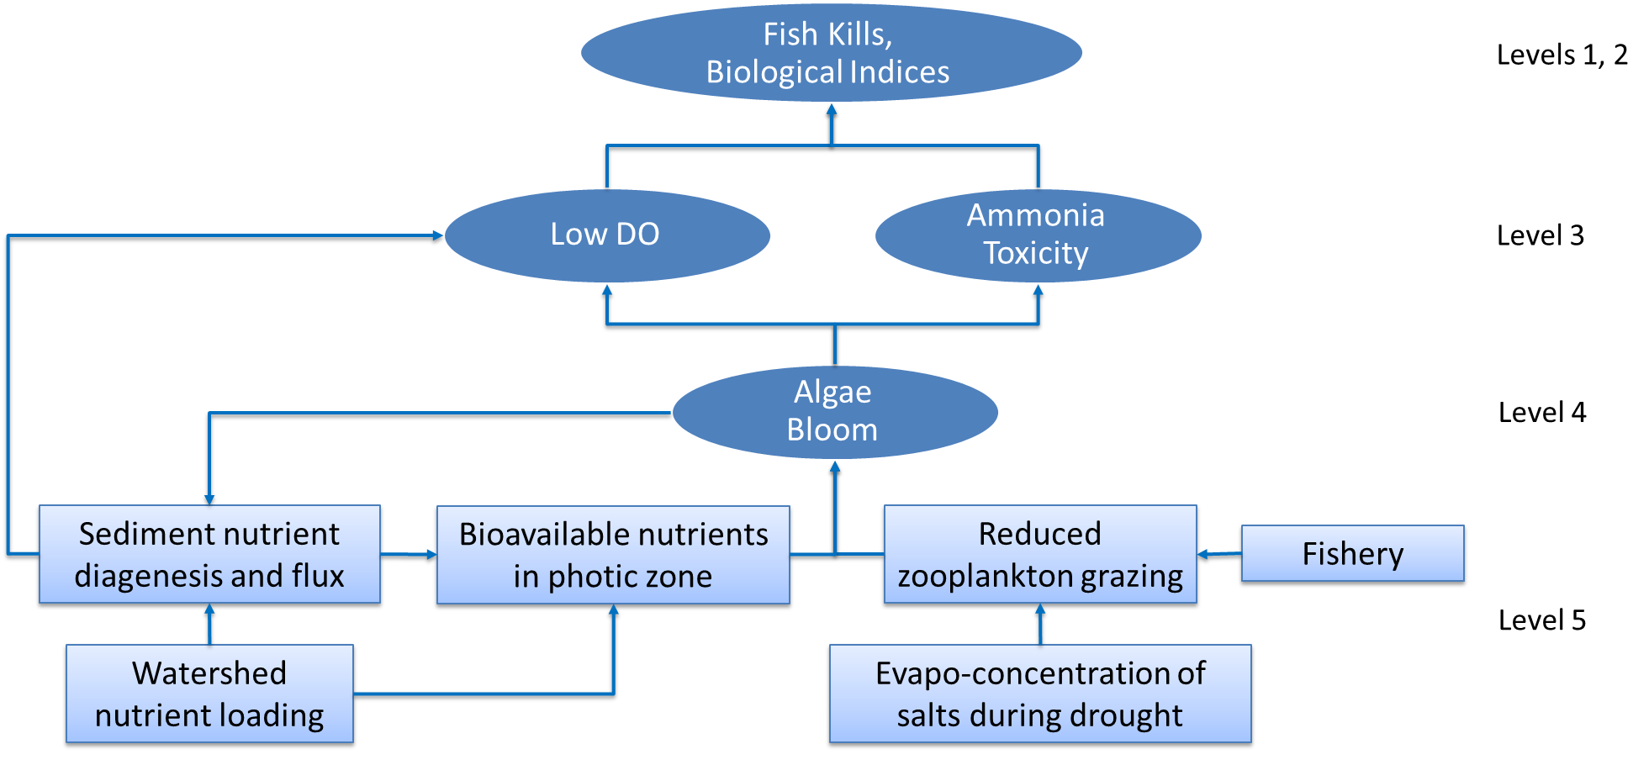
At the bottom of the hierarchy as shown in Table 3-1 are the nutrients nitrogen and phosphorus, which influence algae growth and persistence of algal blooms. Nutrients are the only indicator that can be accounted for in external inputs to the lakes, and therefore provide the basis for the existing TMDL, expressed as the total allowable load of nutrients to each lake segment. The relationship between Level 5 indicator nutrients and Level 1 and 2 direct measures of WARM use attainment involves many complex physical, chemical, and biological processes, as illustrated in Figure 3-1. The TMDL linkage analysis will identify the relationships between nutrients and higher level use attainment indicators, such as algae, dissolved oxygen, and ammonia toxicity.
Figure 3-1
Processes that cause impairment of the WARM use organized according to the use indicator hierarchy (see Table 3-1)
Not included in the WARM use attainment hierarchy (Table 3-1) is the potential effects of extended drought. For example, extended drought can impact algae as depicted in Figure 3-1, and the influence of extended droughts in the watersheds that drain to Canyon Lake and Lake Elsinore can contribute to the severity of WARM use impairments. For example, Figure 3-1 shows how increased salinity by evapoconcentration constrains zooplankton communities, which in turn limits the effectiveness of this aquatic community to graze and mitigate algal levels. Also, as salinity rises, the types of algae that thrive in higher TDS conditions are more prevalent, and tend to be less edible for zooplankton. This process of increasing salinity is most applicable to Lake Elsinore because of its greater susceptibility to extended droughts because of its almost complete lack of flushing, significant evaporative loss from its large surface area, and reduced inflow of freshwater from retention of runoff upstream in Hemet Lake, Mystic Lake and other recharge basins, as well as within Canyon Lake (e.g., see Section 2.2.1 of the Problem Statement).

3.1.2 Water Quality Objectives
The Basin Plan includes WQOs for several of the water quality indicators presented above. Table 2-1 in Chapter 2 (Problem Statement) summarizes these objectives. The following sections summarize how these objectives have been considered in the development of numeric targets for the revised TMDLs:
3.1.2.1 Algae
The water quality objective for algae is narrative and therefore does not include a numeric threshold value for use in developing TMDL numeric targets. Specifically:
“Waste discharges shall not contribute to excessive algal growth in inland surface receiving waters”
Development of a TMDL numeric target requires interpretation of the above narrative language, most notable being the need to interpret the term “excessive” used to describe the level of algae growth that is to be controlled. The approach used to set TMDL numeric targets for Canyon Lake (Main Lake and East Bay) and Lake Elsinore is based on the premise that “excessive” is equivalent to any amount of algae above that which would occur if the upstream watershed were to be returned to a reference condition (see Section 3.2 below). Chlorophyll-a, a pigment found within algae, is a commonly used measure of algae concentration in surface waters and therefore numeric targets in nutrient TMDLs are based on concentrations of chlorophyll-a.
3.1.2.2 Dissolved Oxygen
The Basin Plan water quality objective for dissolved oxygen is as follows:
“The dissolved oxygen content of surface waters shall not be depressed below 5 mg/L for waters designated WARM, or 6 mg/L for waters designated COLD, as a result of controllable water quality factors”
The water quality objective is used to develop TMDL numeric targets based on the threshold concentration of 5 mg/L for WARM use. The Basin Plan dissolved oxygen water quality objective specifically limits the responsibility to dischargers to “controllable water quality factors.” This qualifier supports the use of a reference watershed approach, where impacts to dissolved oxygen in the downstream waterbodies can be related to controllable factors in a developed watershed. The corollary case is that dissolved oxygen impairments that occur naturally, as a result of reference watershed loads, i.e., under pre-development conditions, could be reasonably categorized as resulting from uncontrollable water quality factors.
The dissolved oxygen water quality objective does not include any guidance on how compliance should be evaluated, particularly with regards to spatial or temporal averaging. With regards to the former, dissolved oxygen concentrations may vary significantly from the surface to the bottom of a lake simply because of natural processes associated with stratification. The applicability of DO objectives to the entire water column for Canyon Lake and Lake Elsinore was uncertain per the 2004 TMDL Staff Report, which stated
“The Basin Plan does not identify the depth over which compliance with this objective is to be achieved, nor does it reflect seasonal differences that may result in DO variations associated with stratification in the lakes… As the relationship between nutrient input and dissolved oxygen levels in the lakes is better understood, the TMDL targets for dissolved oxygen can be revised appropriately to ensure protection of aquatic life beneficial uses.”
From a biological standpoint, it is important that fish and aquatic life have sufficient access to waters with greater than 5 mg/L in enough portion of key habitat areas of the lake volume to find refuge during periods of depressed oxygen levels. This especially important given that fish kills resulting from low DO conditions generally occur over small windows of time. The development of numeric targets for the revised Canyon Lake and Lake Elsinore Nutrient TMDs will define the spatial and temporal extent of water with greater than 5 mg/L DO based on conditions that would be expected for a reference watershed (see Section 3.2 below).
      - Ammonia Toxicity
EPA recently completed final criteria in 2013 (EPA-822-R13-001) for ammonia to update the 1999 Update of Ambient Water Quality Criteria for Ammonia (EPA-822-R-99-014) based on new scientific studies. EPA criteria are not WQOs unless included in the Basin Plan. To date, there have been no amendments to the Basin Plan to update WQOs for ammonia; however, the Santa Ana Water Board’s Fiscal Year 2015-2018 Triennial Review Priority List and Work Plan includes a task to review the Basin Plan ammonia objectives based on the 2013 EPA criteria (Resolution R8-2015-0085). While this review has not yet occurred, the Basin Plan does include a narrative objective for general toxic substances as follows:
“The concentrations of toxic pollutants in the water column, sediments or biota shall not adversely affect beneficial uses”
Currently, Lake Elsinore is listed as impaired for “unknown toxicity.” Given this listing, and the toxics narrative objective above, for this TMDL revision numeric targets for ammonia will be developed for Lake Elsinore using the EPA 2013 ammonia criteria.
The 2013 EPA ammonia criteria involves a calculated acute and chronic concentration for total ammonia-N that is dependent upon temperature and pH, which impact the portion of total ammonia that is in the toxic unionized form. The 2013 criteria address the frequency for which acute and chronic concentrations must be protected, as follows:
- Acute - One-hour average concentration does not exceed, more than once every three years on the average.
- Chronic - Thirty-day average concentration does not exceed, more than once every three years on the average.
- Highest four-day average within the 30-day period should not exceed 2.5 times the chronic criteria, more than once every three years on the average.
Two sets of criteria have been published depending upon whether the waterbody contains highly sensitive freshwater mussels in the unionid family. This family of mussels was not present in any surveyed southern California lakes in recent surveys (Howard et. al., 2015; United States Department of Agriculture, 2010), nor from historical surveys by Coney (1993). Despite these surveys not directly involving Canyon Lake and Lake Elsinore, the findings are sufficient to develop TMDL numeric targets based on the absence of unionid mussels. If surveys within Canyon Lake or Lake Elsinore show the presences of unionid mussels in the future, then the TMDL numeric target should be revised to the more stringent criteria.
3.2 Reference Watershed Approach

3.2.1 Framework
The revision of the Canyon Lake and Lake Elsinore Nutrient TMDLs relies on the use of a reference watershed approach for setting numeric targets and determining allowable loading capacity for developing allocations (Figure 3-2). The process shown in Figure 3-2 characterizes the reference watershed approach involving first estimate of nutrient loads for a reference watershed, followed by linkage analysis and numeric target determination. The primary objective of developing a TMDL using a reference watershed approach is to establish targets that when met result in water quality conditions in each lake segment that are to equal or better than would be expected for a natural, or reference, waterbody.
The reference watershed approach embodies the State Water Board’s basis for making an impairment finding:
“A water segment shall be placed on the section 303(d) list if the water segment exhibits significant degradation in biological populations and/or communities as compared to reference site(s) and is associated with water or sediment concentrations of pollutants including but not limited to chemical concentrations, temperature, dissolved oxygen, and trash.”

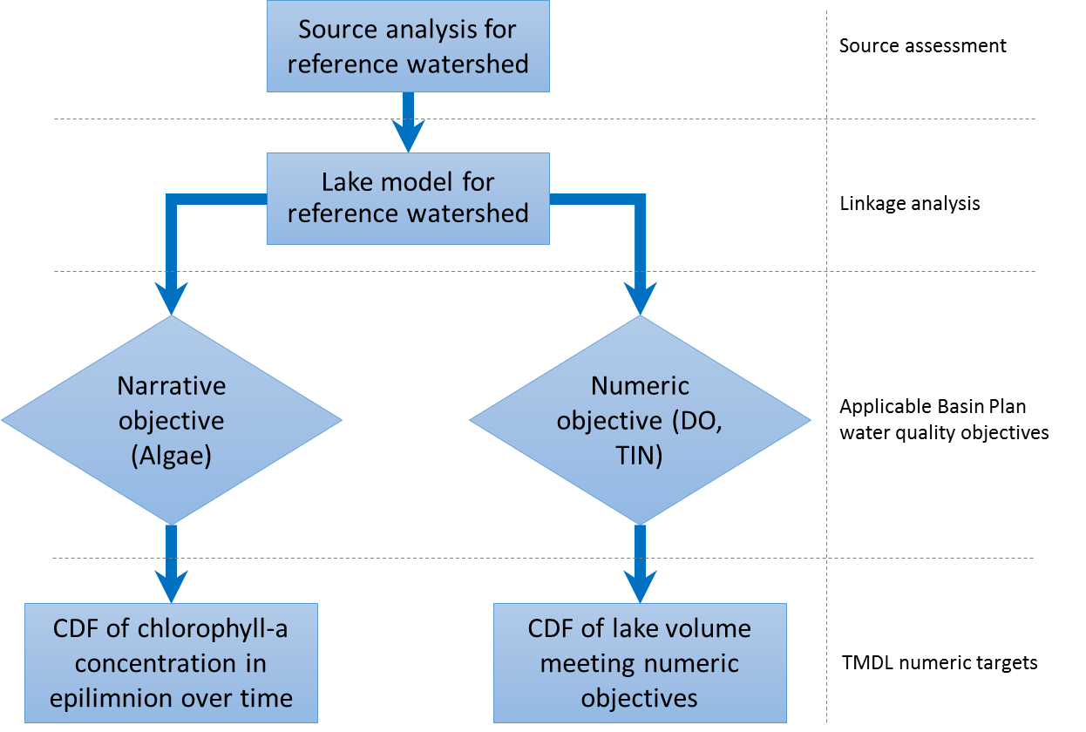
3.2.1.1 Substitution of Watershed for Site
Figure 3-2
Process for developing TMDL numeric targets using a reference watershed approach
There are no comparable inland lakes to Canyon Lake or Lake Elsinore that could be considered reference sites. These lakes have unique conditions that would be very unlikely to be replicated downstream of a natural watershed in the same geographic region where urban development is widespread. These unique conditions were described in the Problem Statement (see Section 2.2). Therefore, for the Canyon Lake and Lake Elsinore Nutrient TMDL revisions, a hypothetical scenario was employed to define the reference site, whereby runoff and nutrient loads representative of a completely natural, or reference, watershed was assumed to comprise the entire drainage area to the existing lake basins. This approach is support by EPA Region 9 in Guidance for Developing TMDLs in California. This guidance recognizes the utility of hillslope targets, such as a reference watershed nutrient load, for setting numeric targets in a TMDL for impaired receiving waters:
“…It is sometimes possible to supplement instream indicators and targets with hillslope targets - measures of conditions within the watershed which are directly associated with waterbodies meeting their water quality standards for the pollutant(s) of concern.”
Within the context of this TMDL revision, this guidance is interpreted to mean that measures of hillslope, or watershed, conditions are directly associated with attainment of water quality standards in their downstream waterbodies. Since meeting water quality standards in Canyon Lake and Lake Elsinore is the ultimate objective of the TMDL, then it is appropriate for the TMDL numeric targets be based on a reference watershed condition.

3.2.1.2 Spatio-temporal Variability
In a reference watershed condition, external nutrient loads are delivered with extreme temporal variation within a single wet season and with year to year variability extending over decadal timescales. The dynamic water quality response within the downstream lakes is even more variable because of other factors that control nutrient cycling, productivity, and sediment diagenesis. Also, Canyon Lake and Lake Elsinore are not completely mixed and exhibit naturally occurring spatial variability in nutrients and aquatic ecosystems. For these reasons, it is inappropriate to set lake-wide average numeric targets based on a static condition. The California approach considered for setting numeric nutrient endpoints (NNEs) came to this same conclusion for freshwaters, stating:
“Evaluation of a target also needs to consider questions of temporal and spatial applicability consistent with the desired use protection. Temporally, a chlorophyll a target can be defined as a point-in-time measurement (or frequency of such measurements) … Spatially, the target could be applied….in relation to specific sub-habitat areas.”
The TMDL requires reduction of nutrient sources to mitigate WARM use impairments in excess of a frequency and magnitude (spatial extent) that would be expected for a reference watershed condition. A critical question for setting numeric targets is, how does one decide what is an excess level of a water quality constituent such that the WARM use is impaired relative to a reference condition accounting for naturally occurring spatio-temporal variability? In short, this question is best addressed by expressing the Canyon Lake and Lake Elsinore TMDL numeric targets as CDFs.
A CDF is a plot of a statistical distribution for a set of data. Figure 3-3 shows a series of historical depth integrated chlorophyll-a concentration converted to a CDF. Review of the time series history plot gives a sense for the long-term temporal variations in water quality. Translation to a CDF removes the consecutive order in a time series plot and instead expresses the long-term frequency of occurrence for different levels of water quality. It would be nearly impossible for future water quality to follow the same temporal pattern shown in the historical time series plot on the left. Fluctuations caused by short term weather phenomena and longer term climate patterns are expected to be similar, but will occur in a unique order. However, over time, future water quality data converted to a CDF should align with the CDF of historical water quality, if no significant changes are made in the watershed or to the lakes that impact water quality in the lakes.
To interpret a CDF graph, pick a point on the curve. For example, as shown in Figure 3-3 chlorophyll-a exceeded 100 µg/L about 60 percent of the time based on historical monitoring over a 14-year monitoring period. Without any significant change in management practices, future water quality monitoring results over any other 14-year period would also be expected to have about 60 percent of samples exceeding 100 µg/L.
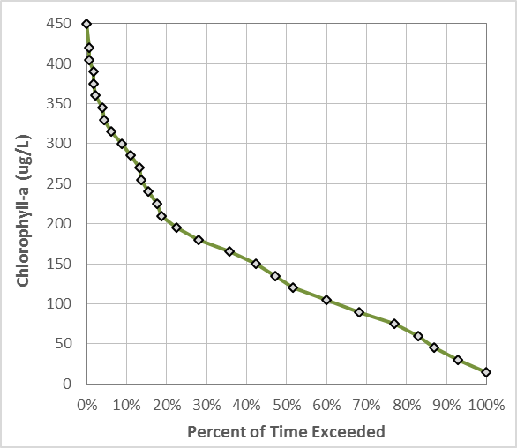
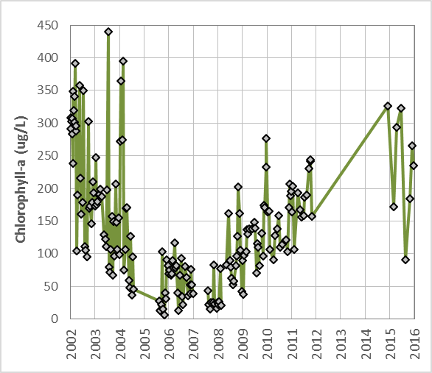
In the case of CDF-based TMDL numeric targets, the data are daily estimates of model results for a reference watershed scenario for WARM use impairment indicators. This expression of the targets is based on the logical premise that returning loads from the watershed to reference levels, would cause in-lake WARM use impairment indicators to exhibit the same spatial and temporal variability expected for a reference watershed condition. In other words, TMDL compliance will be achieved when CDFs developed from future long-term post-implementation monitoring are similar to the reference watershed model-based numeric target CDFs.
Figure 3-3
Conversion of a long-term routine monitoring data set to a CDF curve
The concept for using CDF curves as a basis for defining expected water quality has been used elsewhere. For example, the State of Virginia adopted water quality standards for Chesapeake Bay segments that included a similar approach involving the use of a criteria reference curve for water quality standards attainment assessment. The reference curve was developed to account for naturally occurring conditions of hypoxia in Chesapeake Bay suggested from multiple lines of evidence (EPA, 2003). EPA guidance states:
“Attainment of these criteria shall be assessed through comparison of the generated cumulative frequency distribution of the monitoring data to the applicable criteria reference curve for each designated use. If the monitoring data cumulative frequency curve is completely contained inside the reference curve, then the segment is in attainment of the designated use.”
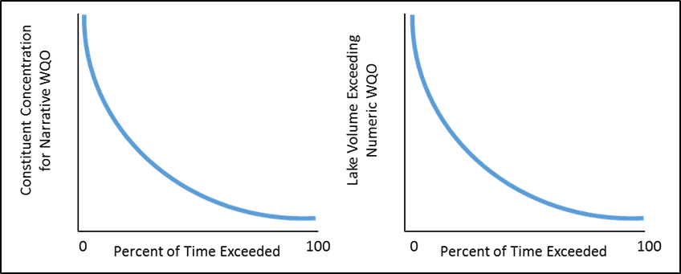
This EPA criteria guidance supporting the use of a reference criteria curve approach for making an attainment assessment was adopted in water quality standards for the States of Virginia and Maryland for Chesapeake Bay segments. The approach described above and illustrated in Figure 3-3 is appropriate for situations where the WQO is narrative. Figure 3-4 portrays an alternative approach for using a CDF to establish a TMDL numeric target where the Basin Plan establishes a numeric WQO for a constituent, such as the WQO for DO not to be depressed to below 5 mg/L to support the WARM use. In this case, the CDF approach is modified to account for both frequency and spatial extent of impairments. This is accomplished by changing the value expression for the y-axis of the CDF from the spatially averaged concentration to the fraction of the total lake volume that is within the numeric WQO threshold (Figure 3-4).
Figure 3-4
Numeric targets are plotted as constituent concentration CDFs (left) for narrative WQOs, i.e. algae, and CDFs of lake volume meeting numeric WQOs (right) for DO and TDS

This alternative method of expressing the CDF is apparent in the methods description for the development of reference criteria curves in the Chesapeake Bay, as follows:
“The cumulative frequency distribution methodology for defining criteria attainment addresses the circumstances under which the criteria may be exceeded in a small percentage of instances…the frequency of instances in which the water quality threshold (e.g., dissolved oxygen concentration) is exceeded, as a function of the area or volume affected at a given place and over a defined period of time.”

Estimation Methods
3.2.2.1 Source Assessment
The reference watershed approach shown in Figure 3-2 above begins with a source assessment for nutrient loads in runoff from a reference watershed. Chapter 4 presents the source assessment for the TMDL revision, including data analysis and modeling of nutrients in watershed runoff for current land use conditions. The same database and watershed model was used to estimate nutrient loads reaching the lake segments for a reference watershed. For example, the watershed model includes simulation of runoff and associated nutrient loading from the remaining 66 percent of the watershed that is currently undeveloped
3.2.2.2 Linkage Analysis
The impact of reference nutrient loads within each lake segment is assessed using a dynamic lake water quality model (see Figure 3-2 above). This step serves as the linkage analysis when developing a TMDL using a reference watershed approach. In other words, the linkage analysis estimates the water quality response of the lake segments to predetermined allowable external nutrient loads estimated for a reference watershed. Conversely, TMDLs that use a stressor-response approach use the linkage analysis to determine the allowable external nutrient load that can be delivered to the receiving waterbody to yield stressor concentrations that would not impair water quality standards.
3.2.2.3 Numeric Target Setting
The results of the linkage analysis are interpreted to develop TMDL numeric targets that account appropriately for spatial and temporal variability in water quality under a reference watershed condition. Different expressions of TMDL numeric targets are used depending upon whether the Basin Plan includes a narrative or numeric water quality objective. Canyon Lake and Lake Elsinore numeric targets associated with narrative Basin Plan objectives include the following:
- Algae - The linkage analysis employs a dynamic lake water quality model that assesses temporal variability of algae (measured as chlorophyll-a concentration) that may result from reference watershed nutrient load inputs. Laterally averaged chlorophyll-a concentrations for each lake segment from the top one meter of the water column are used to characterize a reference watershed condition. Dynamic simulation results of chlorophyll-a data are plotted as CDFs to represent the TMDL numeric targets to prevent excessive algae.
Canyon Lake and Lake Elsinore numeric targets associated with numeric Basin Plan objectives include the following:
- Dissolved Oxygen - For the TMDL revision, the TMDL numeric target will be expressed as a volume of lake expected to have dissolved oxygen concentrations within the thresholds required to support the WARM use under a reference watershed condition. Lake water quality, including dissolved oxygen concentrations in a reference condition, is dynamic, and the volume of the lake that would support WARM use varies temporally. This variability is accounted for by employing a dynamic lake water quality model to generate continuous simulation results reported as total lake volume with dissolved oxygen greater than 5 mg/L. These model results are converted to a CDF to serve as the numeric target. The resulting targets would represent conditions that may have occurred naturally, even if those conditions potentially result in periodic stress to fish populations from low dissolved oxygen.
- Ammonia - As described above, the fraction of total ammonia that is toxic is dependent upon pH and water temperature. It is not possible to calculate the toxicity of ammonia for all volume elements at a daily time-step, using the lake water quality models developed in the linkage analysis. Moreover, it would be infeasible for future monitoring to assess whether ammonia toxicity is at levels that would naturally occur at a comparable spatial scale. Instead, development of a TMDL numeric target was simplified to depth average concentrations of total ammonia-N, to be evaluated at compliance monitoring sites (see Chapter 7 on Monitoring Requirements). The technical basis for this approach is as follows: 1) total ammonia is controlled by the same nutrient cycling mechanisms that must be addressed to return total in-lake nutrient mass, algae, and dissolved oxygen to reference levels; 2) pH is expected to be returned to reference levels with control of algal productivity; and 3) water temperature is not impacted by development in the watershed and current levels are assumed to remain unchanged as a result of human development in the future.
In-lake nutrient concentrations for total nitrogen or total phosphorus were not included as causal numeric targets in the revised TMDL. There are multiple combinations of these two nutrients that would effectively limit algal productivity to cause a return to reference levels for WARM use impairment indicators (algae, DO, ammonia) higher in the hierarchy. Thus, in-lake nutrients will be evaluated in the implementation chapter. For example, one implementation alternative involves reduction of total phosphorus to below reference levels to ensure it is the growth limiting nutrient and to achieve reference conditions for chlorophyll-a with or without returning total nitrogen to reference levels.

3.3 Reference Watershed Characterization
Characteristics that define the reference watershed condition and serve as model inputs and assumptions include hydrology, water quality, and the physical structure of each lake segment. The following sections describe data and assumptions that represent a hypothetical reference watershed state for the drainage areas to Canyon Lake and Lake Elsinore. This condition provides inputs and boundary conditions for the linkage analysis to develop a continuous simulation of lake water quality that serves as the basis for determining TMDL numeric targets.

3.3.1 Reference Condition for Lakes
Both Canyon Lake and Lake Elsinore look different than they would have in prehistoric times. The physical condition of Canyon Lake and Lake Elsinore is an element of the reference watershed approach. Key assumptions are described for each lake below:
- Canyon Lake did not exist prior to the construction of Railroad Canyon Dam in 1928. Thus, the reference condition assumes the existence of Railroad Canyon Dam.
- For Lake Elsinore, projects to change the physical condition of the lake were implemented by the LEMP (see Section 2.2.2 in Chapter 2). The LEMP included lowering of the lake outlet channel to increase outflow to downstream Temescal Creek to provide flood protection when the lake level exceeds an elevation of 1,255 feet. The lower outlet is included in the reference lake condition, because it was a modification to the lake physical condition that was not implemented for water quality improvement. The LEMP also involved construction of a levee to separate the main lake from the back basin, reducing the lake surface area from about 6,000 to 3,000 acres, and thereby prevent significant evaporative losses and improve water quality. This project is not included in the reference condition for Lake Elsinore because it was developed for purposes of improving water quality. Instead, the reduction of the lake surface area is considered as an implementation measures to provide water quality benefits toward compliance with wasteload allocations (see managed lake section of Implementation chapter).

3.3.2 Reference Watershed Hydrology
The runoff response from rainfall over a reference watershed is different than a developed watershed. Development increases impervious or compacted surfaces, which reduces attenuation by infiltration over undistributed pervious areas. Surface conveyance features such as ditches and gutters serve of concentrate runoff for more efficient delivery to larger downstream flood control facilities. This also reduces infiltration of rainfall into watershed soils and increases the peak runoff from storm events. Conversely, runoff downstream of a reference watershed is characterized by less flashy hydrographs and lower total volume. Thus, use of continuous USGS flow gauge data from key inflows to Canyon Lake and Lake Elsinore over recent history (following 1916) is not appropriate for developing a reference watershed scenario. Estimates of runoff inflows from a hypothetical reference watershed to Canyon Lake and Lake Elsinore are presented in the following sections.
3.3.2.1 Canyon Lake
As presented in Section 4.1.3.2, a model for estimating runoff from subareas tributary to each lake segment was developed to support the source assessment for the TMDL. This model computes runoff as a function of rainfall and imperviousness of the upstream drainage area, as well as estimated retention of runoff within unlined channel bottoms. Model parameters were adjusted to fit long-term measured runoff volume. This same model was employed retrospectively, to predict the average annual runoff that may have reached each lake segment for a hypothetical reference watershed with no impervious area. Removal of impervious area reduced the estimated runoff inflows, as shown in Table 3-2.
Table 3-2. Estimated Average Annual Runoff for Existing and Reference Watershed Conditions to Canyon Lake
Lake Segment | Condition | Subarea Runoff (AFY) | Channel Recharge (AFY) | Inflows to Lake Segment (AFY)
Canyon Lake – Main Lake ¹ | Existing | 6,120 | 380 | 5,740
 | Reference | 4,380 | 510 | 3,870
Canyon Lake – East Bay | Existing | 4,700 | 2,200 ² | 2,490
 | Reference | 3,440 | 1,740 | 1,700
1) Includes channel bottom recharge in both Perris Valley Channel and San Jacinto River
2) Increase in channel recharge for existing condition relative to reference watershed is due to the storage impoundments created within Menifee Lakes golf course
In addition to removing impervious area, the reference watershed condition required an adjustment to the estimation of retention within Perris Valley Channel and Salt Creek (see Section 4.1.3.3 for detailed description), as follows:
- Salt Creek - Under current conditions, an estimated 800 AFY is captured, stored, and allowed to percolate beneath a series of water features at the Menifee Lakes golf course. Channel bottom recharge upstream and downstream of the golf course is estimated to recharge 1,400 AFY of runoff that would otherwise have been delivered to the East Bay of Canyon Lake. Thus, for current conditions, total estimates of recharge beneath Salt Creek is 2,200 AFY. In a reference watershed condition, the golf course impoundments of water upstream of Canyon Lake would not exist. Instead, the segment of Salt Creek that is within the current Menifee Lakes golf course boundary, would provide an additional 200 acres of natural channel bottom area for recharge during runoff events. The estimated total recharge beneath Salt Creek in a reference watershed condition is 1,740 AFY.
- Perris Valley Channel – Recharge within the existing unlined portion of Perris Valley Channel is estimated to be 250 AFY. In a reference watershed condition, there would no longer be any lined channels and the area available for channel bottom recharge may increase by 100 acres. This increase in unlined channel bottom results in an increase of 130 AFY for a total recharge of 380 AFY in the reference watershed condition.
- San Jacinto River – The San Jacinto River between Mystic Lake and Perris Valley Channel confluence is currently unlined and it is not expected to be significantly different than for a reference watershed condition. Existing and reference condition models account for 130 AFY of channel bottom recharge in this segment of the San Jacinto River.
3.3.2.2 Lake Elsinore
The portion of the drainage area to Lake Elsinore that is downstream of Canyon Lake (~10 percent of the total watershed area) is referred to as the ‘local Lake Elsinore’ watershed. Runoff volume for a reference condition in the local watershed is estimated by removing imperviousness in the watershed model resulting in a reduction of inflow volume from 2,210 AFY to 1,450 AFY.
Estimation of runoff volume that may reach Lake Elsinore from Canyon Lake overflows in a hypothetical reference watershed condition could not be estimated using a watershed runoff model, because of the complexities of storage and overflow dynamics in Canyon Lake. An alternative approach was developed that compares average annual runoff in overflows from Canyon Lake prior to 1972, when the region was minimally developed with low impervious acreage, with years following 1972, when development increased throughout the San Jacinto River watershed upstream of Canyon Lake.
The average annual rainfall of 11.7 in/yr at the Lake Elsinore meteorological station from the first half of Canyon Lake’s existence (1929-1972) is equivalent to the latter half from 1973-2016. Review of USGS gauge data from the San Jacinto River near Elsinore (Sta 11070500) shows that overflows to Lake Elsinore from the first half of Canyon Lake’s lifespan were ~40 percent lower than runoff from the second half (Figure 3-5). The difference between these periods may be attributed to development in the watershed; however, a diminishing storage capacity because of sedimentation within Canyon Lake may also play a role in rising overflow volumes for periods with functionally equivalent rainfall depths.
Assuming a constant rate of watershed development, a steady annual runoff increase of 0.5 percent would have accrued over time since the construction of Railroad Canyon Dam. Thus, for the reference watershed condition, annual runoff overflows from Canyon Lake to Lake Elsinore are estimated by reducing the downstream USGS gauged flow (Q_{measured}) as a function of the age of Canyon Lake (R_{age}), as follows;$$Q_{reference}= Q_{measured}* \left(1- 0.005*R_{age}\right)$$
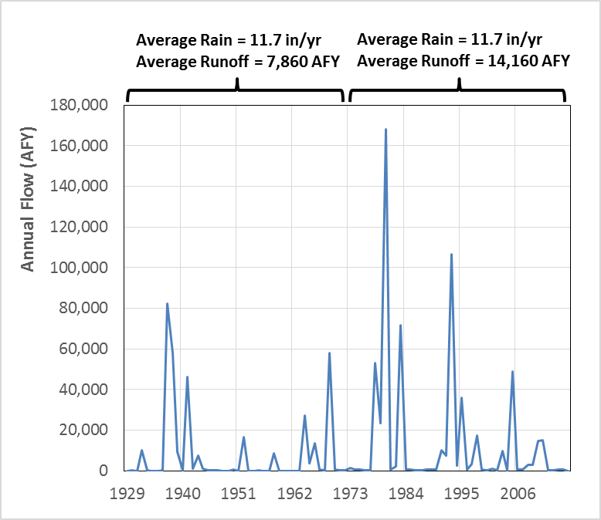
The measured annual runoff volumes and estimated reference condition for Canyon Lake overflows are summarized in Table 3-3. Combined with watershed model results for the local Lake Elsinore watershed with and without imperviousness gives an estimate of the total runoff volume inflow to Lake Elsinore for existing and reference watershed conditions (Table 3-3).
Figure 3-5
Annual runoff from San Jacinto River near Elsinore (USGS 11070500) showing increases in average annual runoff before and after 1972 for equivalent average annual rainfall
Table 3-3. Estimated Average Annual Runoff for Existing and Reference Watershed Conditions to Lake Elsinore
Lake Segment | Condition | Local Watershed Runoff (AFY) | Canyon Lake Overflows (AFY) | Total Inflows to Lake Elsinore (AFY)
Lake Elsinore | Existing | 2,210 | 10,980 | 13,190
 | Reference | 1,450 | 8,500 | 9,950
3.3.3 Reference Nutrient Washoff
Nutrient concentrations representative of a reference watershed were estimated from water quality monitoring data collected from a site on the San Jacinto River at Cranston Guard Station. This site was added to the 2004 TMDL monitoring plan as a reference station. The 142 mi² watershed to this site is comprised of predominantly undeveloped forest or scrublands in the San Jacinto National Forest. The US Forest Service collected 54 samples from this reference site over the course of 11 wet weather events in 2003-2005, 2008, and 2010. The median concentrations of these samples were 0.32 mg/L TP and 0.92 mg/L TN. These median nutrient concentrations were applied to all runoff volume inflow to the lakes to estimate loads for a hypothetical reference watershed condition. It is important to note that this sampling represents expected water quality from an undeveloped watershed in the modern era and not a prehistoric condition. Other sources of nutrients may exist outside of the jurisdictional control of the TMDL, such as atmospheric deposition of nutrients that may be dominated by sources originating from outside of the watershed boundary.

3.3.4 Lake Water Quality Models
Water quality models provide an alternative means to estimate the response within the lakes for a hypothetical reference watershed condition. The Computational Aquatic Ecosystem Dynamics Model (CAEDYM v.3) is a lake water quality model developed to test management alternatives for Canyon Lake and Lake Elsinore (Anderson, 2016). This model is also used to develop the linkage analysis for this TMDL revision (see Section 5 for detailed description of Linkage Analysis). With a reference watershed approach, the linkage analysis is used to estimate the long-term lake water quality that would be expected to have occurred in Canyon Lake and Lake Elsinore for a hypothetical scenario involving a reference upstream watershed, and without any of the existing in-lake nutrient management strategies.
For Lake Elsinore, water quality modeling to support the development of TMDL numeric targets involved a very long simulation period from 1916-2015. This was imperative to capture the full range of dynamic water quality conditions that naturally occur in Lake Elsinore, as presented in the Problem Statement. CAEDYM is an aquatic ecosystem model and is coupled with a hydrodynamic model to facilitate boundary conditions and simulation of spatially varying mechanisms. For Lake Elsinore, a simple 1-D hydrodynamic model, the Dynamics Reservoir Simulation Model (DYRESM), was used for development of laterally averaged vertical profiles. This is appropriate for Lake Elsinore because it has a fairly uniform morphology. For Canyon Lake, there is substantial variability in the lake basin morphology and water quality processes, which required the development of a 3-D hydrodynamic model, the Estuary and Lake Computer Model (ELCOM). These tools are described in detail in Chapter 5 on Linkage Analysis.

3.4 TMDL Numeric Targets
3.4.1 Lake Elsinore
DYRESM-CAEDYM model results of water quality for the reference watershed scenario for the period from 1916-2014 serve as the basis for setting numeric targets for Lake Elsinore. Numeric targets for chlorophyll-a, DO, and ammonia-N are in the form of CDFs, as follows
- Chlorophyll-a: Epilimnion average of daily model results plotted as a CDF for reference condition (Figure 3-6).
- Dissolved Oxygen: The fraction of the total volume of Lake Elsinore with daily average DO greater than 5 mg/L plotted as a CDF for reference condition (Figure 3-7).
- Ammonia-N: Water column depth average of daily model results plotted as a CDF for reference watershed condition (Figure 3-8).
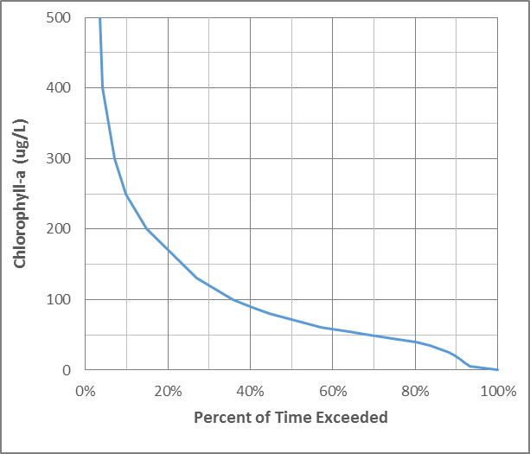
The numeric water quality target requires that CDFs from future long term monitoring results are equal to or better than the target CDFs
Figure 3-6
TMDL numeric target for chlorophyll-a in Lake Elsinore as reference watershed CDF

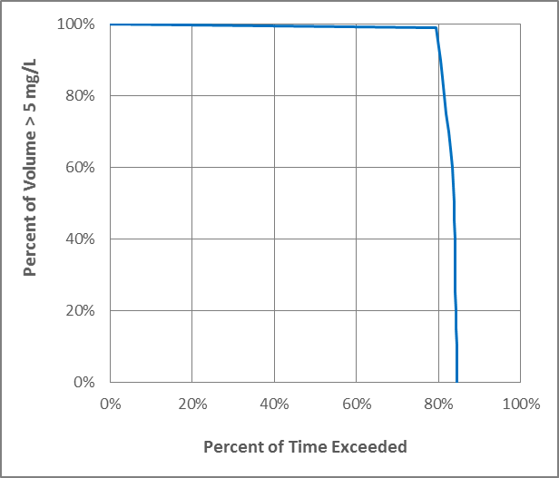
Figure 3-7
TMDL numeric target for DO in Lake Elsinore as reference watershed CDF
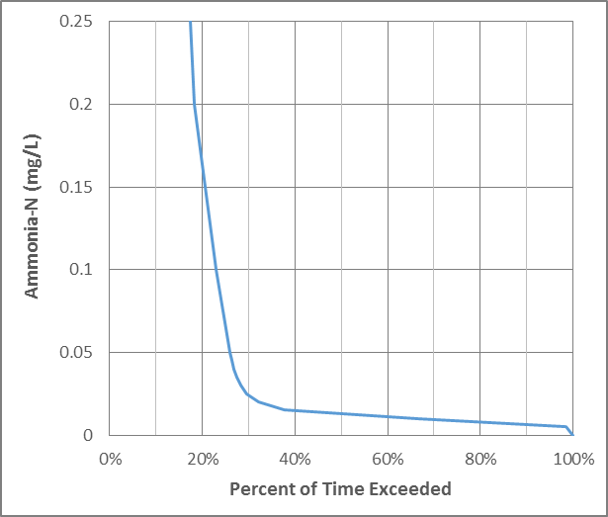
Figure 3-8
TMDL numeric target for ammonia-N in Lake Elsinore as reference watershed CDF

3.4.2 Canyon Lake
To be completed with new modeling results from Dr. Anderson

http://www.waterboards.ca.gov/santaana/water_issues/programs/tmdl/docs/elsinore/final_2.pdf
Levels 1 and 2 are direct indicators of use impairment or ‘measures of effect’; Levels 3, 4 and 5 are indirect indicators of use impairments, with levels 3 and 4 comparable to ‘intermediate measures’ and level 5 comparable to ‘measures of exposure’ as defined in the California’s numeric nutrient endpoint (NNE) framework for freshwater (EPA Region 9 (2006). Technical Approach to Develop Nutrient Numeric Endpoints for California, Prepared by Tetra Tech)
http://www.swrcb.ca.gov/plans_policies/biological_objective.shtml
US Environmental Protection Agency (EPA), 2013. Final Aquatic Life Ambient Water Quality Criteria for Ammonia – Freshwater 2013. EPA-HQ-OW-2009-0921.
http://www.waterboards.ca.gov/santaana/water_issues/programs/basin_plan/docs/2016/Chapter_4_Feb_2016.pdf
http://www.waterboards.ca.gov/santaana/water_issues/programs/basin_plan/docs/2016/Chapter_4_Feb_2016.pdf
https://www.gpo.gov/fdsys/pkg/FR-2013-08-22/html/2013-20307.htm
http://www.waterboards.ca.gov/santaana/water_issues/programs/basin_plan/docs/2016/Chapter_4_Feb_2016.pdf
http://www.waterboards.ca.gov/santaana/water_issues/programs/tmdl/docs/303d/2010_303d.pdf
Howard, Jeanette, Joseph L. Furnish, Jayne Brim Box, and Sarina Jepson, (2015). The decline of native freshwater mussels (Bivalvia: Unionoida) in California as determined from historical and current surveys, CA Fish and Game 101(1):8-23; 2015.
USDA Forest Service (2010). Sensitive Freshwater Mussel Surveys in the Pacific Southwest Region: Assessment of Conservation Status, Prepared by Jeanette Howard, The Nature Conservancy, August 2010.
http://www.waterboards.ca.gov/water_issues/programs/tmdl/docs/ffed_303d_listingpolicy093004.pdf
US Environmental Protection Agency Region 9. (2000). Guidance for Developing TMDLs in California.
US EPA Region 9 (2006). Technical Approach to Develop Nutrient Numeric Endpoints for California, Prepared by Tetra Tech.
EPA, 2003. Ambient Water Quality Criteria for Dissolved Oxygen, Water Clarity and Chlorophyll a for the Chesapeake Bay and Its Tidal Tributaries, EPA 903-R-03-002, April 2003.
http://law.lis.virginia.gov/admincode/title9/agency25/chapter260/section50/
http://www.dsd.state.md.us/comar/comarhtml/26/26.08.02.03-3.htm
EPA, 2003. Ambient Water Quality Criteria for Dissolved Oxygen, Water Clarity and Chlorophyll a for the Chesapeake Bay and Its Tidal Tributaries, EPA 903-R-03-002, April 2003.
Elsinore Valley Municipal Water District (1984). Final Environmental Assessment for Proposed Lake Elsinore Management Project, prepared by Engineering Science, Arcadia, CA.
Anderson, 2016. Technical Memorandum for Task 1.2, “Water Quality in Lake Elsinore Under Selected Scenarios: Model Predictions for 1916-2014 with Current (post-LEMP) Basin”

