Chapter 2  
Problem Statement

The purpose of the Problem Statement is to provide the foundation or basis for the development of a TMDL. The statement typically includes an assessment of current water quality conditions and the basis for the identified impairments of the waterbody’s of concern for which a TMDL is deemed necessary. This Problem Statement provides not only the information used to adopt the original nutrient TMDL for Lake Elsinore and Canyon Lake but also provides an overview of the substantial body of data and information that has been generated since adoption of the 2004 TMDL. This collective body of information provides the basis for revising the existing TMDL.

2.1 Regulatory Background

This section summarizes the basis for the adoption of the 2004 TMDL for Lake Elsinore and Canyon Lake and planned revision of this TMDL.

2.1.1 Beneficial Uses and Water Quality Objectives

Chapters 2 and 3 of the Water Quality Control Plan for the Santa Ana River Basin (“Basin Plan”, Santa Ana Water Board 1995, as updated) establish the beneficial uses and water quality objectives, respectively, applicable to Lake Elsinore and Canyon Lake. **Table 2-1** summarizes each waterbody’s beneficial uses and the numeric and narrative water quality objectives relevant to nutrients and related constituents. These objectives provide the basis for assessing the impairment status of each lake.

2.1.2 Basis for Adoption of 2004 Nutrient TMDL

2.1.2.1 Lake Elsinore

The Santa Ana Water Board first listed Lake Elsinore as impaired in 1994, based on a historical record of periodic fish kills and excessive algae blooms in the lake since the early 20th century. This listing remains in place on the most recently approved impaired waters or 303(d) list for the region[1] and includes unknown toxicity, nutrients, organic enrichment/low dissolved oxygen and sedimentation/siltation. Uses impaired include warm freshwater aquatic habitat (WARM), water contact recreation (REC1) and non-water contact recreation (REC2). Based on these impairments the Santa Ana Water Board developed a nutrient-based TMDL.

During TMDL development, the first Problem Statement identified hypereutrophication as the most significant water quality problem affecting Lake Elsinore.[2] In 2004, a final Problem Statement was developed that updated previous drafts and incorporated the findings of a number of completed studies.[3] These findings provided additional information with regards to the basis for impairment. Specifically, hypereutrophic conditions arise due to nutrient enrichment (phosphorus and nitrogen) resulting in high algal productivity (mostly planktonic algae). Algae respiration and decay depletes available water column oxygen, resulting in adverse effects on aquatic biota, including fish. In 2004, the Problem Statement documented what was known with regards to reported algal blooms and fish kills. **Table 2-2** includes this original information plus updates based on recent research to further document the history of the lake. As can be seen, fish kills and algal blooms have been documented since early last century. (see also Table A-2 in Appendix A).

Table 2-2 shows that in many cases, fish kills have occurred during the summer months and were associated with high temperatures and depletion of oxygen in the water column. The decay of dead algae and fish also produces offensive odors and an unsightly lakeshore, adversely affecting use of the lake for recreational purposes. In addition, the massive population of algal cells in the water column causes high turbidity in the lake, making the water an uninviting murky green color at times.

2.1.2.2 Canyon Lake

Canyon Lake is located approximately five miles upstream of Lake Elsinore. The lake was created as a result of the construction of Railroad Canyon dam in 1928. Only during wet years does Canyon Lake overflow and send water downstream to Lake Elsinore. Concerns regarding water quality were identified in the latter part of the 1990s, in particular concerns regarding periodic algal blooms and fish kills, but neither as significant as occur in Lake Elsinore. However, the water quality concerns were sufficient for the Santa Ana Water Board to place Canyon Lake on the impaired waters list in 1998, where it remains listed for nutrients in the most recent 2010 impairment assessment.

Development of the 2004 nutrient TMDL for Canyon Lake was done in coordination with the Lake Elsinore nutrient TMDL. An initial Problem Statement specific to Canyon Lake was drafted in 2001.[4] This Problem Statement documented that the beneficial uses of the lake were impaired because of excess phosphorus and nitrogen. Subsequently, a revised Problem Statement was prepared in 2004 based on completion of a number of studies that provided additional understanding regarding water quality concerns in Canyon Lake.[5]

2.1.2.3 2004 TMDL Adoption

In June 2004 the Santa Ana Water Board released for public review the *Lake Elsinore and Canyon Lake Nutrient Total Maximum Daily Loads* (see footnote 5) which established numeric targets for both lakes (**Table 2-3**). Based on the outcomes of public workshops held in June and September 2004, a formal resolution to adopt the TMDL was put forward for Board approval. The TMDL was adopted on December 20, 2004.[6] The State Water Resources Control Board (State Water Board) approved the TMDL on May 19, 2005[7]; Office of Administrative Law approved on July 26, 2005, and the EPA approved the TMDL on September 30, 2005.

2.1.3 Basis for TMDL Revision

The post-TMDL implementation period from 2004 to 2016 has been a productive period of planning, monitoring, scientific research and implementation of in-lake projects (see summary in Chapter 1). All of these efforts have established a wealth of new information regarding typical hydrologic and water quality conditions and cycles that exist in each lake and reasonable expectations regarding the water quality benefits that can be achieved through the implementation of water quality management projects. In total, the body of work completed to date provides a firm foundation regarding what is attainable with regards to water quality given the highly managed conditions that exist. Accordingly, these prior work products will serve as the primary resources for updating and revising the current TMDL.

In June 2015, the Task Force petitioned the Santa Ana Water Board to reopen and revise the TMDL based on the wealth of new information developed since TMDL adoption.[8] The Santa Ana Water Board agreed to make this effort a high priority as part of the recent Triennial Review.[9] As part of this agreement, the Task Force accepted responsibility to develop the documentation needed to update and amend the nutrient TMDL for Lake Elsinore and Canyon Lake.

This Problem Statement updates the 2004 Problem Statement. The sections below provide relevant information regarding our current understanding of water quality conditions, lake biology and unique characteristics of the lakes and surrounding watershed after many years of study. This new information will be critical in updating all elements of the TMDL, including, but not limited to, numeric targets, linkage analysis, and source assessment.

2.2 Characteristics of Lake Elsinore and Canyon Lake

2.2.1 San Jacinto River Watershed

Lake Elsinore and Canyon Lake lie within the San Jacinto River Watershed, an area encompassing approximately 780 square miles in the San Jacinto River Basin. Located approximately 60 miles southeast of Los Angeles and 22 miles south of the City of Riverside, the San Jacinto River Watershed lies primarily in Riverside County with a small portion located within Orange County. Area climate is characterized as semi‐arid with dry warm to hot summers and mild winters. Average annual precipitation in Lake Elsinore/Canyon Lake watershed area is approximately 11 inches occurring primarily as rain during winter and spring seasons. Precipitation in the upper watershed averages 18.7 inches annually. Historically, land use development in the San Jacinto watershed has been associated with agricultural activities. However, the current trend involves a shift from agricultural‐related uses to urban.

There are several impoundments upstream in the San Jacinto River watershed that are upstream of Canyon Lake and Lake Elsinore that retain most runoff from their respective drainage areas; including:

* *Lake Perris* – Lake Perris is a drinking water reservoir for the State Water Project which is used to meet demands in the region. An undeveloped drainage area of approximately 10 square miles surrounds Lake Perris and contributes runoff to the lake. Lake Perris does not overflow to the San Jacinto River and therefore this drainage area must by omitted from the TMDL.
* *Mystic Lake* – Mystic Lake is a large depression area in the San Jacinto River watershed that captures all runoff from the upper watershed. Depending upon antecedent moisture conditions, in very wet hydrologic years, Mystic Lake overflows back to the San Jacinto River. In setting WLAs, the 2004 TMDL assumed overflows of Mystic Lake would occur in 16 percent of hydrologic years. The most recent overflow occurred 18 years ago in 1998, despite the fact that 2005 runoff volume was double that of 1998 as recorded in the San Jacinto River between Canyon Lake and Lake Elsinore. The TMDL revision must develop a more appropriate overflow frequency for use in developing allocations for external loads. Moreover, the depression that forms Mystic Lake is subsiding at a rate of ~1 inch/year (in/yr) and thus storage capacity increases are estimated to be 210 acre-feet per year (Riverside County Flood Control & Water Conservation District [RCFCWCD] 2015).
* *Confined Animal Feeding Operations (CAFOs)* – CAFOs must retain runoff from up to a 25 year return period storm event on-site. Retention ponds within CAFO properties are used to comply with this permit requirement, which also serves to limit any discharge to the San Jacinto River or Salt Creek during most hydrologic years. The TMDL revision must account for successful compliance with CAFO Permits.

2.2.2 Lake Elsinore

Lake Elsinore is the largest natural lake in Southern California with an approximate surface area of 3,000 acres, average depth of approximately 13 feet, and a maximum depth of approximately 27 feet. Monitoring data indicate that with the exception of brief periods of stratification Lake Elsinore is typically well-mixed with a limited thermocline. Surface water temperatures typically range from approximately 12°C in the winter months (lowest in February) to 30°C in the summer months. Variations in the lake level and water quality can be substantial in Lake Elsinore due to seasonal fluctuations and alternating periods of drought and heavy rains during El Nino conditions.

Under natural conditions, Lake Elsinore periodically becomes a dry lakebed, eliminating aquatic life as well as opportunities for recreation. Historical records indicate the lake went completely dry in 1810, 1859, 1882, and 1948-1961 (Hudson 1978; also see summary in Appendix B). Periodic drying of the lake has significant effects on water quality, with conditions becoming hypersaline and more hypereutrophic during the drying process. Once the lake bed became dry, salts and nutrients associated with surface sediments would be removed through wind as documented by the intense irritating dust frequently observed during such times (Hudson 1978).

To prevent the lake from drying out and also to mitigate the flooding potential, the U.S. Bureau of Land Management, the U.S. Army Corps of Engineers and the RCFCWCD developed the Lake Elsinore Management Project (LEMP). Three major projects were implemented through the LEMP: (1) construction of a levee to separate the main lake from the back basin to reduce the lake surface area from about 6,000 to 3,000 acres, and thereby prevent significant evaporative losses; (2) realignment of the lake inlet channel to bring natural runoff from the San Jacinto River when Canyon Lake overflows; and, (3) lowering of the lake outlet channel to increase outflow to downstream Temescal Creek when the lake level exceeds an elevation of 1,255 feet. In addition to the LEMP, Elsinore Valley Municipal Water District (EVMWD) provides supplemental makeup water to maintain lake levels at an adopted operation range of 1,240 to 1,249 feet. Sources of supplemental water include imported water from Colorado River, EVMWD reclaimed water, and production from non-potable wells on islands in the lake.

These interventions have been successful in avoiding lakebed desiccation or extremely low lake levels since the last drying cycle ending in 1964, despite multiple periods of severe drought. Furthermore, to enhance recreation use of the lake, several fish species are routinely stocked in Lake Elsinore. The result of these actions is a lake that is now a highly managed waterbody that no longer mimics its historical dynamic pre-development condition.

2.2.3 Canyon Lake

Canyon Lake, also known as Railroad Canyon Reservoir, was constructed in 1928 by the Temescal Water Company. The lake was constructed to store water from the San Jacinto River for agricultural irrigation in the area. The Railroad Canyon Reservoir Dam is located approximately five miles upstream from Lake Elsinore. Approximately 735 square miles of the San Jacinto River Watershed drains into Canyon Lake before reaching Lake Elsinore. In many years, drainage from the San Jacinto River Watershed terminates at Canyon Lake without reaching Lake Elsinore.

After construction of the Railroad Canyon Reservoir Dam by the Temescal Water Company, the Corona Land Company developed the land surrounding Canyon Lake. The lake and the fringe of land around it were owned by the Temescal Water Company and leased to the Canyon Lake Property Owners Association (POA) for recreational purposes. Subsequently, the EVMWD bought the Temescal Water Company, and in 1989, EVMWD entered into a contract to acquire the lake and these leases. The agreement between EVMWD and the Canyon Lake POA requires that the minimum lake elevation be kept at 1,372 feet above sea level.

The surface area of Canyon Lake is approximately 500 acres, with an estimated current storage capacity of 8,760 acre-feet. Canyon Lake receives inflows from two sources: (1) San Jacinto River drains to the Main Lake; and (2) Salt Creek drains to the East Bay. Canyon Lake has a small surface area (500 acres) and steep topography. Water depth varies greatly depending on the location in the Lake. The Main Lake is deepest (over 50 feet near the Dam); the East Bay is shallow (approximately 8 feet near the Salt Creek inflow). A detailed bathymetric survey was conducted by UCR in the summer of 2015 to map the lake bottom elevation and to study the nutrient cycles in Canyon Lake.

The temperature profile of the Canyon Lake water column routinely demonstrates that the Lake is thermally stratified in the summer. The most pronounced stratification occurs at the Dam where the water is deepest. Thermal stratification within Canyon Lake disappears in the fall and winter when the lake turns over resulting in more uniform water temperatures and dissolved oxygen profiles throughout the water column. The water column at the East Bay sampling locations is generally well-mixed year-round in areas less than 3 meters deep. The differences in water temperature, dissolved oxygen, and turbidity at the four sampling locations are due to the differences in water depth at the four sites (**Table 2-4**).

In addition to recreational uses, Canyon Lake is also a source of drinking water. EVMWD draws water from Canyon Lake (near the Dam) and treats it at the Canyon Lake Water Treatment Plant, before delivery to the District’s customers. The eutrophic conditions in Canyon Lake may impact the MUN beneficial use. Low oxygen levels result in high concentrations of manganese and iron in the hypolimnion. When manganese levels in the water column exceed 0.45 mg/L, EVMWD shuts down the water treatment plant. The high algal productivity also necessitates periodic shutdown of the Canyon Lake Water Treatment Plant because algal cells can clog the water treatment filters.

2.3 Historical and Current Conditions

The purpose of this section is to identify the known historical and current conditions in Lake Elsinore and Canyon Lake. Prior to 2004, this type of information was used to establish numeric targets in the existing nutrient TMDL. All data, especially the data collected since 2004 will be used to support the basis for revised numeric targets in the revised TMDL.

2.3.1 Lake Elsinore

The following sections summarize the monitoring history and water quality and biological characteristics observed in Lake Elsinore since 1975.

2.3.1.1 Monitoring History

The following information summarizes the monitoring history relevant to the existing nutrient TMDL and planned revision to these TMDL:

* In 1975, EPA conducted a eutrophic survey among 24 lakes and reservoirs in the western United States, including Lake Elsinore (EPA 1975). The study categorized Lake Elsinore as hypereutrophic due to high levels of chlorophyll *a*, TP, TN, and low Secchi depth readings. As part of the EPA study, an effort was made to determine whether the limiting nutrient was nitrogen or phosphorus. The study consisted of an algal growth test (assay) using the algae *Selenastrum capricomutum*. Results indicated that at that time, nitrogen was the limiting nutrient (EPA 1978). A survey of phytoplankton indicated a dominance of flagellate-green, blue-green algae and diatoms. The abundance of the algal cells increased the turbidity of the water column. The presence of the blue-green algae suggested that nitrogen fixation was a process for the blue-green algae to utilize nitrogen directly from the atmosphere.
* The Santa Ana Watershed Project Authority (SAWPA) was awarded a Clean Water Act Section 314 grant (Clean Lakes Study) in 1993 to conduct a water quality study of Lake Elsinore. Black & Veatch was retained by SAWPA to conduct a water quality monitoring program under the contract with the then Lake Elsinore Management Authority (LEMA) from 1994 through 1997. The results and findings of the studies were reported in two technical documents prepared by Black & Veatch in 1994 and1996 and are summarized in the original TMDL Problem Statement for Lake Elsinore[10].
* Santa Ana Water Board staff and stakeholders began monitoring the water quality of Lake Elsinore and Canyon Lake in May 2000, specifically for nutrients and chlorophyll, as part of the TMDL development effort. Water samples were routinely collected for nutrient analysis, chlorophyll *a*, and a number of other associated measures including biological and chemical oxygen demand (BOD and COD), total and dissolved organic carbon (TOC and DOC), and total dissolved solids (TDS) at one to three sampling stations, LEE1, LEE2, and LEE3 located along a central axis in the center of the lake (**Figure 2-1**). The highest frequency of monitoring occurred at the most central location, LEE2.

Between 2001 and 2012 monitoring was typically performed at a weekly or bi-weekly frequency during the summer months (June, July, August, and September), and bi-weekly or monthly from October through May. Water samples for nutrients and other associated measures generally were collected as an integrated composite of the water column. Chlorophyll *a* has frequently been measured as an integrated surface sample representative of the top 2 meters of the water column. Physical parameters such as temperature, DO, pH, conductivity, and water clarity were also measured at three feet intervals at the time of sample collection.

Between 2000 and 2012 a number of other special studies were performed to gather nutrient-related water quality data at a number of other locations to enhance understanding of spatial variability throughout the lake, assess any changes in water quality related to amending the lake with reclaimed water and groundwater, and to assess the effectiveness of the aeration/ missing system. A break in monitoring occurred between 2012 and 2015 to reallocate resources for the implementation of water quality BMPs in both Lake Elsinore and Canyon Lake, but was reinitiated in 2015.

Currently, field monitoring and analysis of nutrients and chlorophyll *a* occurs monthly during the summer months of July, August, and September, and bi-monthly between September and July. Beginning in July 2016, the monitoring frequency of Lake Elsinore will increase to bi-weekly during the summer months of July, August, and September. Nutrients and TDS are analyzed in a single surface to bottom integrated sample as described in the Work Plan for the current TMDL monitoring program.[11] Chlorophyll *a* is measured in both an integrated sample of the entire water column, as well as a surface sample representative of the top 2 meters of the water column. Depth profiles of temperature, DO, pH, conductivity, and water clarity are also measured at 1-m intervals on the day of sampling for nutrients. For the first time these measures are now being performed twice during the day (am and pm) to assess diel variability associated with photosynthesis and respiration cycles of algae which can substantially alter DO concentrations over short periods of time.

For comparison purposes, a summary of routine Lake Elsinore monitoring results is provided below for the following four distinct time periods for comparison purposes:

1. March to November 1975 - Eutrophic Study of Lake Elsinore;
2. 1992 – 1997 - Clean Lakes Study and Lake Elsinore Water Quality Monitoring Program;
3. 2002- 2012 - TMDL compliance efforts conducted by stakeholders; and
4. July 2015 – Present - TMDL compliance monitoring efforts by stakeholders.

2.3.1.2 Water Quality

A significant body of monitoring data has been collected for Lake Elsinore over the past 15 years. These data are reviewed here with the goal of developing of statistical relationships to understand the dominant drivers of water quality (especially chlorophyll *a* concentrations). Importantly, this time period includes periods of pronounced drought, resulting in increased salinities and lower lake levels, as well as El Nino events with large freshwater inputs that are generally elevated in dissolved nutrients. It is well-recognized that water quality in Lake Elsinore has varied markedly historically. Data herein are presented for Site LEE2 given its central location and the greatest history of data at this site. In addition, spatial differences on any given day for nutrients are generally limited based on a review of past monitoring data.

Nutrients (Phosphorus and Nitrogen)

The current Basin Plan objective and TMDL causal target for TP in Lake Elsinore is 0.1 mg/L to be achieved by 2020 as an annual average concentration (see Table 2-3). The Basin Plan and TMDL causal target for TN in Lake Elsinore is 0.75 mg/L to be achieved by 2020 as an annual average concentration (see Table 2-3).

Total phosphorus includes orthophosphate and organic phosphorus (Ortho-P). Orthophosphate is the soluble reactive form that algae can take up directly from the water column. When the sample includes a significant amount of algal cells, Ortho-P is primarily the phosphorus content of the algal cells.

TP and Ortho-P concentration data from 1992 through 1997 are shown graphically in the 2000 Nutrient TMDL Problem Statement. Prior to January 1993, orthophosphate concentrations in Lake Elsinore were below the detection limit. In January 1993, Canyon Lake overflowed which altered the phosphorus concentrations in Lake Elsinore. After the Canyon Lake overflow, both Ortho-P and TP increased dramatically: Ortho-P increased from non-detect to 0.5 mg/L, and TP increased from 0.5 mg/L to 1.2 mg/L. The increase in phosphorus more than likely came from the San Jacinto River as Canyon Lake overflowed.

Phosphorus concentrations from 2002 to present have also exhibited strong seasonal and inter-annual variations as well. **Figure 2-2** shows graphical summary of available TP data from 2002 to 2016. **Table 2-5** provides the associated range, average, and median values of TP from 2002 to present. For the summaries that follow, only TP is presented for direct comparability to Basin Plan objectives and the existing TMDL targets. In general, a majority of the TP is in the organic form and trends between the two are tightly coupled.

Overall, TP has averaged between 0.1 and 0.4 mg/L in Lake Elsinore between 2002 and 2016 with no visually discernable long-term trend. Low values of < 0.1 mg/L have been reported on a few dates (October, 2002, April 2008, and May 2012). Values increased to > 0.5 mg/L in 2003-2004. Concentrations decreased beginning in 2005 and have more recently ranged from about 0.2 – 0.3 mg/L with the exception of one large spike to 0.9 mg/L in April 2011 and a spike to 0.5 mg/L in June of the same year. Current values over monitoring periods in July 2015 to February 2016 have ranged from 0.3 to 0.6 mg/L (Figure 2-2).

All of the forms of nitrogen were analyzed in the Clean Lakes Study and the subsequent TMDL compliance monitoring efforts; nitrate nitrite, ammonium, and total kjeldahl nitrogen (TKN). TN is calculated as the sum of TKN, nitrite, and nitrite. Like phosphorus, nitrogen concentrations also exhibit strong seasonal and inter-annual variations as well.

In Lake Elsinore, the major form of nitrogen exists as organic nitrogen. During the Clean Lakes Study, nitrogen forms were reported separately, but a majority of the TN was captured by TKN with generally very low concentrations of nitrate and in Lake Elsinore. Concentration of TKN was as high as 13 mg/L prior to the Canyon Lake overflow in January 1993. After the overflow, nitrogen concentrations dropped dramatically to 2 mg/L. There was an increase in TKN concentration (mostly the organic nitrogen) in October 1993, up to 6 mg/L, possibly due to an algal bloom. There are no data for TKN concentrations in 1994; analyses resumed in 1995 and the TKN concentrations remained stable from 1995 through 1997 at approximately 3 mg/L.

**Figure 2-3** shows graphical summary of available TN data from 2002 to 2016. Table 2-5 provides the associated range, average, and median values of TN from 2002 to present. Between 2002 and 2012, TN concentrations were generally between 2 and 6 mg/L with an average of approximately 4.0 mg/L. As with phosphorus, there appears to be no visually discernable long-term trend in nitrogen concentrations. There have been several spikes of TN greater than 8.0 mg/L in November 2003, January, 2004, and August and October of 2004, and most recently in February, 2016. The near record runoff in the winter of 2005 dramatically reduced TN concentrations in the lake. Within a period of a couple months TN concentrations declined from 8 mg/L to almost 2 mg/L. The lowest concentration of TN recorded in Lake Elsinore since 2002 was 0.8 mg/L in May, 2008.

An evaluation of the ratio of TN to TP can be used to determine whether the limiting nutrient is nitrogen or phosphorus with regard to algal productivity. In general a TN:TP ratio of < 10 indicates a lake with productivity limited by phosphorus, while a TN:TP ratio > 20 indicates a lake with productivity limited due to phosphorus (EPA 2000). Once the limiting nutrient is identified, specific control measures targeted at that nutrient can be identified and implemented. A plot of the ratio of TN to TP from 1992 to 1997 in Lake Elsinore is provided in the 2000 TMDL Problem Statement. Phosphorus was the limiting nutrient from 1992 to the 1993 before the overflow of Canyon Lake. After Canyon Lake overflowed, nitrogen became the limiting nutrient in Lake Elsinore. From 1995 to 1997, phosphorus became the limiting nutrient once again.

The TN:TP ratio has accordingly varied strongly over the past decade (**Figure 2-4**). Ratios suggesting phosphorus-limitation are typical, as well as intervals in 2005-2006 and short periods in 2008 and 2011 where nitrogen-limitations might be inferred, although the overall availability of nutrients has generally been sufficiently high that light or other limitations are thought to be more important in regulating algal productivity in the lake. For example, periods of low dissolved Silicon are traditionally seen during the spring, likely serving as a limitation to diatom production.

It is apparent from evaluation of the data during both wet and dry conditions, that both nitrogen and phosphorus are critical nutrients with regards to algal growth in Lake Elsinore. Because the limiting nutrient can vary depending on the hydrologic conditions, the current TMDL address both nutrients.

Ammonia

Ammonia is a toxic component of the nitrogen cycle, formed and released from the breakdown of organic material under anoxic conditions. Acute and chronic objectives for total ammonia are derived based on the pH, temperature, and salinity of the lake at the time of sampling. These parameters, particularly pH, drive the fraction of un-ionized ammonia, which is the most toxic form of this compound. As pH increases, the fraction of un-ionized ammonia increases. The formulas used to derive criteria for a given sample are provided in Table 2-1. For comparison, formulas are provided following EPA’s freshwater criteria for aquatic life document published in 1999 (used for the 2004 TMDL), and updated more stringent criteria published by EPA (EPA 2013).

Concentrations of ammonia were not reported in the studies summarized in the 2000 TMDL Problem Statement that included results from the 1975 EPA study and monitoring by Black and Veatch between 1992 and 1997. However, results are available and have been summarized for studies from 2002 to 2016 (**Figure 2-5** and **2-6**). Table 2-5 provides the associated range, average, and median values of total and un-ionized ammonia from 2002 to 2016.

Levels of total ammonia are generally very low in Lake Elsinore with a range from less than 0.05 mg/L to 1.5 mg/L and a mean value of 0.18 mg/L between 2002 and 2012. The mean value for total ammonia in 2015 was 0.08 mg/L, ranging from 0.05 to 0.13 mg/L. Associated measures of un-ionized ammonia throughout the 2002 to 2016 period are also generally very low despite the elevated pH observed in Lake Elsinore. Values range from less than detection to 0.28 mg/L, with an average of 0.02 to 0.04 mg/L which is well below that expected to cause toxic effects to species found in Lake Elsinore as described further in Section 2.3.3.3 below.

Chlorophyll a

Chlorophyll *a* is an indicator for algal biomass and eutrophication status. In general, a lake with an average chlorophyll *a* concentration of over 20 µg/L is considered eutrophic (EPA 2000). The current TMDL compliance threshold target for chlorophyll *a* in Lake Elsinore is a summer average value of < 40 µg/L in 2015 and < 25 µg/L in 2020 (see Table 2-3).

In the EPA study performed in 1975, chlorophyll *a* in Lake Elsinore ranged from 42 to 118 µg/L (**Table 2-6**). During the Clean Lakes Study and Lake Elsinore Water Quality Monitoring Program chlorophyll *a* reached a maximum concentration of 950 µg/L in October 1993. A seasonal pattern was observed between 1995 and 1997, with values ranging from 100 to 624 µg/L between July and November, and concentrations ranging from < 10 to 65 µg/L during December to May.

**Figure 2-7** shows available chlorophyll *a* data for TMDL compliance monitoring studies performed from 2002 to 2016. Table 2-5 provides the associated range, average, and median values of chlorophyll *a* during this same period of time. Values presented in Figure 2-7 and   
Table 2-5 represent top to bottom depth-integrated concentrations. Between 2002 and 2012 chlorophyll *a* concentrations have ranged from < 10 µg/L in a few samples (June 2006 and January 2007), to values in excess of 300 µg/L in late summer-fall of 2002-2004. Concentrations on average were less than 100 µg/L between 2004 and 2008, with a few spikes greater than 200 µg/L. Concentrations of chlorophyll *a* have generally been increasing since 2008, corresponding with drier conditions overall. During the three most recent monitoring dates between July and December 2015, chlorophyll *a* concentrations have ranged from 172 to 326 µg/L, with the greatest concentration measured in July, 2015. On average, concentrations of chlorophyll *a* between 2002 and 2012 were greatest in the fall and winter (172 and 150 µg/L respectively), compared to 100 µg/L in spring and 117 µg/L in summer.

Dr. Michael Anderson (UCR) conducted a simple correlation analysis in 2010 to explore statistical relationships between summer-average chlorophyll *a* concentrations and TP, TN, TN:TP ratio, and TDS (Anderson 2010). A summer average was evaluated to reduce the "noise" associated with seasonal variability in water quality. This simple statistical analysis indicates that total P alone is a poor predictor of summer average chlorophyll *a* concentrations in the lake, while lake level, salinity and TN each individually account for 49-62% of the variance in observed chlorophyll *a* levels. Adding a second variable predictably improved regressions, with TDS in combination with TP or TN accounting for 69-72% of the variance in chlorophyll *a* concentrations.

Dissolved Oxygen

The 2000 TMDL Problem Statement for Lake Elsinore shows the average dissolved oxygen concentrations for the Lake Elsinore stations (measured at the top, middle and bottom of the water column) from March 1994 to June 1996. DO values were not reported in the 1975 EPA study summarized in the 2000 TMDL Problem Statement. DO concentrations between 2002 and present and shown graphically in **Figure 2-8** as a top to bottom depth-integrated measure, and in **Figure 2-9** for the portion of the water column approximately 1-m from the bottom of the lake. Table 2-5 provides the associated range, average, and median values from 2002 to present.

Depth-integrated (average) concentrations of dissolved oxygen in Lake Elsinore range from approximately 6.0 to 7.0 mg/L. As with nutrients there is substantial seasonal and inter-annual variability with no discernable visual long-term trend over time for this parameter. Unlike temperature, there often is vertical stratification for this parameter, with typically much lower concentrations near the sediment surface, averaging approximately 4.0 mg/L. This stratification of DO is a natural condition for most lakes. The low dissolved oxygen near the bottom, particularly during the summer months (occasionally at or near zero mg/L), indicates that there is a high oxygen demand from the sediment. Many of the documented historic fish kills have been associated with periods of high temperature and low DO. The elevated dissolved oxygen often recorded at the surface indicates that algae photosynthesis is frequently supersaturating the water with dissolved oxygen.

Total Dissolved Solids

With large evaporative losses from the lake each summer, combined with winters of limited rainfall and periodic El Nino events, TDS concentrations have varied substantially in Lake Elsinore. TDS values were not reported in the studies summarized in the 2000 TMDL Problem Statement that included a results from the EPA 1975 study and monitoring by Black and Veatch between 1992 and 1997. However, results are available and have been summarized for studies from 2003 to 2016 (**Figure 2-10**). Table 2-5 provides the associated range, average, and median values of TDS from 2003 to present.

TDS concentrations increased approximately exponentially during the drought of 2000-2002 to values over 2,200 mg/L, before decreasing following rainfall and runoff in 2003 to about 1,400 mg/L, and declining further in 2005 to about 800 mg/L as reported by Anderson (2010). TDS concentrations increased from 2006-2007 and remained around 1,600 mg/L into the summer of 2009 (Figure 2-10). In the midst of a severe drought, the most recent concentrations of TDS in the lake have ranged from 2,600 to 3,000 mg/L between July 2015 and February 2016.

Thresholds for TDS and conductivity related to aquatic life are discussed further in Section 2.3.3.1. Concentrations are below that expected to be problematic for fish species that use the lake, but exceed concentrations at times that will affect invertebrate species, particularly large cladocerans that are more effective at grazing and reducing algae concentrations.

2.3.1.3 Aquatic Biology

This section provides a summary of the biological characteristics as known in Lake Elsinore. Supporting figures and tables are provided in Appendix A.

Fish community

Lake Elsinore has a highly variable fishery, with periodic fish kills and intervals of low diversity ranging from periods of high densities of Common Carp (*Cyprinus carpio*) and low abundance of sport (EIP 2004) to periods of increased diversity with higher densities of sport fish (Anderson 2008). Historically, the native Arroyo Chub (*Gila orcuttii*) existed in the lake (Couch 1952); however, Lake Elsinore is now a managed fishery with regular stockings of a variety of fish primarily for the purpose of recreational fishing. Stock fish species have included, but are not limited to, Largemouth Bass (*Micropterus salmoides*), Channel Catfish (*Ictalurus punctatus*), Black Crappie (*Pomoxis nigromaculatus*), Bluegill (*Lepomis macrochirus*), and Hybrid Striped Bass (*Morone saxatilis* x *chrysops*).

Other fish known to reside in the lake and considered nuisance species are the Common Carp and Threadfin Shad (*Dorosoma petenense*). The presence of these two nuisance species aggravate the nutrient problem in Lake Elsinore. Carp are benthic feeders that forage for food in the sediment, which stirs it up. This action, called "bioturbation," resuspends organic silt and thereby increases the amount of nutrients released to the water column. Shad are zooplanktivores, consuming planktonic cladoceran and copepod species that in turn feed on planktonic algae. This predation by shad reduces the zooplankton population, particularly the large-bodied taxa which are the most efficient feeders, thus reducing the ability of the zooplankton to keep algal blooms in check. Efforts have been made to reduce the populations of these two nuisance species through netting (carp) beginning in 2002 and the stocking of hybrid striped bass which feed on both carp juveniles and shad. The carp removal program in Lake Elsinore has been successful in that it has reduced the percentage of large fish composed of carp from 88.5 percent in 2003 to 15-43 percent in 2008, and reduced the pounds of carp per acre from 533 in 2003 to 62 in 2008. At the same time, large gamefish density increased from 9.5 percent of fish captured in 2003 to 57-85 percent in 2008.

Due to the natural cycle of periodic lake drying events, the last of which occurred in the 1960-1964 time period, mass extinction events of the fish populations have occurred. The in-lake fishery has recovered from these drying events primarily as a result of stocking and secondarily by repopulation from upstream sources (i.e., Canyon Lake) during high flow events.

The most recent hydroacoustic survey of the fish population was performed by Dr. Michael Anderson in April 2015 (Anderson 2016). This survey found the density of fish within the lake to be approximately 56,600 fish per acre (fish/acre), more than double the highest density observed among previous surveys by Dr. Anderson of 27,720 fish/acre in December 2010 (Appendix A, Table A-1). The vast majority of the fish observed in April 2015 (95.6%) were < 3.5 centimeters (cm) in length, consistent with threadfin shad, known to be a dominant fish in the lake. Previous surveys of the fish population in Lake Elsinore by Dr. Anderson in April 2008 and March/December 2010 have yielded fairly consistent mean fish length ranging from 4.0 – 4.7 cm. However, the April 2015 survey indicated a dramatic decrease in mean size to 1.8 cm. The number of large fish per acre (> 20 cm) has fluctuated somewhat decreasing from a high of 1,050 in April 2008, to a low of 6 in March 2010, rebounding in December of 2010 to 273, and the most recent survey exhibiting a density of 12 large fish/acre. However, the large fish population have never comprised more than 5.8 percent of the fish community in Lake Elsinore.

There is a long history of fish kills in Lake Elsinore dating back to 1883 (Appendix A, Table A-2). These fish kills have been minor consisting of 300 pounds of fish, to major consisting of 100,000 tons of fish. Potential historical causes of the kills have been linked to “sulfurous gases”, lake level, “salty water”, temperature, dissolved oxygen, over-abundance of algae, “sudden change in mineral content”, and the lake drying up.

Invertebrate Communities

There are two distinct types of invertebrate populations in Lake Elsinore: a benthic community which resides in or on the lake-bottom sediment, and a pelagic zooplankton community residing in the water column. The primary source of planktonic community studies in Lake Elsinore is Dr. Michael Anderson’s laboratory at the UCR (Veiga Nascimento 2004 and Tobin 2011). These two zooplankton studies demonstrate that while there were some similarities, some large differences were exhibited between both seasons and years. An additional extensive benthic invertebrate study of multiple sites was performed by the Santa Ana Water Board in 2003 (Santa Ana Water Board 2007).

* *Benthic Invertebrates -* The 2003 Santa Ana Water Board study sampled both the wet (April) and dry (June & October) seasons. Low overall taxa richness was observed across all sample locations and during both sample seasons. None of the stations contained sensitive, pollutant-intolerant taxa. The taxa present were those typically found at disturbed or stressed sites and included: snail, *Physa* sp., benthic daphnids (water fleas), amphipod, *Hyalella* sp., chironomid spp. (midges), tubificid spp. (worms), corixid species (water boatmen), and ostracod spp. (seed shrimp).
* *Zooplankton* - The zooplankton community in Lake Elsinore is composed of three primary types of invertebrates: cladocerans (water fleas), copepods, and rotifers. Of these three groups, the algal grazing rates of large bodied cladocerans such as *Daphnia* spp. are considered to be quite high compared to the other zooplankton (Moss 1998).

The zooplankton populations in Lake Elsinore exhibit large seasonal variations in composition and density (Appendix A, Figures A-1 to A-3). Veiga Nascimento (2004) found that with the exception of two rotifer species, the winter of 2003 seemed to be a period of overall reduction in the Lake Elsinore zooplankton community, as all three of the major zooplankton groups were noticeably reduced at this time. This was followed by all three types of zooplankton (cladocerans, copepods, and rotifers) exhibiting peak populations during the late spring and summer of 2003 and 2004. Copepod and rotifer communities were typically on the order of hundreds to thousands of organisms per liter (organisms/L, org/L) at their peaks, while the cladocerans reached approximately 60 org/L during this same time period. Overall, the cladoceran population was substantially reduced in comparison to the copepod and rotifer communities. The minor population of cladocerans observed in the lake were small-bodied and did not have efficient filtering capacities. In particular, the important filter feeder *Daphnia exilis* was rarely present.

Tobin (2011) observed a slightly different pattern in 2009 and 2010. The zooplankton community was composed primarily of smaller zooplankters, dominated by rotifers during summer through fall and cyclopoid copepods, which were more prominent during cooler seasons (Appendix A, Figure A-4). Again, the cladoceran community in the lake was very small to nonexistent (Appendix A, Figure A-5) and only found early in 2010 after heavy rainfall caused Canyon Lake to spill over into Lake Elsinore. Estimated zooplankton species richness was greatest in February 2010 with a second, slightly lower peak in October 2010 and the lowest values in June 2010.

Anderson (2016) sampled Lake Elsinore zooplankton at two locations (San Jacinto River inlet and Site LEE2) in March 2015. Adult copepods dominated the zooplankton community, comprising 83.8 percent of the total individuals counted. Juvenile copepods (nauplii) were the second most abundant group of zooplankton at 14.7 percent of the community. Few rotifers were observed and only comprised 0.8 percent of the entire sample. A single *Daphnia* individual was present in the samples, corresponding to a relative abundance of 0.2 percent within the zooplankton community.

These zooplankton studies demonstrate that while there were some similarities between seasons and years, some large differences were exhibited as well. Anderson (2016) and Tobin (2011) observed copepod dominance during early spring, while Veiga Nascimento (2004) observed a noticeable reduction in all three groups at this time. The low proportion of *Daphnia* within the zooplankton community in 2015 was consistent with findings from 2003-04 and 2009-10 when cladocerans comprised approximately < 0.6% of the community.

Phytoplankton community

As with zooplankton, the primary source of phytoplankton community data have been studies conducted by Dr. Michael Anderson’s UCR laboratory (Veiga Nascimento 2004 and Tobin 2011). Tobin (2011) described the phytoplankton community of Lake Elsinore as a complex assemblage of genera and species that followed a seasonal succession dominated by diatoms in the winter and cyanobacteria during summer months (Appendix A, Figure A-6) – a finding that may be expected for a shallow eutrophic lake.

Veiga Nascimento (2004) noted that in 2002 through 2004, the cyanobacteria *Oscillatoria* sp. was the dominant phytoplankton. Evidence suggests that *Daphnia* growth and reproduction is reduced by increasing concentrations of *Oscillatoria* from 0-400 cells/mL even in the presence of adequate food supplies (Infante and Abella 1985).

Anderson (2016) found the cyanobacteria *Pseudanabaena limnetica* (formerly *Oscillatoria*) to dominate (> 95 percent) the algal community during the spring and summer of 2015. This same species dominated the community during the very poor transparencies and very high chlorophyll *a* concentrations observed in 2002-2004, and was also the dominant phytoplankton during the summer of 2010 (75-90 percent of the biomass in June-August 2010).

2.3.2 Canyon Lake

The following sections summarize the monitoring history and water quality and biological characteristics observed in Canyon Lake, primarily since the early 1980s.

2.3.2.1 Monitoring History

Prior to the 1980s few water quality data, in particular nutrient data, are available from Canyon Lake. Since then water quality data became available from various sources:

* Santa Ana Water Board staff collected water samples from Canyon Lake from 1983-1986 for various constituents as part of the Region’s monitoring and assessment program.
* Earth Sciences Consultants measured temperature, dissolved oxygen and electrical conductivity at three stations in Canyon Lake and five stations in Lake Elsinore on August 19, 1994. The three stations in Canyon Lake, “Boom”, Buoy”, and “Intake”, were all in close proximity to the dam.
* SAWPA measured dissolved oxygen, water temperature, specific conductance, and pH near the Canyon Lake dam on July 10, 1996 in order to compare Canyon Lake water quality with Lake Elsinore. The results were similar to those obtained by the Earth Sciences Consultants in 1994.
* Black & Veatch collected water samples (one composite from the upper level and one composite sample from the lower level) from one station in Canyon Lake for conventional chemical constituent analysis in July and October 1995 and January, April and July 1996.
* EVMWD began monitoring the water quality of Canyon Lake in March 1996. A Hydrolab multi-probe has been used to measure the water temperature, dissolved oxygen and other parameters. These data are used by EVMWD to develop the water column depth profile to determine the appropriate depth for water withdrawal and also to determine when lake “turn-over” occurs. EVMWD also collected surface water samples from near shore locations for analysis of various constituents. EVMWD continues to monitor the physical and chemical characteristics of Canyon Lake at their treatment plant uptake points; however, EVMWD discontinued the surface water quality monitoring program since the Santa Ana Water board and stakeholders initiated the TMDL monitoring program in the summer of 2000 (see below).
* The U.S. Geological Survey (USGS) began the National Water Quality Assessment (NAWQA) Study in the Santa Ana Watershed in 1998. One sediment core was taken in Canyon Lake to determine the sedimentation rate and to analyze for metals, organochlorine pesticides, and polyaromatic hydrocarbons.
* RCFCWCD collected water quality data in the San Jacinto River watershed (1992-1999) as required by their MS4 stormwater permit. The data provided some understanding of the dynamics of Canyon Lake in relation to its watershed.
* The Santa Ana Water Board and stakeholders began monitoring the water quality of Canyon and Lake Elsinore in May 2000, specifically for nutrients and chlorophyll, as part of the TMDL development effort. Water samples were collected for nutrient analysis at four sampling stations, CL07, CL08, CL09 and CL10 (**Figure 2-11**). Between 2001 and 2012 monitoring was typically performed at a weekly or bi-weekly frequency during the summer months (June, July, August, and September), and bi-weekly or monthly from October through May. Water samples generally have been collected at two to three depths to characterize the vertical variation. Physical parameters such as temperature, dissolved oxygen, pH, conductivity, and turbidity are also measured at three foot intervals at the time of sample collection. This nutrient TMDL monitoring program continued through 2012.

A break in monitoring occurred between 2012 and 2015 to reallocate resources for the implementation of water quality BMPs in both lakes, but was reinitiated in 2015. Currently field monitoring and analysis of nutrients and chlorophyll *a* occurs monthly during the summer months of July, August, and September, and bi-monthly between September and July.

For comparative purposes, the following sections below provide a summary of water quality findings for three for three distinct time periods:

1. May 2000 through May 2001 – Santa Ana Water Board data used for the original TMDL as summarized in the Canyon Lake Nutrient TMDL Problem Statement.
2. 2002 – 2012 - TMDL compliance monitoring activities conducted by the Task Force.
3. July 2015 to Present - TMDL compliance monitoring activities conducted by the Task Force.

2.3.2.2 Water Quality

This section discusses past and current water quality conditions in Canyon Lake based on the monitoring studies completed to date.

Nutrients (Phosphorus and Nitrogen)

There are several forms of phosphorus and nitrogen in the water column; both phosphorus and nitrogen are essential nutrients for algal growth. As in Lake Elsinore, phosphorus concentrations in Canyon Lake exhibited strong seasonal and inter-annual variations. **Table 2-7** provides a tabular summary of nutrient measurements conducted by the Santa Ana Water Board in 2000-2001. **Figure 2-12** shows a graphical summary of available TP data collected during TMDL compliance monitoring efforts from 2001 to 2016. **Tables 2-8 and 2-9** provide the associated range, average, and median values of TP from 2001 to 2016 for the Main Basin (Sites CL-07 and CL-08), and East Basin (Sites CL-09 and CL-10) sites, respectively.

During TMDL compliance monitoring efforts in Canyon Lake between 2001 and 2016, the concentrations of TP have ranged from 0.09 to 2.3 mg/L, with a mean of 0.57 mg/L in the Main Basin and 0.52 in the East Basin (Tables 2-8 and 2-9). These values encompass the range observed by the Santa Ana Water Board in 2000-2001. As in Lake Elsinore, a majority of the phosphorus in the water column in Canyon Lake exists in soluble reactive form (Ortho-P). Spikes in TP of greater than 1.0 mg/L were recorded in August 2007, and several dates between October 2010 and June 2011. The elevated concentrations in the spring and early summer of 2011 appear to follow a few large storm events and some flooding that was documented in December 2010 - January 2011. Notably, the mean concentrations of TP during the four monitoring events from July 2015 through February 2016 are substantially lower than that historically observed, with an average concentration of 0.05 and 0.13 mg/L in the Main and East Basins of the lake, respectively. The reduced concentrations of phosphorus during this time frame correspond with the application of alum treatments designed to reduce mobility of phosphorus from the sediments in the lake, indicating that these efforts appear to be successful.

Like phosphorus, nitrogen concentrations also exhibit strong seasonal and inter-annual variations as well. **Figure 2-13** shows a graphical summary of TN data collected during TMDL compliance monitoring efforts from 2001 to 2016. Tables 2-8 and 2-9 provide the associated range, average, and median values of TN from 2001 to 2016 for the Main Basin (Sites CL-07 and CL-08) and the East Basin (Sites CL-09 and CL-10), respectively.

As in Lake Elsinore, nitrate-nitrogen and nitrite-nitrogen are typically below analytical detection limits (0.1 mg/L) in Canyon Lake. Since nitrate and nitrite are mostly below detection limits, TKN represents total nitrogen. Ammonium-nitrogen is the main form of inorganic nitrogen in Canyon Lake.

During TMDL compliance monitoring efforts in Canyon Lake between 2001 and 2016, the concentrations of TN have ranged from 0.01 to 8.0 mg/L, with a mean of 2.0 mg/L in both the Main Basin and East Basin (Tables 2-8 and 2-9). These values encompass the range observed by the Santa Ana Water Board in 2000-2001. A few spikes in TN above 4.0 mg/L were recorded from August to November 2007 and again in February, 2012. Mean concentrations of TP during the four monitoring events from July 2015 through February 2016 are similar to that historically observed, with an average concentration of 1.5 and 1.6 mg/L in the Main and East Basins of the lake, respectively.

The TN:TP ratio for Canyon Lake is variable, ranging from 0.3 to 96, with an average of 6.4 in the Main Basin and 7.6 in the East Basin (**Figure 2-14**). The ratio varies spatially and temporally in Canyon Lake. On average, conditions throughout Canyon Lake are nitrogen-limited, which is the opposite of that for Lake Elsinore. However, since 2015 and application of the alum treatments, Canyon Lake appears to have shifted to a more phosphorus-limited condition which was a goal for this water quality management approach.

A review of seasonal trends indicates that phosphorus is occasionally the limiting nutrient for brief periods in the summer; in the fall and winter, nitrogen becomes the limiting nutrient. At various times and locations, both phosphorus and nitrogen can be the limiting nutrient in Canyon Lake; therefore, both nutrients should be controlled to control excessive algal growth.

Ammonia

Consistent with Lake Elsinore, levels of total ammonia are generally low in Canyon Lake, though slightly greater overall in this waterbody. Total ammonia in Canyon Lake during TMDL compliance monitoring efforts between 2007 and 2012 ranged from less than 0.05 mg/L to 2.9 mg/L, with corresponding mean values of 0.84 mg/L in the Main Basin and 0.51 mg/L in the East Basin (**Figure 2-15** and Tables 2-8 and 2-9). These values encompass the range observed by the Santa Ana Water Board in 2000-2001 with the exception of a greater maximum value of 5.4 mg/L reported during that timeframe.

Associated measures of un-ionized ammonia throughout the 2001 to 2016 period are also generally low, but can vary substantially with depth on any given day given a gradient of pH that is often lower near the bottom and greater near the surface in Canyon Lake. Integrated depth-averaged total ammonia and pH values were used to derive the un-ionized values presented herein. Concentrations of un-ionized ammonia ranged from less than detection to 0.5 mg/L, with an average of 0.03 in the Main Basin and 0.04 in the East Basin (**Figure 2-16**; Tables 2-8 and 2-9). These average values are well below that expected to cause toxic effects to species found in Canyon Lake as described further in Section 2.3.3.3 below. A single transient spike of greater than 0.2 mg/L was recorded in 2008 which might approach a chronic toxicological threshold of potential concern for fish species in the lake.

Chlorophyll a

The current TMDL compliance threshold target for chlorophyll a in Canyon Lake is a summer average value of < 40 µg/L in 2015 and < 25 µg/L in 2020. During TMDL compliance monitoring efforts in Canyon Lake between 2001 and 2016, the concentrations of chlorophyll *a* have varied widely from 1 µg/L to a maximum of 220 µg/L in the East Basin. Unlike nutrient concentrations which are relatively similar in all portions of the lake on a given day, average concentrations of chlorophyll *a* are typically lower in the deeper East Basin relative to that in the shallower West Basin with average concentrations of 38 and 60 µg/L, respectively between 2001 and 2016 (**Figure 2-17**; Tables 2-8 and 2-9). These values encompass the range observed by the Santa Ana Water Board in 2000-2001. Chlorophyll *a* concentrations are routinely less in Canyon Lake relative to that in Lake Elsinore.

A few spikes in chlorophyll *a* above 100 µg/L were recorded in Canyon Lake in November 2008, August 2010, July through February 2011, and most recently in December 2015. All of these values were reported within the East Basin with the exception of the December 2015 result which was reported in the Main Basin.

Chlorophyll *a* concentrations at all sites in Canyon Lake generally remain low in the summertime and then increase in the fall/winter season when the lake turns over, though this trend is not consistent all the time (Figure 2-17). During summertime, the lake is stratified so that the nutrients in the hypolimnion are not available for algae uptake; meanwhile the nutrients in the epilimnion can be used for algal productivity, but are in limited supply. When the lake turns over, the hypolimnion provides a new source of nutrients that can cause an increase in algal productivity. Since turnover usually occurs in the fall/winter period when temperatures are lower and days are shorter, algal responses and growth are not as likely to result in severe algal blooms. Such a phenomenon is quite different from Lake Elsinore, which usually has algal blooms in the summertime when the lake bottom water becomes more anoxic. Because Lake Elsinore is much shallower and does not stratify during the summer, nutrients released from the sediments are readily available for algal growth at all times. Although Canyon Lake receives more nutrients from the San Jacinto River and Salt Creek Watersheds than Lake Elsinore, algal blooms and fish kills are not as severe as those that occur in Lake Elsinore. The greater water depth in Canyon Lake prevents the nutrients from the sediment from becoming available for algal growth in the photic zone.

Because of the algal biomass increase during the Canyon Lake turnover period, EVMWD typically stops operation of the water treatment plant for about two weeks because algal cells can clog the filters in the treatment plant. Occasionally, copper sulfate is applied by the Canyon Lake POA and EVMWD staff as an algaecide during algal blooms to improve water clarity.

Dissolved Oxygen

**Figures 2-18** and **2-19** show dissolved oxygen concentrations between 2002 and 2016 for the Main Basin (average for Sites CL07 and CL08), and East Basin (average for Sites CL07 and CL08) areas, respectively. Depth-integrated average values are shown for the epilimnion (above the thermocline) and the hypolimnion (below the thermocline). When a thermocline was not present depth-integrated average values are presented for measures taken throughout the entire water column. Tables 2-8 and 2-9 provide the associated range, average, and median values from 2002 to 2016 in the epilimnion and hypolimnion, respectively.

Dissolved oxygen levels in Canyon Lake range from over-saturation at the surface to near zero below at the thermocline. During the TMDL compliance monitoring efforts from 2007 through 2016 average concentrations of dissolved oxygen in Canyon Lake in the epilimnion ranged from approximately 1.2 to 19 mg/L with average values of 8.6 mg/L in the Main Basin and 10 mg/L in the East Basin. Average concentrations of dissolved oxygen in the hypolimnion ranged from approximately 0.0 to 10 mg/L with average values of 0.67 mg/L in the Main Basin and 0.92 mg/L in the East Basin. The low dissolved oxygen below the hypolimnion, particularly during the summer months (occasionally at or near zero mg/L), is likely attributable to the decomposition of algae, high oxygen demand from the sediment surface, and the lack of mixing. This stratification of DO is a natural condition for most lakes. Low DO levels below approximately 5.0 mg/L for extended periods of time may cause effects to aquatic life including occasional fish kills (see Section 2.3.3.2).

The low dissolved oxygen levels have also resulted in the release of high levels of soluble manganese and iron from the sediment. EVMWD shuts down the water treatment plant when the manganese concentration is above 0.45 mg/L. The anoxic condition in the hypolimnion may also facilitate the release of phosphorus and ammonia from the sediment, both of which then become available for algal growth when the lake turns over.

Total Dissolved Solids

During TMDL compliance monitoring efforts in Canyon Lake between 2001 and 2016, the concentrations of TDS have varied from 152 to 1,206 mg/L with average concentrations of 593 in the deeper Main Basin, and 701 mg/L in the shallower East Basin (**Figure 2-20**; Tables 2-8 and   
2-9). These concentrations are comparable with the range of TDS observed in watershed runoff to Canyon Lake from Salt Creek. Concentrations of TDS from the San Jacinto River entering the north arm and Main Basin of the lake are generally less than 200 mg/L.[12] TDS concentrations are consistently much lower in Canyon Lake relative to that in Lake Elsinore. Thresholds for TDS and conductivity related to aquatic life are discussed further in Section 2.3.3.1. Concentrations are below that expected to be problematic for fish species that use the lake, but exceed concentrations at times that might affect survival and reproduction of sensitive invertebrate species.

Chemical Stratification

As discussed above, Canyon Lake is thermally stratified in the summer, mixes in the fall and stays mixed through the winter. During late spring, the lake stratifies again. This thermal stratification can also result in the chemical stratification of constituents such as orthophosphate-P, total phosphate-P and TKN during the summertime. When the lake turns over, the chemical concentrations throughout the water column become uniform until stratification occurs again in the spring or summer. A review of historic data indicates that stratification of nutrients is generally limited overall in Canyon Lake, though trends are apparent occasionally. Due to limited differentiation between the top and bottom of the water column, current TMDL compliance monitoring methods include the collection of a single depth-integrated sample for analysis of nutrients and TDS. Stratification of chlorophyll *a*, however has been more prominent, with values typically greater near the surface where sunlight penetrates and algae accumulates. Given this trend, chlorophyll *a* is currently measured in both a top to bottom depth-integrated sample, as well as a 0-2 meter depth integrated sample representing just the surface.

2.3.2.3 Aquatic Biology

This section provides a summary of the biological characteristics as known in Canyon Lake. Supporting figures and tables are provided in Appendix A

Fish Community (will supplement from Anderson 2014 hydroacoustic survey when results become available)

The fish community characteristics of Canyon Lake are less known than the fish community in Lake Elsinore. The lake was originally populated with fish that had migrated (or been washed down) from the San Jacinto River watershed as the lake filled after completion of the dam. The lake was owned by the Evans family who started a fishing business on the lake in 1937. During this time Canyon Lake was marketed as a fishing “hot spot”. The lake was drained in 1949 to perform repairs to the floodgates, and the lake slowly refilled over the next two years. In 1951, the California Department of Fish and Game (CDFG) restocked the lake with largemouth bass, crappie, and bluegill, and the heavy rains of 1952 brought the water level high enough that the resort could reopen in 1953. The fishing camp was in operation until 1968. It is likely that the lake contains catfish and other sunfish (*Lepomis* spp., as well as small baitfish such a threadfin shad given its prevalence in Lake Elsinore.

Unlike Lake Elsinore, very little information is available on fish kills in Canyon Lake. In the original TMDL staff report,[13] the Santa Ana Water Board staff stated it could find no written record of fish kills for Canyon Lake, but anecdotal information indicates that there have been fish kills. However, the document also states that Canyon Lake experiences periods of oxygen depletion due to algae respiration and decomposition that can result in fish kills, adversely affecting the warmwater aquatic habitat beneficial use.

Invertebrate community (will supplement with data from Dr. Anderson when available)

Very little is known of the aquatic invertebrate populations in Canyon Lake. At this time the only known effort to evaluate the invertebrate community in Canyon Lake was a July 2004 benthic invertebrate study (Weston Solutions 2004). This study sampled eight open water locations and two locations along the shoreline. The study observed a total of 24 taxa and found a significant difference between the offshore benthic community and those along the shoreline. The open water sites were composed almost exclusively of one taxa, the phantom midge *Chaoborus* spp., and a relatively small number of oligochaetes (aquatic worms). The shoreline sites contained from 8 to 18 taxa. The midge, *Chironomus* spp. and the amphipod, *Hyalella* spp. were the most abundant taxa, comprising 28 and 36 percent of the entire community, respectively. Other taxa included the damselfly, *Enallagma* sp., the aquatic beetle, *Tropisternus* sp., the mayfly, *Caenis* sp., the caddisfly, *Oxyethira* sp. and the water mite, *Koenikea* sp. Three snail genera were also collected. The study did not observe the presence of any sensitive taxa. Of the entire benthic invertebrate community, 79 percent was considered tolerant of generalized pollutants with a Hilsenhoff Biotic Index value of ≥7 (Hilsenhoff 1987, 1998) (on a scale of 1 to 10 with higher values indicating a more pollutant-tolerant community.

Phytoplankton community

Information on the phytoplankton community is also limited. The Canyon Lake Nutrient TMDL Problem Statement indicated that the dominant types of algal species in Canyon Lake are flagellate-green and green algae.[14] It is likely that diatoms also comprise some proportion of the community during times of the year, given the brownish-green tint of the water during recent 2015-2016 monitoring events.

2.3.3 Sensitivity of Biological Communities to Proximate Stressors

Proximate stressors are those that are in contact with the organism(s) in question, e.g., chemical constituents that can cause a direct effect on the organisms, such as low dissolved oxygen, elevated ammonia, or conductivity. This is opposed to indirect stressors such as nutrients or chlorophyll *a*, which are related, but are not the causative agent of deleterious effects. The following sections describe the sensitivity of the organisms found in Lake Elsinore and Canyon Lake (or closely related organisms) to four probable proximate stressors within these lakes.

2.3.3.1 Conductivity

Conductivity in Lake Elsinore is elevated and has been measured as high as 8,650 microSiemens per centimeter (µS/cm) (4.8 parts per thousand [ppt] salinity) during routine water quality monitoring events dating back to 2002. It has been identified as a likely stressor particularly to the zooplankton populations with the lake. The conductivity in Canyon Lake is considerably lower, measured as high as 1,719 µS/cm dating back to 2007, and is not likely a stressor to the biological community there.

Elevated conductivity acts as an osmotic stressor by interfering with the proper balance of salts and water within the body of an organism, which is necessary to maintain various physiological and biochemical processes. The fish and zooplankton that reside in Lake Elsinore are exposed to rising levels of conductivity during summers and particularly during extended drought periods when rainfall totals do not keep up with evaporation rates. The addition of recycled supplemental water to Lake Elsinore has helped to decrease spikes in conductivity during drought periods, but also elevates the long term mean conductivity.

Conductivity levels currently observed in Lake Elsinore do not appear to be high enough to cause significant acute stress to the fish found there, as these taxa exhibit a relatively high tolerance to elevated conductivity (Appendix A, Table A-3). However, the conductivity threshold of cladocerans (water fleas) is within the range in which a toxicological effect would be expected at typical conductivities observed in Lake Elsinore (Appendix A, Table A-4). Rotifers and copepods exhibit a higher tolerance to conductivity than cladocerans, with LC50 values (the concentration at which one would expect 50 percent mortality) above the highest conductivity measured during routine water quality monitoring events dating back to 2001.

2.3.3.2 Dissolved Oxygen

Both Canyon Lake and Lake Elsinore experience low dissolved oxygen concentrations for at least some portion of the lake and for some portion of the year. During summer months both lakes stratify with rapidly decreasing dissolved oxygen concentrations below the thermocline, and often times super-saturated waters near the surface. During summer months dissolved oxygen concentrations are near zero at the bottom. As the lakes turnover in late fall and winter, in addition to the increased winds causing mixing of the water column in late fall and early winter (e.g., Santa Ana winds) and low dissolved oxygen water near the bottom mixes with surface water potentially causing impacts to fish and other organisms which can no longer escape to higher oxygenated surface areas of the lake.

Fish are more sensitive to low dissolved oxygen levels in general (relative to some invertebrates), and particularly sensitive to dissolved oxygen levels that drop sharply. Fish are able to adapt to short term exposures to low dissolved oxygen (assuming the concentration is not zero) and are more likely to adapt if the dissolved oxygen concentration exhibits a gradual decline. Additionally, fish have the ability to move to areas of higher dissolved oxygen when localized depressed concentrations are experienced. Sharp drops in dissolved oxygen, such as during lake turnover or caused by algal respiration at night during algal blooms, can cause acute mortality in short periods of time.

Given that fish kills were cited as a major factor in the original 303(d) impairment listing, data are presented here for both acute and chronic dissolved oxygen sensitivity thresholds of the various fish species found in both lakes (Appendix A, Table A-5). Of the fish observed in Lake Elsinore and Canyon Lake, largemouth bass appear to be the most sensitive to decreased dissolved oxygen levels. Petit (1973) reported that largemouth bass begin to experience distress (e.g., increased respiration and reduced metabolic rate) when dissolved oxygen concentrations fall below 5.0 mg/L. Moore (1942) reported that black crappie begin to experience decreased survival rates when held at a dissolved oxygen concentration of 4.3 mg/L for more than 24 hours at 26 °C. Carp begin to experience stress related to low dissolved oxygen concentrations at 4.2 mg/L (Beamish 1964) and increased mortality at concentrations < 1.0 mg/L (Opuszyfiski 1967). Krouse (1968) reported that striped bass (*Morone saxatilis*) begin to experience reduction in survival at 3.0 mg/L dissolved oxygen and Bailey et al. (2014) reported an LC50 of 1.6 mg/L dissolved oxygen. Gizzard shad (*Dorosoma cepedianum*), a close relative of the threadfin shad, begins to experience increased mortality at 2.0 mg/L (Gephart, and Summerfelt 1978).

Dissolved oxygen available to fish is also influenced by temperature, with increases in temperature causing a reduction in the ability of water to hold oxygen (i.e., lower saturation). Studies have also shown that as the dissolved oxygen saturation level declines to less than 50 percent saturation, significant reductions in the survival times of some fish species occur when exposed to lethal solutions of un-ionized ammonia concentrations [reference to be incorporated]. Therefore, there are interactions between chemical constituents that may cause accelerated responses or synergistic effects at concentrations that would normally be benign for either constituent.

2.3.3.3 Ammonia

Ammonia is acutely toxic to aquatic life. While measured total ammonia can be toxic to aquatic life, it is the un-ionized fraction that is particularly lethal. While the ratio of total ammonia to un-ionized ammonia is driven by pH, salinity, and temperature, it is primarily driven by pH, with a sharp increase in un-ionized ammonia as pH rises above 8.3.

Fish are much more sensitive to elevated levels of un-ionized ammonia than are invertebrates, as can be seen in the two species sensitivity distributions (SSD) presented in (Appendix A, Figures A-7 and A-8). According to these SSDs, at 1.0 mg/L unionized ammonia, approximately 44 percent of the invertebrate species surveyed would exhibit a lethal response. At the same concentration of un-ionized ammonia, this lethal response increases to 70 percent of fish species surveyed.

Of the fish species found in the lakes, the hybrid striped bass with a species mean acute value (SMAV) of 0.43 mg/L un-ionized ammonia appears to be the most sensitive, followed by bluegill (0.99 mg/L), largemouth bass (1.09 mg/L), channel catfish (1.43 mg/L), and carp (1.44 mg/L) (Appendix A, Table A-6). The invertebrate population in the lakes consisting primarily of planktonic rotifers, copepods, cladocerans, and benthic midges is less sensitive to un-ionized ammonia. The water flea, *Ceriodaphnia acanthine* (a close relative of *Ceriodaphnia quadrangula* found in Lake Elsinore) was the most sensitive of the invertebrates surveyed, with an SMAV of 0.62 mg/L un-ionized ammonia (Appendix A, Table A-7).

Historical concentrations of un-ionized ammonia in Lake Elsinore calculated using historical depth integrated total ammonia measures, along with depth integrated mean pH, temperature, and salinity show that these concentrations are below the levels expected to cause acute toxicity to fish and invertebrates in Lake Elsinore (Appendix A, Figure A-9). The sensitivity of one fish species, the white perch, *Morone americana*, not found in the lake, but within the same genus as the hybrid striped bass, does fall within the upper range of un-ionized ammonia concentrations observed in Lake Elsinore. This is not to say that un-ionized ammonia has not been related to any fish kills in Lake Elsinore. Lake Elsinore is dynamic and toxic conditions can be fleeting as it relates to the presence of un-ionized ammonia. Under the right conditions (high pH and high temperature) acutely toxic concentrations of un-ionized ammonia can have a quick effect on fish populations, which may not be detected during routine monitoring activities which are “point-in-time” measures. The effects of elevated un-ionized ammonia concentrations can be exacerbated by low dissolved oxygen and elevated temperature, which add additional stresses to the fish.

2.3.3.4 Zooplankton Food Sources

The diet of zooplankton, particularly the types found in Lake Elsinore, feed largely on phytoplankton, with a relatively minor portion of their diet consisting of protozoans, bacteria, and detritus. The zooplankton community at Lake Elsinore is heavily dominated by copepods and rotifers, which are not as efficient at grazing dense phytoplankton populations as cladocerans. The small population of cladocerans observed in the lake were small-bodied and did not have efficient filtering capacities. However, even a robust *Daphnia* population may not be able to adequately graze the majority phytoplankton in the lake due to the strong dominance of *Pseudanabaena limnetica* (formerly *Oscillatoria*). This species of blue-green algae is a poor food resource for filter-feeding *Daphnia* and other large-bodied cladocerans, since the algal filaments are too large to enter the mouth and further interfere with filtration of smaller phytoplankton. This species is also thought to potentially produce neurotoxins (Jakubowska et al. 2013) which could induce acute or chronic effects in both fish and invertebrates. So while phytoplankton (a major proportion of diet of zooplankton) densities are high, the carrying capacity of the lakes for populations of large bodied cladocerans may be suppressed by the type of algae that typically dominates the phytoplankton community.

2.4 Unique Characteristics of Lake Elsinore and Canyon Lake

More than ten years of studies completed on Lake Elsinore and Canyon Lake have provide new insight regarding the attainability of uses in each lake. In particular, Lake Elsinore and Canyon Lake must remain highly managed waterbodies in order to ensure that existing recreational, municipal, and habitat uses can be sustained in spite of uniquely challenging conditions affecting water quality. Unique factors that must be considered in developing revised TMDL for the lakes, include:

* In Lake Elsinore, extended droughts that cause severe evapo-concentration of salts and nutrients to levels that cannot support expected biological communities as well as periodic lakebed desiccation that completely eliminates the aquatic ecosystem.
* Highly efficient retention of runoff and associated sediment and nutrients in both Canyon Lake and Lake Elsinore, which severely limits the water quality benefits that occur during periodic flushing.
* Natural land cover in the San Jacinto River watershed is characterized by highly erodible soils that are rich in nutrients that generate atypical sediment loads to the lakes during extreme wet weather events.

These factors lead to evapo-concentration of salts in Lake Elsinore during periods of extended drought and, if recycled water were not discharged to the lake, eventual lakebed desiccation. In Canyon Lake, sedimentation rates far in excess of typical ranges for reservoirs facilitate the buildup of nutrient rich lake bottom sediments that continually depletes dissolved oxygen and sustains hypereutrophic conditions through repeated internal cycling.

In addition to these unique factors, which are discussed in more detail below, the Task Force has been conducting studies that have provided better understanding of lake dynamics. These findings will also need to be considered when revising the TMDL, as discussed below.

2.4.1 Extended Drought

Measured inflows to Canyon Lake and inflows from Canyon Lake to Lake Elsinore show that extended drought, upstream runoff retention, and the very large drainage area exasperate long-term fluctuations in water delivered to the lakes. While the watershed to Canyon Lake is large relative to the lake surface area, it is also very efficient at retaining runoff in upstream impoundments such as Lake Hemet and Mystic Lake and through natural channel bottom recharge. In addition, Canyon Lake is used as a water supply source for EVMWD. Complete retention of runoff inflows to Canyon Lake has occurred in approximately half of hydrologic years since 1916. Conversely, in years with wet weather in excess of the watershed retention storage capacity, runoff volumes commonly greater than the total Canyon Lake storage capacity are flushed through to Lake Elsinore.

USGS gauge data for inflows to Lake Elsinore show significant variability exists even when considering decadal averages (**Figure 2-21**). Review of cumulative runoff volume delivered to Lake Elsinore from the San Jacinto River shows that as much as two thirds of total inflow volume since the lake was dry in 1964 has been delivered during just five of 52 years. (**Figure 2-22**).

Long-term periods of low (1950-1966) and high (1980-1990) inflow volumes can alter the hydrology of Lake Elsinore from complete lakebed desiccation at a water elevation of approximately 1225’ to wet weather overflow to Temescal Creek at water elevation 1255’, as shown in historical water level records (**Figure 2-23**). **Table 2-10** presents key findings related to droughts in the region from a review of the natural history of Lake Elsinore, which discovered that complete desiccation of the lakebed has occurred in approximately 5 percent of years leading up to the most recent significant dry period that generally lasted from 1948 to 1961 (see Appendix B for information regarding history of Lake Elsinore).

Management of the lakes water level by addition of supplemental water began after 1964 and has successfully avoided extremely low water levels from occurring in Lake Elsinore. The DRYESM-CAEDYM model for Lake Elsinore includes a water budget, which suggests that without any supplemental water additions, the current extended drought would have yielded a lake level of 1225’ (Anderson 2016). This level would be comparable to the modeled level around 1960, when multiple references document the presence of a completely dry lakebed (see Table 2-10). Further, without the implementation of the LEMP project to reduce the surface area of Lake Elsinore, it is plausible that even sharper water level declines would have occurred in response to the current drought.

The impact of extended droughts that historically lead to lakebed desiccation is a complete reset of the aquatic ecosystem. Prior to desiccation, water quality is degraded by evapo-concentration of nutrients and other salts in the water column. As the lake volume slowly declines to zero, the concentrations of ammonia and TDS reach extremely high values that far exceed acute toxicity thresholds for aquatic organisms (see Section 2.3.3.1). In addition, nutrient concentrations reach levels that may sustain blooms of algae in the remaining volume to harmful levels. Thus, not only does the drying out of the lake pose a significant threat to the aquatic ecosystem, but also the evapo-concentration during extended droughts prior to complete desiccation causes water quality conditions that may substantially impact most organisms.

Prevention of such use impairment requires interventions involving supplemental water additions. Supplemental water available to stabilize the water level in Lake Elsinore has a typically higher concentration of TDS than runoff in overflows from Canyon Lake or stormwater from the City of Lake Elsinore. DYRESM-CAEDYM model results estimated a higher long-term average TDS concentration in the lake with supplemental water addition, but successful avoidance of lakebed desiccation or evapo-concentration to levels that exceed toxicity thresholds in most years (Anderson 2016).

2.4.2 Sediment and Nutrient Retention

Flushing is a hydrologic process involving the conveyance of detained water through a waterbody to downstream waters. The water quality benefits of hydrologic flushing are to remove nutrients and algae contained in stored water and reduce the residence time of bioavailable nutrients to support new algal growth. Flowing waters are continually flushed. Generally, lakes with low storage capacity relative to their drainage area size, like Canyon Lake and Lake Elsinore, overflow during moderately sized storms. However, highly variable hydrology and upstream retention limit the amount of flushing that these lakes experience. The opposite of flushing is retention. Runoff retention equates to complete retention of external loads of sediment and nutrients, which enhances eutrophic conditions of increased productivity and cycling of nutrients within the waterbody. Even without retaining all runoff, sediment and nutrients may still be retained by settling to the lake bottom before overflowing to the downstream waterbody.

Both Canyon Lake and Lake Elsinore have a uniquely low rate of hydrologic flushing and are configured in a way that facilitates retention of most external loads of sediment and nutrients. This characteristic poses substantial challenges with regards to what water quality and biological conditions can be expected to be attained in each lake. Sediment and nutrient retention characteristics of each lake are discussed below.

2.4.2.1 Lake Elsinore

In the period with concurrent gauge data (2001-2015), almost 90 percent of overflow volume from Canyon Lake to Lake Elsinore occurred during two wet season: 2004-2005 and 2010-2011. The volumes delivered in these wet seasons amounted to 4-5 times the total storage capacity of Canyon Lake. No overflows from Lake Elsinore to Temescal Creek have occurred since 1993, and therefore all runoff and associated sediment and nutrients that have passed through Canyon Lake have been retained in Lake Elsinore.

When overflows to Temescal Creek do occur, significant water quality benefits are expected, in particular salt, nutrient, and algae export via flushing. Historically, overflows to Temescal Creek occurred in roughly 10 percent of hydrologic years, but more efficient upstream retention appears to be reducing the frequency of overflows with the last event occurring in 1995.

2.4.2.2 Canyon Lake

Canyon Lake retains a significant portion of sediment and nutrients, as shown by unusually high sedimentation rates of 2-3 in/yr, roughly 60 times greater than a typical lake (Horne, 2002). This sediment accumulation rate was estimated from three bathymetric surveys conducted in 1986, 1997, and 2015 (as reported in Horne 2002 for 1986 and 1997; Anderson 2015 for 2015) (**Table 2-11**).

In the most recent bathymetric survey, Anderson (2015) collected hydroacoustic echograms at three frequencies which allowed for mapping of the lake bottom, as well as an estimate of the thickness of sediment. Sediment samples collected at the same time as the hydroacoustic surveys showed that mobile-P was correlated to the low frequency echograms, which facilitated mapping of areas with greater organic content and mobile-P across the lake bottom (**Figure 2-24**). These areas, generally in the more downstream region of each lake segment pose the greatest potential for oxygen depletion and for releasing bioavailable nutrients to the water column.

Historically, the sediment and nutrients retained in Canyon Lake would naturally (without Railroad Canyon Dam) have been delivered to Lake Elsinore, since 94 percent of the Lake Elsinore watershed area is upstream of Canyon Lake. Of the sediment and nutrient loads that are not retained in Canyon Lake, referred to as pass-through, most are ultimately retained within Lake Elsinore.

The nutrient load to Canyon Lake and from Canyon Lake to Lake Elsinore can be determined from historical flow and water quality data from the two inputs to Canyon Lake (Salt Creek and San Jacinto River[15]) and overflow to Lake Elsinore. Continuous flow data was obtained from USGS gauges at these sites for the period of 2001 through 2014. **Figure 2-25** compares the total inflow runoff volume to Canyon Lake from Salt Creek and the San Jacinto River with overflow volume to Lake Elsinore. The estimate of Canyon Lake overflow is from USGS Gauge 11070500 (San Jacinto River near Lake Elsinore), which is approximately 2 miles downstream of the Canyon Lake spillway and therefore includes some runoff from a small subarea (~7,000 acres) between the two lakes in addition to Canyon Lake overflows. Annual runoff volumes from this gauge were summed for years when Canyon Lake exceeded its spill water elevation of 1,381.76 feet (2003-2005, 2008, and 2010-2011). In dry years when the lake did not reach its spill elevation, outflow was assumed to be zero (2002, 2006, 2007, and 2009). Results from wet weather monitoring during 25 storm events since 2007 for inflows to and outflow from Canyon Lake show that nutrient concentrations are reduced by approximately 50 percent when overflows are occurring (see Chapter 4, “Source Assessment”). Combining nutrient and sediment loads that are retained when volume is retained and the estimated settling prior to overflows in wet years, an estimated 62 and 41 percent of long-term average external loads of TP and TN, respectively, is retained in Canyon Lake.

2.3.3 Watershed Soil Erosion

Monitoring data show very high concentrations of suspended solids and nutrients during high intensity storm events (most recently in January 2011) that generate significant soil erosion, even from undeveloped hillsides. Sediment loads from these types of events may exceed typical winter storms by 100 times (Horne 2002). While these events may be infrequent and episodic, the impact to water quality in the downstream lakes persists for multiple years in the form of enrichment of bottom sediments and subsequent nutrient flux rates to the water column.[16] The TMDL revision must consider that these episodic nutrient loads are partially attributable to natural background lands areas and would be likely to occur in a pre-developed or “reference” watershed.

2.4.4 Canyon Lake Dynamics

The existing nutrient TMDL for Canyon Lake employed a linkage analysis that assumed a single fully mixed lake basin and thereby developed a single set of allocations for external loading. However, studies show that Canyon Lake has three distinct segments, namely the Main Lake, North Ski Area, and East Bay. The North Ski Area and Main Lake receive runoff from the San Jacinto River. Runoff from the San Jacinto River flows into the North Ski Area and then through culverts under Greenwald Avenue to the Main Lake. Hydraulically, these two lake segments are completely connected, and the North Ski Area is an extension of the Main Lake to its transition to the San Jacinto River inflow. For this reason, these two lake segments are not treated as separate receiving waters in the TMDL revision.

Conversely, the East Bay of Canyon Lake is very different in many ways from the Main Lake (**Table 2-12**). The East Bay has an entirely different drainage area than the Main Lake, with most runoff coming from Salt Creek. During wet weather events water from East Bay outflows to the lower part of the Main Lake via a single 12’ culvert under Canyon Lake Drive. Exchanges between the Main Lake and East Bay are minor during dry weather conditions. Thus, it is important for East Bay, and its Salt Creek source area, to be treated separately in the revised TMDL.

2.5 Summary

This Problem Statement has identified a number of key findings from more than 10 years of research that need to be considered as part of the TMDL Revision to provide a more appropriate basis for the establishment of numeric targets in Canyon Lake and Lake Elsinore. These findings include:

* Better understanding of the San Jacinto River Watershed and retention of flows in the upper watershed, e.g., as retained by Lake Perris, Mystic Lake.
* The highly managed nature of Canyon Lake and Lake Elsinore and its influence on expected water quality and biological conditions.
* Water quality conditions related to hydrologic cycles that influence water quality and aquatic biological expectations, especially for Lake Elsinore.
* Dynamics of sediment and nutrient retention and their influence on conditions in each lake.
* Role that natural background levels of nutrients in the watershed have on downstream water quality.
* Better understanding of the differences in the dynamics in the East Bay versus the Main Lake in Canyon Lake and how this may influence water quality expectations.

2.6 References *(References will be moved to Chapter 9 in final TMDL Report)*

Anderson, M.A. 2008. Hydroacoustic Fisheries Survey for Lake Elsinore: Spring, 2008*.* Draft Final Report to the City of Lake Elsinore. 15 pp.

Anderson, M.A. 2010. Bathymetric, Sedimentological, and Retrospective Water Quality Analysis to Evaluate Effectiveness of the Lake Elsinore Recycled Water Pipeline Project. Final Report Submitted to: Lake Elsinore & San Jacinto Watersheds Authority Riverside, CA. Submitted by: Michael Anderson Dept. of Environmental Sciences University of California – Riverside. 15 September 2010.

Anderson, M.A. 2015. Canyon Lake Hydroacoustic Survey

Anderson, M.A. 2016. Fishery Hydroacoustic Survey and Ecology of Lake Elsinore: Spring 2015. Technical Memorandum. February.

Bailey, H., C. Curran, S. Poucher, and M. Sutula. 2014. Science Supporting Dissolved Oxygen Objectives for Suisun Marsh. SCCWRP technical Report 830, March.

Beamish, F. W. H. 1964. Respiration of fishes with special emphasis on standard oxygen consumption. II. Influence of weight and temperature on respiration of several species. Can. J. Zool., 42: 177-188.

Couch, 1952.

EIP, 2004. Fisheries Management Plan for Lake Elsinore. Draft Final Report to Lake Elsinore & San Jacinto Watersheds Authority.

EPA, 1975.

EPA, 1978.

EPA, 2000.

Gephart, G.E. and R.C. Summerfelt. 1978. Seasonal Growth rates of fishes in relation to conditions of lake stratification. Proc. Oklahoma Acad. Sci, 58: 6-10.

Hilsenhoff, W.L. 1987. An improved biotic index of organic stream pollution. Great Lakes Entomology. 20; 31–39.

Hilsenhoff, W.L. 1998. A modification of the biotic index of organic stream pollution to remedy problems and permit its use throughout the year. Great Lakes Entomologist. 33:1-12.

Horne, A.J. 2002. Restoration of Canyon Lake and Benefits to Lake Elsinore Downstream. Report to the Santa Ana Watershed Project Authority. January 23, 2002.

Hudson, T. 1978. Lake Elsinore Valley its Story 1776-1977.

Infante, A., Abella, S. 1985. Inhibition of *Daphnia* by *Oscillatoria* in Lake Washington. *Limnology and Oceanography* 30 (5) 1046-1052.

Jakubowska, N., P. Zagajewski, and R. Gołdyn. 2013. Water Blooms and Cyanobacteria Toxins in Lakes. Pol. J. Environ. Stud. Vol. 22, No. 4 (2013), 1077-1082.

Krouse, J. S. 1968. Effects of dissolved oxygen, temperature, and salinity on survival of young striped bass, *Roccus (Morone) saxatilis* (Walbaum). M.S. Thesis, Univ. of Maine, Orono. 61 pp.

Moore, W. G. 1942. Field studies on the oxygen requirements of certain freshwater fishes. Ecology 23(3):319-329.

Moss, B. 1998. Ecology of Fresh Waters Man and Medium, Past to Future. Blackwell Science Ltd. Malden, MA.

Opuszyfiski, K. 1967. Comparison of temperature and oxygen tolerance in grass carp (*Ctenopharyngodon idella* Val.), silver carp (*Hypophthalmichthys molitrix* Val.), and mirror carp (*Cyprinus carpio* L.). Ekol. pol.

(Series A), 15(17): 385-400.

Petit, G. D. 1973. Effects of dissolved oxygen on survival and behavior of selected fishes of western Lake Erie. Ohio Biol. Surv. Bull. 4(4):1-76.

RCFCWCD, 2015.

Santa Ana Water Board. 2007. California Regional Water Quality Control Board, Santa Ana Region. Lake Elsinore Sediment and Water Column Toxicity Study. May.

Tobin, M.E. 2011. A Characterization of the Phytoplankton, Zooplankton, and Benthic Invertebrate Communities of Lake Elsinore. University of California, Riverside Masters Thesis. December.

Veiga Nascimento, R.A. 2004. Water Quality and Zooplankton Community in a Southern California Lake Receiving Recycled Water Discharge. University of California, Riverside Masters Thesis. September.

Weston Solutions, 2004.

|  |  |  |
| --- | --- | --- |
| **Table 2-1. Lake Elsinore and Canyon Lake Beneficial Uses and Water Quality Objectives (1995 Basin Plan as updated in 2008 and 2011)** | | |
| **Lake** | **Constituent** | **Relevant Water Quality Objectives** |
| **Lake Elsinore**   * Warm Freshwater Aquatic Habitat – (WARM) * Water Contact Recreation (REC1) * Non-Contact Recreation (REC2) * Wildlife Habitat (WILD) | Total Inorganic Nitrogen (TIN)1 | 1.5 mg/L |
| Algae | Waste discharges shall not contribute to excessive algal growth in receiving waters |
| Un-ionized Ammonia2 | * Acute (1-hour) Objective = 0.822 [0.87/FT/FPH/2] * Chronic (4-day) UIA-N Objective = 0.822 [0.87/FT/FPH/RATIO] |
| Dissolved Oxygen | Dissolved oxygen content of surface waters shall not be depressed below 5 mg/L for waters designated WARM |
| **Canyon Lake**   * Municipal and Domestic Water Supply (MUN) * Agriculture Water Supply (AGR) * Groundwater Recharge (GWR) * Water Contact Recreation (REC1) * Non-Contact Recreation (REC2) * Warm Freshwater Aquatic Habitat (WARM) * Wildlife Habitat (WILD) | Total Inorganic Nitrogen (TIN)1 | 8 mg/L |
| Algae | Waste discharges shall not contribute to excessive algal growth in receiving waters |
| Un-ionized Ammonia2 | * Acute (1-hour) Objective = 0.822 [0.87/FT/FPH/2] * Chronic (4-day) UIA-N Objective = 0.822 [0.87/FT/FPH/RATIO] |
| Dissolved Oxygen | Dissolved oxygen content of surface waters shall not be depressed below 5 mg/L for waters designated WARM |
| 1 TIN is the sum of nitrate, nitrite and ammonia forms of nitrogen. The TIN water quality objective was established based on the TIN historical average in the lake prior to 1975.  2 See page 4-8 of the Basin Plan for formulas for “FT”, “FPH”, and “RATIO” relevant to pH and water temperature | | |

|  |  |
| --- | --- |
| **Table 2-2. Summary of Fish Kills in Lake Elsinore, 1915-Present** | |
| **Year** | **Description** |
| 1915 | Low lake level, salty water, and die off of “black bass” documented by Couch (1952). |
| 1917 | Fish kill (unspecified) and associated high water temperature. Couch (1952). |
| 1927 | Fish kill (unspecified) reported by the Elsinore Valley News (September 22, 1927). |
| 1933 | Fish kill (carp and minnows/ arroyo chub), and associated algal bloom in April reported by State Bureau of Sanitary Engineering and the Elsinore Reader Press (May 4, 1933). |
| 1940 | Large fish kill reported by State Bureau of Fish Conservation. |
| 1941 | Large fish kill reported by DFG. |
| 1948 | 300-500 tons of carp died from August 31 to approximately September 2. Reported by DFG. |
| 1950 | “There are no fish in the Lake.” Reported by Riverside County Health Department. |
| 1966 | “An extensive die-off of fish.” Reported by DFG. |
| 1972 | “During the last week of August, and continuing through September, tons of fish were buried or taken to the dump, mostly thread-fin shad.” Reported by DFG. |
| 1975 | Large fish kill documented in August by Bovee (1989). |
| 1976 | Large fish kill in fall with an estimate of 41 tons of fish documented by Bovee (1989). |
| 1987 | Minor fish kill in August, primarily threadfin shad documented by Bovee (1989). |
| 1988 | Minor fish kill in July/August (approximately 300 pounds) documented in October documented by Bovee (1989). |
| 1990 | Large fish kill of approximately 1500 tons (species not specified) documented by MWH (2002). |
| 1991 | 120 thousand tons of fish killed by algae. Reported by The Press Enterprise. |
| 1992 | 12-15 tons fish kill on August 17. Reported by The Press Enterprise. |
| 1993 | More than 100,000 tons of fish died. Reported by Black & Veatch (1996). |
| 1995 | Approximately 200 tons of fish (various species) killed in June/July associated with low DO. Reported by the North County Times (22 August 2002). |
| 1995 | 10 tons of fish killed, shad and bluegill in September. Reported by The Press Enterprise. |
| 1996 | Small fish die-off in August. Reported by The Press Enterprise. |
| 1997 | 7 tons of shad died of oxygen depletion in April. Reported by The Press Enterprise. |
| 1998 | 240 ton fish kill (threadfin shad) November 11 associated with low DO. Reported by The Press Enterprise. |
| 2001 | Die off of carp noted in August, volume unspecified. Reported by LESJWA (2002). |
| 2002 | 100 ton of fish kill (primarily carp) August 22 associated with low DO. Reported by The Press Enterprise and North County Times. |
| 2009 | Moderate to large fish kill (estimate of 500,000 shad and 6,000 larger fish), associated with high temperatures and low DO. July 27, 2009. Reported by the City of Lake Elsinore and the San Diego union Tribune. |
| 2012 | Minor fish kill (threadfin shad) April 28. Reported by the Lake Elsinore-Wildomar Patch. |
| 2015 | Moderate fish kill of approximately 10 tons August 4-8 (primarily carp and threadfin shad, with some bass and catfish). Associated with high temperatures and low DO. Reported by the Press Enterprise August 5, 2015. |
| Additional Sources: EDAW Inc., 1974, Press Enterprise Reports, and LEMA, 1996, others TBD | |

|  |  |  |
| --- | --- | --- |
| **Table 2-3. 2004 TMDL Numeric Compliance Targets** | | |
| **Indicator** | **Lake Elsinore** | **Canyon Lake** |
| Total Phosphorus Concentration (Final) | Annual average no greater than 0.1 mg/L to be attained no later than 2020 | Annual average no greater than 0.1 mg/L to be attained no later than 2020 |
| Total Nitrogen Concentration (Final) | Annual average no greater than 0.75 mg/L to be attained no later than 2020 | Annual average no greater than 0.75 mg/L to be attained no later than 2020 |
| Ammonia Nitrogen Concentration (Final) | Calculated concentrations to be attained no later than 2020  *Acute*: 1 hour average concentration of total ammonia nitrogen (mg/L) not to exceed, more than once every three years on the average, the Criterion Maximum Concentration (CMC) (acute criteria), where  CMC = 0.411/(1+107.204-pH) + 58.4/(1+10pH-7.204)  *Chronic*: 30-day average concentration of total ammonia nitrogen (mg/L) not to exceed, more than once every three years on the average, the Criterion Continuous Concentration (CCC) (chronic criteria), where  CCC = (0.0577/(1+107.688-pH) + 2.487/(1+10pH-7.688)) * min (2.85, 1.45*100.028(25-T) | Calculated concentrations to be attained no later than 2020  *Acute*: 1 hour average concentration of total ammonia nitrogen (mg/L) not to exceed, more than once every three years on the average, the Criterion Maximum Concentration (CMC) (acute criteria), where  CMC = 0.411/(1+107.204-pH) + 58.4/(1+10pH-7.204)  *Chronic*: 30-day average concentration of total ammonia nitrogen (mg/L) not to exceed, more than once every three years on the average, the Criterion Continuous Concentration (CCC) (chronic criteria), where  CCC = (0.0577/(1+107.688-pH) + 2.487/(1+10pH-7.688)) * min (2.85, 1.45*100.028(25-T) |
| Chlorophyll *a* concentration (Interim) | Summer average no greater than 40 µg/L; to be attained no later than 2015 | Annual average no greater than 40 µg/L; to be attained no later than 2015 |
| Chlorophyll *a* Concentration (Final) | Summer average no greater than 25 µg/L; to be attained no later than 2020 | Annual average no greater than 25 µg/L; to be attained no later than 2020 |
| Dissolved Oxygen Concentration (Interim) | Depth average no less than 5 mg/L; to be attained no later than 2015 | Minimum of 5 mg/L above thermocline; to be attained no later than 2015 |
| Dissolved Oxygen Concentration (Final) | No less than 5 mg/L 1 meter above lake bottom to be attained no later than 2015 | Daily average in hypolimnion no less than 5 mg/L; to be attained no later than 2015 |

|  |  |  |  |
| --- | --- | --- | --- |
| **Table 2-4. Canyon Lake Water Depth and Secchi Depth** | | | |
| **Sample Site** | **Location Description** | **Total Depth (ft)** | **Secchi Depth (in)1** |
| CL-07 | At Dam | 50 | 38 |
| CL-08 | North Channel | 27 | 48 |
| CL-09 | Canyon Bay | 19 | 33 |
| CL-10 | East Bay | 9 | 30 |
| 1 Mean of all measurements for each site as of November 2000. | | | |

|  |  |  |  |  |  |  |  |  |  |  |
| --- | --- | --- | --- | --- | --- | --- | --- | --- | --- | --- |
| Table 2-5. Historical Dissolved Oxygen, Nutrient, Chlorophyll *a*, and TDS Summary for Lake Elsinore between 2002 and 2016 (TMDL Compliance Monitoring) | | | | | | | | | | |
| Parameter | Date Type | No of Samples  (2002-2012) | 2002-2012 | | | | 2015-2016  (N = 3 to 4) | | | |
| **Min** | **Max** | **Mean** | **Median** | **Min** | **Max** | **Mean** | **Median** |
| Dissolved Oxygen (mg/L) | Depth-Integrated | 113 | 2.0 | 11.7 | 6.3 | 6.1 | 4.7 | 11.1 | 7.1 | 5.5 |
| Bottom  1-m | 113 | 0.02 | 10.5 | 4.2 | 4.2 | 0.65 | 11.0 | 4.5 | 3.2 |
| Chlorophyll *a* (µg/L) | Depth-Integrated | 178 | 6.2 | 440 | 137 | 116 | 172 | 326 | 264 | 293 |
| Total N (mg/L) | Depth-Integrated | 226 | 0 | 9.9 | 4.1 | 3.8 | 5.0 | 9.8 | 7.0 | 6.7 |
| Total P (mg/L) | Depth-Integrated | 235 | 0.03 | 0.89 | 0.29 | 0.23 | 0.28 | 0.56 | 0.38 | 0.34 |
| Total Ammonia (mg/L) | Depth-Integrated | 187 | < 0.05 | 1.52 | 0.18 | 0.11 | 0.05 | 0.13 | 0.08 | 0.05 |
| Un-ionized Ammonia (mg/L) | Depth-Integrated | 187 | 0 | 0.28 | 0.04 | 0.02 | 0.01 | 0.02 | 0.02 | 0.02 |
| TDS (mg/L) | Depth-Integrated | 188 | 427 | 2240 | 1376 | 1433 | 2600 | 3000 | 2825 | 2850 |

|  |  |  |  |  |  |
| --- | --- | --- | --- | --- | --- |
| **Table 2-6. EPA 1975 Eutrophic Survey Results of Lake Elsinore\*** | | | | | |
| **Sampling**  **Date** | **Chlorophyll *a***  **(µg/L)** | **Total-P (mg/L)** | **Ortho-P**  **(mg/L)** | **lnorganic-N**  **(mg/L)** | **Secchi Depth**  **(m)** |
| 3/10/75 | 52.1 | 0.52 | 0.25 | 0.08 | 0.3 |
| 6/23/75 | 41.9 | 0.47 | 0.09 | 0.12 | 0.2 |
| 11/13/75 | 118 | 0.37 | 0.05 | 0.24 | 0.3 |
| **Mean** | **70.6** | **0.45** | **0.13** | **0.15** | **0.3** |
| * As reported in the Santa Ana Water Board 2000 TMDL Problem Statement for Lake Elsinore. | | | | | |

|  |  |  |  |  |  |  |  |  |
| --- | --- | --- | --- | --- | --- | --- | --- | --- |
| **Table 2-7. Nutrient and Chlorophyll *a* Concentrations in Canyon Lake between 2000 and 2001\*** | | | | | | | | |
| **Statistic** | **Ortho-P (mg/L)** | **Total P (mg/L)** | **Chlorophyll *a* (µg/L)** | **TKN (mg/L)** | **Nitrate as N (mg/L)** | **Nitrite as N (mg/L)** | **Ammonium-N (mg/L)** | **TKN/P Ratio** |
| Detection Limit | 0.02 | 0.02 | 1 | 0.5 | 0.1 | 0.1 | 0.1 | NA |
| Min | ND | 0.06 | ND | ND | ND | ND | ND | 2 |
| Max | 1.61 | 1.9 | 180 | 7 | 0.38 | ND | 5.4 | 15.7 |
| Median | 0.18 | 0.25 | 17.6 | 1.1 | ND | ND | 0.14 | 7.8 |
| Mean | NA | 0.46 | NA | NA | NA | NA | NA | 7.97 |
| N | 116 | 129 | 64 | 139 | 139 | 130 | 143 | 46 |
| * As reported in the Santa Ana Water Board, Canyon Lake Problem Statement; October 26, 2001 Staff Report | | | | | | | | |

|  |  |  |  |  |  |  |  |  |  |  |
| --- | --- | --- | --- | --- | --- | --- | --- | --- | --- | --- |
| Table 2-8. Historical Dissolved Oxygen, Nutrient, Chlorophyll *a*, and TDS Summary for Canyon Lake between 2002 and 2016 - Sites CL-07 and CL-08 (Main Basin) (TMDL Compliance Monitoring) | | | | | | | | | | |
| Parameter | Sample Type | No. of Samples  (2002-2012) | 2002-2012 | | | | 2015-2016 (N = 4) | | | |
| **Min** | **Max** | **Mean** | **Median** | **Min** | **Max** | **Mean** | **Median** |
| Dissolved Oxygen (mg/L) | Above the Thermocline | 74 | 1.2 | 19 | 8.7 | 8.4 | 4.6 | 10 | 7.6 | 8.2 |
| Hypolimnion | 74 | 0.0 | 6.3 | 0.59 | 0.21 | 0.41 | 5.3 | 2.6 | 2.1 |
| Chlorophyll *a* (µg/L) | Depth-Integrated | 53 | 5.2 | 459 | 45 | 40 | 59 | 79 | 68 | 66 |
| Total N (mg/L) | Depth-Integrated | 61 | 0.20 | 5.81 | 2.0 | 1.7 | 1.2 | 1.7 | 1.5 | 1.5 |
| Total P (mg/L) | Depth-Integrated | 77 | 0.10 | 1.74 | 0.57 | 0.57 | 0.03 | 0.11 | 0.05 | 0.03 |
| Total Ammonia (mg/L) | Depth-Integrated | 75 | 0.03 | 2.88 | 0.84 | 0.83 | 0.05 | 1.5 | 0.83 | 0.88 |
| Un-ionized Ammonia (mg/L) | Depth-Integrated | 75 | 0.0 | 0.18 | 0.03 | 0.02 | < 0.01 | 0.03 | 0.01 | 0.01 |
| TDS (mg/L) | Depth-Integrated | 101 | 152 | 985 | 593 | 593 | 705 | 825 | 761 | 758 |

|  |  |  |  |  |  |  |  |  |  |  |
| --- | --- | --- | --- | --- | --- | --- | --- | --- | --- | --- |
| Table 2-9. Historical Dissolved Oxygen, Nutrient, Chlorophyll *a*, and TDS Summary for Canyon Lake between 2002 and 2016 - Sites CL-09 and CL-10 (East Basin) (TMDL Compliance Monitoring) | | | | | | | | | | |
| Parameter | Sample Type | No. of Samples  (2002-2012) | 2002-2012 | | | | 2015-2016 (N = 4) | | | |
| **Min** | **Max** | **Mean** | **Median** | **Min** | **Max** | **Mean** | **Median** |
| Dissolved Oxygen (mg/L) | Above the Thermocline | 44 | 5.6 | 16 | 10 | 10 | 7.1 | 10 | 8.4 | 7.8 |
| Hypolimnion | 44 | 0.0 | 4.0 | 0.59 | 0.24 | 0.48 | 10 | 6.6 | 5.3 |
| Chlorophyll *a* (µg/L) | Depth-Integrated | 61 | 1.0 | 220 | 60 | 53 | 16 | 102 | 53 | 40 |
| Total N (mg/L) | Depth-Integrated | 73 | 0.11 | 8.0 | 2.0 | 1.7 | 1.1 | 2.1 | 1.6 | 1.6 |
| Total P (mg/L) | Depth-Integrated | 83 | 0.09 | 2.3 | 0.52 | 0.47 | 0.03 | 0.36 | 0.13 | 0.07 |
| Total Ammonia (mg/L) | Depth-Integrated | 67 | 0.03 | 1.54 | 0.51 | 0.35 | 0.05 | 0.14 | 0.09 | 0.09 |
| Un-ionized Ammonia (mg/L) | Depth-Integrated | 67 | 0 | 0.5 | 0.04 | 0.02 | < 0.01 | < 0.01 | < 0.01 | < 0.01 |
| TDS (mg/L) | Depth-Integrated | 97 | 336 | 1206 | 701 | 671 | 640 | 930 | 818 | 850 |

|  |  |  |
| --- | --- | --- |
| **Table 2-10. Years with Reported Drought Conditions or Completely Dry Lakebed (TBD to be filled in)** | | |
| **Reported Drought Conditions** | **Years Reported as Having Dry Lakebed** | **Source(s)** |
| 1810 | 1810 | TBD |
| 1830 | -- | TBD |
| 1859 | 1859 | TBD |
| 1866-67 | -- | TBD |
| 1881-83 | 1882 | TBD |
| 1888-89 | -- | TBD |
| 1893 | -- | TBD |
| 1923 | -- | TBD |
| 1936 | -- | TBD |
| 1938 | -- | TBD |
| 1941 | -- | TBD |
| 1948 | 1948 | TBD |
| 1950-51 | 1950-51 | TBD |
| 1954-55 | 1954-55 | TBD |
| 1958-61 | 1958-61 | TBD |

|  |  |  |  |  |
| --- | --- | --- | --- | --- |
| **Table 2-11. Sediment Accumulation in Canyon Lake since 1986 (TBD to be filled in)** | | | | |
| **Site** | **Approximate Sediment Depth (in)** | | | **Average Annual Sediment Deposition (in/yr)** |
| **1986** | **1997** | **2014** |
| Site 1 | 6.5 | 9.1 | TBD | TBD |
| Site 2 | 2.2 | 4.3 | TBD | TBD |
| Site 3 | 2.7 | 4.5 | TBD | TBD |
| Site 4 | 1.4 | 3.2 | TBD | TBD |
| Site 5 | 1.2 | 3.5 | TBD | TBD |

|  |  |  |
| --- | --- | --- |
| **Table 2-12. Key Differences between Canyon Lake Main Lake and East Bay** | | |
| **Characteristic** | **Main Lake** | **East Bay** |
| Watershed | San Jacinto River | Salt Creek |
| Lake Depth | 30-60 feet | 5-15 feet |
| Thermal Stratification | Hypolimnion ~1,500 AF (30% of full pool) April – November | Hypolimnion ~200 AF (5% of full pool)  April – September |
| Water Quality Drivers | Low DO, high NH3, SRP in hypolimnion mixes over water column at turnover and causes fish kills, algal blooms | Nutrient rich sediments from large watershed loadings, flux to water column sustains algal blooms throughout the year |
| Primary Conveyance | Overflow to Lake Elsinore | To Main Lake through culvert |

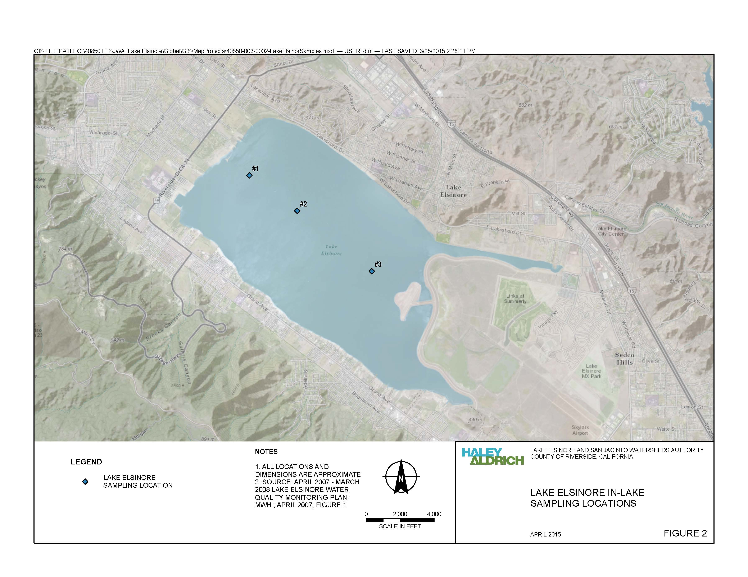

**Figure 2-1. Location of Lake Elsinore Sample Locations (LEE1, #1; LEE2, #2; and LEE3, #3). Figure 2 from Lake Elsinore & Canyon Lake Nutrient TMDL Compliance Monitoring Work Plan (Haley & Aldrich 2015)**



**Figure 2-2. Total Phosphorus Concentrations in Lake Elsinore - 2002-2016**



**Figure 2-3. Total Nitrogen Concentrations in Lake Elsinore - 2002-2016**



**Figure 2-4. Nitrogen to Phosphorus Ratios in Lake Elsinore - 2002-2016**



**Figure 2-5. Total Ammonia Concentrations in Lake Elsinore - 2002-2016**



**Figure 2-6. Un-ionized Ammonia Concentrations in Lake Elsinore - 2002-2016**



**Figure 2-7. Chlorophyll *a* Concentrations (Depth Integrated) in Lake Elsinore - 2002-2015**



**Figure 2-8. Dissolved Oxygen Concentrations (Depth Integrated) in Lake Elsinore - 2006-2016**



**Figure 2-9. Dissolved Oxygen Concentrations (1-m from Bottom) in Lake Elsinore - 2006-2016**



**Figure 2-10. TDS Concentrations in Lake Elsinore - 2003-2016**

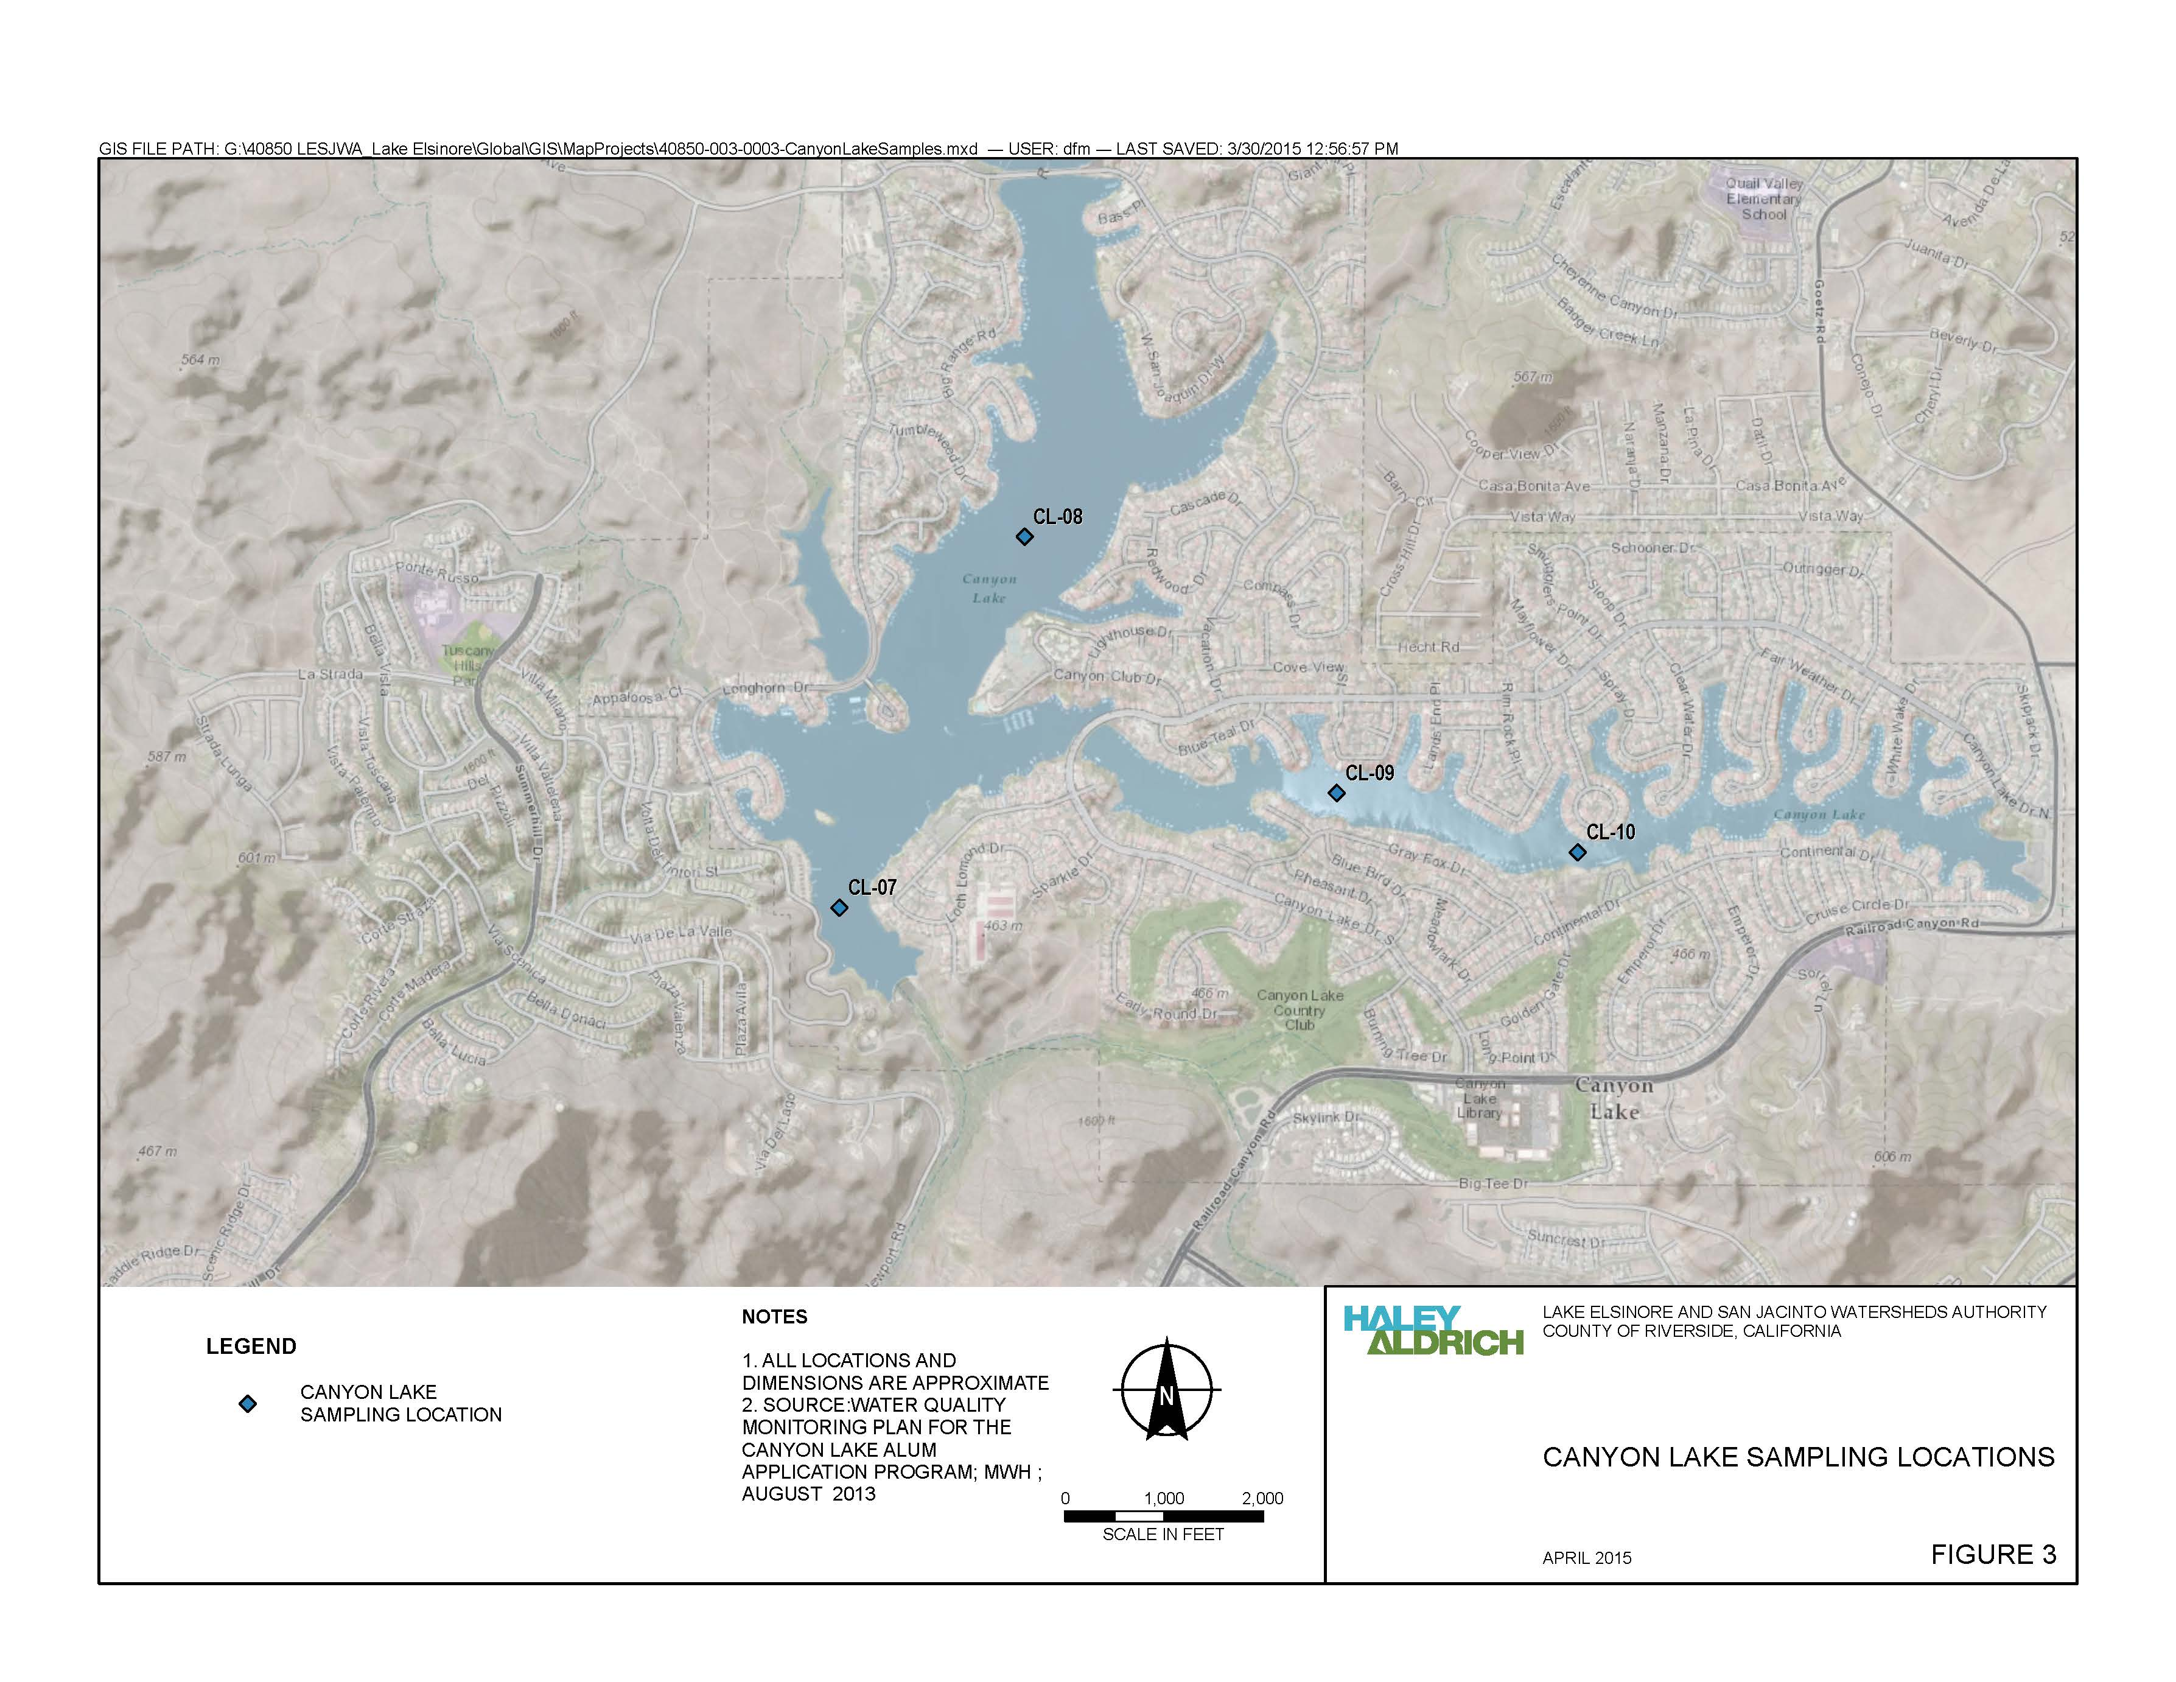

**Figure 2-11. Location of Canyon Lake Sample Locations (CL-07, CL-08, CL-09, and CL-10). Figure 3 from Lake Elsinore & Canyon Lake Nutrient TMDL Compliance Monitoring Work Plan (Haley & Aldrich 2015)**



**Figure 2-12. Total Phosphorus Concentrations in Canyon Lake - 2001-2016**



**Figure 2-13. Total Nitrogen Concentrations in Canyon Lake - 2001-2016**



**Figure 2-14. Nitrogen to Phosphorus Ratios in Canyon Lake - 2001-2016**



**Figure 2-15. Total Ammonia Concentrations in Canyon Lake - 2007-2016**



**Figure 2-16. Un-ionized Ammonia Concentrations in Canyon Lake - 2007-2016**



**Figure 2-17. Chlorophyll *a* Concentrations (Depth Integrated) in Canyon Lake - 2001-2015**

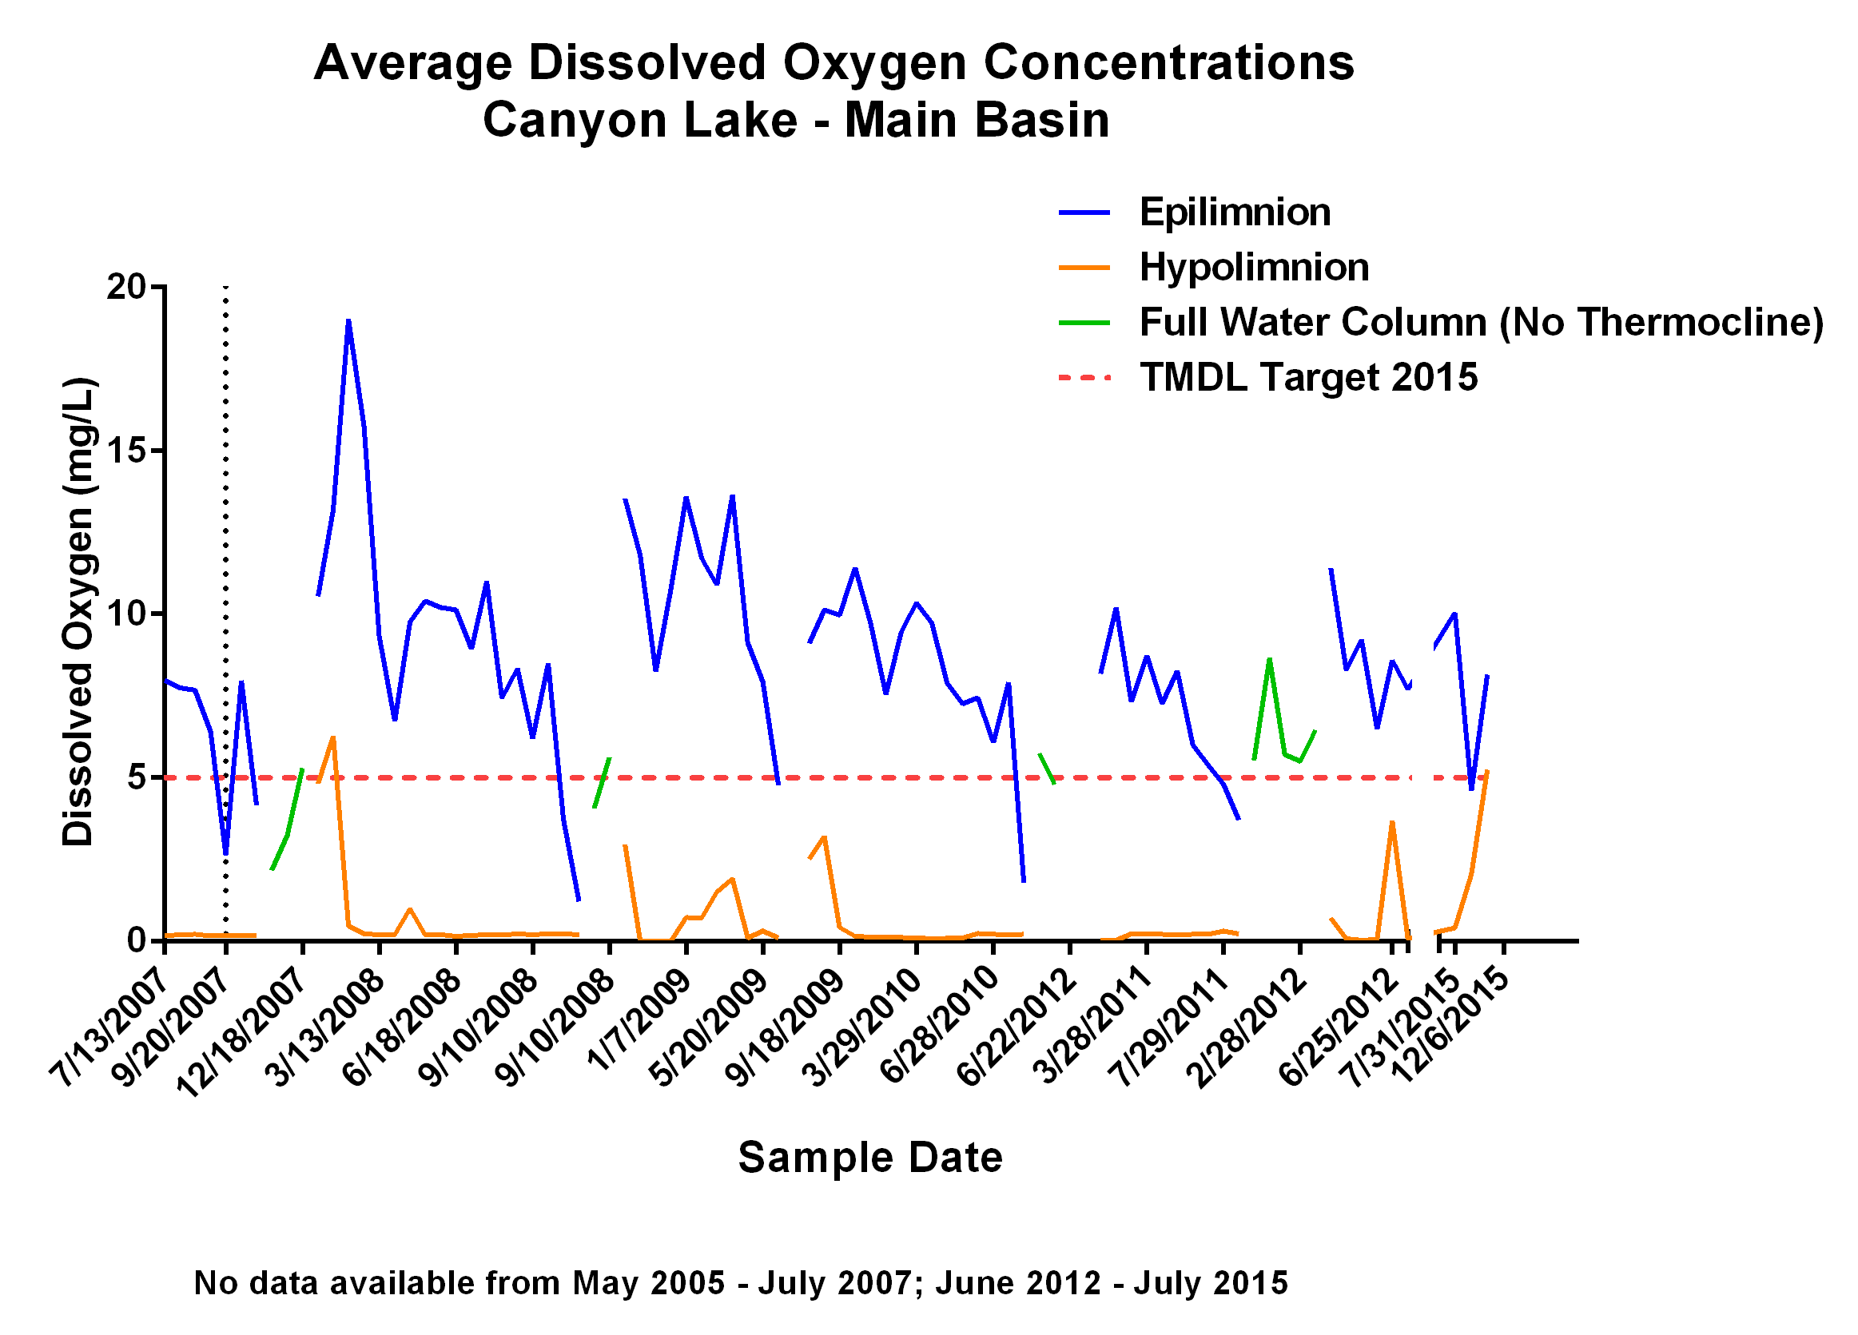

**Figure 2-18. Dissolved Oxygen Concentrations in Canyon Lake (Main Basin) - 2007-2016**

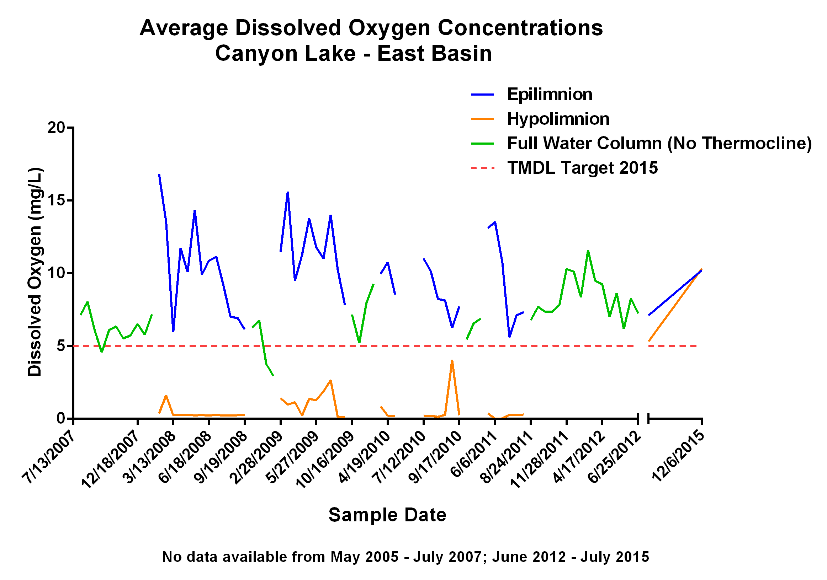

**Figure 2-19. Dissolved Oxygen Concentrations in Canyon Lake (East Basin) - 2007-2016**



**Figure 2-20. TDS Concentrations in Canyon Lake - 2001-2016**

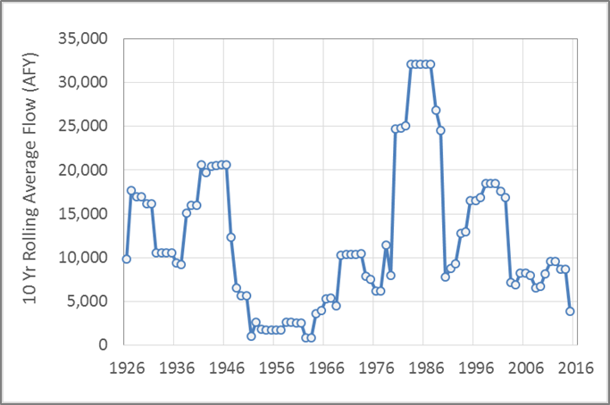

**Figure 2-21. 10-Year Rolling Average Annual Runoff Inflow to Lake Elsinore from San Jacinto River Watershed**

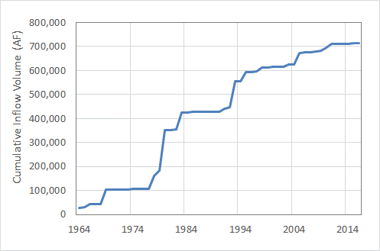**Figure 2-22. Cumulative Delivery of Runoff Volume to Lake Elsinore from the San Jacinto River (1964-2016)**

**Figure 2-23. Modeled water level in Lake Elsinore for Scenarios with and without Supplemental Water Additions (from Anderson, 2015a)**



**Figure 2-24. Estimated Concentration of Mobile-P in Canyon Lake Bottom Sediments Based on 2014 Hydroacoustic Survey (from Anderson 2015b)**

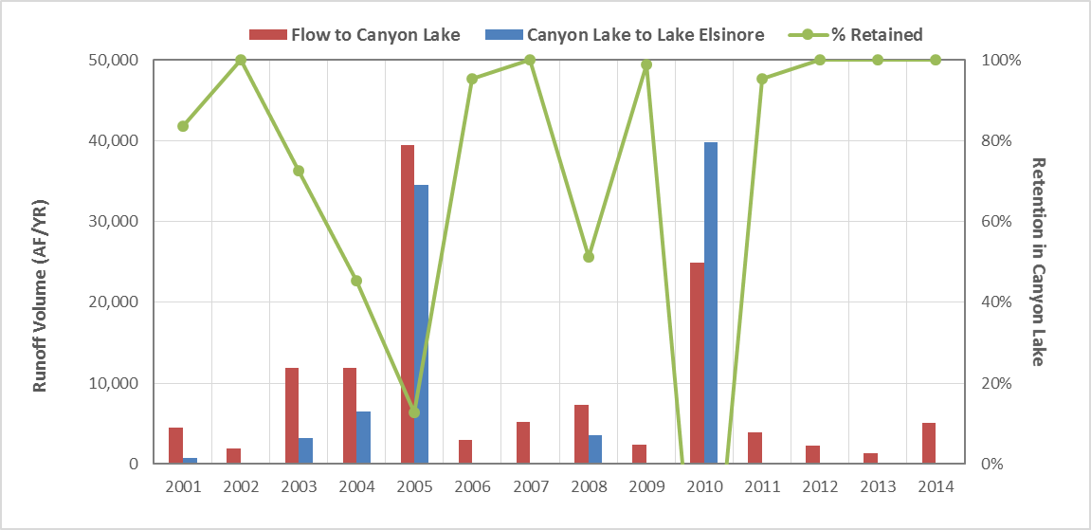

**Figure 2-25. Annual Runoff Volume into Canyon Lake and Overflow to Lake Elsinore**

1. State Water Board’s 2010 Integrated Report; <http://www.waterboards.ca.gov/water_issues/programs/tmdl/integrated2010.shtml>
2. Santa Ana Water Board, 2000. Lake Elsinore Nutrient TMDL Problem Statement.
3. See Santa Ana Water Board, 2004. Lake Elsinore and Canyon Lake Nutrient Total Maximum Daily Loads, Chapter 3, Problem Statement for summary of studies.
4. Santa Ana Water Board, 2001. Canyon Lake Nutrient TMDL Problem Statement.
5. For summary of studies, see Santa Ana Water Board, 2004. Lake Elsinore and Canyon Lake Nutrient Total Maximum Daily Loads, Chapter 3, Problem Statement.
6. Santa Ana Water Board Resolution No. R8-2004-0037
7. State Water Board Resolution No. 2005-0038
8. Santa Ana Water Board, Triennial Review of the Water Quality Control Plan for the Santa Ana River, July 24, 2015.
9. Santa Ana Water Board, Resolution No. R8-2015-0085; Adoption of the FY2015-2018 Triennial Review Priority List and Work Plan.
10. Santa Ana Water Board, 2000. Lake Elsinore Nutrient TMDL Problem Statement
11. Work Plan is available at: <http://www.sawpa.org/wp-content/uploads/2012/05/2015_0423_HAI_LakeElsinorePhII-MonPln__F.pdf>
12. To be added: references to annual TMDL Monitoring Reports.
13. Santa Ana Water Board, 2004. Lake Elsinore and Canyon Lake Nutrient Total Maximum Daily Loads,
14. Santa Ana Water Board, 2001. Canyon Lake Nutrient TMDL Problem Statement
15. However, as noted in Section 2.2.2, flows from the San Jacinto River Watershed need to be revised per new understanding regarding upstream retention, e.g., in the Mystic Lake subwatershed.
16. Chapter 4, “Source Assessment” characterizes existing information of nutrient washoff from watershed lands during such events and the conditions that may explain their occurrence.